EXP-16
Aim:To explore the USArrests dataset by finding summary statistics, extreme crime rates, correlations, and visualizing the data.
Algorithm
- Import pandas and matplotlib libraries.
- Load the USArrests dataset.
- Display summary statistics.
- Find the state with the largest rape arrests.
- Find maximum and minimum murder rates.
- Calculate correlation between variables.
- Identify states with assault above the median.
- Identify states in the bottom 25% for murder rate.
- Create histogram, density plot, scatterplot, and bar graph.
Pseudocode
START
Import libraries
Load dataset
Display summary statistics
Find state with highest rape arrests
Find max and min murder rates
Calculate correlation
Find states with assault above median
Find bottom 25% states for murder
Create histogram, density plot, scatterplot, bar graph
END
Output
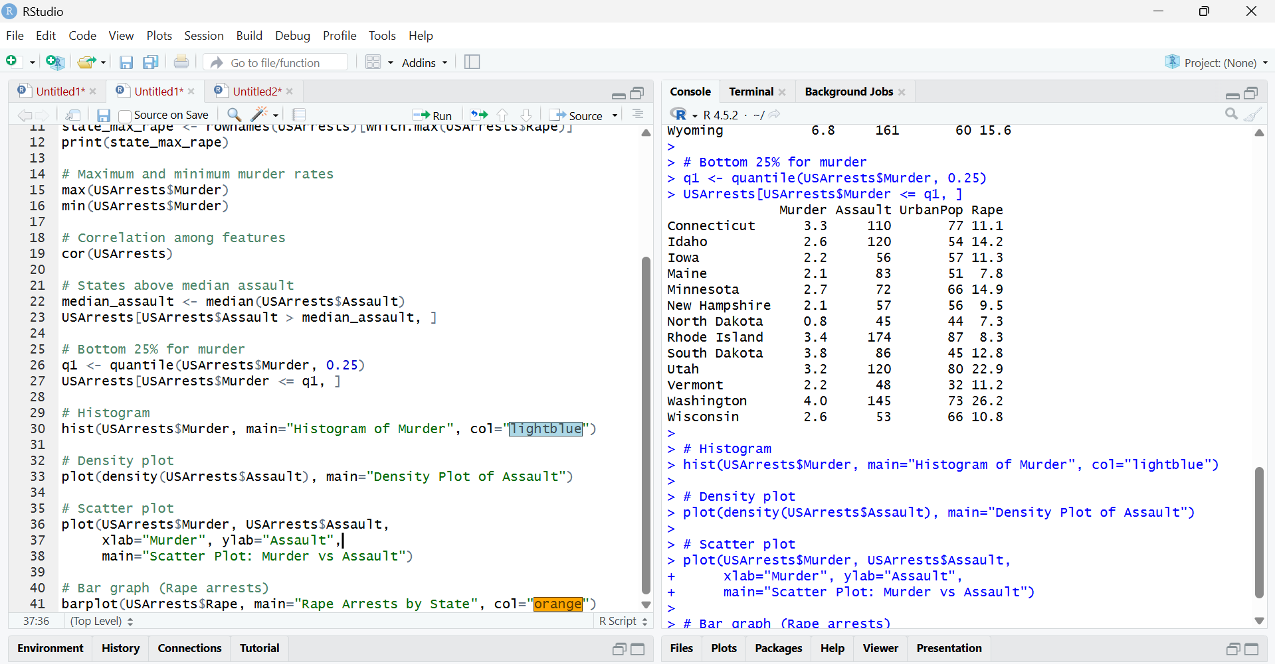
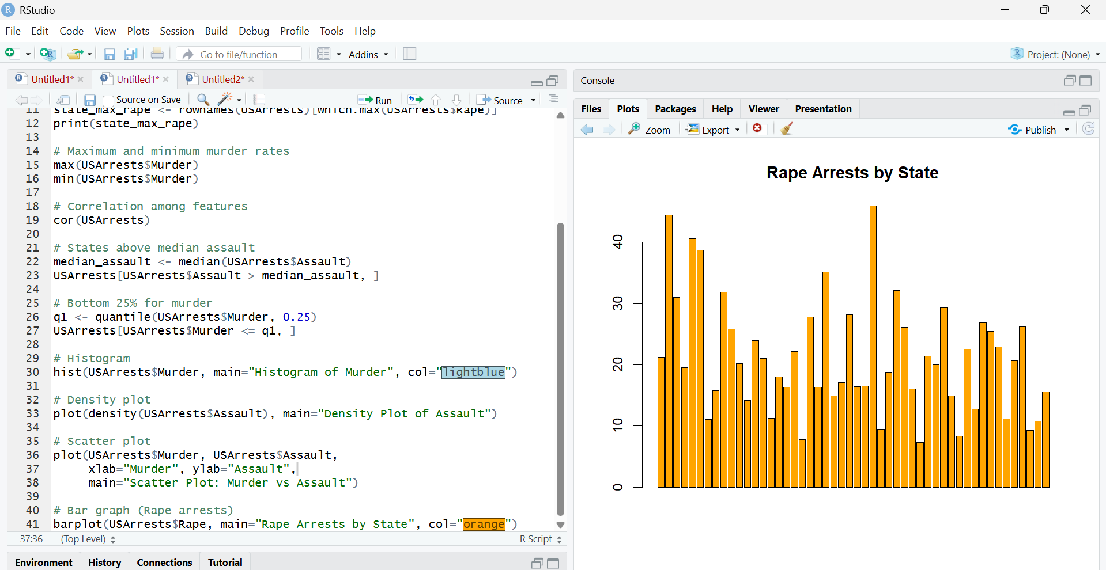
Result
The USArrests dataset was analyzed. Summary statistics, correlations, and crime rate extremes were identified. The data was visualized using histogram, density plot, scatter plot, and bar graph.

