EXP-17
Aim
To explore the Titanic dataset and visualize the relationship between passenger survival and passenger class, analyze survival by gender, and study the age distribution of passengers using graphical plots.
Algorithm
- Import required Python libraries such as pandas, seaborn, and matplotlib.
- Load the Titanic dataset using the Seaborn library.
- Display the dataset to understand its structure.
- Create a bar chart to visualize survival rate with respect to passenger class.
- Modify the bar chart by adding gender as a hue to compare male and female survival rates.
- Plot a histogram of the Age column to understand the distribution of passenger ages.
- Display all the plots using matplotlib.
- Interpret the visualization results.
Pseudocode
START
Import pandas
Import seaborn
Import matplotlib
Load Titanic dataset
Display first few rows of dataset
Plot bar chart:
X-axis → Passenger Class
Y-axis → Survival
Title → Survival Rate by Class
Plot modified bar chart:
X-axis → Passenger Class
Y-axis → Survival
Hue → Gender
Plot histogram:
Data → Age column
Number of bins → 20
Display all plots
END

Output:
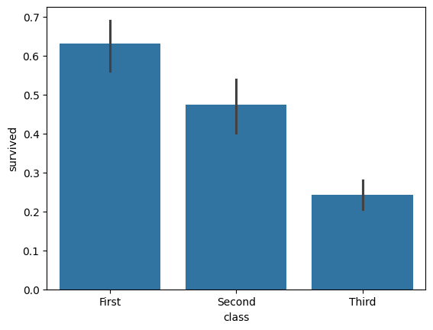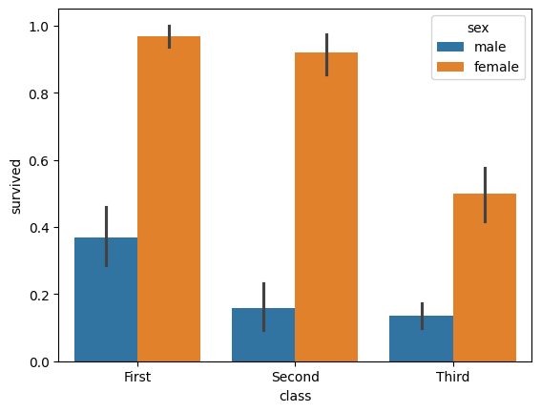
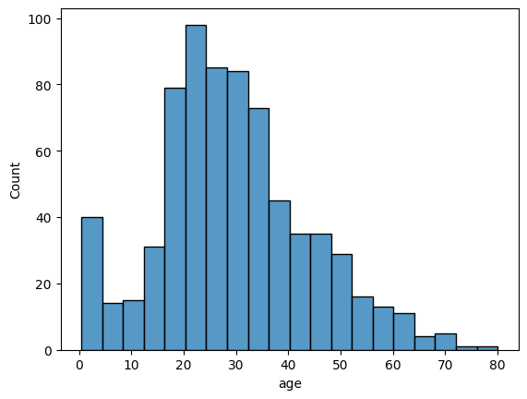
Result:
“First-class and female passengers had the highest survival rates, third-class and male passengers had the lowest, and most passengers were aged between 20–40 years.”

