EXP-11
AIM
To write an R program to read a .csv file and display its contents.
ALGORITHM
- Specify the file path of the CSV file.
- Use read.csv() function to read the file.
- Store the data in a variable.
- Display the contents using print() or View().
- Stop.
PSEUDOCODE
Start
Give file path
Read file using read.csv()
Store in variable
Print data
Stop
OUTPUT:
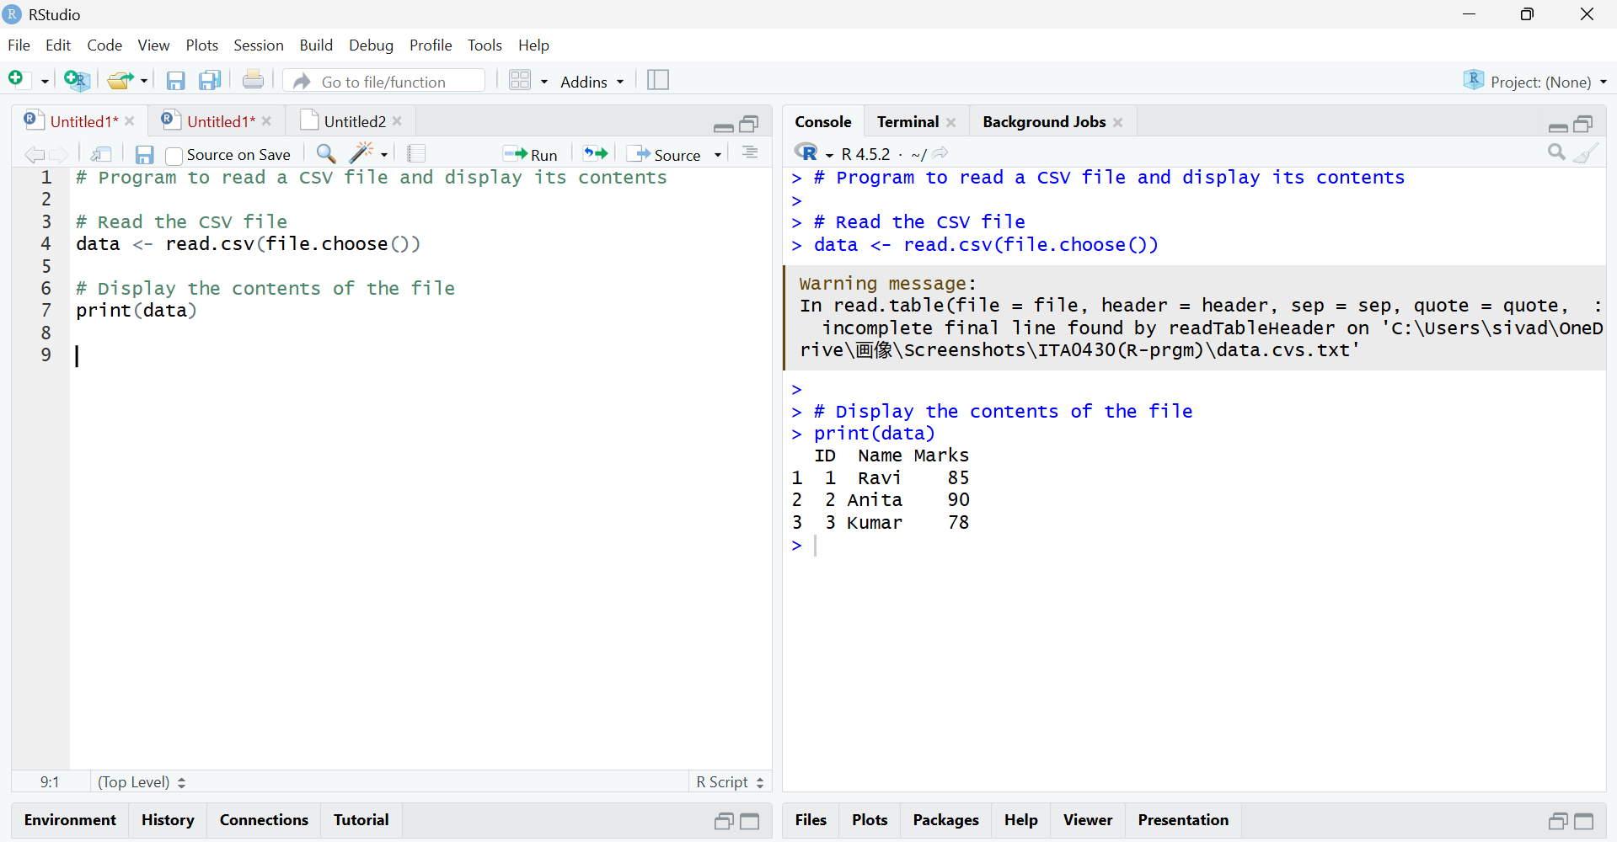

RESULT
The CSV file was successfully read and its contents were displayed.

