EXP-12
AIM
To reshape the airquality dataset using melt and cast, and compute monthly averages for Ozone, Solar.R, Wind, and Temp.

ALGORITHM
- Load the airquality dataset.
- Explore the dataset: view first few rows and structure.
- Load the reshape2 library.
- Melt the dataset into long format with Month as id variable.
- Use dcast to compute monthly averages for each variable.
- Display the reshaped dataset with averages.

PSEUDOCODE
Start
Load airquality dataset
View first few rows and structure
Load reshape2 library
Melt dataset using Month as id variable
Cast dataset to calculate mean of Ozone, Solar.R, Wind, Temp by Month
Print monthly averages
Stop
OUTPUT:
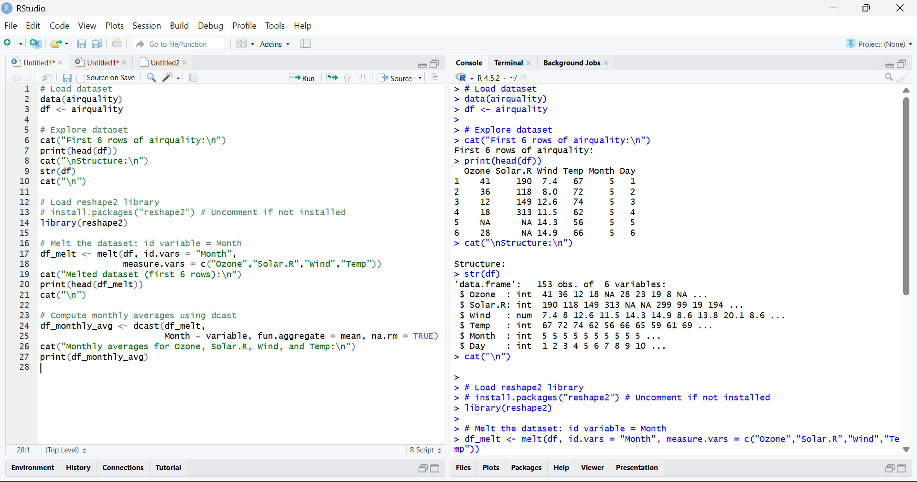
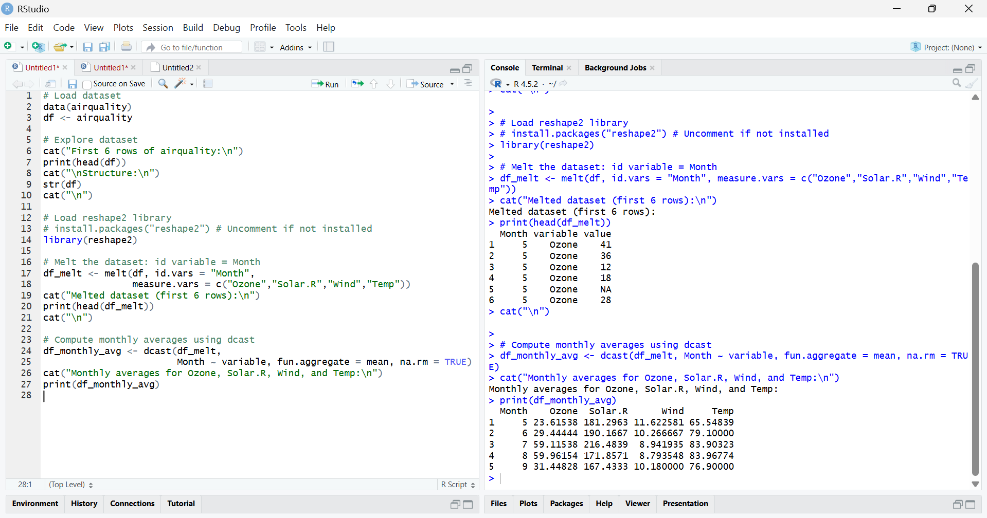

RESULT:
The airquality dataset was reshaped using melt and dcast, and monthly averages for Ozone, Solar.R, Wind, and Temp were computed for each month.

