EXP-13
AIM
To combine multiple arrays (or vectors/matrices) row-wise into a single matrix in R.
ALGORITHM
- Create two or more arrays (or vectors).
- Use the rbind() function to combine them row-wise.
- Display the resulting combined matrix.
PSEUDOCODE
Start
Create array1
Create array2
Use rbind(array1, array2) to combine row-wise
Print the combined array
Stop
OUTPUT:
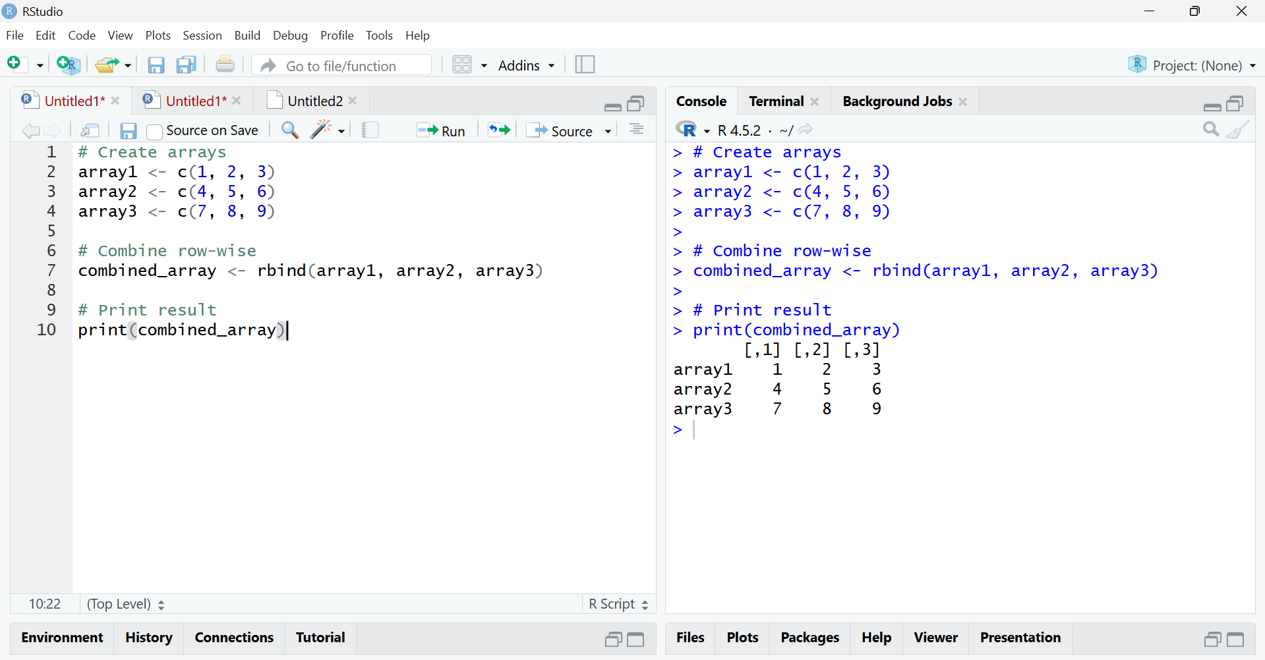
RESULT:
The arrays array1, array2, and array3 were combined row-wise into a single matrix:
[,1] [,2] [,3]
array1 1 2 3
array2 4 5 6
array3 7 8 9

