EXP-14
AIM
To explore and manipulate the built-in ChickWeight dataset in R, including sorting, reshaping using melt and dcast, and analyzing weight by Diet.
ALGORITHM
- Load the ChickWeight dataset.
- Explore the dataset: view first few rows, summary, and structure.
- Sort the dataset by weight.
- Reshape the dataset using melt to long format.
- Use dcast to create a summary table of mean weight by Diet and Time.

PSEUDOCODE
Start
Load ChickWeight dataset
View first few rows, summary, and structure
Sort dataset by weight in ascending order
Load reshape2 library
Melt dataset to long format (id.vars: Chick, Diet)
Cast dataset to wide format (mean weight by Diet and Time)
Stop
OUTPUT:
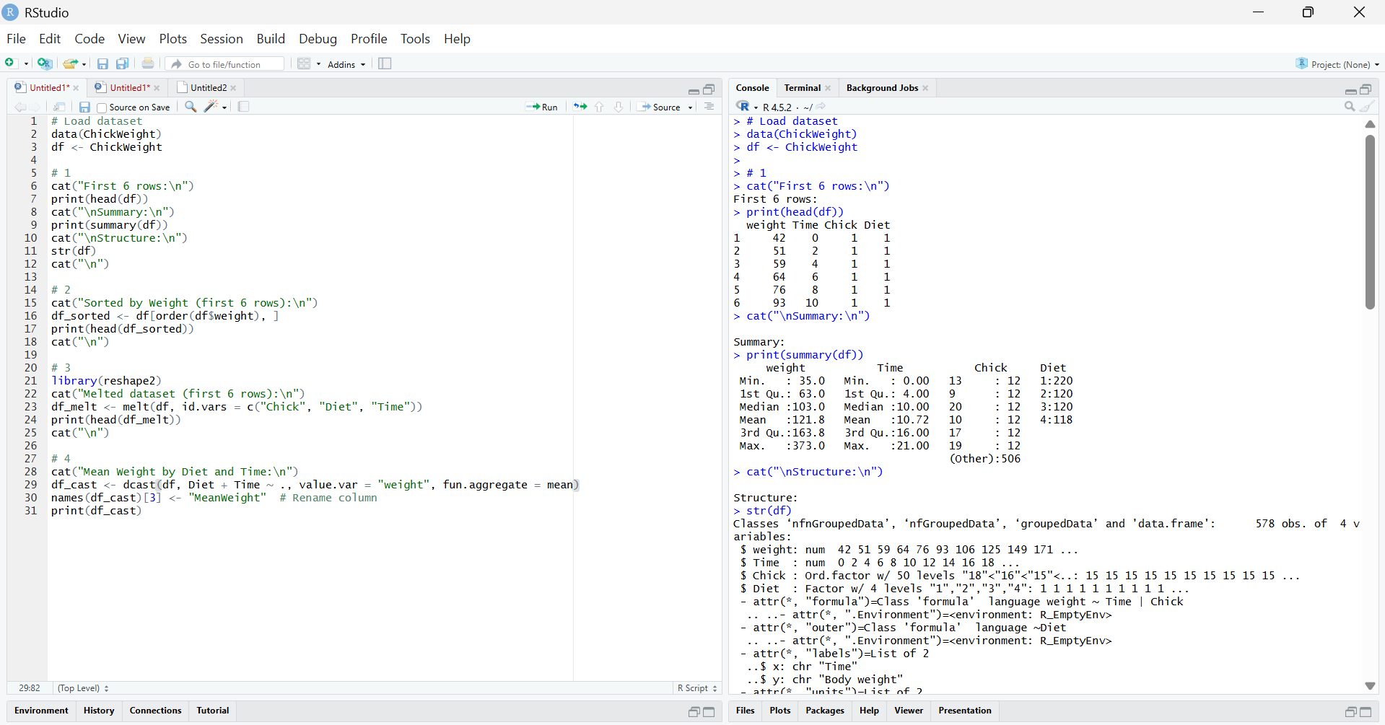
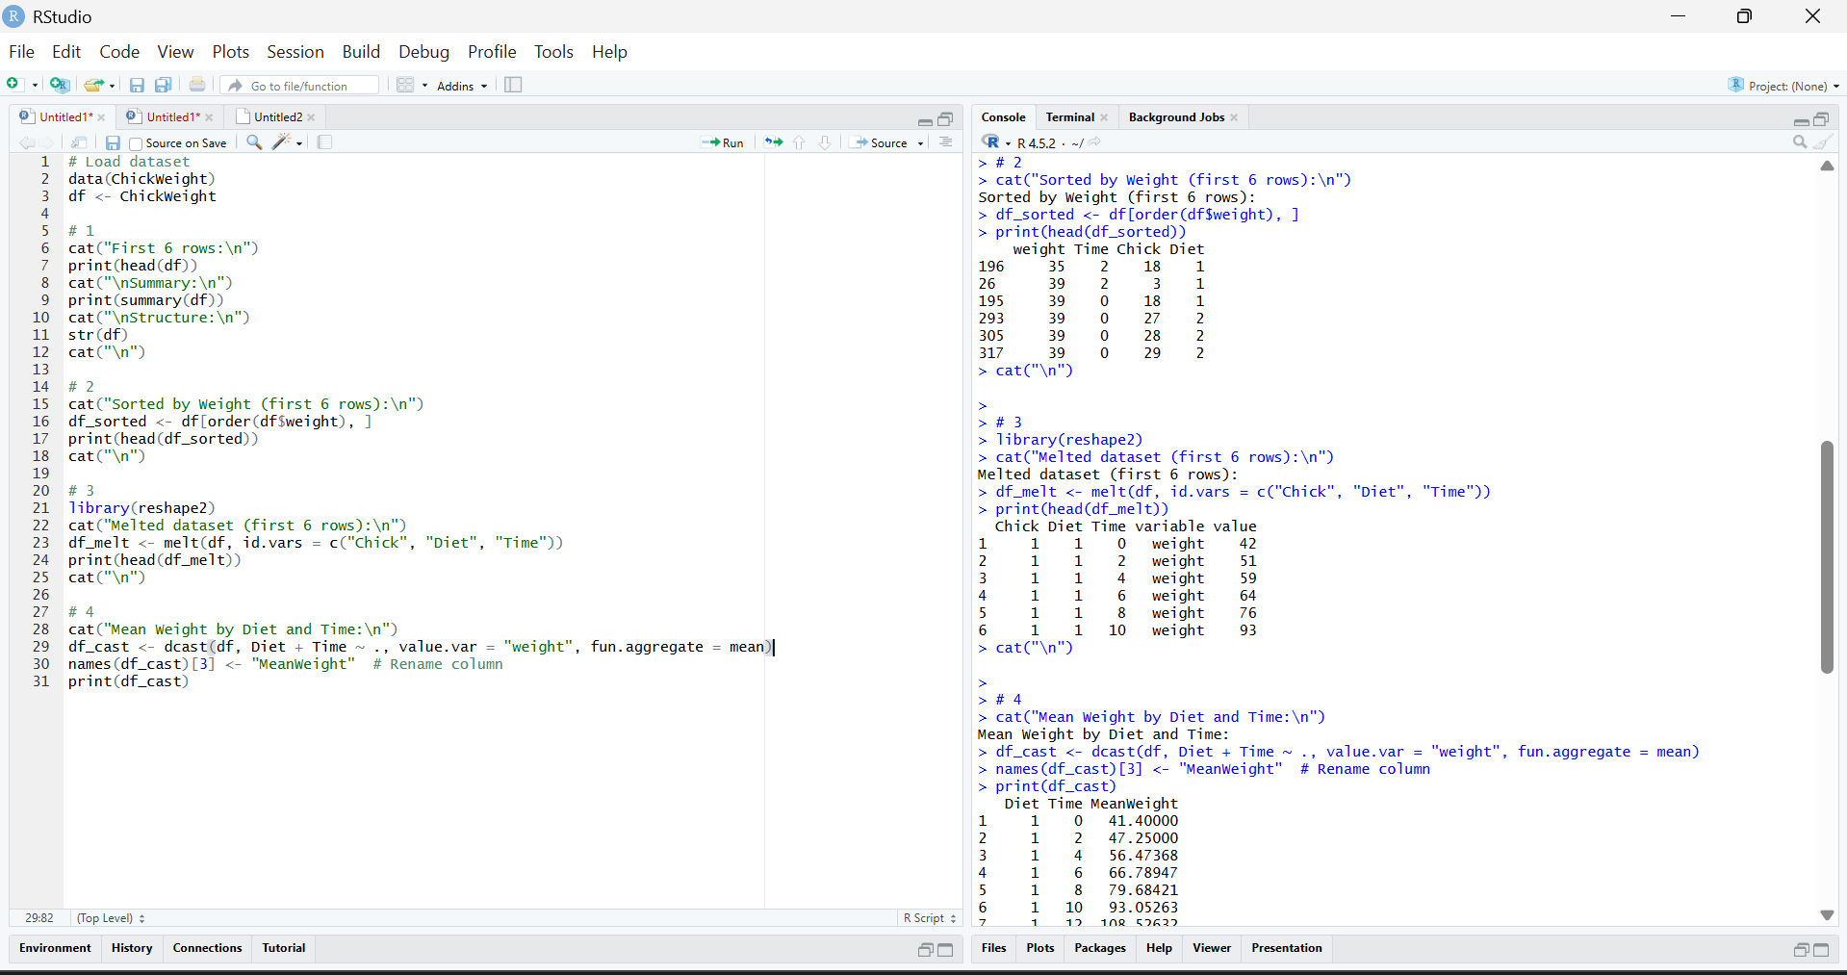
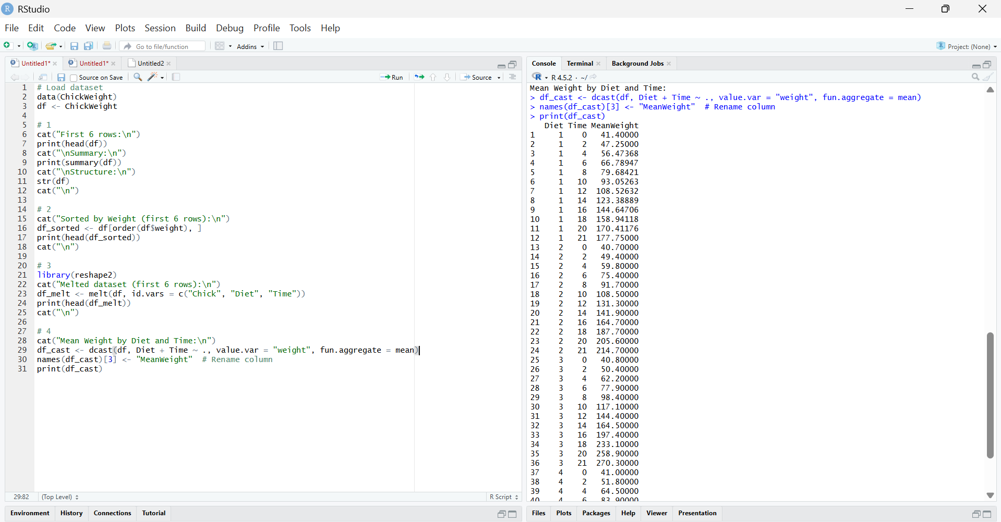
RESULT:
The Chick Weight dataset was explored, sorted by weight, melted into long format, and cast to show mean weight by Diet and Time, enabling clear comparison of chick growth across diets.

