EXP-15
AIM
To perform Exploratory Data Analysis (EDA) on the iris dataset, including:
- Checking dimensions
- Viewing summary statistics
- Calculating standard deviation
- Finding quantiles
- Grouping by Species
- Creating a pivot table
- Categorizing Sepal.Length and analyzing groups
ALGORITHM
- Load the iris dataset.
- Check the dimensions of the dataset.
- Generate summary statistics for all columns.
- Calculate standard deviation for numeric columns.
- Calculate quantiles for Sepal.Length.
- Group data by Species and compute mean values.
- Create a pivot table for mean Sepal.Length by Species.
- Create categories for Sepal.Length (Small, Medium, Large).
- Count the number of entries in each Species × SepalCategory combination.

PSEUDOCODE
Start
Load iris dataset
Print dimensions (rows, columns)
Print summary statistics
Calculate standard deviation for numeric columns
Calculate quantiles for Sepal.Length
Group data by Species and calculate mean Sepal.Length
Create pivot table for mean Sepal.Length by Species
Create Sepal.Length categories (Small, Medium, Large)
Count number of entries for each Species × SepalCategory
Stop

OUTPUT:
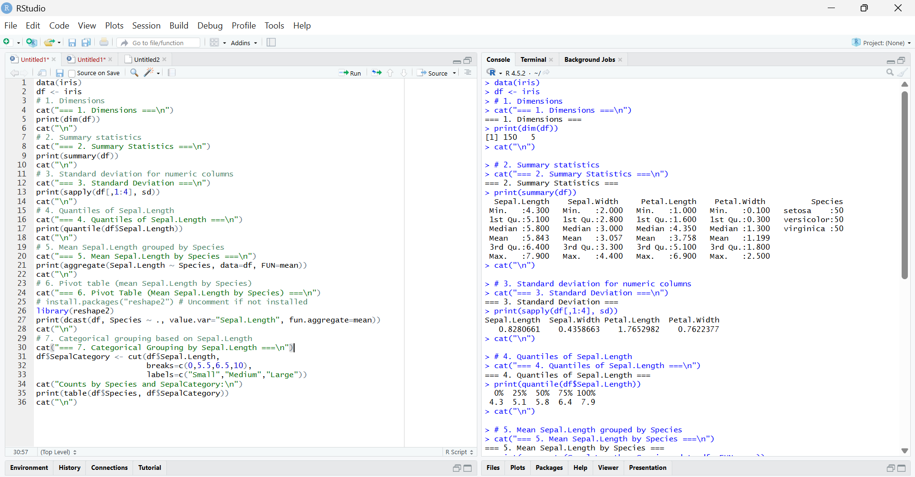
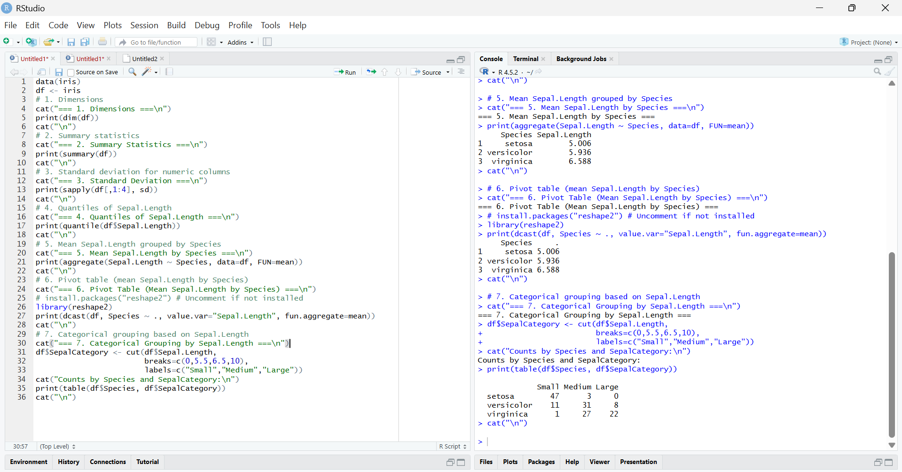
RESULT:
The EDA on the iris dataset showed 150 rows and 5 columns, with summary statistics, standard deviations, quantiles, Species-wise means, and Sepal.Length categorized as Small, Medium, and Large.

