EXPERIMENT-1
AIM:
To read a colour image and convert it into a grayscale image using the OpenCV library in Python.
Program:
import cv2
image = cv2.imread(r"C:\Users\sivad\OneDrive\Desktop\Computer Vision\sample(1).jpg.png")
if image is None:
print("Error: Image not found!")
exit()
gray_image = cv2.cvtColor(image, cv2.COLOR_BGR2GRAY)
cv2.imwrite(r"C:\Users\sivad\OneDrive\Desktop\Computer Vision\gray_output.jpg", gray_image)
cv2.imshow("Original Image", image)
cv2.imshow("Grayscale Image", gray_image)
cv2.waitKey(0)
cv2.destroyAllWindows()
Input:
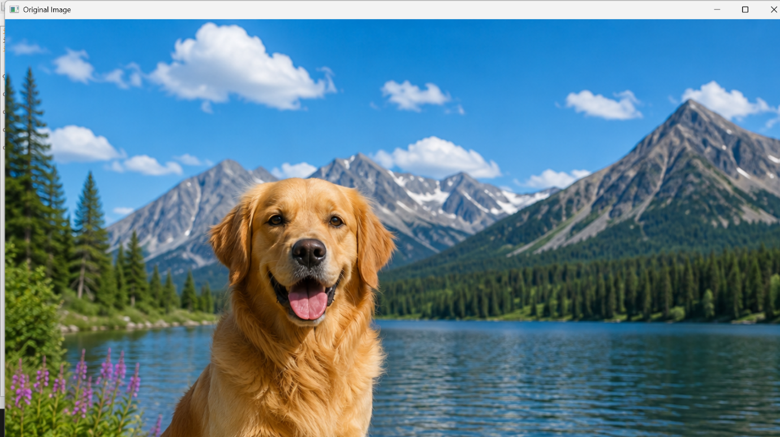
Output:
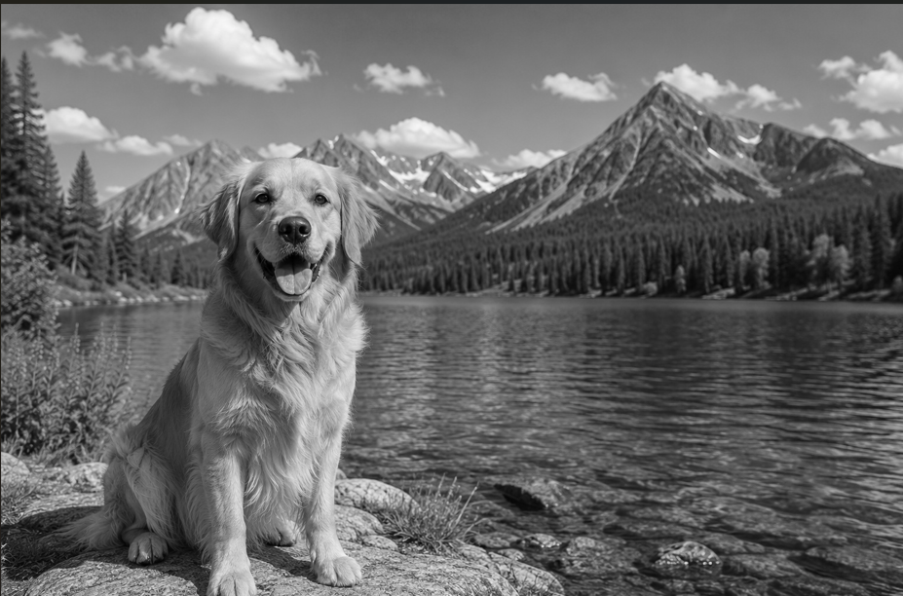
Result:
Successfully read the input image, converted it into a grayscale image, displayed both the original and grayscale images, and saved the grayscale image using OpenCV in Python.

