EXPERIMENT-2
AIM:
To read a color image and apply Gaussian Blur using the OpenCV library in Python.
Program:
import cv2
image = cv2.imread(r"C:\Users\sivad\OneDrive\Desktop\Computer Vision\sample(1).jpg.png")
if image is None:
print("Error: Image not found!")
exit()
blurred_image = cv2.GaussianBlur(image, (15, 15), 0)
cv2.imwrite(r"C:\Users\sivad\OneDrive\Desktop\Computer Vision\blurred_output.jpg", blurred_image)
cv2.imshow("Original Image", image)
cv2.imshow("Blurred Image", blurred_image)
cv2.waitKey(0)
cv2.destroyAllWindows()
Input:
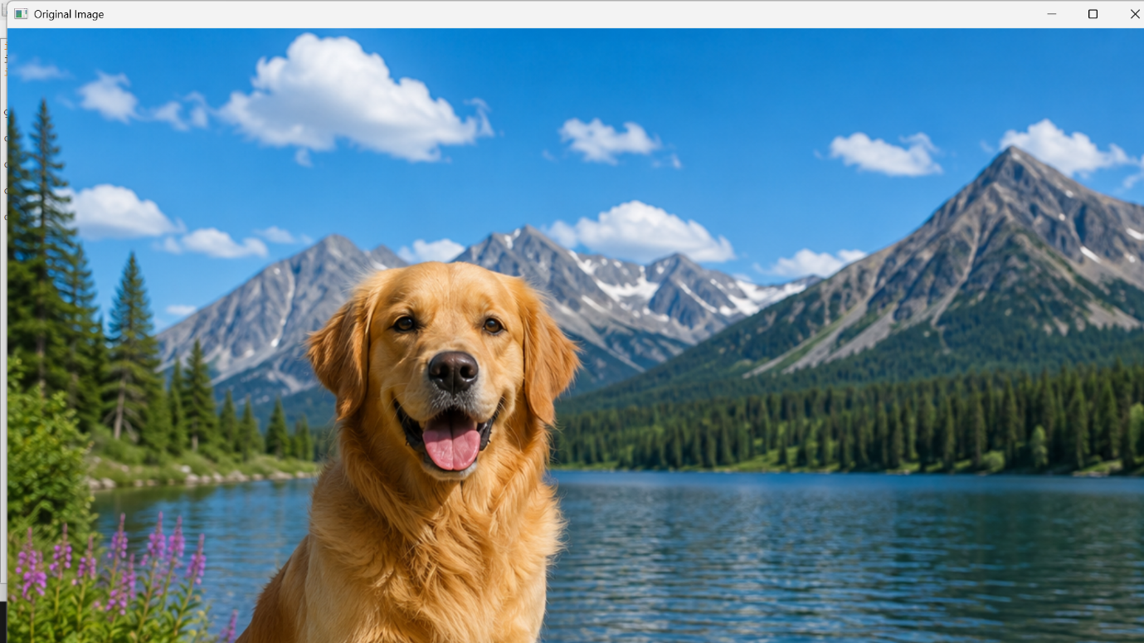
Output:
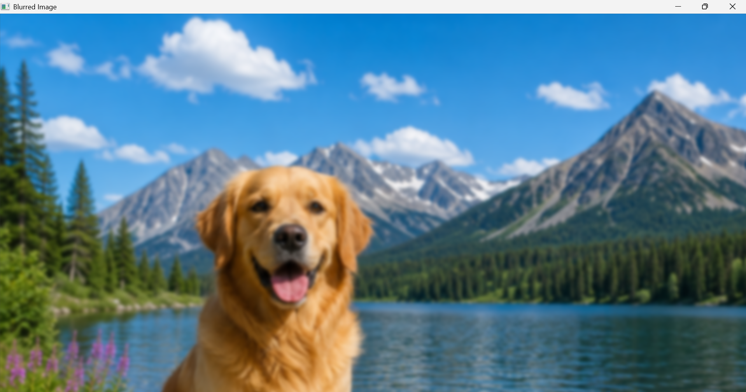

Result:
Successfully read the input image and applied Gaussian Blur using OpenCV in Python.

