EXPERIMENT-3
AIM:
To read a color image and detect its edges using the Canny function in OpenCV with Python..
Program:
import cv2
image = cv2.imread(r"C:\Users\sivad\OneDrive\Desktop\Computer Vision\sample(1).jpg.png")
if image is None:
print("Error: Image not found!")
exit()
gray_image = cv2.cvtColor(image, cv2.COLOR_BGR2GRAY)
edges = cv2.Canny(gray_image, 100, 200)
cv2.imwrite(r"C:\Users\sivad\OneDrive\Desktop\Computer Vision\edge_output.jpg", edges)
cv2.imshow("Original Image", image)
cv2.imshow("Edge Detected Image", edges)
cv2.waitKey(0)
cv2.destroyAllWindows()
Input:
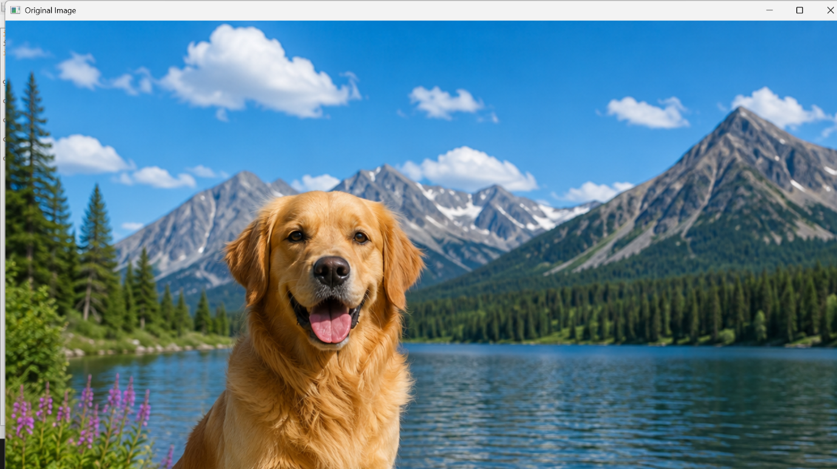
Output:
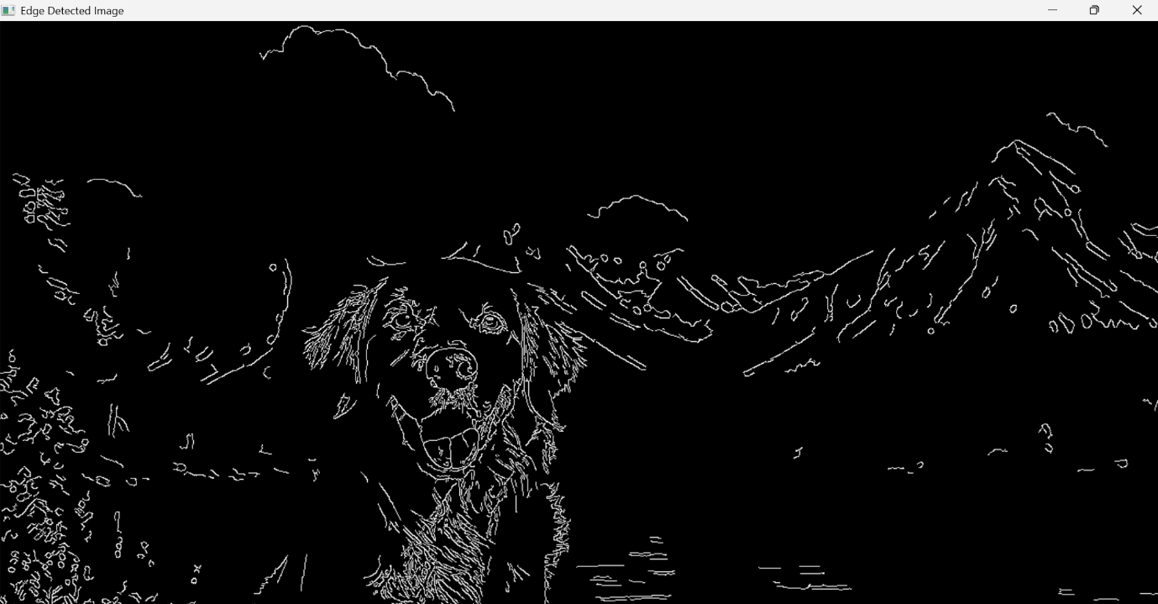

Result:
Successfully read the input image and detected its edges using the Canny function in OpenCV with Python.

