**Software System Requirement**

**For**

**The Bowl (Food Delivery System)**

**Version 1.0**

**Team Members:** ( Bommisetty Ganesh, Akhil Kata, Siva Kumar Sai Pulavarthy, Shasidhar Jampana, Sandeep Gangullapattu, Satish Babu Nalajala, Pramodh Chava)

**University of North Texas**

**October 1 2021**

Contant:

1. Introduction 3

1.1 Purpose 3

1.2 Document Conventions 3

1.3 Intended Audience and Reading Suggestions 3

1.4 Project Scope 3

1.5 References 3

2. Overall Structure of Project 4

2.1 Product Description 4

2.2 System Features 5

2.3 Operating Environment 5

2.4 Assumptions and Dependencies 6

3. System Features 6

3.1 Sign-up Page 6

3.2 Login Page…………………………………………………………………………………………..6

3.3 Update and Delete item Page………………………………………………………………………..6

3.4 Place the Order 6

3.2 Ready item’s Page………………………………………………………………………………….7

4. External Interface Requirements 7

4.1 User Interfaces 7

4.2 Hardware Interfaces 7

4.3 Software Interfaces 7

5. Other Nonfunctional Requirements 8

5.1 Performance Requirements 8

5.2 Safety Requirements 8

5.3 Security Requirements 8

5.4 Software Quality Attributes 8

6. Development Phase 9

6.1 Development Phase-1 9

6.2 Development Phase-2 9

6.3 Development Phase-3 10

7. Members Contribution 10

8. Minutes of Meeting 11

List of Figure:

Figure: 1 System Diagram 4

1. Introduction:
   1. Proposal:

The principal of "The Bowl" is to provide the users with an online interface for ordering food hassle-free. The proposed system supports the user to place orders conveniently and also provides the feature of canceling the order anytime before delivery. In a manual scenario, both the parties (the owner and the customer) might face issues like misinterpretation, delay, fatigue, etc. To overcome such cases we propose this system which will deliver results pleasing both parties. Another added feature is the ability to cancel the order anytime and the canceled food will be available for future customers to buy at a slashed price for a certain period.

1.2 Document Conventions:

The Documentation was done in Microsoft Word. The first page of the document contains the project name and the team member’s details, continued by the table content. In the table content, it describes the information’s of the project like the overview, system feature, interfaces and the development phases. Coming to the font and styles used for the documentation are ‘Times New Roman’, and for the font size all the headings are written in 14fnts, and the information in 12fnts.

1.3 Intended Audience and Reading Suggestions:

Using this S**oftware Requirements Specification** (SRS) sheet development team, testing team, and also potential business owners can have a better understanding of "The Bowl". A qualified individual can refer to this SRS to ensure the project is on track favoring the desired requirements and achieving the milestones created during the planning phase. Using this we can constantly monitor the feature and functionality changes/developments in every phase.

1.4 Project Scope:

The sole purpose of the project is to make the online food ordering process even simpler and beneficial. The benefits of this online system are to save time, control food wastage to an extent, bring profits both to customer and owner, and overcome challenges faced when done manually.

The bowl application has two roles: customer and Admin. Customers can view the menu, order, and cancel ordered food items. Admin can change items in the menu, edit readied items, place or cancel orders.

1.5 Reference:

* <https://www.academia.edu/33253493/An_Online_Food_Ordering_System_System_Documentation>
* https://scholarworks.gvsu.edu/cgi/viewcontent.cgi?referer=&httpsredir=1&article=1222&context=cistechlib

1. Overall Structure of the Project:

2.1 Project Description:

The Bowl is a web application developed for ordering food. This system is a replacement for the old fashion way of ordering food manually. This online arrangement saves the time of both customer and owner. This application helps in understanding the order requirements precisely, make any desired changes to them, and plan cooking activities in the kitchen accordingly. The order details are present in the database, which will help avoid problems like time consumption and miscommunication.

System Diagram:

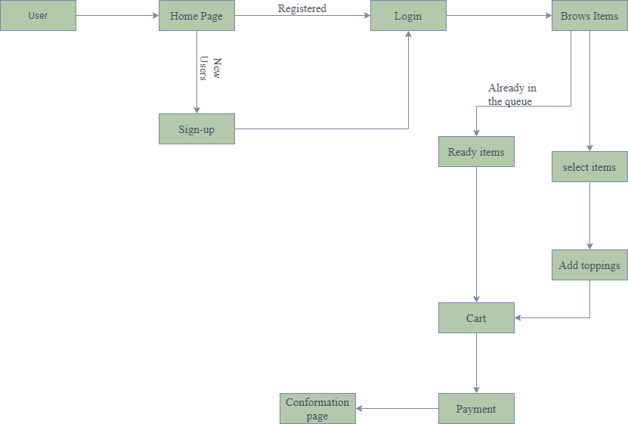

Fig: 1 System Diagram

2.2 System Features:

* Home Page:

Once the user has successfully authenticated himself//herself, they will land on the home page. On the home page, depending on the login type, the user can place an order, go through an order or make changes to an order.

* Sign-up Page:

This page takes the required details such as name, email, phone number, address, and password to create an account.

* Login Page:

It takes username and password as input. If the user credentials are valid, the user will be redirected to the user page. If the admin credentials are valid, the admin will be redirected to the admin page.

* Admin Page:

Admin can add, update and delete a user or an order.

* User Page:

The User can view the menu, place an order and also view his/her order details.

* 1. Operating Environments:
* Database Server : MySql
* Database Client :MySql Workbench
* Server :Apache Tomcat
* Platform :JAVA
* Server side Technologies :JEE(Servlets, JDBC connectivity)
* Client Side Technologies :HTML, CSS, Java Script, Bootstrap
* IDE :Eclipse
* E-R Modeling Tool :Lucidchart,Draw.io
* Testing Tools :Junit
* Operating System :Windows
  1. Assumptions and Dependencies
* Every user should have at least basic computer knowledge to order from the web application.
* User information will be protected, and admin details are not shared with anyone and protected for the security purpose.
* Adding of items and updating the items will be only done by admin

1. System Features:

Functional Specifications:

* 1. Sign-up Page:
* Users can create an account through the sign-up page.
* Sign up page contains fields like user’s name, email, phone, address, and password which help us to create an account.
* Validations will be performed on the text fields if required any.
* Once the account is created, the user details are stored in the database for future use.
  1. Login Page:
* Login page amid the user to enter into website
* Login page contain two major field username and password.
* Login page will authenticate the users based on the credentials submitted and redirect them to their respective interfaces like admin or customer page.
* If the user has forgotten or having issues with credentials, they can always reset/recover their password using the "Forgot Password" feature implemented on this page.
* If the credentials entered are invalid, the page will display an error message like “Invalid username or password”.
  1. Update and Delete Items in Menu:
* The task of updating and deleting an item from the menu is controlled by the admin whereas no other user can access this feature
* The food items are displayed on the home page once the admin has added them.
* If the admin deletes a food item, customers cannot order that item from their page.
* Admin can update the food item details like the price, quantity, and ingredients.
  1. Placing the order:
* Customers are the users who utilize the feature of placing an order.
* Users can view the food items available; the ingredients used the quantity, and the price.
* Users have to select the food items they want to order and proceed to the payments page.
* After the user completes payment for the items ordered, they receive a confirmation email to the registered email address.
* The user can also cancel items from his order or entirely cancel his order until the point of order collection.
* Users can view their current and previous orders.
* Allows the user to know the food items they have ordered and the respective details.
* Also, the user has a “cancel” option for the current orders.
  1. Ready item’s page:
* If the customer has placed an order and due to some circumstances if the customer cancels the order, then the item will be placed in the Ready item’s page.
* So that the customers who want to order any item then the customers will be shown this item in the ready item’s page so people can order from the ready item page and can save their time.
* If there are no items in the ready item’s page then the page will be empty

1. External Interface Requirements:

4.1 Hardware Technologies:

* Processor: Intel 5th gen or Latest version
* Ram: minimum of 4gb, maximum of 8gb

4.2 Software Technologies:

* Front-end Languages: Html, Css, JavaScript, Bootstrap
* Back-end Languages: Sql, Java
* Testing: Junit
  1. User Interface:

1. Home page:

Once the user has authenticated by them then the user will be redirected to the home page then in the home page user will be able to browse the items that he/she wants to order and the user will be able to customize the order for them.

1. Sing-up page:

At first the user will be able to choose the sign in options between the customer and admin and according to the option the user will be able to enter their credentials and authenticate themselves and redirected to the homepage.

1. Login page:

In the user page user can edit the user preferences and can update the user details.

1. Non-Functional Requirements:
   1. Performance Requirement:
2. **Response Time:**

Response time should be minimal. Example: loading a page or, login credentials should not take more than the specified time like 5 seconds.

1. **Workload:**

We should be able to handle the workload Example: generally, if our web application traffic is 100 visitors and the response time is 5ms suddenly the 100 visitors are increased to 500 then in this case our requirement is to handle the 500 visitors with considerable response time.

1. **Scalability:**

The system should handle the increase in workload. Example: it should handle the maximum customers without server down. In the payment options, the system should be able to handle the multiple transactions at a time.

* 1. Safety Requirements:
* The customer’s data and the order’s data should be backed up in the regular intervals (for every 1-2 hours) because in case of power cut or any damage to database happens, these backups will be helpful.
  1. Security Requirements:
* **Confidentiality:** confidential information should not be disclosed and guarantee that the personal information is not disclosed anywhere.
* The communication between the main server and the customer server is encrypted.

## 5.4 Software Quality Attributes

* Availability: The system should be accessible all the time
* Performance: The System should handle all the performance requirements
* Reliability: The system is reliable that user can change the details and depending upon the information the system stores the data in the protected and private way.

# Development phases

* With respect to the development phase, we plan to develop our project by dividing the functionalities into three phases. We offer user features such as ordering, canceling food, payment, and admin features such as adding items, deleting items that they have ordered.

* 1. Development Phase – 1:

During the first phase of development, the functional requirements and pages implemented are:

* Home Page:

The Home page consist of two login options the admin or customer login, choose the option accordingly.

* Sign-up Page:

If a user need to create an account he/she first need to sign-up. It consist of field that are related to the user such as user’s-First name, middle name, email id, phone number, and finally he need to set a password for his account. After filling these fields a user can create his account.

* Login Page:

Once the user created his account he can directly login into our website using his/her credentials like username and password.

* Forgot Password:

If a user he/she forgot his password, this characteristic helps them to resolve their problem.

* Sign-out:

By clicking the logout button, the user can leave the website securely.

## Development Phase – 2

In the second phase of the project we concentrate on functional requirements

* Dash Board:

This feature enables the user to view all the items in the menu that are available on that day.

* Search Items:

The search option enables the user to search all the items in the menu that are available on that day.

* Update Items:

This update option works for admin and user. It enables the admin to update the menu whereas the user can update his order according to his preference.

* Delete Items:

The User has an option to delete the item ahead of the payment.

* 1. Development Phase – 3

Finally, in the last phase of the project we are implementing these features

* Place the order-

This feature helps the user to place the order

* Payment-

This feature assists the user to make the payment for the items they have ordered.

* View item-

This feature aids the user to know the items he/she ordered.

* Cancel item-

These options used for the user to cancel the order.

* Ready item’s page:

If the customer has placed an order and due to some circumstances if the customer cancels the order, then the item will be placed in the Ready item’s page.

1. Members Contribution:

|  |  |  |  |
| --- | --- | --- | --- |
| Member name | Contribution  Description | Overall  Contribution (%) | Note  (if applicable) |
| 1. Siva Kumar Sai Pulavarthy | Minutes of meeting | 100% |  |
| 2. Ganesh Bommisetty | Development Phase, system diagram | 100% |  |
| 3. Akhil Kata | Functional requirements | 100% |  |
| 4.Shasidhar Jampana | Non-functional requirements | 100% |  |
| 5. Sandeep Gangullapattu | Overall structure | 100% |  |
| 6. Satish Babu Nalajala | Interface | 100% |  |
| 7. Pramodh Chava | Interface | 100% |  |

1. Minutes of Meetings:

In Person Elicitation Workshop Meeting,

On 09/18/2021 – 8:30AM To 11AM

Attendees-

* Siva Kumar Sri Sai Pulavarthy
* Ganesh Bommisetty
* Akhil Kata
* ShasidharJampana
* Sandeep Gangullapattu
* Satish Babu Nalajala
* And Team: Runtime_Terror

Things Discussed-

Discussions about Our Project i.e. The Bowl

* Explained Team: Runtime_Terror about our planning and vision in developing our project.
* Explained them about the approaches we are going to use.
* Discussed about the various features and interface designs we will be developing.
* Finally, asked if Team: Runtime_ Terror would provide any inputs or feature ideas that they would like to see in our project.

Feature Requests by Team: Runtime_Terror:

* Team: Runtime_Terror asked us to implement a feature which would differentiate our project from already existing projects.
* We proposed a feature which Runtime_Terror Team liked, the idea is: When a customer orders a bowl and in any case wants to cancel the order, instead of wasting the already prepared bowl, we display it in a separate section to be bought by other customers at a discounted price. By adding this feature, there will be less food wastage and will help a customer in a hurry to purchase food quickly.
* Team: Runtime_Terror proposed to add an “Estimated Time” Timer based on number of chefs available and pre-existing orders but keeping the time lines in mind we turned down this proposal as we will have to make other changes to our implementation if we need to include this feature.

We discussed about Team: Runtime_Terror’s project, understood it and proposed features they could add to their project.