Deliverable-4

3.

As we mentioned in the last Deliverable the phase-1 requirements which were not implemented in the Deliverable-3 are being implemented in the deliverable-4. Mentioned requirements are:

1) Login functionality for the user.

2) Signup for the user page.

3) Logout functionality.

4) Search bar implementation in the home page.

5) Menu has been enabled in the home page.

6) Add / manage/update the food in the Admin.

7) Manage/update the order in the Admin.

a. Requirements:

1. User Sign-up:

* New user need to sign-up before enter into the website.
* To sign-up he needs to enter the following details like- Name, username, email, and password.

2. User Login:

* If the user is the existing user he can login to the website using his/her credentials.
* To login into the website the user need a username and password.
* Login page then checks if the credentials given are right or wrong.
* If the credentials are invalid, it will show the error.

3. User Sign-out:

* User can sign-out from the website once he clicks the sign-out button.

4. Food:

* The food page contains all the items that are present on that day.
* Admin can create a menu accordingly with the items present in the day.
* Admin can also update or delete the menu items.

5. Order:

* The order page contains the details of the order that ate selected by the user.
* The components present in the order page are id, customer name, price, quantity, total amount.
* A user can order the items that are available at that time.

6. Food Search:

* It is a search bar where user can search the items he/she needs to order.
* This functionality reduces the search time for the user in searching an item.

b. UML Diagram:

1. Class Diagram:

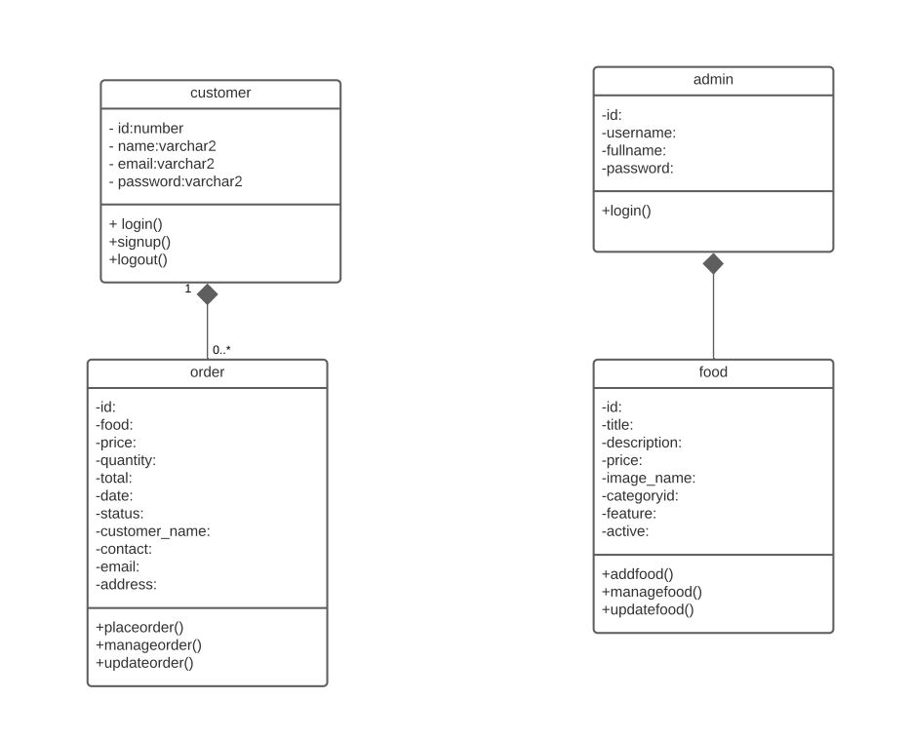

2. Use case Diagram:

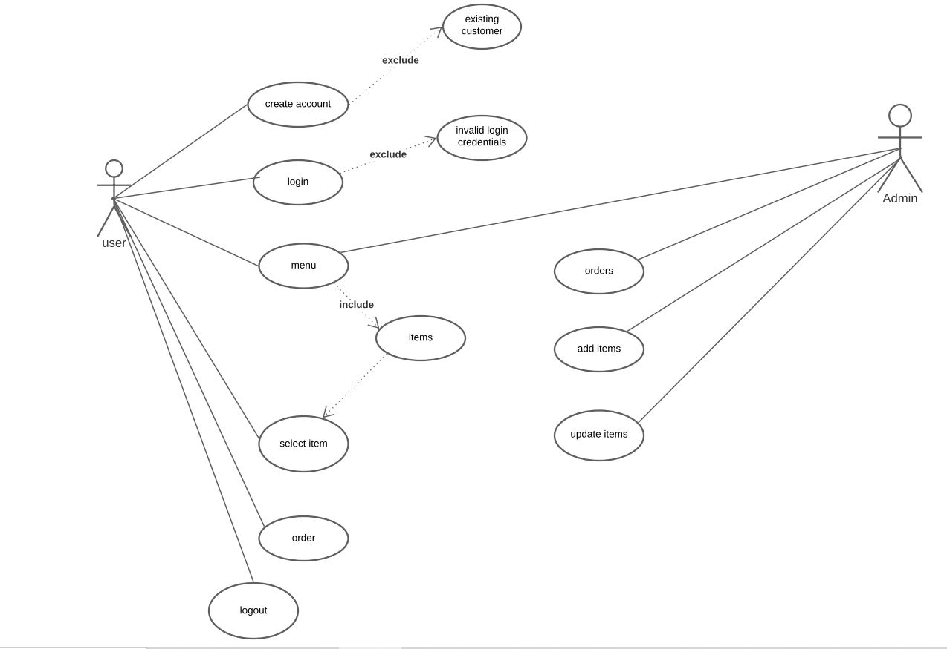

3. Sequence Diagram:

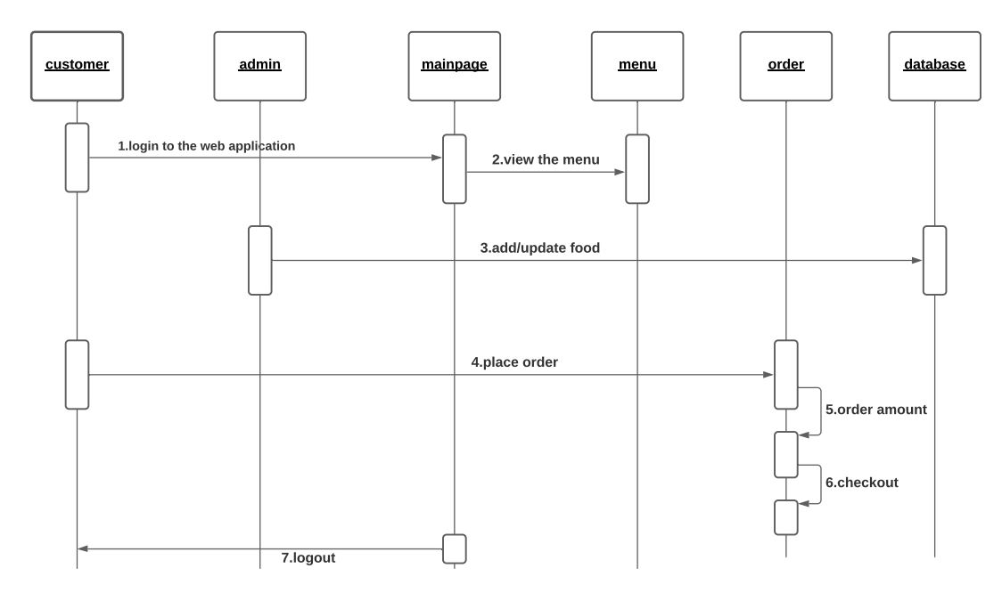

c. Test Case:

|  |  |  |  |  |
| --- | --- | --- | --- | --- |
| S.no | Test case | Expected Results | Result | Remarks  (if fails) |
| 1. | User Login | User can login successfully. | Pass | If a valid User with valid credentials is unable to login. |
| 2. | User Sign Up | New user can sign up successfully | Pass | If a valid User with valid details is unable to login. |
| 3. | User Logout | User should be able to logout successfully. | Pass | If user is unable to logout from the system or the session doesn't terminate even after the admin logs out. |
| 4. | Creating a new food item | Admin is able to add a new food item. | pass | Existing admin is unable to add a new item category. |
| 5. | Update an existing food item | Admin is able to update the existing food item. | Pass | Existing admin is unable to update the details of a food item. |
| 6. | Delete food item | Existing admin should be able to delete an existing food item. | Pass | Fails when the existing admin is unable to delete an existing food item. |
| 7. | Update Order | Admin is able to update the order status of any present order. | Pass | If admin is unable to update the status of existing order. |
| 8. | Food Search | When the user enters a valid keywork, they should be able to see the respective results. | Pass | If the search results don’t populate even when there are valid food items available. |

d.

The bowl web application runs on the local host server we will be hosting the application on the xampp server and the web application is developed with php, html, Sql, css ,bootstrap .This web application allows the user to order the food from the following menu.

e. Instructions to run the project:

1) Any user or developer who wants to run the project in their system their system requirements should be:

a) Minimum Intel i3 configuration or higher

b) Ram: 4 GB or higher preferred

c) 5 GB disk space

2) First the user wants to install any IDE we prefer visual studio to write the code.

3) User wants to install the xampp server/ mamp for windows/ Mac respectively in their system.

4) The user wants to start the xampp server by starting their apache and myql in their xampp control panel.

5) The user wants to open PHP Myadmin and then create a database according to the connection file in the project. Then import the sql file to the database from the respective project folder.

6) Then the user can run the project by typing localhost/project_folder_name in their web browser.

Starting the Project in Detail:

* Download the project as zip.
* Extract the zip file.
* Place the extracted files in htdocs folder of xampp.
* Create a database in phpMyAdmin with the name “TheBowlDB”
* Import the “TheBowlDB.sql” into the database.
* Update the TheBowl1/config/constants.php file according to you database configurations.
* To start as the admin use the following link “localhost/thebowl1/admin/”
* To start as the user use the following link “localhost/thwbowl1/”

f. Feedback for the code Inspection Session:

* The opposite team suggested us that have a login page for the user rather than keeping it as a guest user.
* They suggested us to design a search bar which helps the user to reduce his search time while searching for the items.

Actions taken:

* As we mentioned in the last Deliverable the phase-1 requirements which were not implemented in the Deliverable-3 are being implemented in the deliverable-4
* As per the opposite team suggestion we have also developed a search bar in our system.

g.

The main challenge that we have faced in the deliverable-4 was when we are trying to order the food from the user the order was placing but when we are trying to access them from the user orders we are unable to reflect it so just we are pushing the order functionality to the next deliverable.

h. Member Contribution:

|  |  |  |  |
| --- | --- | --- | --- |
| Member name | Contribution  Description | Overall  Contribution (%) | Note  (if applicable) |
| 1. Siva Kumar Sai Pulavarthy | Core functionality  Skeleton, login.php  register.php, sever.php, test-case | 100% |  |
| 2. Ganesh Bommisetty | error.php, index1.php,  Search bar.  Report: Requirements, class diagram | 100% |  |
| 3. Akhil Kata | Menu1.php,menu3.php,  order.php.  Report: Sequence diagram, use case diagram | 100% |  |
| 4.Shasidhar Jampana | update order, manage order  Report: Challenges | 100% |  |
| 5. Sandeep Gangullapattu | add food, delete food  Report:  Instructions | 100% |  |
| 6. Satish Babu Nalajala | update food, manage food  Report:  Feedbacks | 100% |  |