Deliverable-5

2.

In this deliverable we have modified some of the functionalities that are not working properly in the previous deliverable and make necessary change to work effectively and we have improve the visualization of our UI and more over we have implemented the following functionalities:

1. Cart
2. Check-out
3. Payment Page
4. Order Details

a. Requirements:

1. Cart:

This feature helps the user to view the item they selected added into the cart .

2. Check-out:

This feature directs the user to the payment page and it also show the total cost of the items that the user has placed.

3. Payment Page:

This feature is used by the customer to make the payment which he/she ordered.

4. Order Details:

It shows the user the status of the order and also it will show the previous orders of the user.

b. UML Diagrams:

1. Use-case Diagram

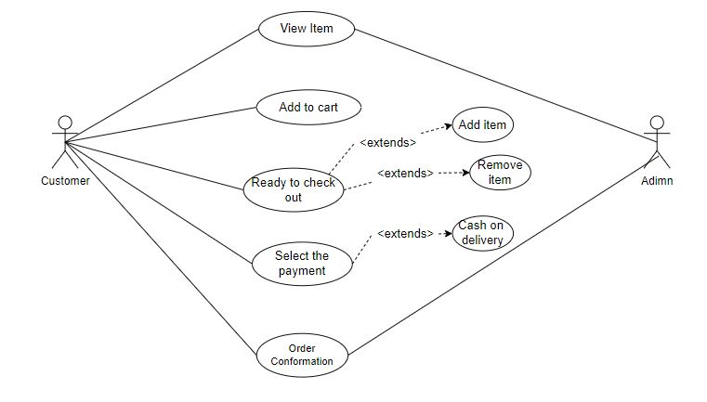

2. Class Diagram

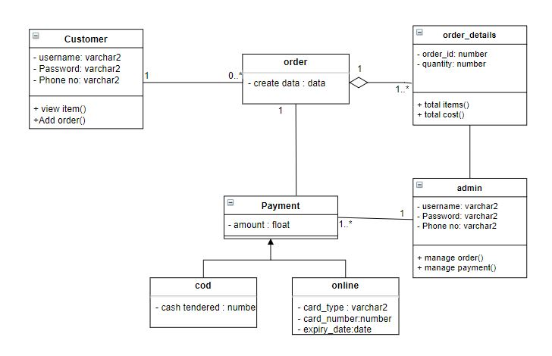

3. Sequence Diagram:

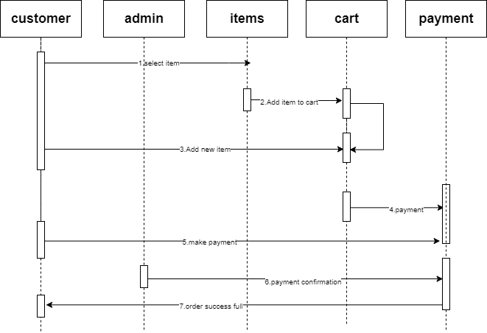

c. Unit Testing:

|  |  |  |  |  |
| --- | --- | --- | --- | --- |
| S.no | Test case | Expected Results | Result | Remarks  (if fails) |
| 1. | Add item into the cart | Item should be displayed in the cart | Pass | If he does not login into the page. |
| 2. | Check-out | The page should direct the user to the  Order detail page | Pass | The user might have given the wrong password.  He might have entered the phone number in incorrect format. |
| 3. | Payment-option | The user has to choose only cash on delivery | Pass | The user should not select the online payment. |

System Testing:

In the system testing the whole web –application is tested in many aspects.

1. User login: Is user able to login to the system or not.
2. User signup: Is user able to sign up to the application and are the user details are reverting back to the user table in the database or not.
3. Adding item to the cart: Is user able to add the item to the cart.
4. Checkout: when the user able to check out from the cart page then the system asks the user to enter the details the details entered in the checkout page is the mobile number containing 10 digits or not and the entered password is matched with the user password or not.
5. Orders: once the user placed the order whether the user order is reflecting in the orders page of the user or not and the details of the order are storing in the database or not.
6. Contact us: if a user enters a message in the contact us page then the entered password in the contact us page is matched with the user password or not and the message sent by the user is stored in the data base or not.
7. Home: Is the user able to add an item into the cart without logging in to the system or not.
8. Search bar: is the user able to search an item in the system using the search bar .
9. Categories: Is user able to view the categories page and can select the category and the food item in the category or not.
10. Admin Login: Is admin able to login to the system or not
11. Admin Order: Is admin able to view the orders of users and update the status of the users or not.
12. Admin categories: Is admin able to view the categories and delete, add and update the categories of the system.
13. Admin Items: Is admin able to view, delete, edit, update the items of the each category type or not.
14. Admin Contact Info: Is admin able to view the contact us information of the user and able to send the reply for the user or not.
15. Admin users: Is admin able to view, edit, delete, the users of the system and the admin cannot delete the main admin of the system.
16. Functionality Testing:

* Data base: all the forms and data are storing in the db or not and are we able to retrieve the information from the database or not.
* UI: is the user interface of the user is responding or not.
* Links: testing the reflection of the links to the other pages are working or not.
* Forms: are all the forms in the system are working or not.

d.

1) User wants to install the xampp server/ mamp for windows/ Mac respectively in their system.

2) The user wants to start the xampp server by starting their apache and myql in their xampp control panel.

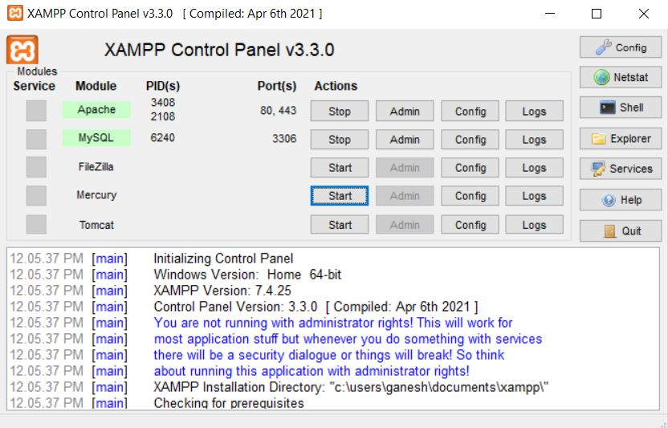

3) The user wants to open PHP Myadmin and then create a database according to the connection file in the project. Then import the sql file to the database from the respective project folder.

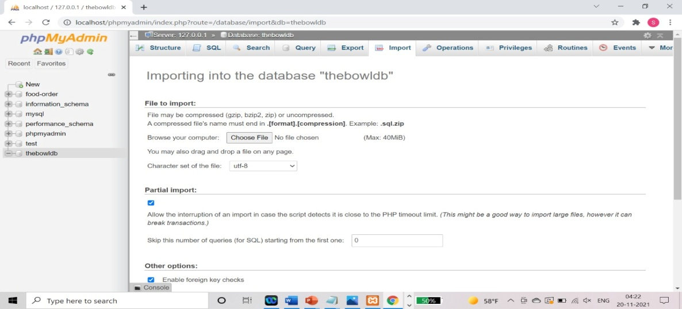

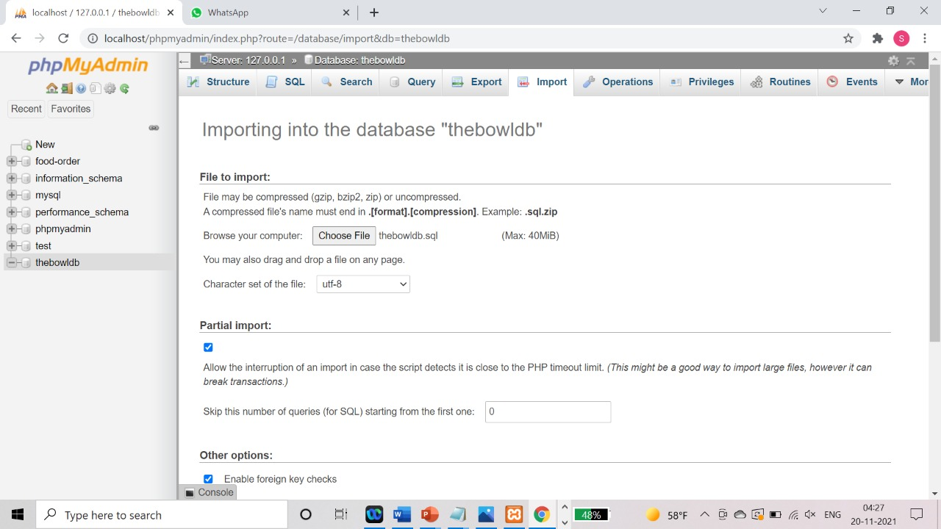

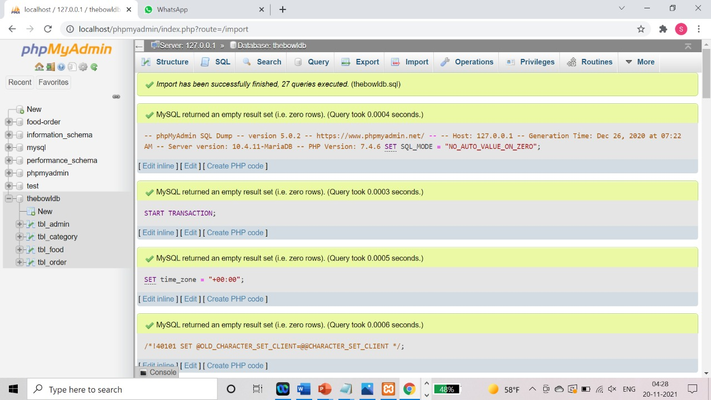

4) Then the user can run the project by typing localhost/project_folder_name in their web browser.

e.

Starting the Project in Detail:

* Download the project as zip.
* Extract the zip file.
* Place the extracted files in htdocs folder of xampp.
* Create a database in phpMyAdmin with the name “thebowl1”
* Import the “thebowl1” into the database.
* Update the OnlinebowlDelivery/config/constants.php file according to you database configurations.
* To start as the admin use the following link “localhost/thebowl1/admin/”
* To start as the user use the following link “localhost/OnlinebowlDelivery/”

f.

We successfully implemented all the functionalities that we mentioned in the beginning of the project but when it came to implementing the cart and the payments we have faced many consequences but we have successfully implemented those functionalities.

We have got some suggestions from the peer review sessions the first one was implementing the orders page for the users in which the user can see his orders history as we promised to complete it we have implemented it in the best way possible.

The second thing they have suggested us that to implement a page containing the cancelled items by the user in certain period of time so that people who are in a hurry can grab them with the low cost but while ongoing the implementation of this functionality it is affecting the system functionalities that has already done.

This is the main functionality that we want to include in our project in the future phase of the project.

g.

The main challenge that we have faced in the deliverable-5was when we are trying to select the item from the menu we are able to select it but it is not reflecting in the cart page. We have gone through the code and made necessary change in the session, and finally got the result. The items are added into the cart.

And in the next step when we are working in the payment module we have got the results when we choose the C.O.D method but when we are using the card payment the gateway is not working so we haven’t implemented the card payment.

h.

|  |  |  |  |
| --- | --- | --- | --- |
| Member name | Contribution  Description | Overall  Contribution (%) | Note  (if applicable) |
| 1. Siva Kumar Sai Pulavarthy | Payment | 100% |  |
| 2. Ganesh Bommisetty | Check-out  Report:  UML Diagrams | 100% |  |
| 3. Akhil Kata | Cart Functionality | 100% |  |
| 4.Shasidhar Jampana | Report: Unit Testing | 100% |  |
| 5. Sandeep Gangullapattu | Report: System Testing | 100% |  |
| 6. Satish Babu Nalajala | Documentation | 100% |  |