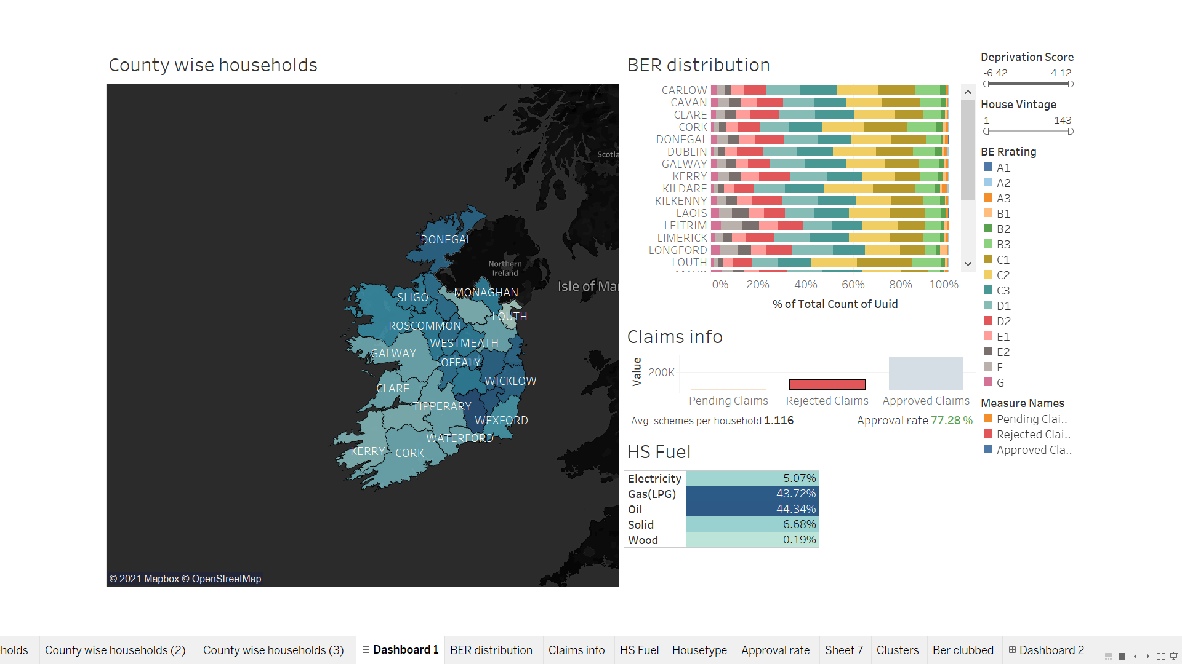

This is the look-like of the first dashboard we have built on for the general analysis for the data. This dashboard is interactive and can observe distribution of households countywise, BER, HS fuel and status of the claims. The filters that we have kept are Deprivation score and house vintage. The color shading of the counties in the map above is as per the potential of the county. Potential here is derived as 1-(no. of households with installation requests in that county)/(total no. of households in that county) . The higher the potential, darker is the shade and vice-versa.

Let us see through a few examples on how the dashboard looks like on selecting and applying a few filters.

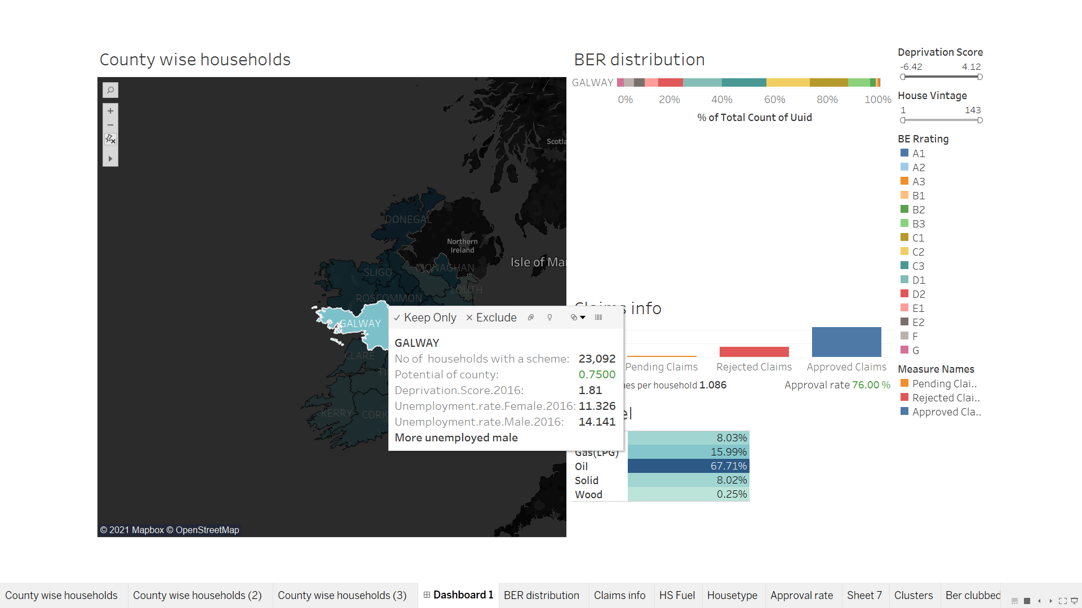

Here, we have selected Galway as the sample county. On the tool tip of map, one can observe the following information- number of households in that county, potential of that county, deprivation score, unemployment rate of male and female and last statement is a draws comparison between the unemployment rate of males and females in that county. We also observe, since it is an interactive dashboard, consequent changes in other charts are seen.

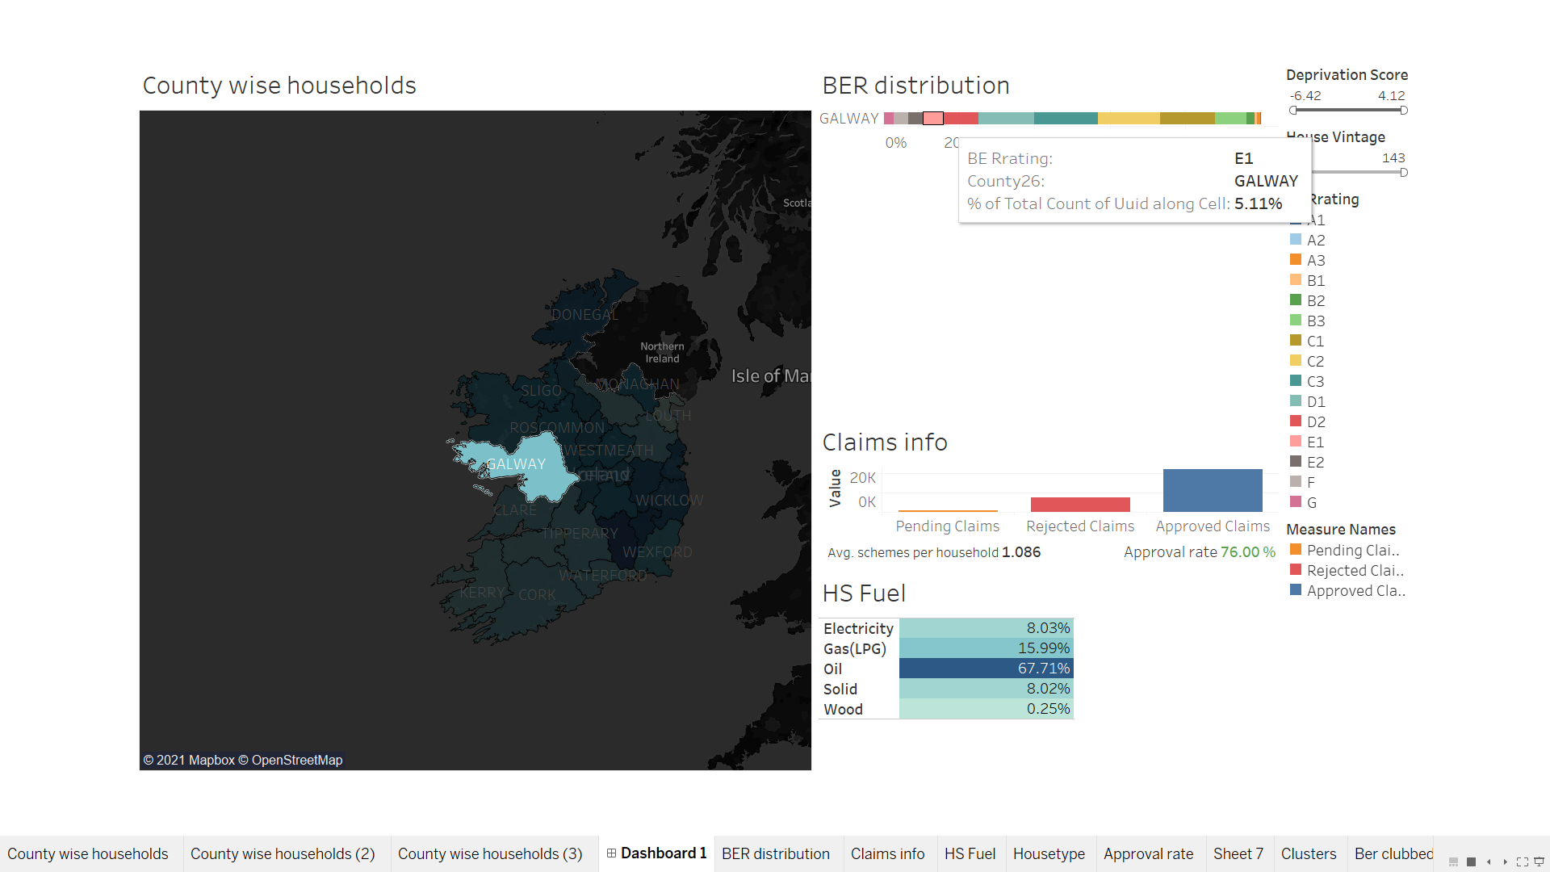

The tool tip at BER distribution chart conveys the BER Rating for that county along with number of households in percentage belonging to that rating.

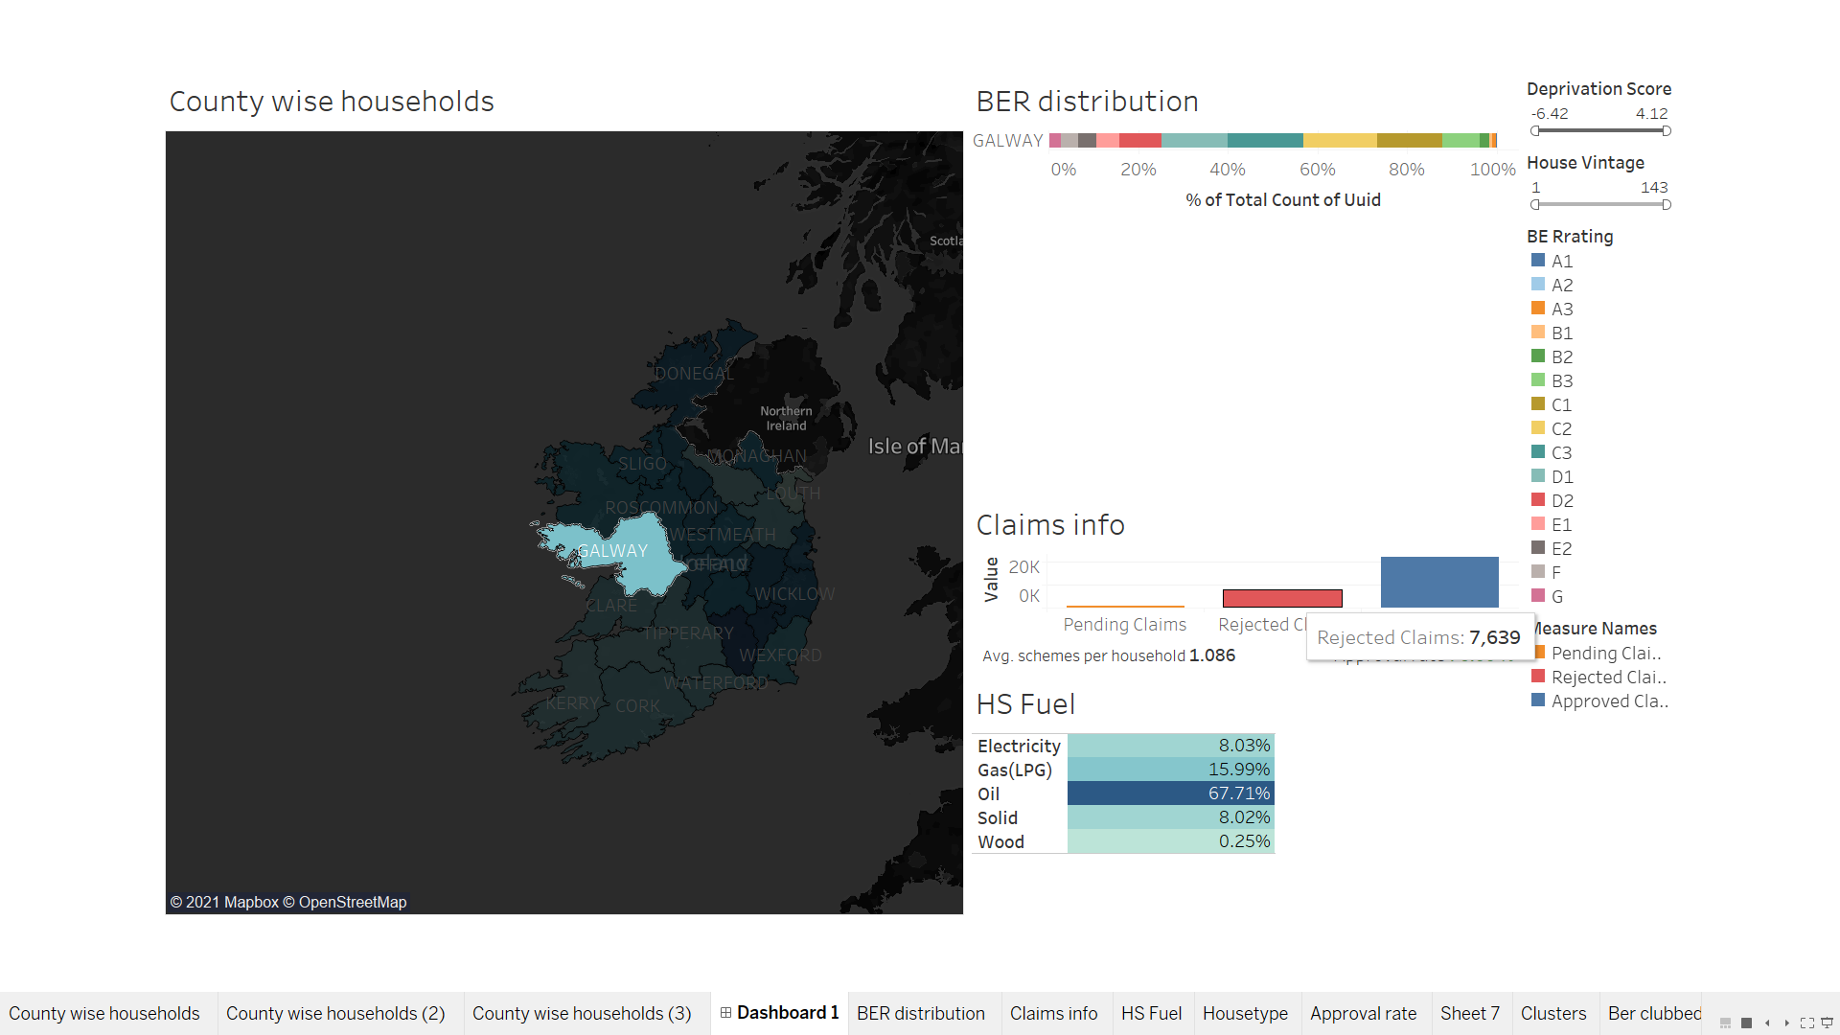

The claims info chart displaying the status of application. From the above image, the tooltip is on rejected claims, it gives the number of claims which were rejected in that county.

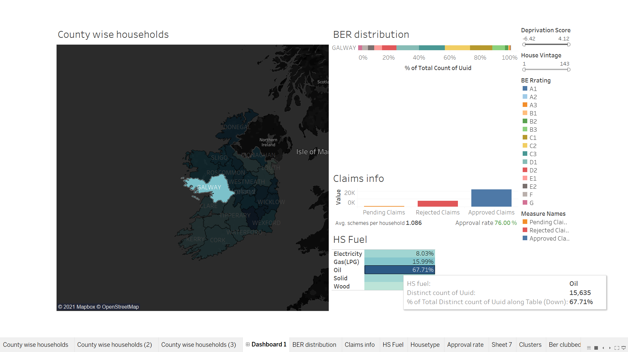

The above image also depicts information such as average schemes per household in that county. Households in Galway for this example has 1.08 schemes on an average and the approval rate on submission is 76% of these households. The tooltip for HS Fuel chart in the above image is for Oil. It displays information such as number of households using oil as their fuel and in terms of percentage.

One can also apply filters of deprivation score for example counties having >0 deprivation score or households in counties having vintage between 7months to 14 months, etc. Since all the filters are connected to these charts in dashboard, it automatically updates and interacts with each other. This dashboard was useful for our meeting with the client to understand the general behaviour of the households across Ireland. This dashboard was built before clustering.