National Institute of Technology Calicut

**Applying certificates online in Academic Section**

# USAGE MANUAL



Project done by

K A Siva Vardhan Reddy B160333CS

P Satyanarayana B160340CS

B Maheshwara Rao B160349CS

K Pavan Kalyan B160723CS

# HOME PAGE

* This page has 3 types of logins: students, staff and admin.
* The user can select any one of the categories depending on his credentials.
* Then the website will be redirected to the corresponding login page
* All categories of users are provided with their respective login credentials, which are used to login and proceed further
* If the user has not registered yet he will be able to see “NEW USER” and he can register using that link.

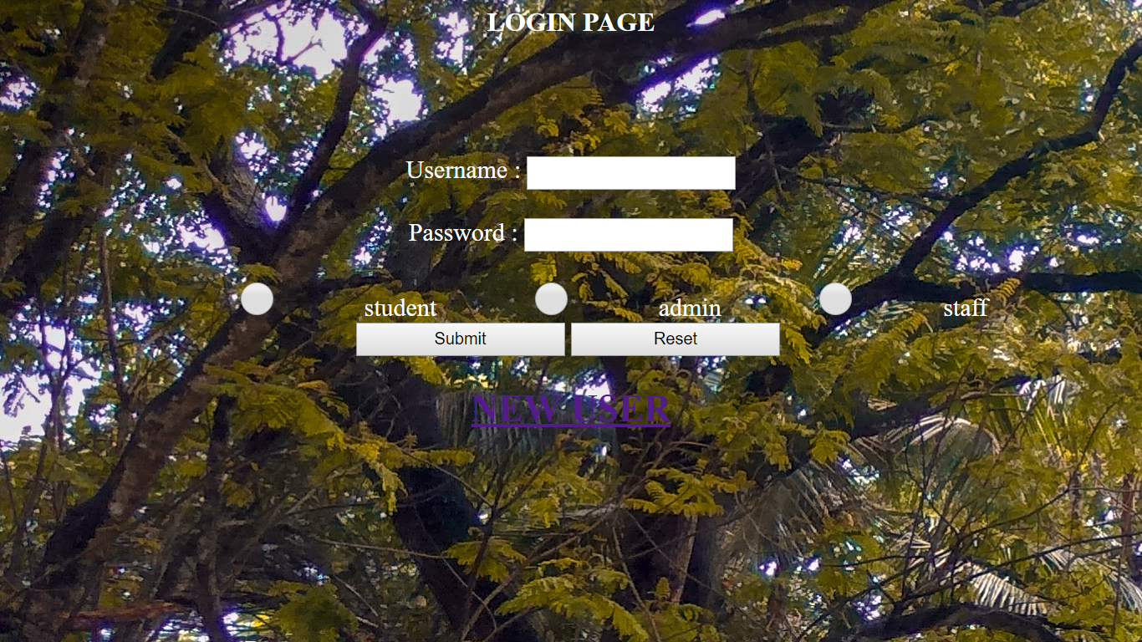

REGISTRATION FORM

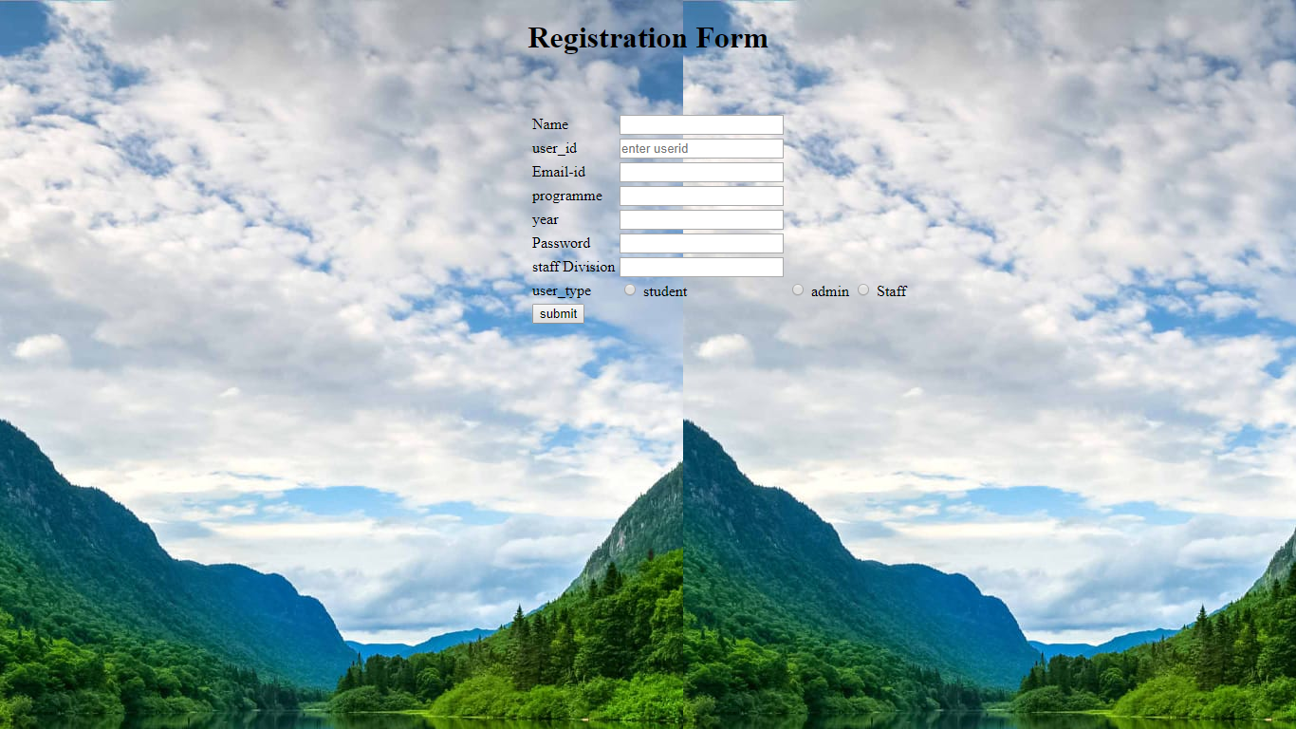

A new user can fill his corresponding details in the

registration form below and can log in using the above login page.

**Student Home page**

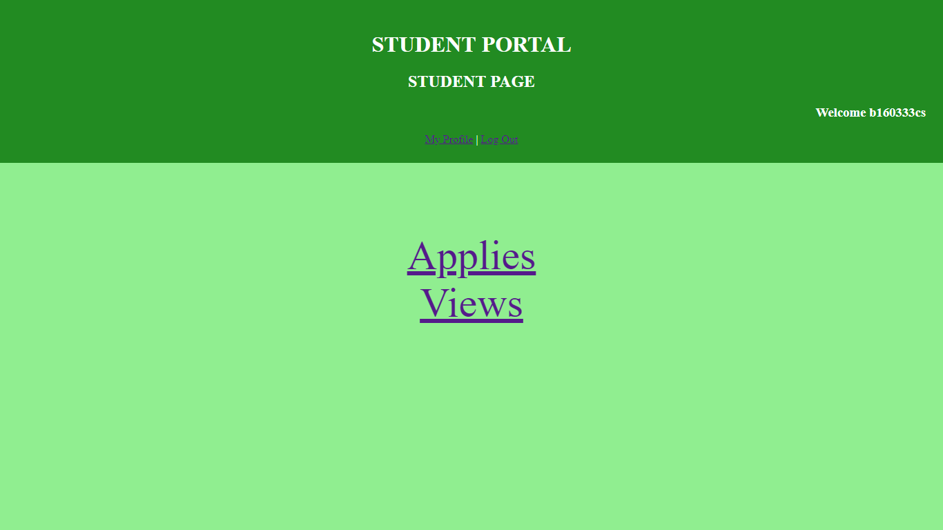

In the student home page, student will be able to see “My Profile”, “Log Out”, ”Applies” and “Views”.

**My Profile**

|  |
| --- |
|  |

In this page, student will be able to see all his details.

**Views page**

|  |
| --- |
|  |

In this page, student will be able to see the different types of certificates i.e., the status may be applied, processing or completed. If the status of certificate is processing, the certificate is assigned to the corresponding staff. Once the status of certificate is set to completed, the student can collect the corresponding certificate from the Academic Section. If status of Duplicate ID is rejected, then the student can remove that details by using delete button and can reapply for that again by filling the right credentials.

**Applies page**

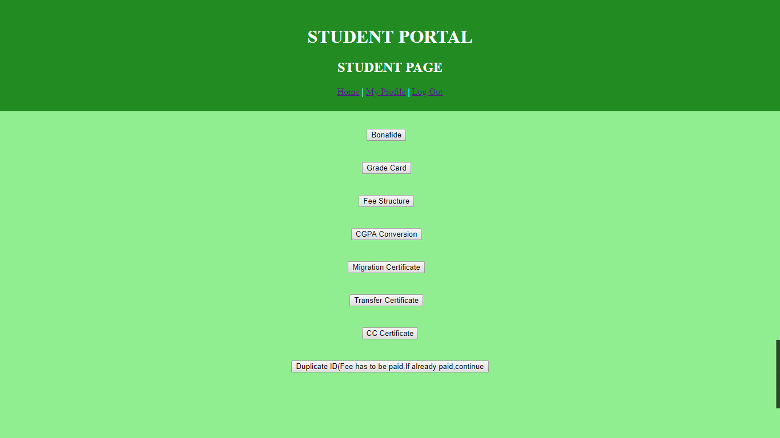

In this page, student is allowed to choose one of the different types of document that he wishes to apply in the Academic Section.

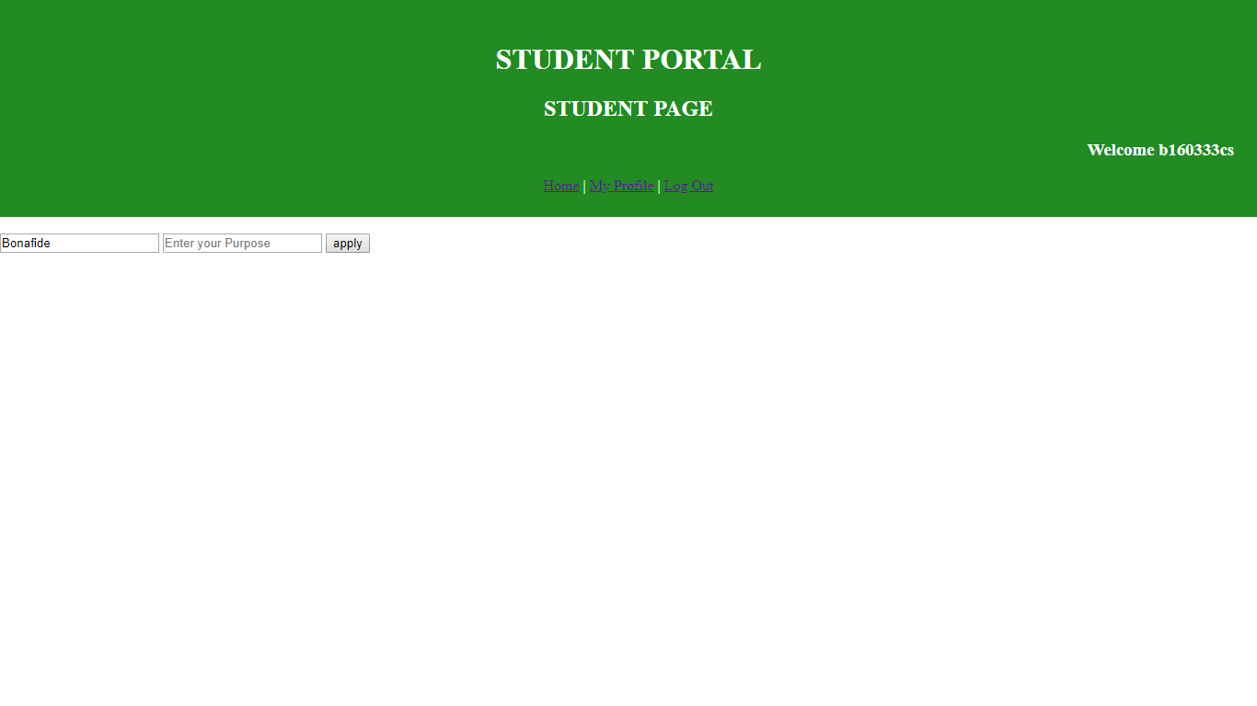

In this page, the student is allowed to fill the corresponding details such as purpose. If a student needs to apply for Duplicate ID card, the corresponding fee to the document has to be paid in favour of admin and he should enter the reference number and type of bank that he used to pay the fee. On clicking the submit button, the corresponding certificate’s status is set to applied.

**ADMIN HOME PAGE**

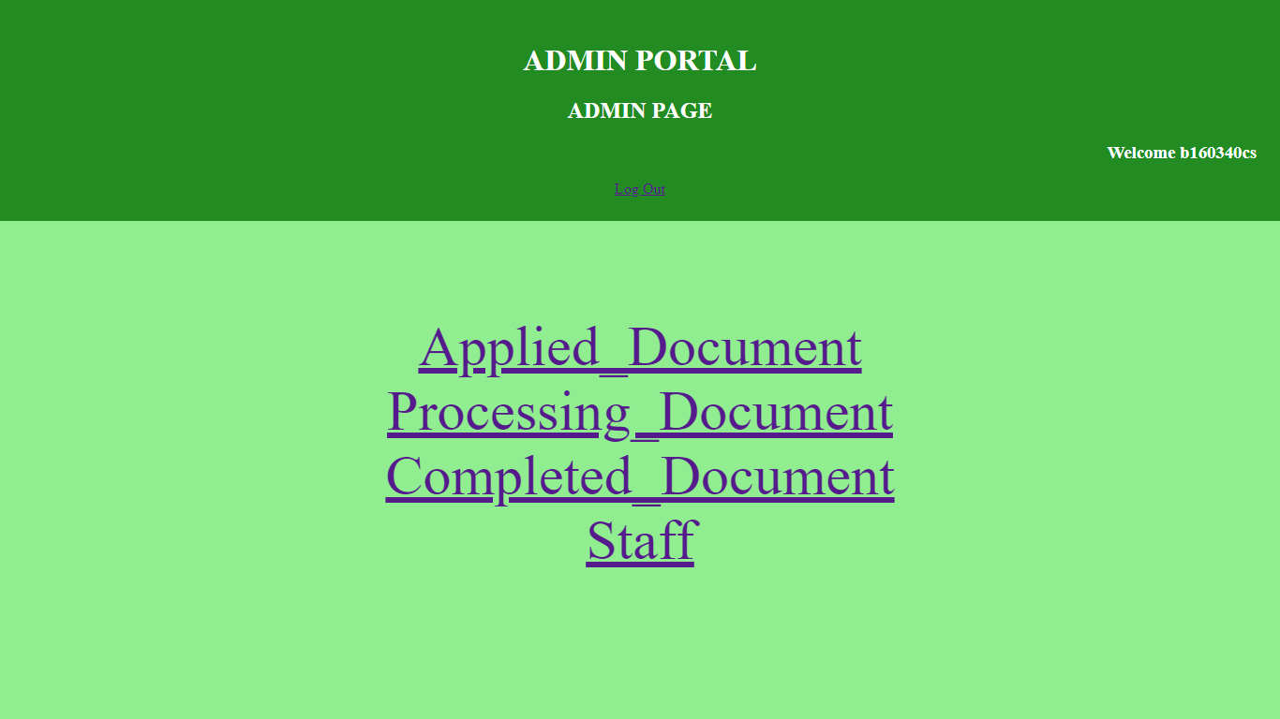

In this page, admin will be able to see “Applied_Document”, ”Processing_Document”, “Completed_Document” and “Staff”.

**Staff Details**

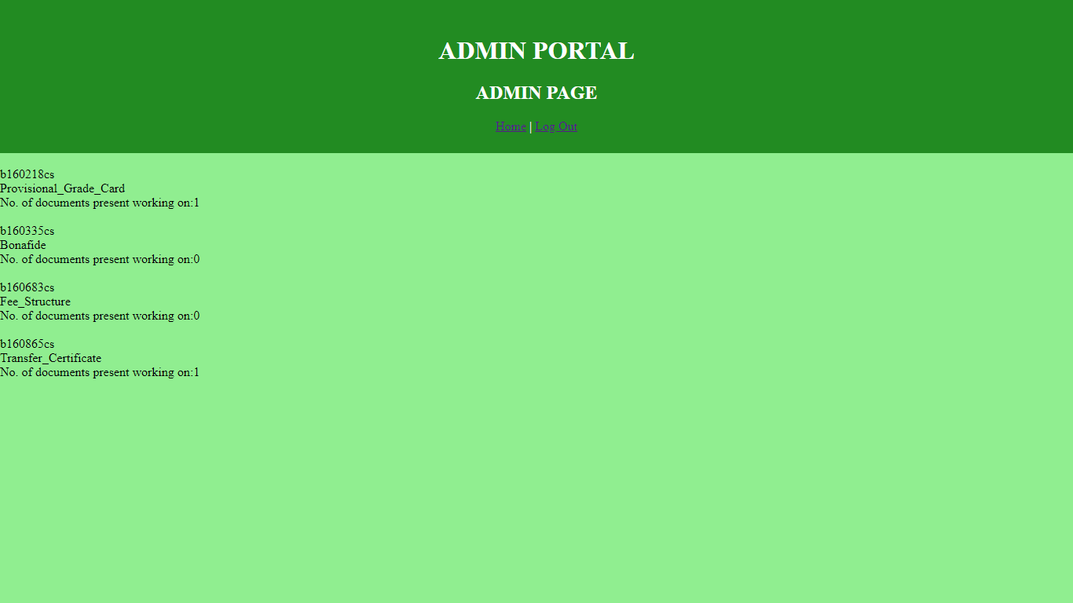

In this page, admin will see the details of the staff such as user_id, staff_division and currently the number of documents working on by the staff.

**Applied_Document page**

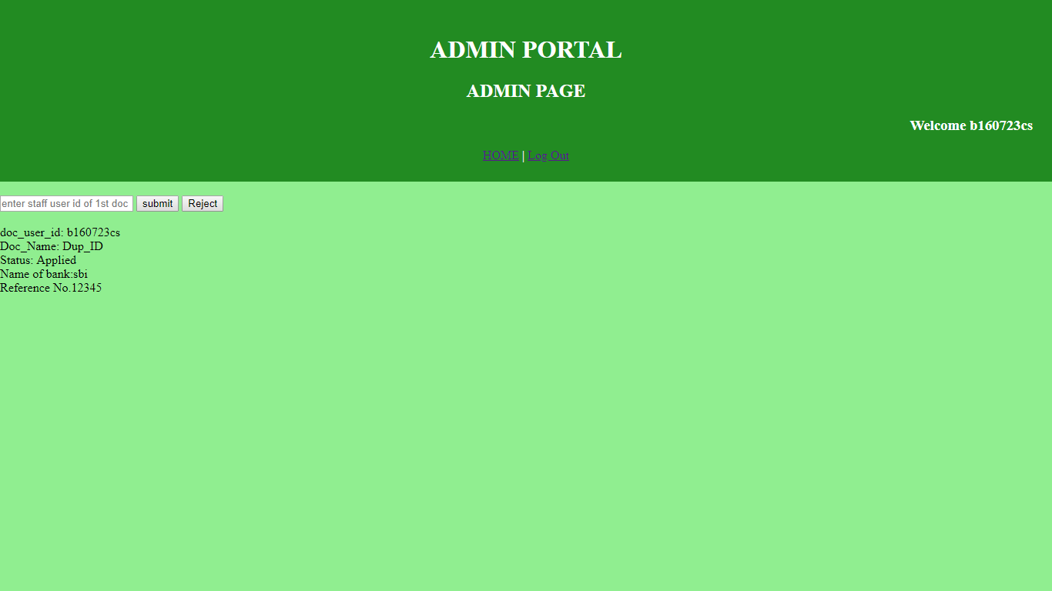

In this page, admin will allocate the first document to the corresponding staff by entering user_id. If the staff for a particular is more in number then the admin will see the staff details and allocate to that staff who is working on least number of documents and make the status of it as processing. If the document type is duplicate ID card, admin will check the fee payment details entered by that student is valid or not. If not, he will make the status of document as rejected.

**Processing_Documents**

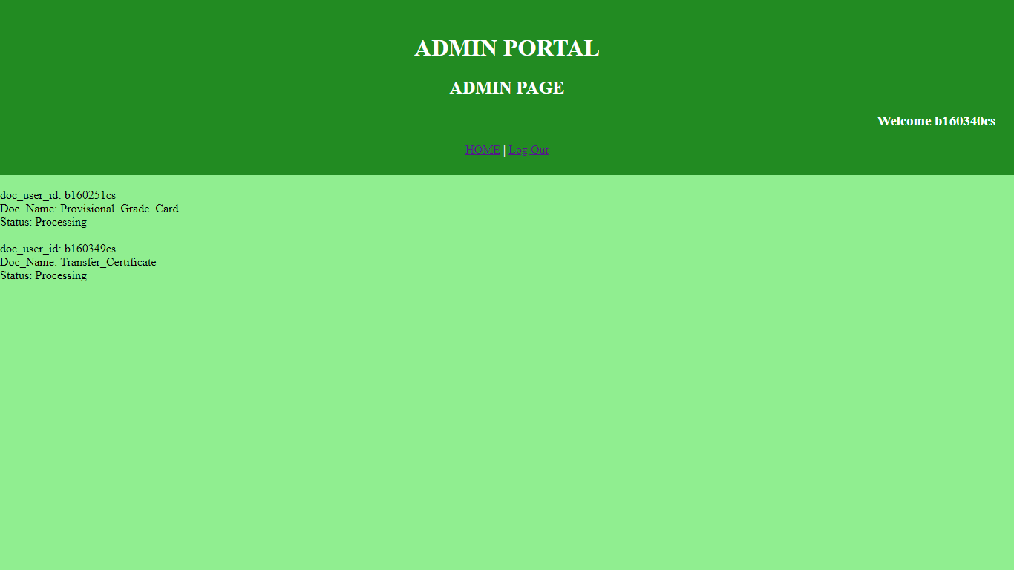

In this page, admin will see all the processing documents i.e., in the above page, when the admin changes status of document from applied to processing, corresponding entity will delete in that page and added to this page.

**Completed_Documents**

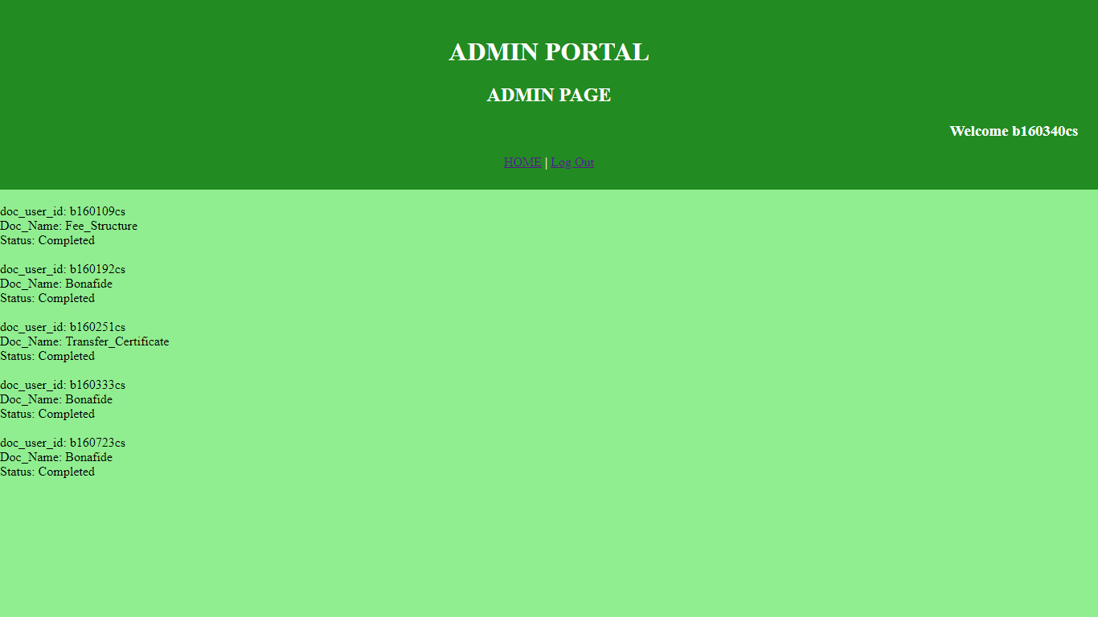

In this page, admin will see the documents that are completed.

STAFF HOME PAGE

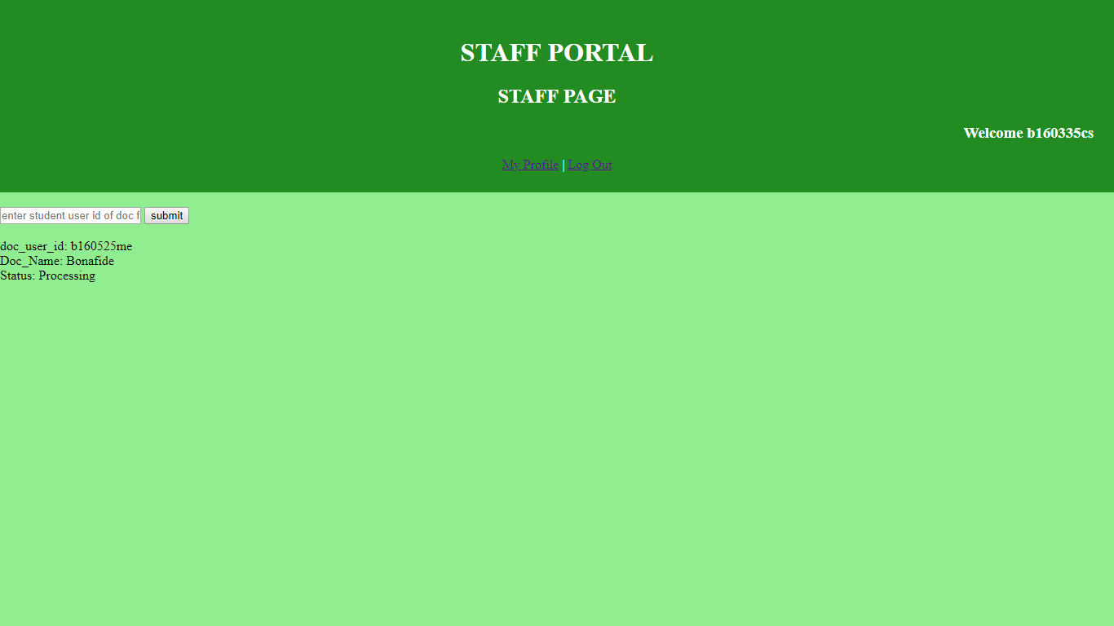

In this page, staff can see all the certificates that are allocated to him by the admin. Once if he finishes any one of the certificates allocated, he will enter the doc_user_id of that document then that certificate will disappear from the staff home page i.e., the status of that certificate is changed from processing to completed. Now when the student sees that his certificate is completed, he will go to Academic Section to collect his certificate.

**Staff_Profile**

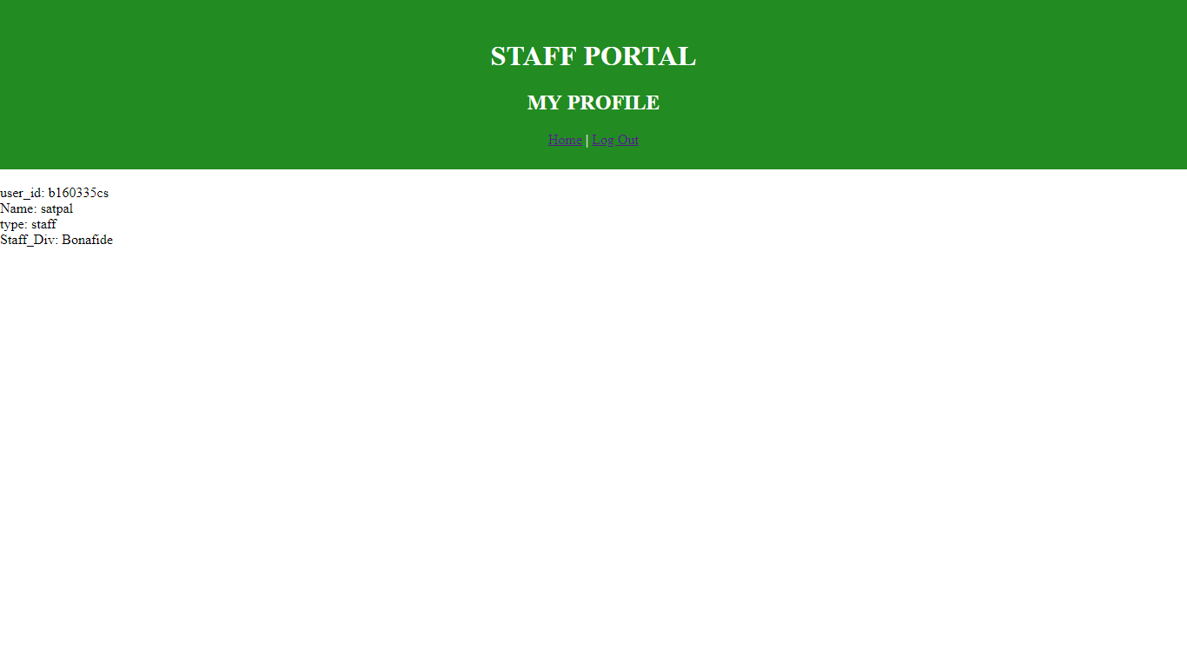

In this page, staff will be able to see all his details.

On clicking on “Log Out” at any page, the corresponding user will be logged out from the session and he will be redirected to login page.