The Tragedy of Flight: A Comprehensive crash analysis

**PROJECT BASED EXPERIMENTAL LEARNING PROGRAM**

.

DONE BY

SIVASUBRAMANIAN..B

INTRODUCTION:

An airplane crash analysis is a detailed investigation into the causes of an aviation accident. The goal of an airplane crash analysis is to identify any factors that contributed to the accident, with the ultimate goal of improving safety and preventing future accidents. The process of conducting an airplane crash analysis typically involves the collection and analysis of a wide range of data, including information about the aircraft and its systems, the operators, and any other relevant factors. This data is typically collected from Kaggle. Once the data has been collected, it is analysed through tableau, to identify any potential causes of the accident. The results of an airplane crash analysis are typically published in a report, which may include recommendations for improving safety and preventing similar accidents in the future. These recommendations may be implemented by the relevant authorities or industry organizations.

PURPOSE:

Main purpose of the project is to avoid the similar way of accidents in flights and how overcome it.

PROBLEM DEFINITION & DESIGN THINKING :

**Define Problem / Problem Understanding**

@ EMPATHY MAPPING:

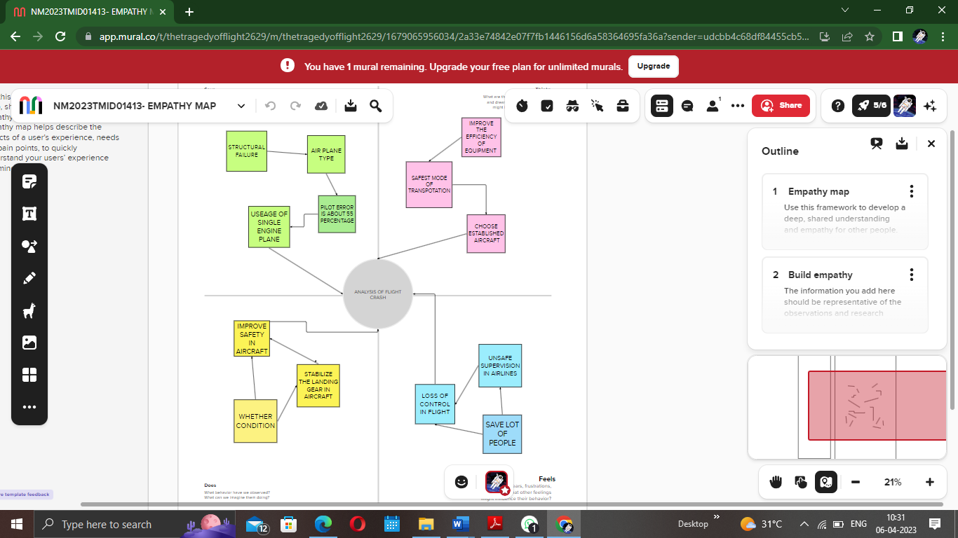/

@ BRAINSTROMING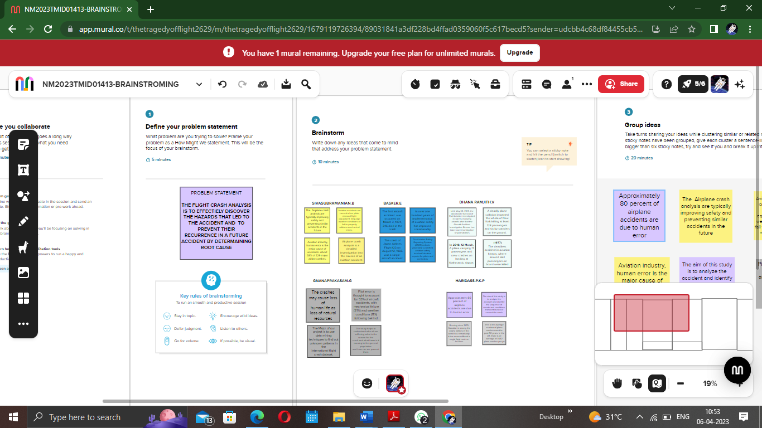

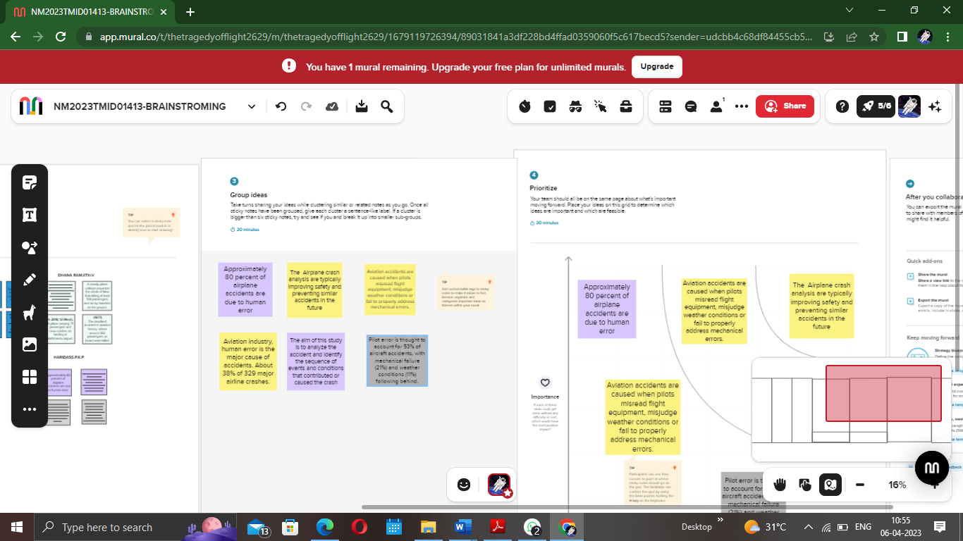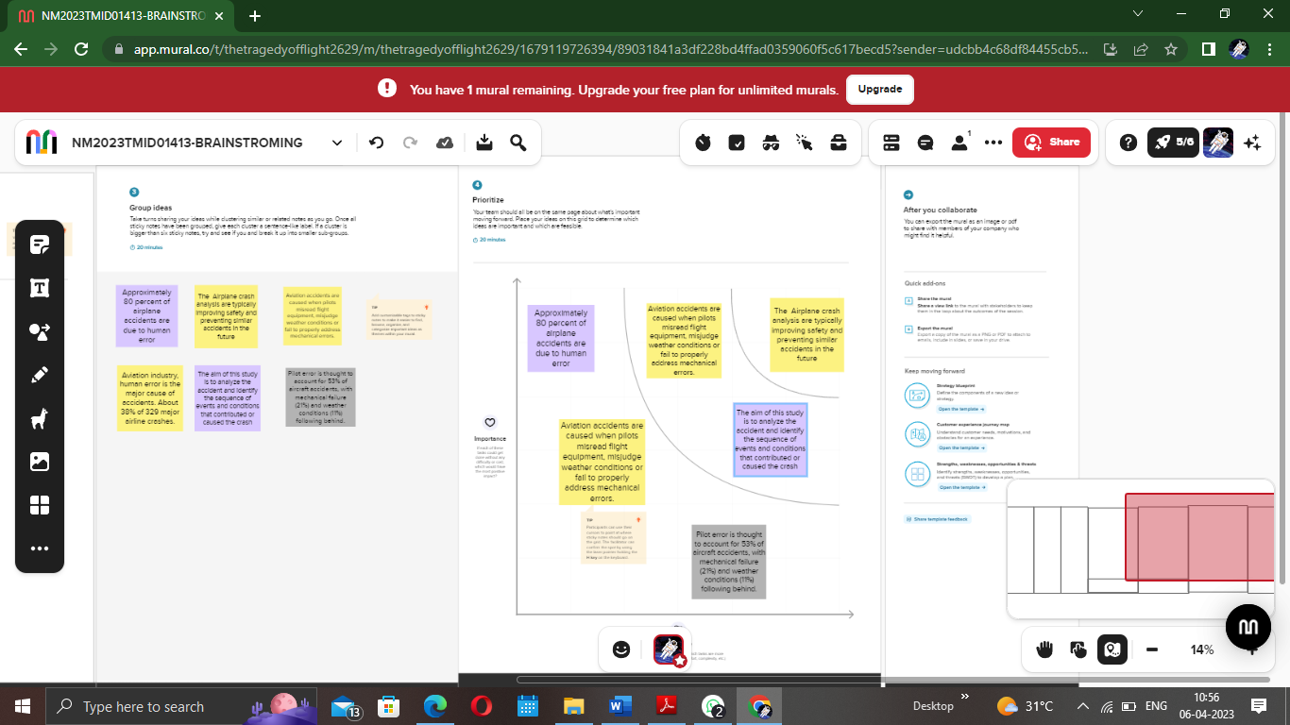

**Data Collection & Extraction from Database :**

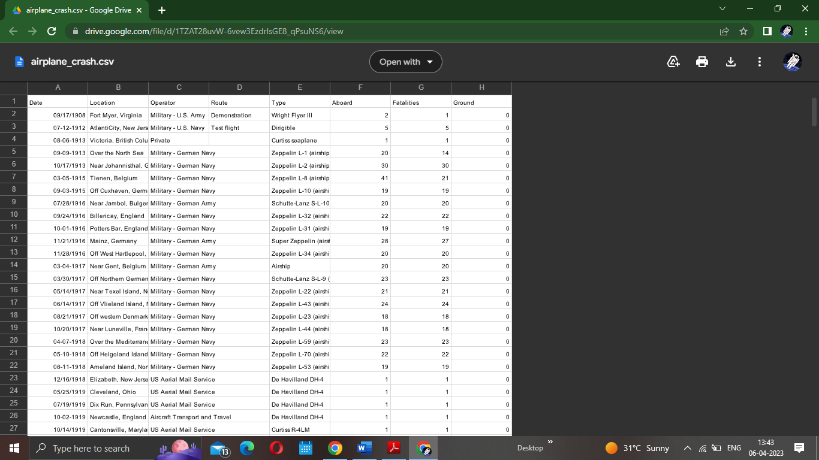

**Storing Data in DB & Perform SQL Operations:**

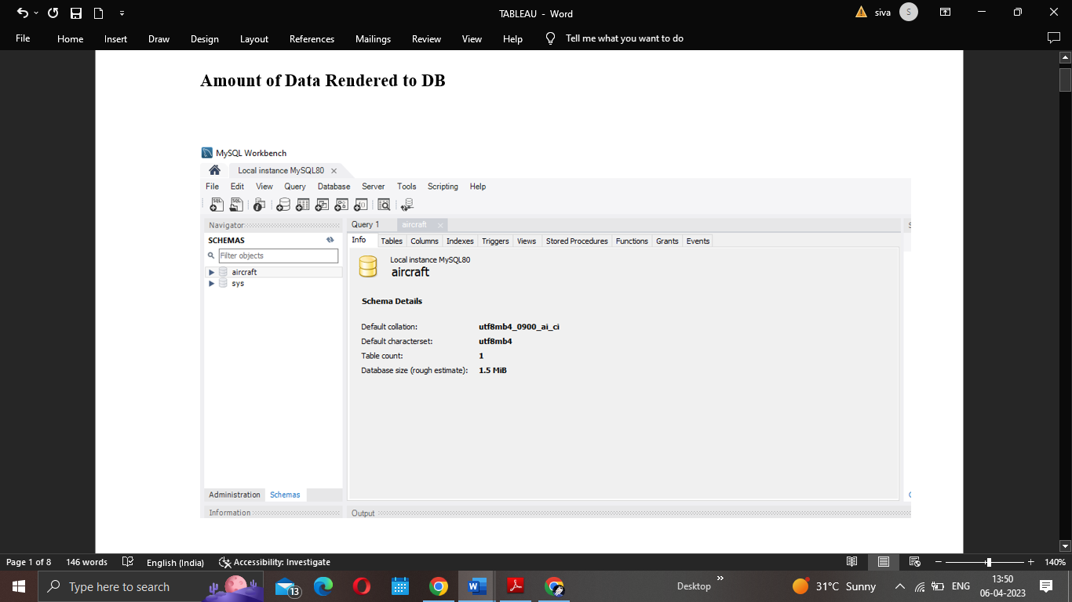

**Connect DB with Tableau:**

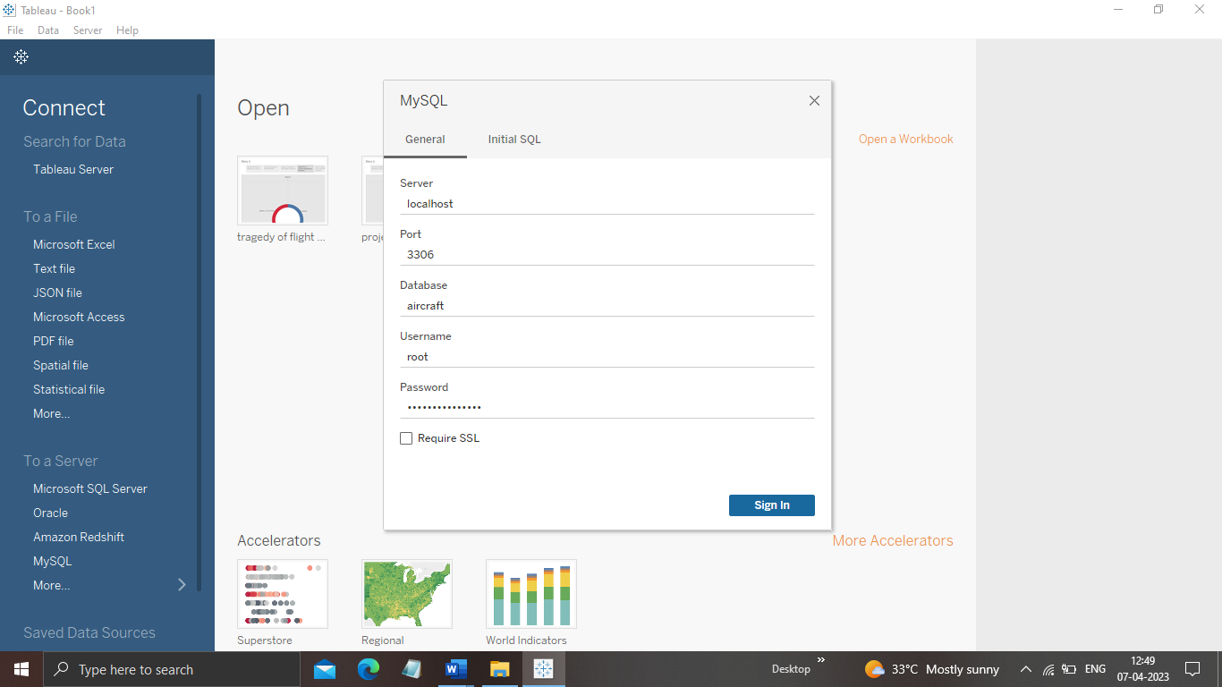

**RESULT:**

**Data Preparation**

**Prepare the Data for Visualization**

Preparing the data for visualization involves cleaning the data to remove irrelevant or missing data, transforming the data into a format that can be easily visualized, exploring the data to identify patterns and trends, filtering the data to focus on specific subsets of data, preparing the data for visualization software, and ensuring the data is accurate and complete. This process helps to make the data easily understandable and ready for creating visualizations to gain insights into the performance and efficiency.

**Data Visualization**

**No of Visualizations/ Graphs**

1. Comparing Aboard vs Fatalities vs Ground

2. Max accidents based on years

3. Accidents happened in 1972 (MAX ACCIDENTS) based on months

4. Highest No. of accident happened by Operators

5. Top 10 locations which had more accidents

6. Top 5 flights which have max accident history

7. Accidents based on regions

Comparing Aboard vs Fatalities vs Ground

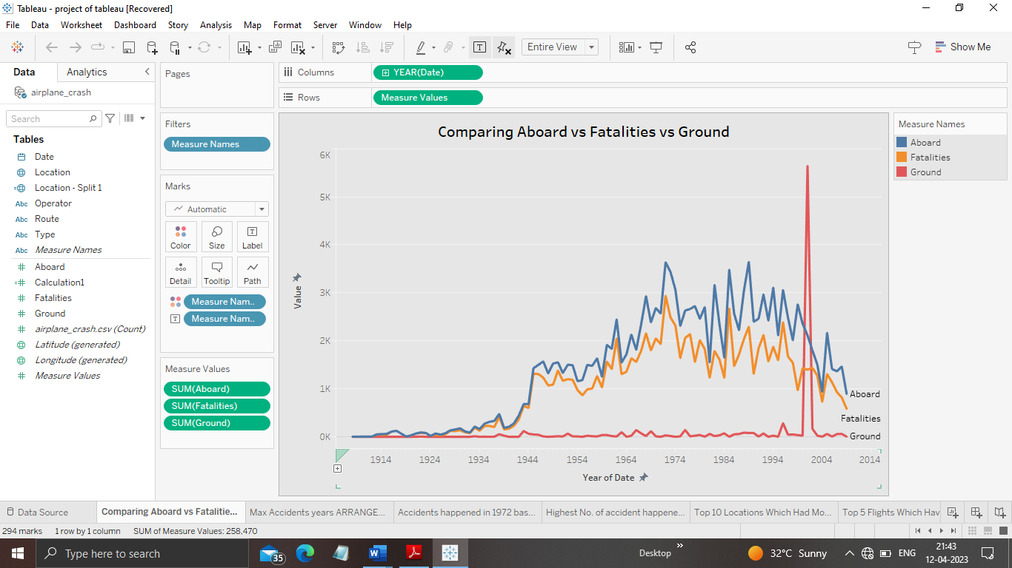

Max accidents based on years

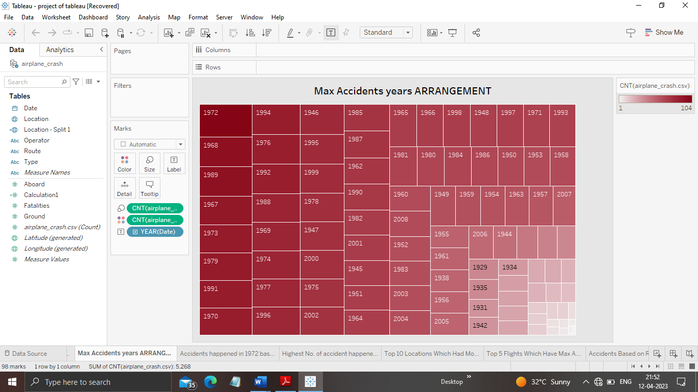

Accidents happened in 1972 (MAX ACCIDENTS) based on months

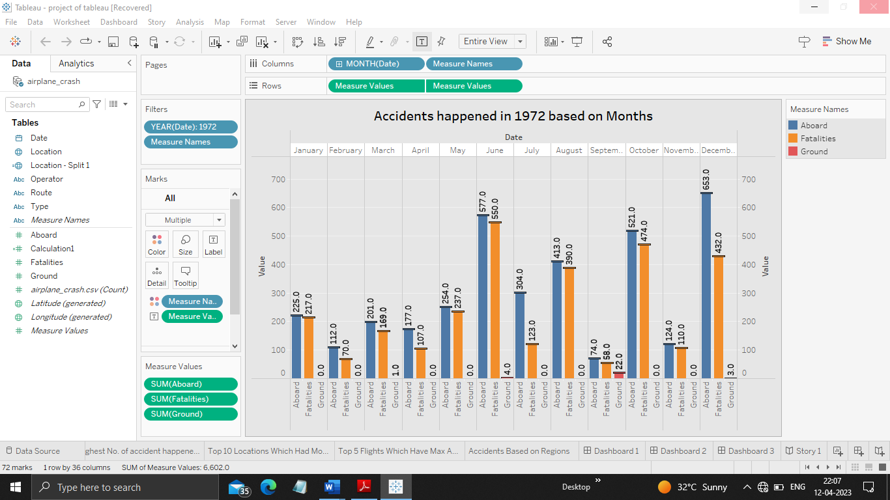

Highest No. of accident happened by Operators

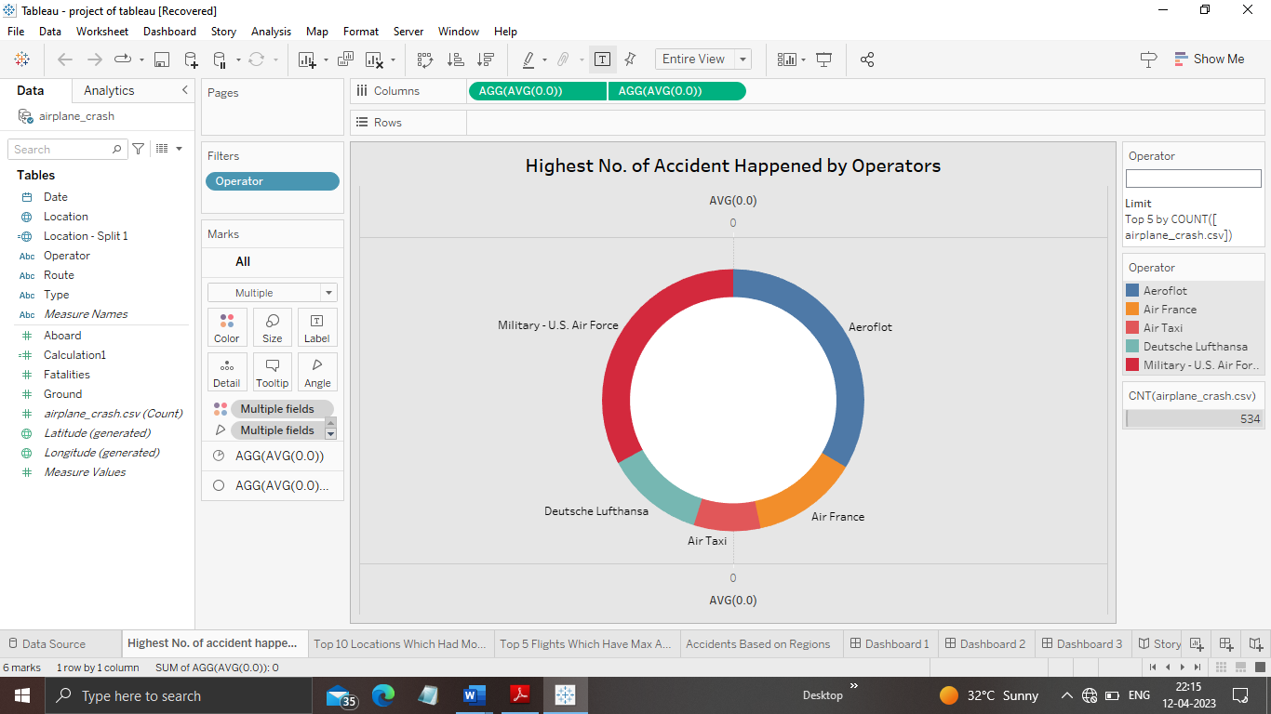

Top 10 locations which had more accidents

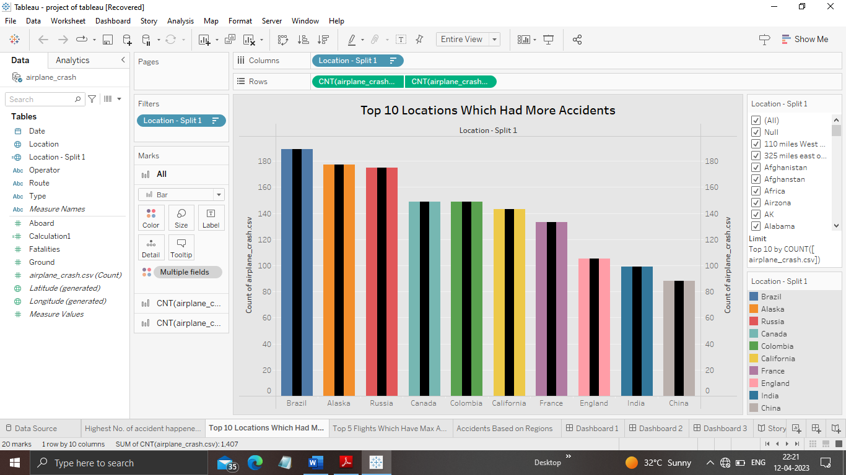

Top 5 flights which have max accident history

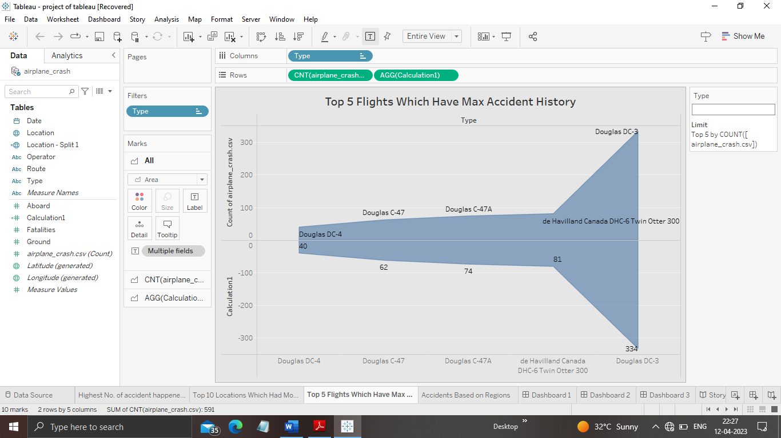

Accidents based on regions

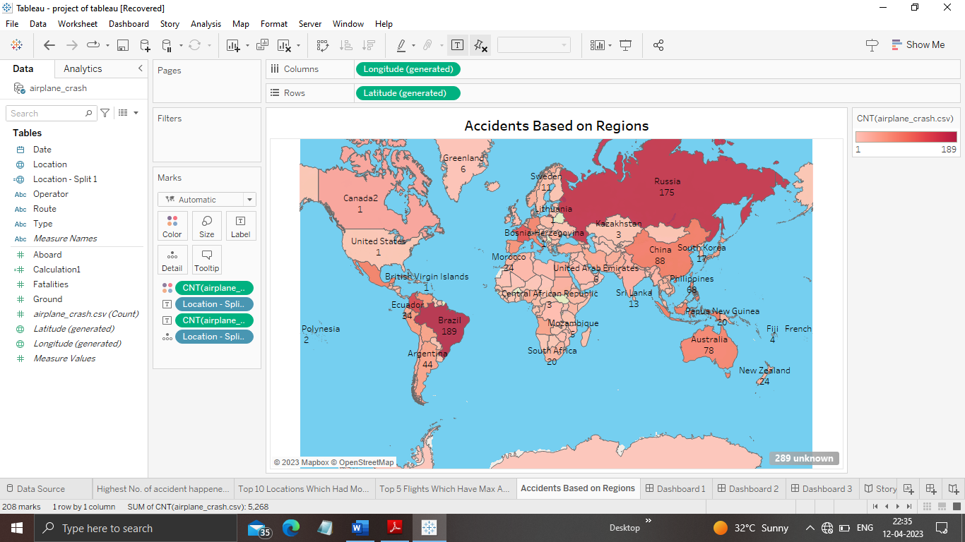

DASHBOARD

Dashboard is the collection of activity sheet .this gives the quick revise about the project.