**EARTHQUAKE PREDICTION MODEL USING PYTHON**

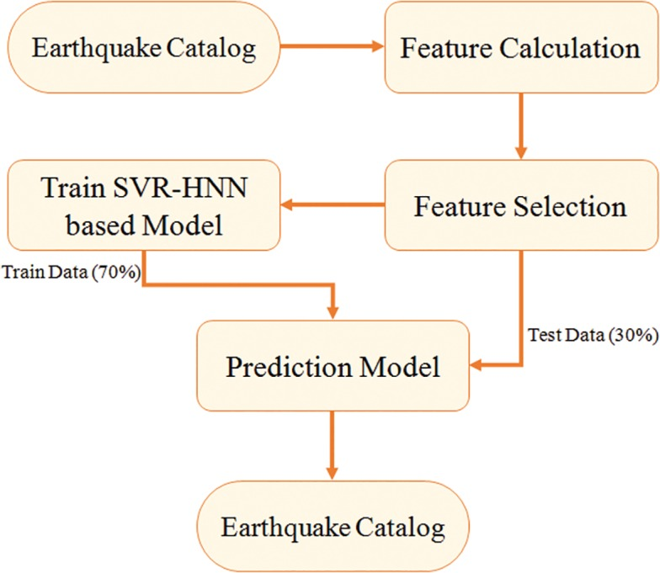

**1. Tensorflow & Keras Artificial Neural Networks (ANN):**

TensorFlow and Keras are powerful libraries for building artificial neural networks (ANNs). In the context of your earthquake prediction model, you can use ANNs for various purposes, such as feature extraction, data preprocessing, and model training. Here are some detailed notes:

Introduction to ANN: Artificial Neural Networks are computational models inspired by the human brain, used for various machine learning tasks, including earthquake prediction.

TensorFlow: TensorFlow is an open-source machine learning library developed by Google. It provides tools for building and training ANNs efficiently.

Keras: Keras is a high-level neural networks API that runs on top of TensorFlow. It simplifies the process of building and training neural networks.

Model Architecture: Discuss the architecture of your ANN, including the number of layers, activation functions, and other architectural details relevant to your earthquake prediction model.

Data Preprocessing: Explain how you preprocess your earthquake data to feed it into the ANN. This may include normalizing data, handling missing values, and feature scaling.

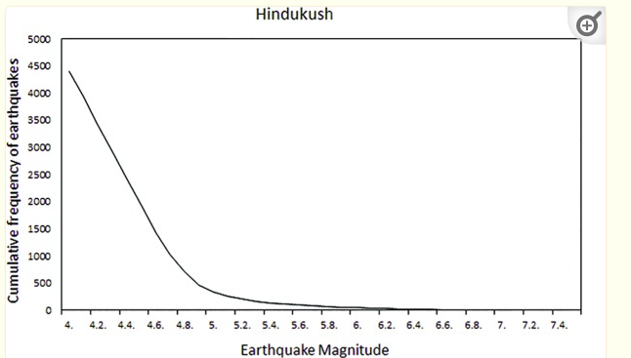

Training and Validation: Detail the process of training your model using TensorFlow and Keras. Describe the use of training and validation datasets, loss functions, and optimizers.

Hyperparameter Tuning: Mention techniques for tuning hyperparameters, like learning rate and batch size, to improve the model's performance.

Evaluation Metrics: Describe the evaluation metrics you will use to assess the model's accuracy and performance in earthquake prediction.

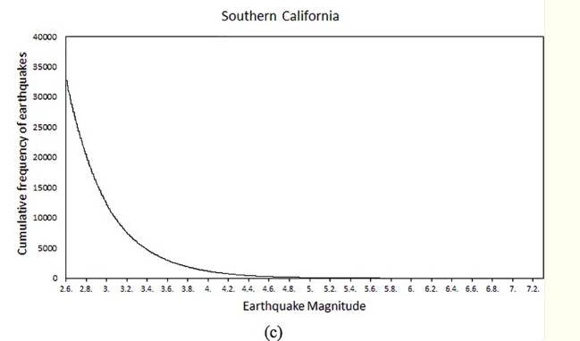

**PROGRAM MODULE**

import tensorflow as tf

from tensorflow import keras

from tensorflow.keras import layers

# Create a simple neural network model

model = keras.Sequential()

# Add an input layer

model.add(layers.Input(shape=(input_shape,))) # Replace 'input_shape' with the actual shape of your data

# Add one or more hidden layers

model.add(layers.Dense(units=64, activation='relu'))

model.add(layers.Dense(units=32, activation='relu'))

# Add an output layer (for binary classification)

model.add(layers.Dense(units=1, activation='sigmoid'))

# Compile the model

model.compile(optimizer='adam', loss='binary_crossentropy', metrics=['accuracy'])

# Train the model

model.fit(X_train, y_train, epochs=10, batch_size=32)

# Evaluate the model

loss, accuracy = model.evaluate(X_test, y_test)

print(f"Test Loss: {loss}, Test Accuracy: {accuracy}")

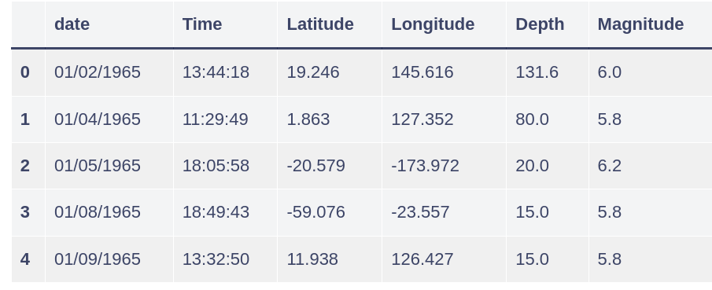

**2. Convolutional Neural Network (CNN):**

CNNs are essential for image-based data, and they can be particularly helpful if your project involves image data or any spatial characteristics. Here are detailed notes for this topic:

Introduction to CNN: Explain what CNNs are and their applications in image processing and feature extraction.

Convolutional Layers: Discuss how CNNs use convolutional layers to detect patterns and features within images. Highlight the importance of filters and pooling layers.

Data Preparation: Explain how you prepare image data for input to the CNN. This might involve resizing, normalization, or data augmentation.

Model Architecture: Describe the CNN architecture you will use in your earthquake prediction project. Explain the number of layers, filter sizes, and activation functions.

Transfer Learning: If applicable, discuss the possibility of using pre-trained CNN models (e.g., VGG, ResNet) for feature extraction.

Training and Fine-Tuning: Detail how you train the CNN model and fine-tune it for your specific earthquake prediction task.

Performance Metrics: Mention the performance metrics specific to CNNs, such as accuracy, precision, recall, and F1-score.

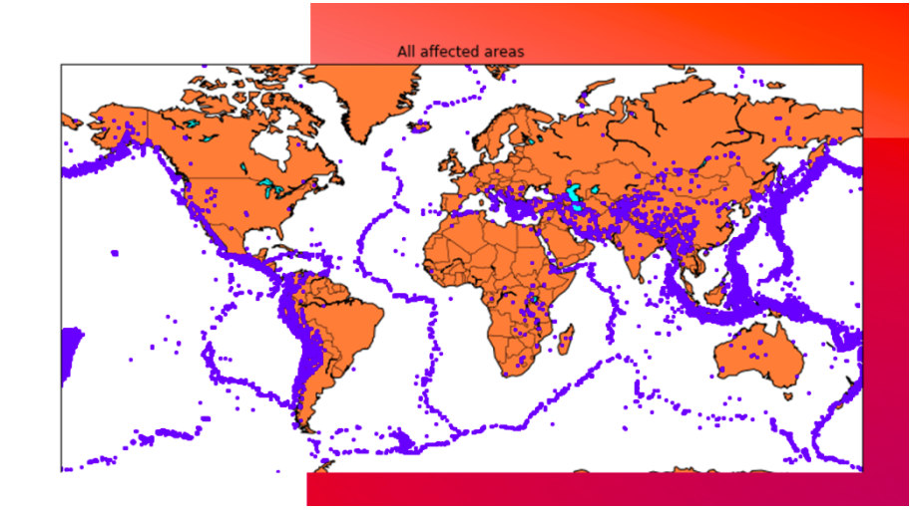

**PROGRAM MODULE:**

import tensorflow as tf

from tensorflow import keras

from tensorflow.keras import layers

from tensorflow.keras.preprocessing.image import ImageDataGenerator

# Define the CNN model

model = keras.Sequential()

# Add convolutional layers

model.add(layers.Conv2D(32, (3, 3), activation='relu', input_shape=(150, 150, 3)))

model.add(layers.MaxPooling2D((2, 2)))

model.add(layers.Conv2D(64, (3, 3), activation='relu'))

model.add(layers.MaxPooling2D((2, 2)))

model.add(layers.Conv2D(128, (3, 3), activation='relu'))

model.add(layers.MaxPooling2D((2, 2))

# Flatten the output before fully connected layers

model.add(layers.Flatten())

# Add fully connected layers

model.add(layers.Dense(512, activation='relu'))

model.add(layers.Dense(1, activation='sigmoid')) # Binary classification

# Compile the model

model.compile(optimizer='adam',

loss='binary_crossentropy',

metrics=['accuracy'])

# Data augmentation for training data (optional but recommended)

train_datagen = ImageDataGenerator(

rescale=1./255,

rotation_range=40,

width_shift_range=0.2,

height_shift_range=0.2,

shear_range=0.2,

zoom_range=0.2,

horizontal_flip=True,

fill_mode='nearest')

# Load and preprocess your dataset

train_generator = train_datagen.flow_from_directory(

'train_data_directory',

target_size=(150, 150),

batch_size=32,

class_mode='binary') # Assuming two classes for binary classification

# Train the model

model.fit(train_generator, epochs=10) # You may adjust the number of epochs

# Save the model

model.save('earthquake_prediction_cnn.h5')

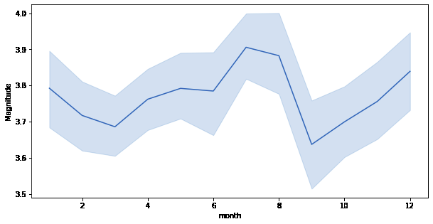

**3. OpenCV (Open Source Computer Vision Library):**

OpenCV is crucial for image processing and computer vision tasks. If your project involves image data, OpenCV can be a valuable tool. Here are detailed notes:

Introduction to OpenCV: Provide an overview of OpenCV and its applications in computer vision and image processing.

Image Preprocessing: Explain how OpenCV can be used to preprocess earthquake images, including tasks like image resizing, noise reduction, and edge detection.

Feature Extraction: Describe how OpenCV can help extract meaningful features from earthquake images, which can be used in your prediction model.

Object Detection: If applicable, discuss how OpenCV can be used for object detection in earthquake-related imagery.

Integration with Machine Learning Models: Explain how OpenCV can work alongside TensorFlow, Keras, or CNN models to enhance earthquake prediction.

Examples and Use Cases: Provide specific examples and use cases within your project where OpenCV plays a critical role.

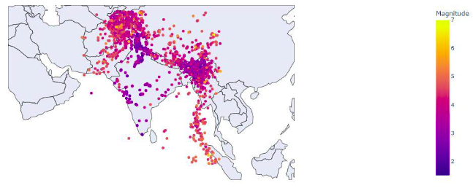

**PROGRAM MODULE:**

import cv2

import numpy as np

# Load an example image

image = cv2.imread('earthquake_image.jpg')

# Preprocessing: Resize the image

resized_image = cv2.resize(image, (150, 150))

# Preprocessing: Convert to grayscale

gray_image = cv2.cvtColor(resized_image, cv2.COLOR_BGR2GRAY)

# Preprocessing: Denoising (you can use more advanced denoising methods)

denoised_image = cv2.fastNlMeansDenoising(gray_image, None, 10, 7, 21)

# Edge detection using Canny

edges = cv2.Canny(denoised_image, 30, 70)

# Find contours in the edge-detected image

contours, _ = cv2.findContours(edges, cv2.RETR_EXTERNAL, cv2.CHAIN_APPROX_SIMPLE)

# Draw the contours on the original image

cv2.drawContours(resized_image, contours, -1, (0, 255, 0), 2)

# Display the processed image

cv2.imshow('Processed Image', resized_image)

cv2.waitKey(0)

cv2.destroyAllWindows()

