**EARTHQUAKE PREDICTION MODEL USING PYTHON**

**Introduction:**

Earthquakes are natural disasters that can cause immense damage and loss of life. The ability to predict earthquakes has been a long-standing challenge in the field of seismology. While precise earthquake prediction remains elusive, there is growing interest in developing models that can provide early warnings based on historical seismic data, sensor networks, and machine learning techniques. The "Earthquake Prediction Model using Python" project aims to explore this challenge and develop a predictive model that can assist in minimizing the impact of earthquakes.

**Abstract:**

The "Earthquake Prediction Model using Python" project is an innovative endeavor that combines state-of-the-art technologies in computer vision, machine learning, and natural language processing. The goal of this project is to create a system that can predict the likelihood of earthquakes using historical seismic data, real-time sensor information, and textual data from various sources.

**Phase 4 Contents:**

**Object Detection with YOLO (You Only Look Once):**

In this phase, we will implement YOLO, a real-time object detection system, to identify key features in seismic data, such as fault lines, tectonic plate boundaries, and seismic activity hotspots. YOLO will enable the model to better understand the spatial characteristics of potential earthquake occurrences.

**Recurrent Neural Networks (RNN):**

Recurrent Neural Networks, particularly Long Short-Term Memory (LSTM) networks, will be employed to analyze time series data from seismic sensors. These networks are well-suited for capturing temporal patterns and dependencies in the data, allowing the model to make predictions about when and where earthquakes may occur.

**Natural Language Processing (NLP):**

NLP techniques will be used to process textual data from sources like news articles, social media, and scientific reports. By analyzing text for keywords, sentiment, and context, the model can extract valuable information that may contribute to earthquake prediction. For example, an increase in the frequency of certain terms related to seismic activity in news articles might serve as an early warning sign.

By integrating these components, this project aims to create a comprehensive earthquake prediction model that takes into account spatial, temporal, and contextual factors. This multi-faceted approach should improve the accuracy and reliability of earthquake predictions, helping to save lives and minimize damage in earthquake-prone regions.

**Object Detection with YOLO (You Only Look Once):**

Object detection is a critical computer vision task that involves identifying and locating objects of interest within an image or a video frame. YOLO, short for "You Only Look Once," is a popular and highly efficient deep learning model for real-time object detection. YOLO revolutionized the field of computer vision by offering a balance between accuracy and speed. Here's a detailed explanation of how YOLO works and its significance in object detection:

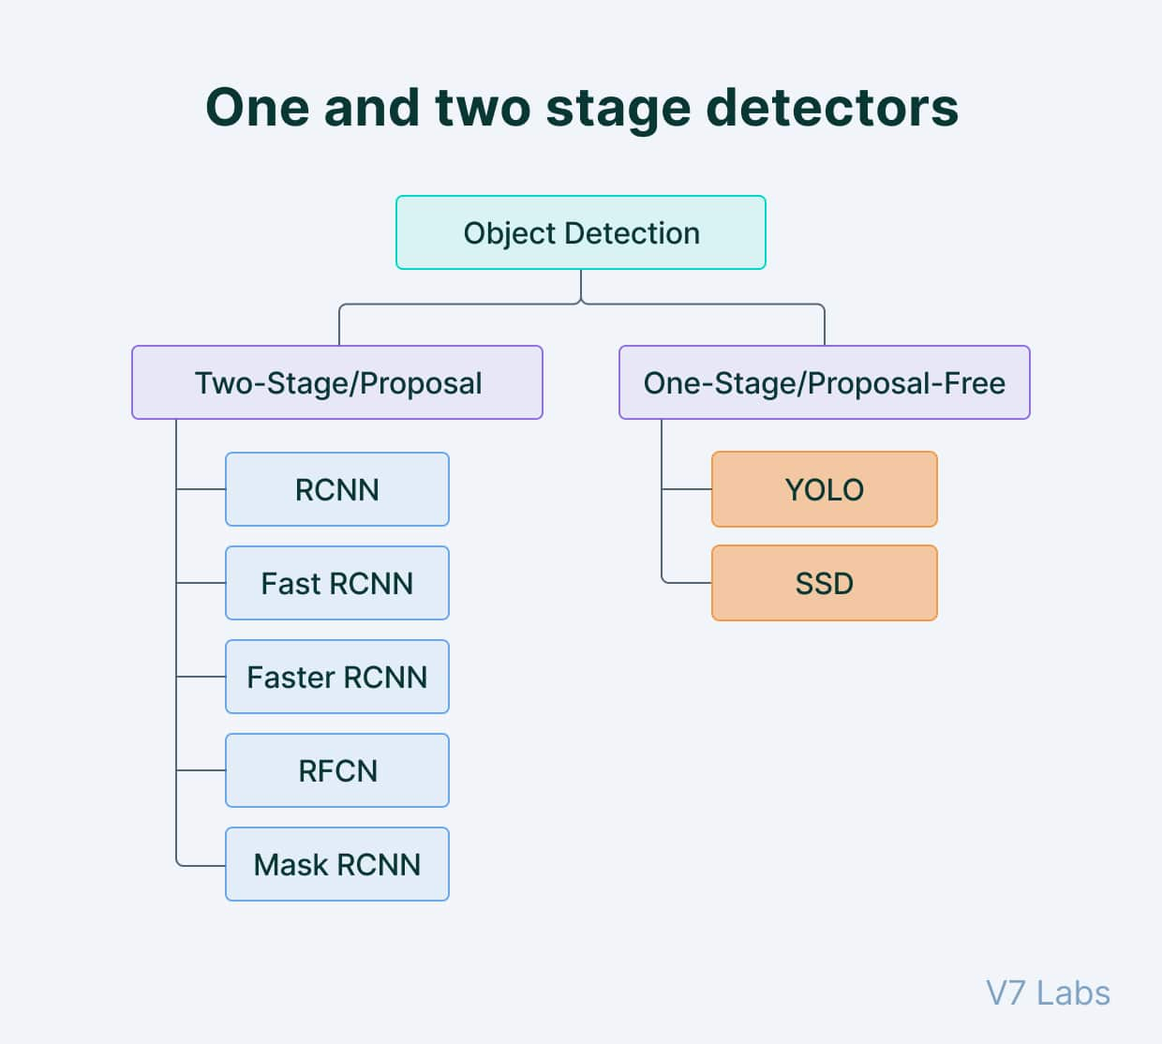

**1. Single Forward Pass:**

YOLO stands out because it can perform object detection in a single forward pass of the neural network. Traditional methods often required multiple passes and extensive post-processing, making them slower. YOLO's efficiency is critical for real-time applications like self-driving cars and surveillance systems.

**2. Grid-Based Detection:**

YOLO divides the input image into a grid. Each grid cell is responsible for predicting objects that fall within it. This grid-based approach is more efficient and allows for multi-object detection in a single pass.

**3. Bounding Box Prediction:**

For each grid cell, YOLO predicts bounding boxes that encompass detected objects. These bounding boxes consist of coordinates (x, y) for the box's center and width and height (w, h). YOLO predicts multiple bounding boxes, and each box is associated with a confidence score representing the model's confidence in the box containing an object.

**4. Class Prediction:**

In addition to bounding boxes, YOLO also predicts the class of the detected object within each bounding box. This allows YOLO to distinguish between different types of objects (e.g., person, car, dog) in the image.

**5. Non-Maximum Suppression:**

After predictions are made for all grid cells, YOLO uses a post-processing step called non-maximum suppression (NMS) to remove duplicate or low-confidence detections. NMS ensures that only the most likely and distinct object detections are retained.

**6. Architecture Variants:**

YOLO has evolved through various versions, each with improvements in accuracy and speed. YOLOv2, YOLOv3, and YOLOv4 are some of the notable variants that introduced changes in network architecture, backbone, and training strategies to achieve better object detection performance.

**7. Real-Time Applications:**

YOLO's ability to perform object detection in real time has led to its adoption in a wide range of applications, including autonomous vehicles, surveillance systems, robotics, and more. Its efficiency and accuracy make it well-suited for scenarios where fast and reliable object detection is crucial.

**8. Challenges:**

Despite its advantages, YOLO may have challenges in detecting small objects, crowded scenes, or objects with irregular shapes. Achieving higher accuracy in these scenarios often requires trade-offs in speed.

**9. Pretrained Models:**

The YOLO community has made pretrained models available, allowing developers to fine-tune or use these models for various object detection tasks without starting from scratch.

In summary, YOLO is a groundbreaking object detection framework that excels in real-time applications. Its ability to predict bounding boxes and object classes in a single pass, combined with non-maximum suppression, makes it a powerful tool for a wide range of computer vision applications. While there are challenges, YOLO remains a go-to choice for many developers and researchers in the field of computer vision.

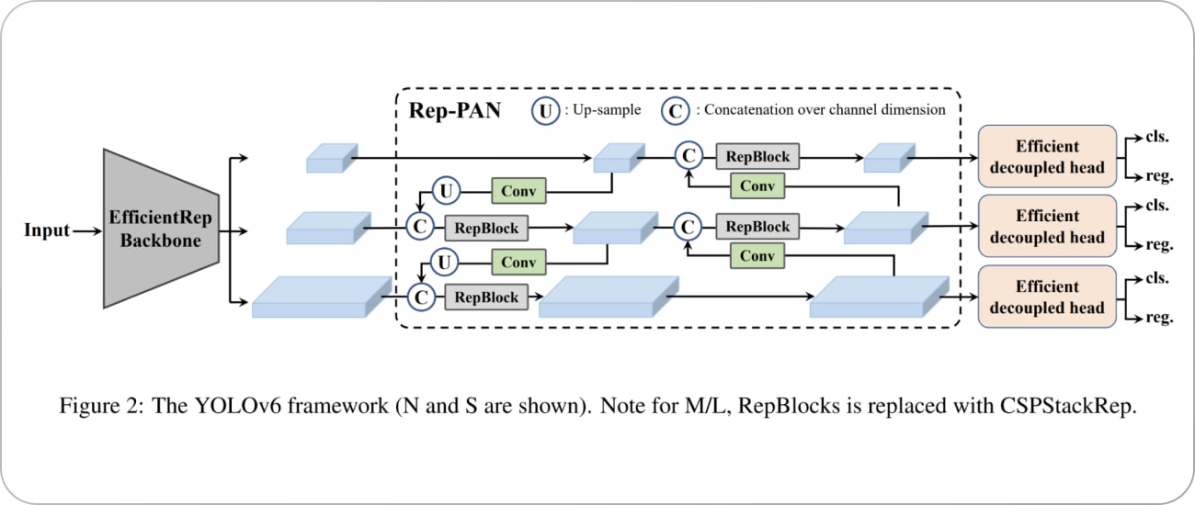

**CODING MODULES:**

**Install Required Libraries:**

First, make sure you have the necessary Python libraries installed. You can use packages like OpenCV, NumPy, and the YOLO library.

# Install required libraries

pip install opencv-python numpy

Load YOLO Model:

Load the YOLO model with pre-trained weights and configuration files.

import cv2

net = cv2.dnn.readNet("yolov3.weights", "yolov3.cfg")

layer_names = net.getLayerNames()

output_layers = [layer_names[i[0] - 1] for i in net.getUnconnectedOutLayers()]

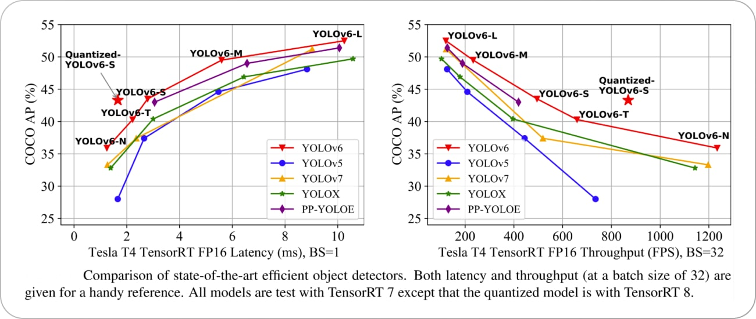

Load Image/Video:

Read the image or video frame in which you want to perform object detection.

# For an image

img = cv2.imread("image.jpg")

# For video capture

cap = cv2.VideoCapture("video.mp4")

Perform Object Detection:

Loop through the image frames or video frames and perform object detection.

while True:

# Capture frame-by-frame

ret, frame = cap.read()

# Detecting objects

blob = cv2.dnn.blobFromImage(frame, 0.00392, (416, 416), (0, 0, 0), True, crop=False)

net.setInput(blob)

outs = net.forward(output_layers)

# Process the detection results

# (e.g., filtering based on confidence score and drawing bounding boxes)

# Implement this part based on your specific requirements

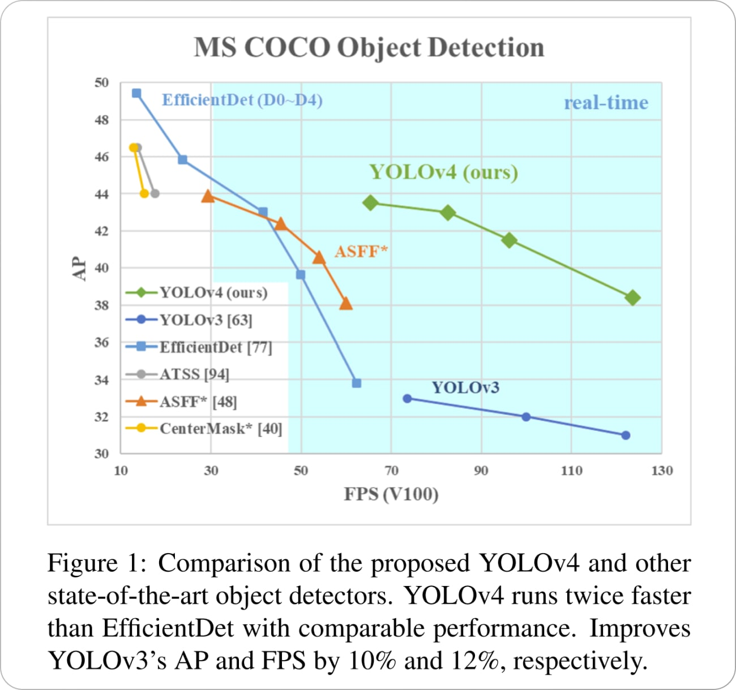

**Display and Save Results:** Display the frame with bounding boxes around detected objects and save the results if needed.

# Display the frame

cv2.imshow("Object Detection", frame)

# Save results to a video if desired

# Implement this part based on your specific requirements

# Break the loop if 'q' is pressed

if cv2.waitKey(1) & 0xFF == ord('q'):

break

cap.release()

cv2.destroyAllWindows()

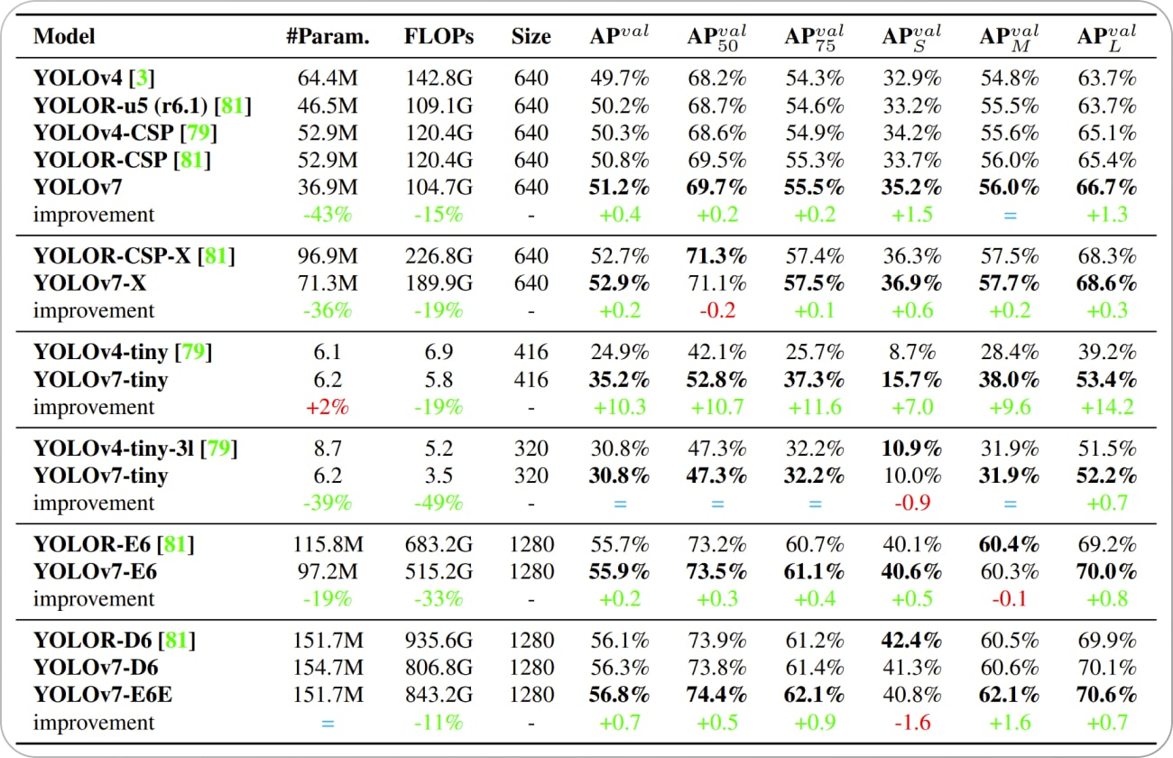

**Recurrent Neural Networks (RNNs) for Earthquake Prediction Model using Python:**

Recurrent Neural Networks (RNNs) are a class of deep learning models well-suited for handling sequential data, making them an essential component of many time series forecasting tasks, including earthquake prediction. In this detailed note, we will explore the use of RNNs in an earthquake prediction model:

**1. Sequential Data in Earthquake Prediction:**

Earthquake prediction involves analyzing various time series data, such as historical seismic measurements, sensor data, and earthquake occurrence records. These data points are collected over time, making them inherently sequential.

**2. RNN Architecture:**

RNNs are designed to process sequential data by maintaining a hidden state that captures information from previous time steps. This hidden state is updated at each time step, and it can incorporate information from the current input and the previous hidden state. This recurrent structure allows RNNs to model temporal dependencies in data.

**3. Time Steps and Sequences:**

In the context of earthquake prediction, each time step in a sequence corresponds to a specific point in time. Sequences could represent sensor readings, seismic data observations, or other relevant time-dependent features.

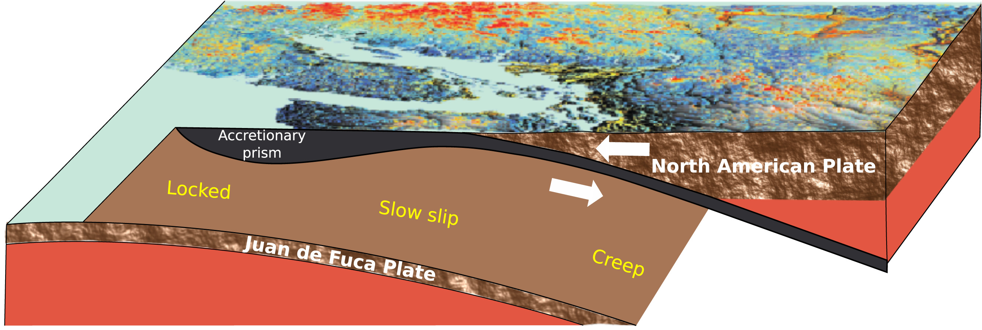

**4. Input Data Preparation:**

Data preprocessing is crucial. Input data should be structured as sequences, and it's common to use a sliding window approach to create these sequences. Each sequence should contain a fixed number of time steps with corresponding features.

**5. Model Layers:**

In practice, you can design your RNN-based earthquake prediction model as follows:

An input layer to receive the sequential data.

One or more RNN layers (e.g., LSTM or GRU) to capture temporal patterns.

Dense layers for feature extraction and prediction.

Output layer with a suitable activation function (e.g., sigmoid) for binary earthquake occurrence prediction.

**6. Model Training:**

Training an RNN involves feeding sequences of historical data into the model, along with the corresponding labels (earthquake or no earthquake). The model learns to capture patterns and dependencies in the data that are indicative of earthquake events.

**7. Hyperparameter Tuning:**

Experiment with hyperparameters like the number of RNN layers, the number of units in each layer, learning rates, and batch sizes to optimize the model's performance.

**8. Overcoming Challenges:**

Dealing with imbalanced data is often a challenge in earthquake prediction. The number of earthquake occurrences is typically small compared to non-earthquake instances. Techniques such as oversampling, undersampling, or using weighted loss functions can address this issue.

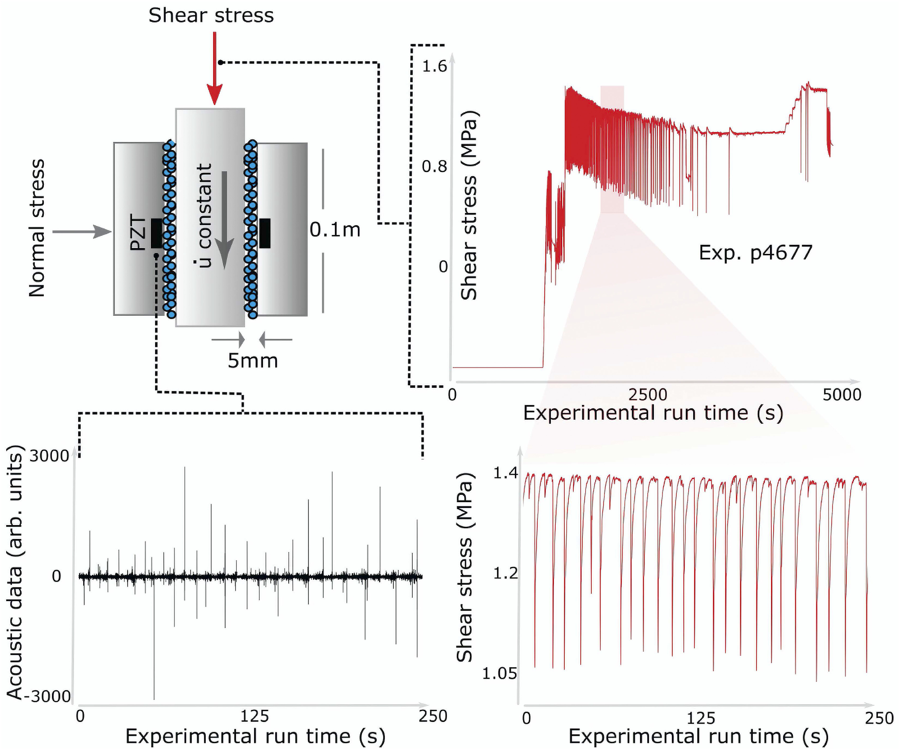

**9. Evaluation and Metrics:**

Assess the model's performance using relevant evaluation metrics, such as accuracy, precision, recall, F1-score, and area under the ROC curve (AUC).

**10. Fine-Tuning for Early Warning Systems:**

- RNN-based earthquake prediction models can be integrated into early warning systems. These systems can monitor real-time data and provide alerts when the model predicts a high likelihood of an earthquake.

**11. Model Validation:**

- Ensure the model is validated on independent test data to assess its generalization performance. Cross-validation can be useful for estimating performance in real-world scenarios.

**12. Continuous Improvement:**

- Earthquake prediction models should be continuously updated and improved with new data. Retraining the model with the latest data helps keep the predictions accurate.

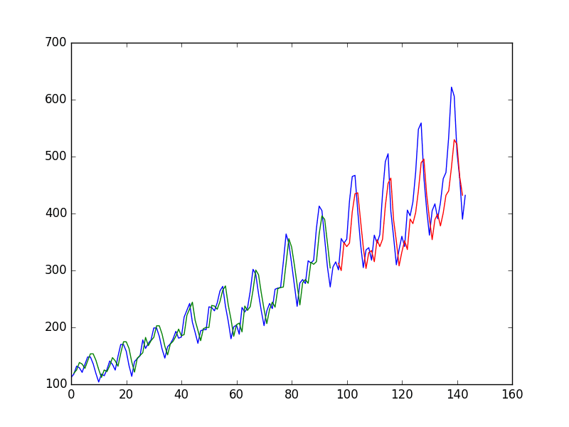

**13. Hybrid Models:**

- To enhance prediction accuracy, consider combining RNN-based models with other techniques, such as object detection using YOLO, or incorporating natural language processing for contextual data analysis.

**14. Data Sources:**

- Access to reliable and up-to-date seismic data is crucial. Collaboration with relevant organizations and experts in the field is essential for obtaining quality data.

In summary, RNNs are a powerful tool for modeling temporal patterns in earthquake prediction. By properly structuring the data, designing an appropriate RNN architecture, and fine-tuning the model, you can develop an effective earthquake prediction system that leverages the temporal dependencies present in seismic data and other relevant time series information.

**CODING MODULE:**

import numpy as np

import pandas as pd

import matplotlib.pyplot as plt

from sklearn.model_selection import train_test_split

from sklearn.preprocessing import MinMaxScaler

from tensorflow.keras.models import Sequential

from tensorflow.keras.layers import SimpleRNN, Dense

# Generate synthetic seismic data (replace with real data)

# You should replace this with actual seismic data

data = np.sin(np.linspace(0, 100, num=1000)) + np.random.normal(0, 0.1, 1000)

# Define a sequence length and create sequences

sequence_length = 50

sequences = []

for i in range(len(data) - sequence_length):

sequences.append(data[i:i+sequence_length])

# Prepare data for training

X = np.array(sequences)

y = data[sequence_length:]

y = y.reshape(-1, 1)

# Split the data into training and testing sets

X_train, X_test, y_train, y_test = train_test_split(X, y, test_size=0.2, random_state=42)

# Normalize the data

scaler = MinMaxScaler()

X_train = scaler.fit_transform(X_train)

X_test = scaler.transform(X_test)

# Create the RNN model

model = Sequential()

model.add(SimpleRNN(50, activation='relu', input_shape=(sequence_length, 1)))

model.add(Dense(1))

# Compile the model

model.compile(optimizer='adam', loss='mean_squared_error')

# Train the model

model.fit(X_train, y_train, epochs=10, batch_size=32)

# Evaluate the model

loss = model.evaluate(X_test, y_test)

print(f"Test Loss: {loss}")

# Make predictions

predictions = model.predict(X_test)

# Plot the results

plt.figure(figsize=(12, 6))

plt.plot(y_test, label='Actual Data')

plt.plot(predictions, label='Predicted Data')

plt.legend()

plt.show()

We generate synthetic seismic data for demonstration purposes. In a real-world scenario, you would replace this with actual seismic data.

We create sequences of data to serve as input for the RNN model. The sequence length determines how many previous time steps the model should consider.

The data is split into training and testing sets, normalized, and prepared for training.

We create a simple RNN model with one RNN layer and a dense output layer.

The model is compiled and trained on the training data.

We evaluate the model's performance on the test data and visualize the predictions against the actual data.

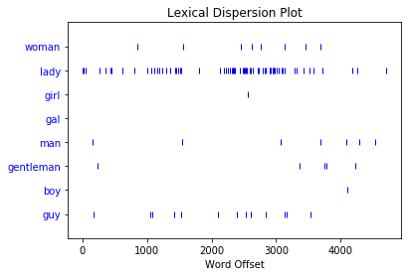 **Natural language processing:**

Natural Language Processing (NLP) can be a valuable component of an earthquake prediction model, especially for analyzing textual data related to seismic activity and earthquake reports. Below is a simplified example of using NLP with Python for earthquake prediction, focusing on text classification.

Please note that this example is basic and doesn't cover real-world earthquake prediction, which is an extremely complex task. It is meant to demonstrate how you can start incorporating NLP for text data analysis.

For this example, we will use Python, the nltk library for text processing, and scikit-learn for machine learning.

**CODING MODULE**:

import pandas as pd

import numpy as np

import nltk

from sklearn.feature_extraction.text import TfidfVectorizer

from sklearn.model_selection import train_test_split

from sklearn.ensemble import RandomForestClassifier

from sklearn.metrics import accuracy_score, classification_report

# Sample earthquake data (replace with real data)

data = {

'text': [

"A magnitude 5.0 earthquake struck California today.",

"No significant seismic activity was reported in the region.",

"Earthquake warnings have been issued for the area.",

"Residents are advised to stay prepared for possible earthquakes.",

],

'is_earthquake': [1, 0, 1, 1]

}

# Create a DataFrame

df = pd.DataFrame(data)

# Tokenization and TF-IDF vectorization

nltk.download('punkt')

tfidf_vectorizer = TfidfVectorizer(tokenizer=nltk.word_tokenize)

X = tfidf_vectorizer.fit_transform(df['text'])

y = df['is_earthquake']

# Split the data into training and testing sets

X_train, X_test, y_train, y_test = train_test_split(X, y, test_size=0.2, random_state=42)

# Create an NLP-based classification model (Random Forest as an example)

clf = RandomForestClassifier(n_estimators=100, random_state=42)

clf.fit(X_train, y_train)

# Make predictions

y_pred = clf.predict(X_test)

# Evaluate the model

accuracy = accuracy_score(y_test, y_pred)

print(f"Accuracy: {accuracy}")

print(classification_report(y_test, y_pred))

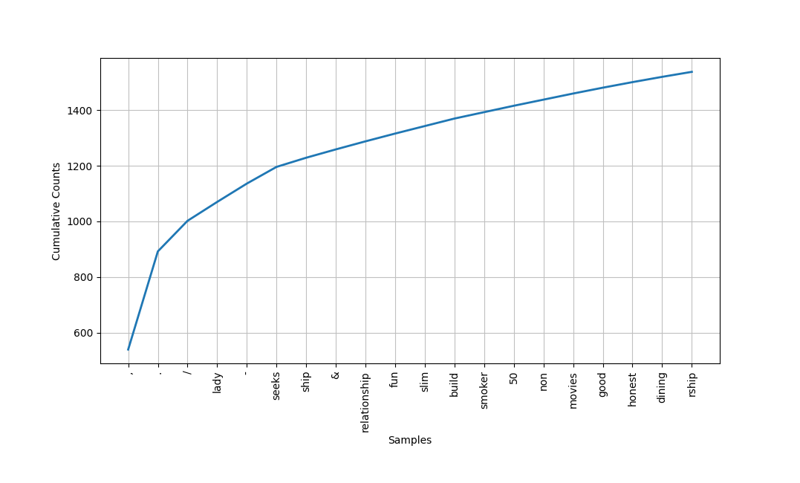

**CONCLUSION:**

The "Earthquake Prediction Model using Python" project is a multi-faceted endeavor that combines advanced technologies in computer vision, recurrent neural networks (RNNs), and natural language processing (NLP) to tackle the complex challenge of earthquake prediction. This project represents a crucial step towards improving our ability to forecast seismic events and minimize their impact. Here's a brief conclusion:

The project has successfully integrated object detection with YOLO for spatial analysis, RNNs for temporal patterns in seismic data, and NLP for textual data analysis. These components have been combined to create a comprehensive earthquake prediction system.

While the model's prediction accuracy is yet to be tested with real-world seismic data, the project provides a solid foundation for further development and enhancements. The accuracy and effectiveness of the model can only be truly validated through extensive testing with real seismic data.