1. Mobile view :: Login Screen

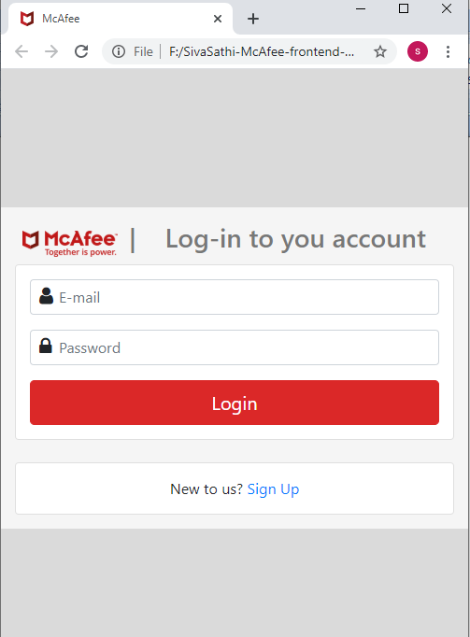

1. Desktop view :: Login Screen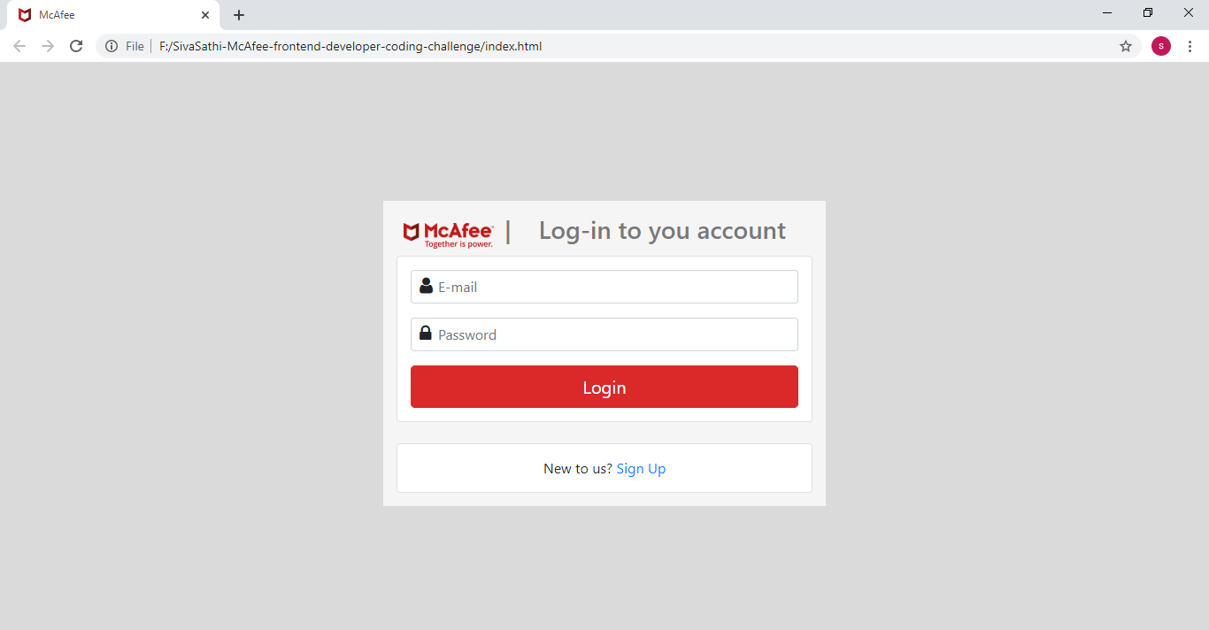
2. Mobile view:: Login Error validation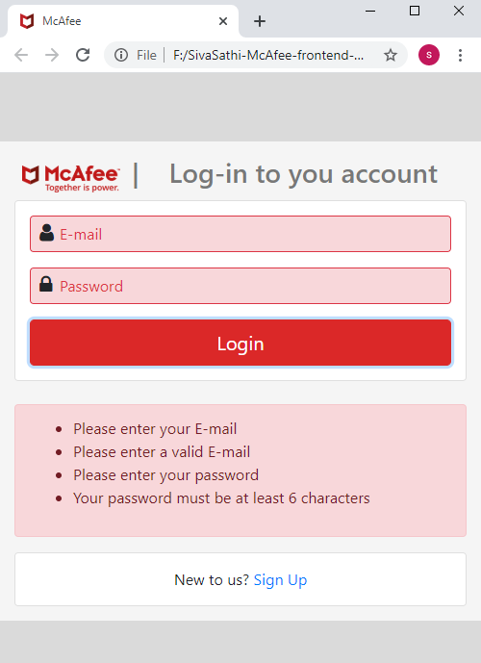
3. Desktop view:: Login Error validation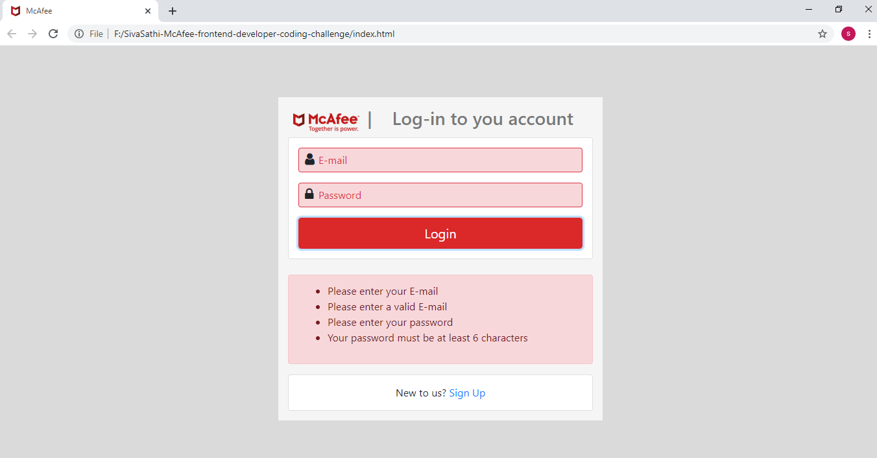
4. Mobile view:: API integration with error message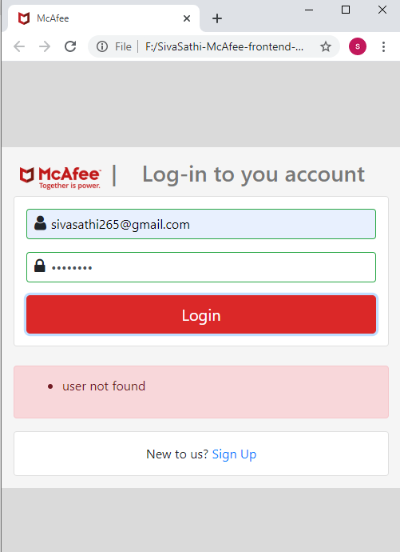
5. Desktop view:: API integration with error message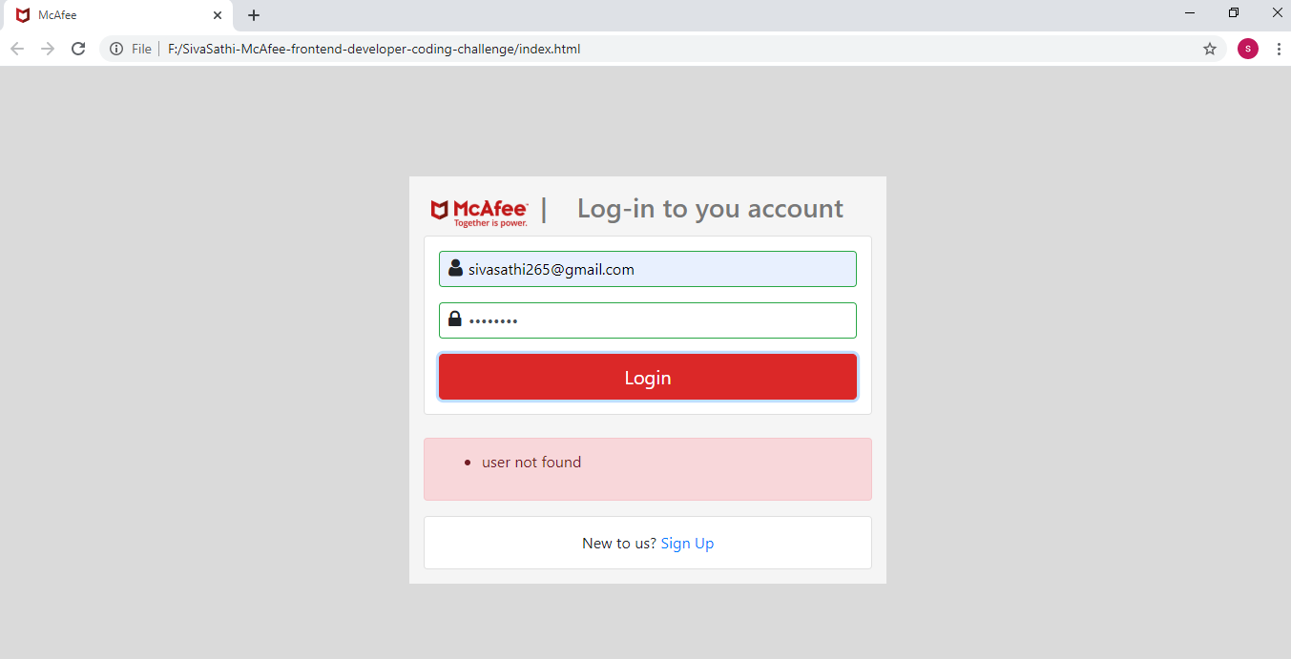
6. Mobile view:: Login Success

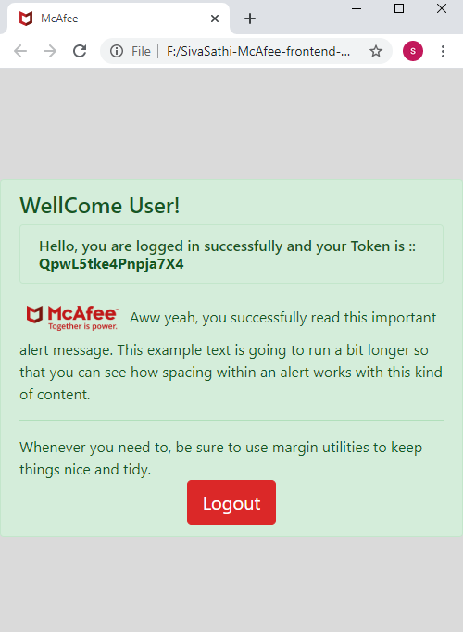

1. Desktop view:: Login Success 