**Detail with screenshot**

1. **Launch EC2 instance**

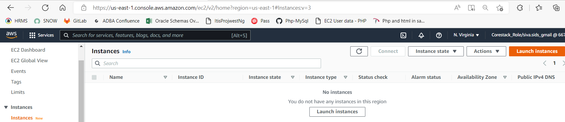

**2) Name of instance: RDS-EC2**

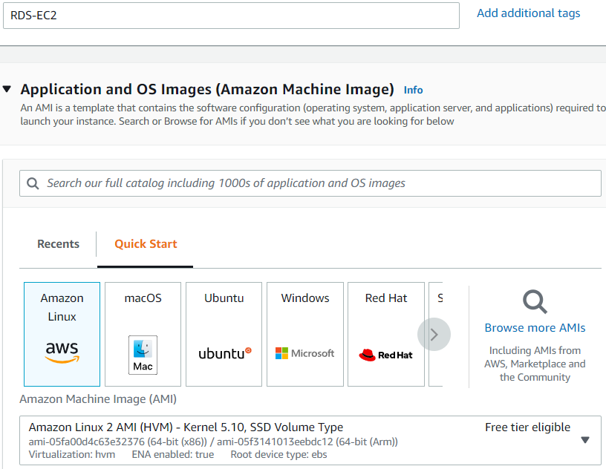

**3) Additional security http, https added (mainly for route-53 health check config.):**

**4) Default configuration needed while launching instance**

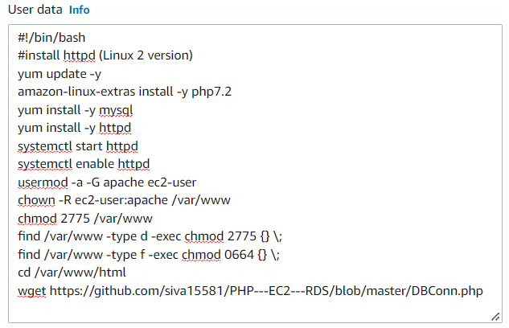

**5) Instance up and running  
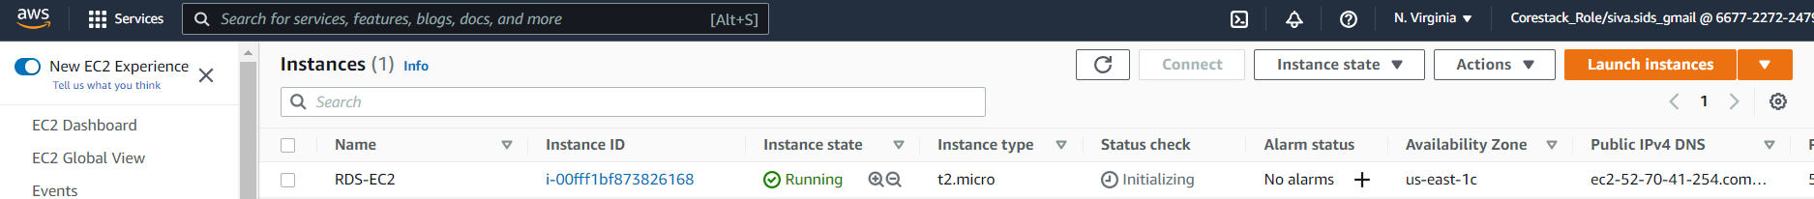**

**6) Modify security group by adding another inbound rule for RDS entry  
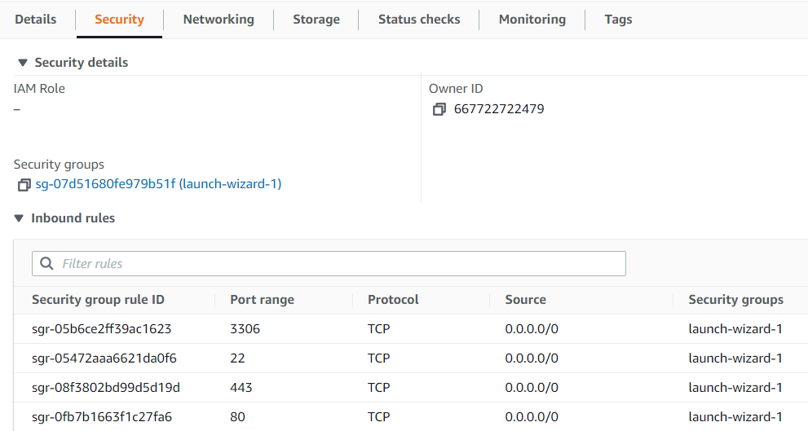**

**7) Associate all subnets under the EC2 mapped default VPC to the VPC mapped route table  
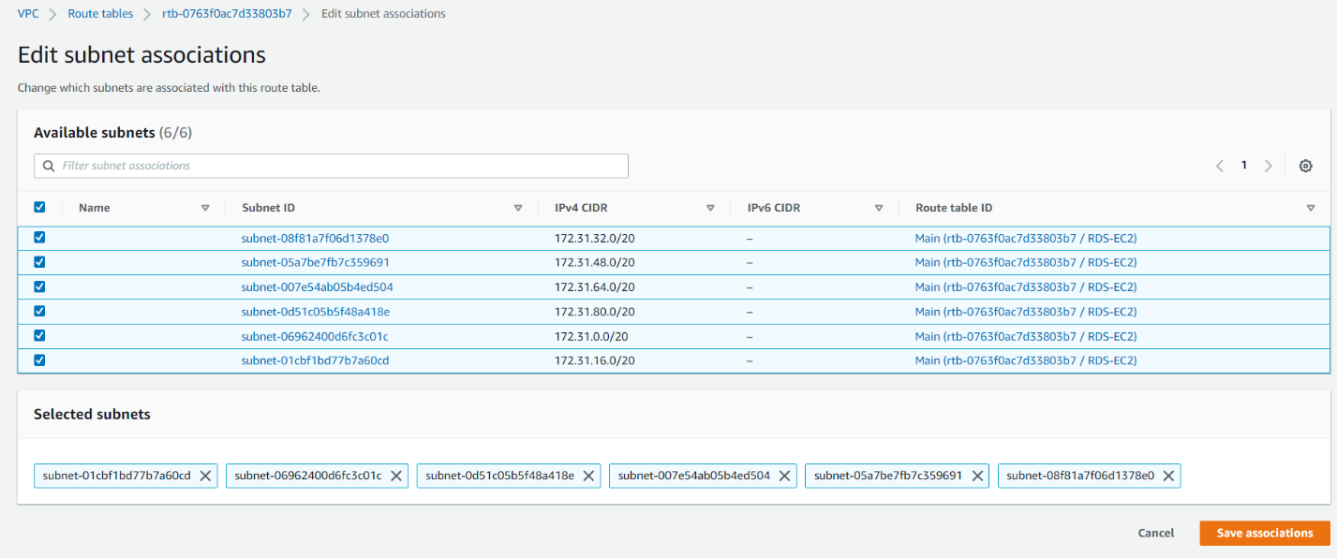**

**8) Check if the default Internet gateway is assigned to route table and if not associate it.  
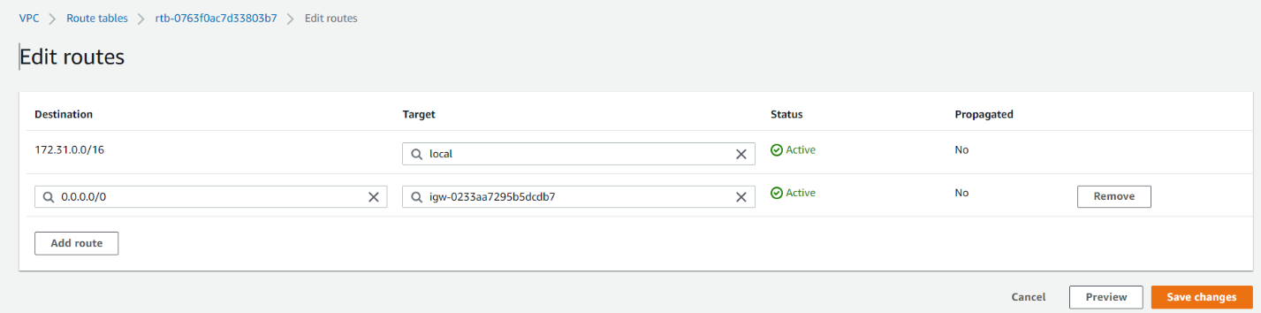**

**9) Create Image out of EC2 instance created for Auto scaling  
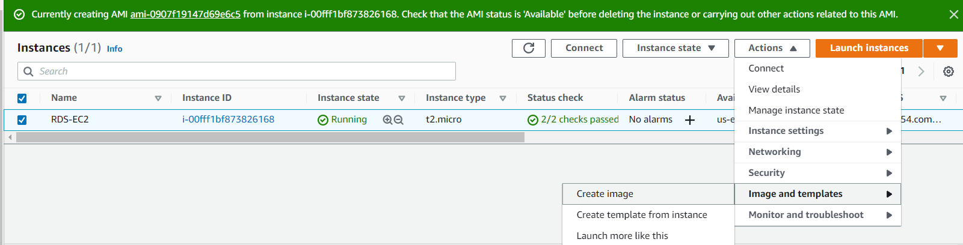**

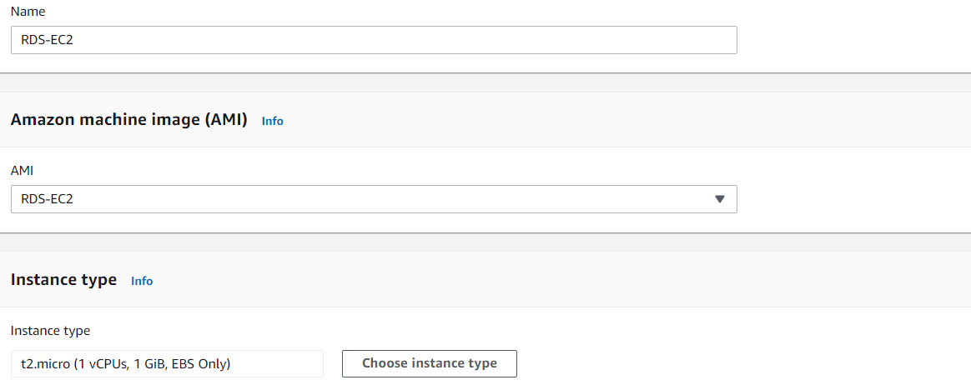

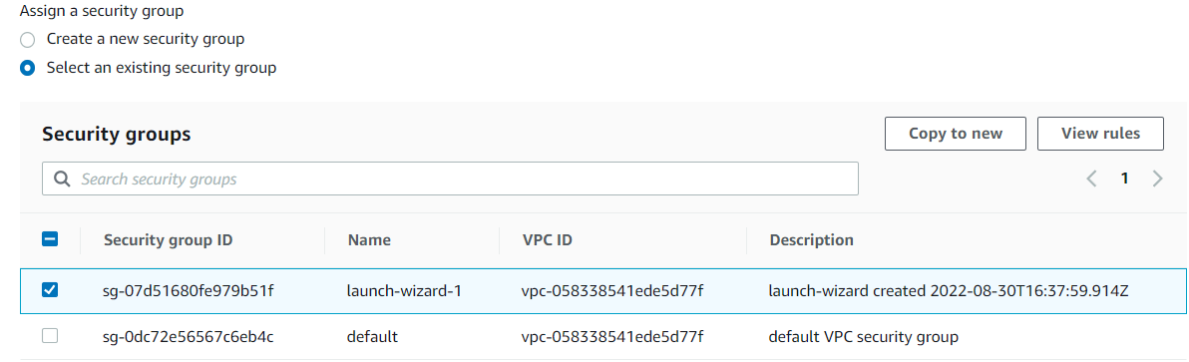

**10) Create launch template out of the launch configuration  
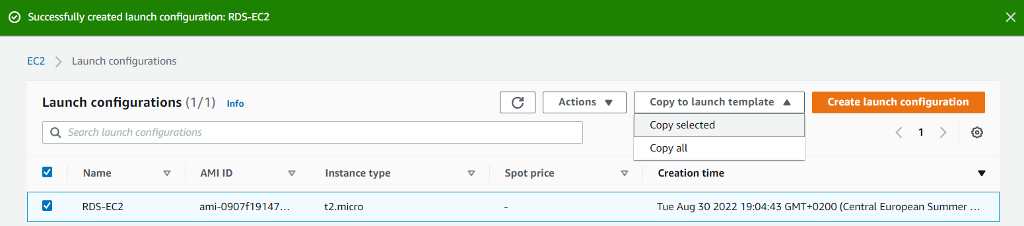  
  
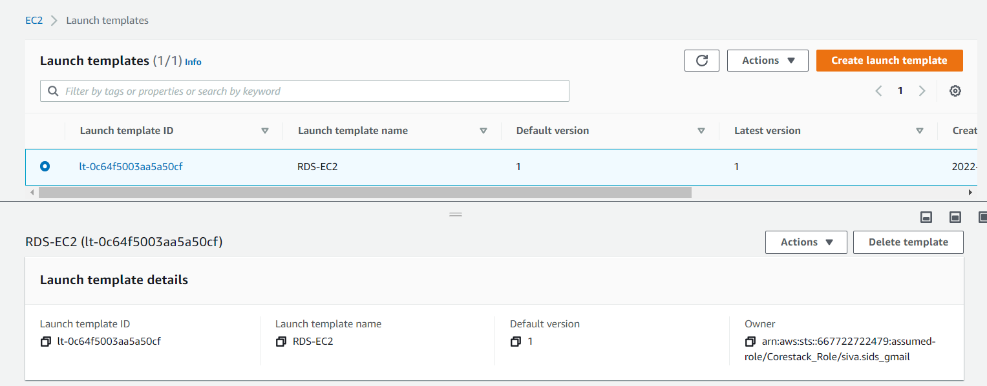**

**11) Create target group out of the instances**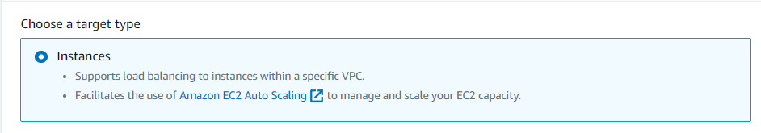

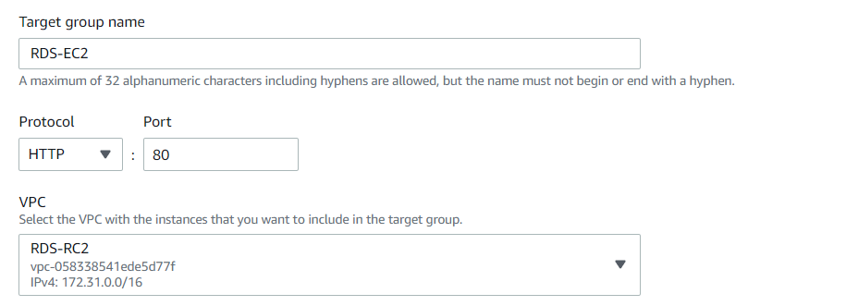

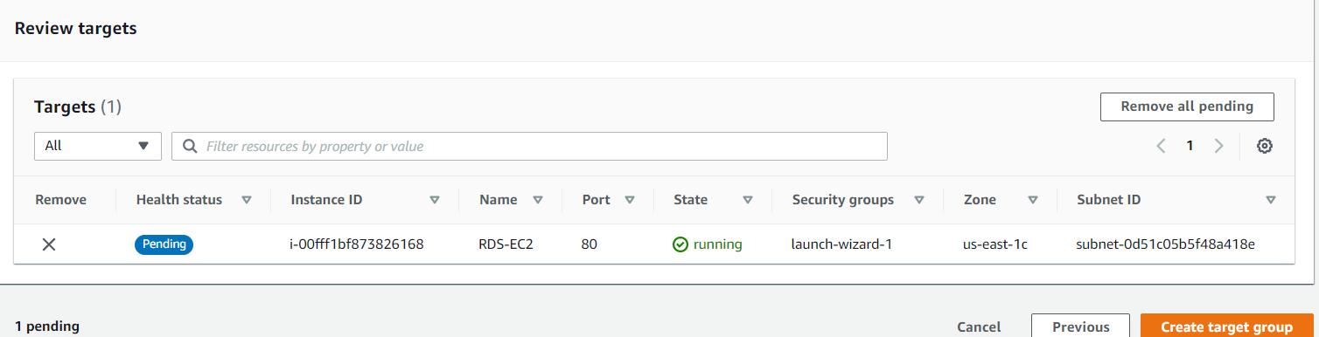

**12) Associate target group with a new Load balancer within the same VPC with all subnets included and assigning the same security group created above  
Add listener as EC2 instance created:  
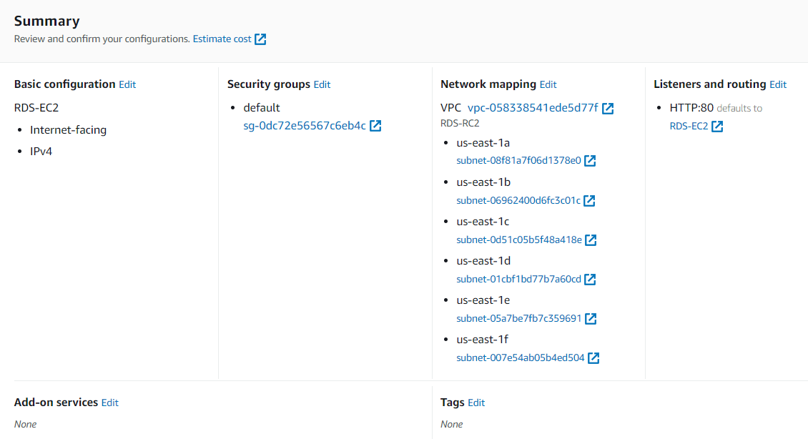**

**Right load balancer is attched to the target group  
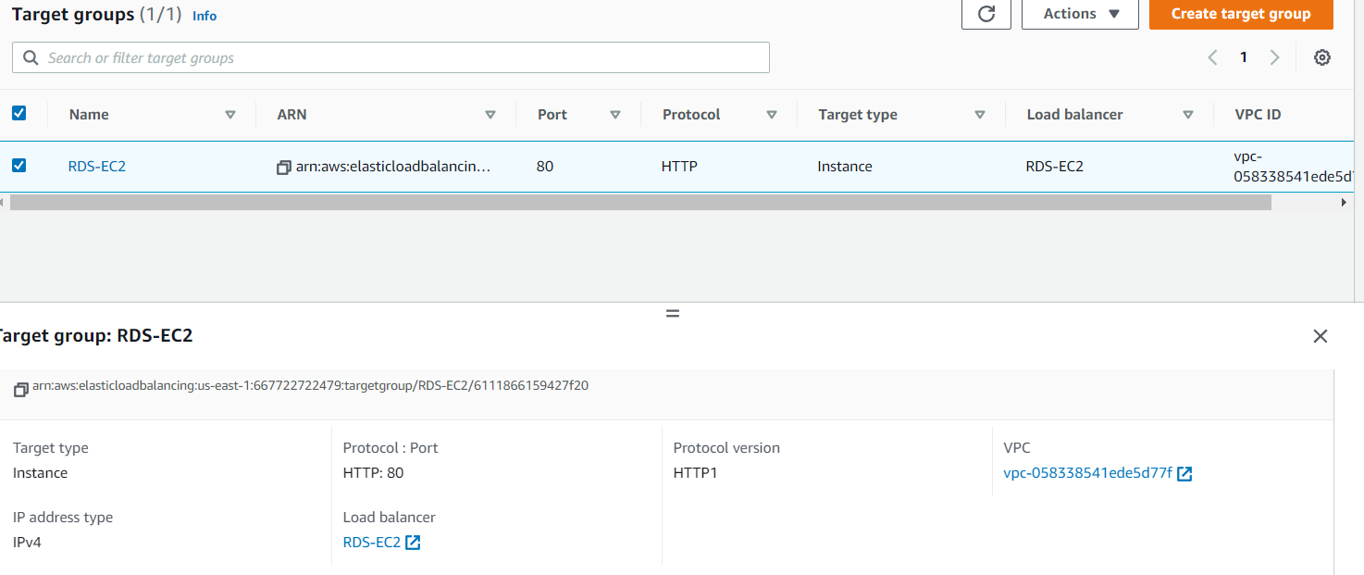**

**13) Create Auto scaling out of the launch configuration  
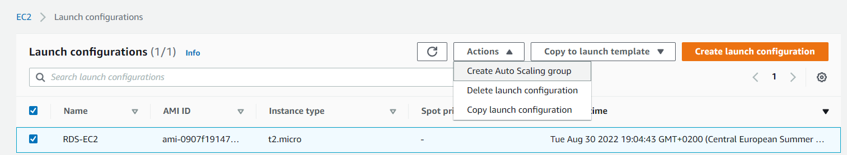**

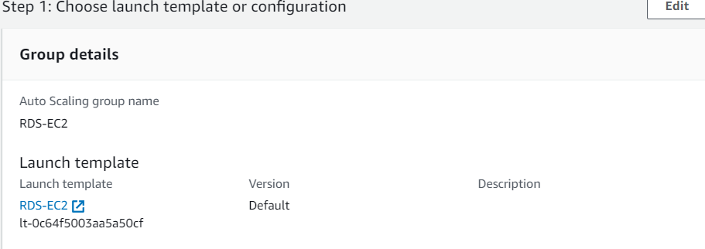

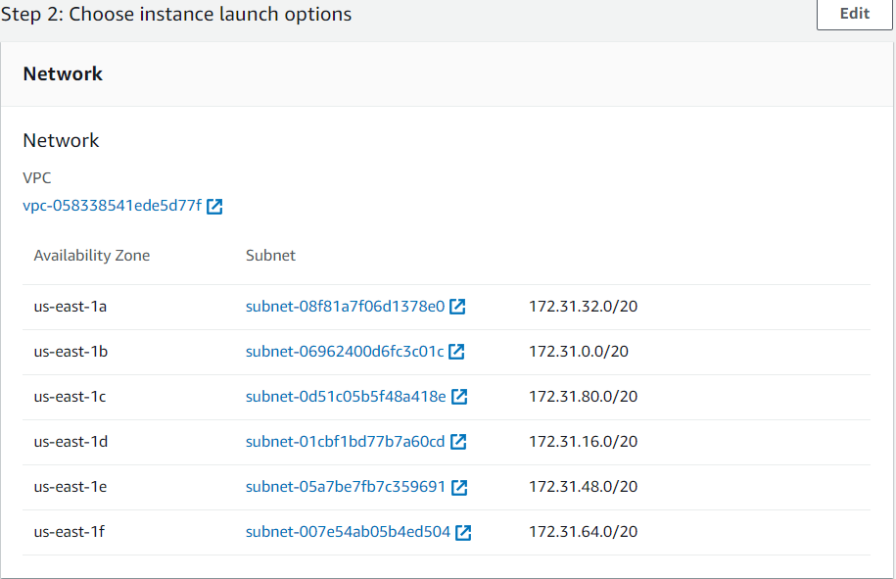

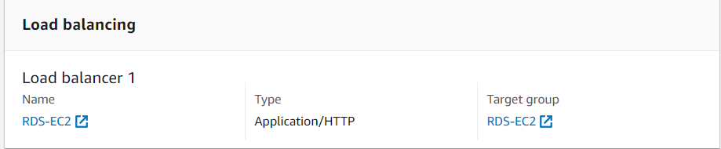

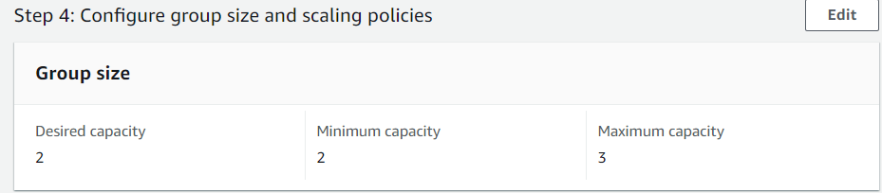

**Instances created as per auto scaling configurations**

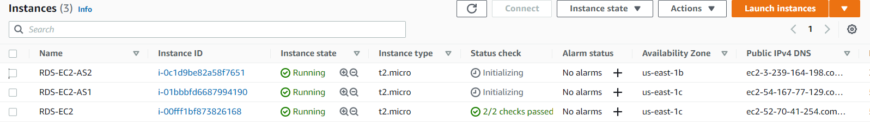

**14) All the necessary installations done in the auto scaled EC2 instances  
EC2 – 172.31.93.166  
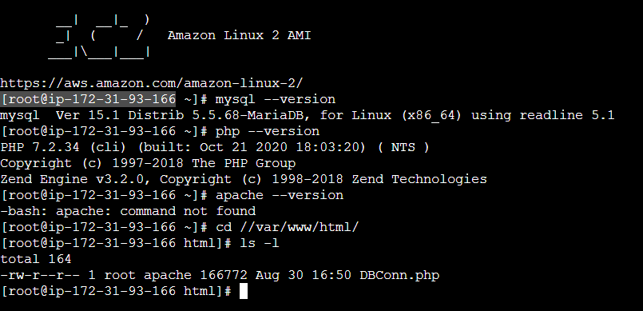**

**EC2 – 172.31.9.241  
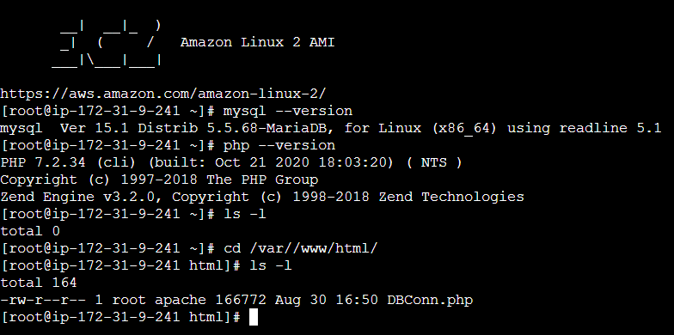**

**15) Create RDS instance with ‘’Standard”, “MYSql”, “db.t2.micro”, “same VPC as EC2”, “same security group as EC2”  
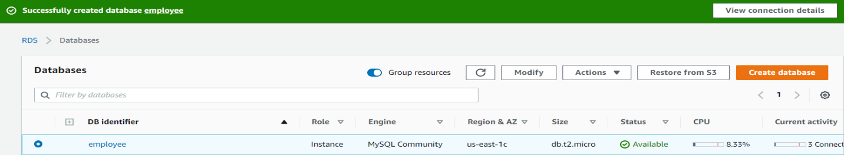**

**16) Test DB connection EC2-172.31.9.241, public-ip: 3.239.164.198  
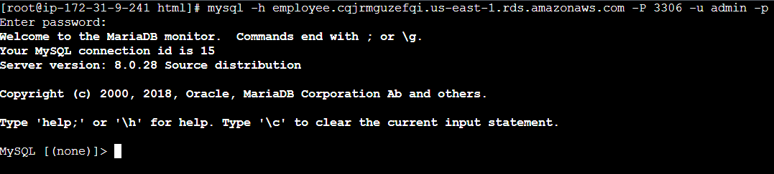**

**Test DB connection EC2-172.31.93.166, public-ip: 54.167.77.129  
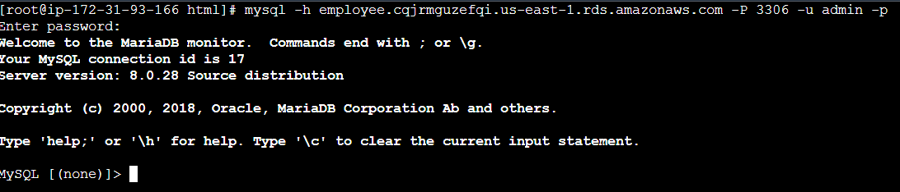**

**17) Testing Data entry via public-ip of both the above instances  
 From EC2- private-ip: 172.31.9.241 , public-ip: 3.239.164.198**

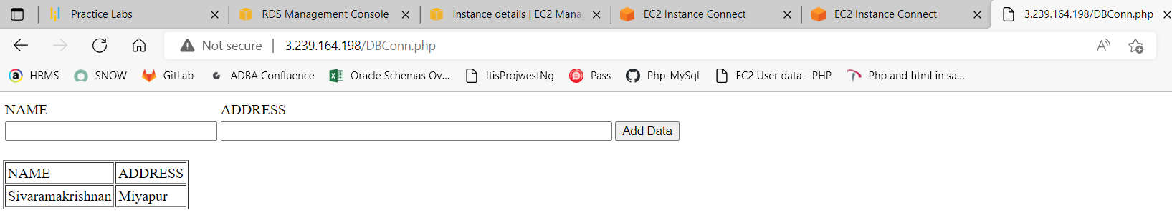

**From EC2- private-ip: 172.31.93.166, public-ip: 54.167.77.129**

