## SIVAKUMAR R

## ASSIGNMENT

## 1. Walmart Sales Analysis:

A. Analyse the performance of sales and revenue at the city and branch level:

Google colab : [Jar BA assignment.ipynb](https://colab.research.google.com/drive/1XKwuczpRX78zKXL3A-Qx8OU1PSfYOb55?usp=sharing)

**Sales and revenue data for each city:**

| **City** | **Branch** | **Revenue** | **Sales** |
| --- | --- | --- | --- |
| Mandalay | A | 34130.09 | 637 |
| Mandalay | B | 37215.93 | 664 |
| Mandalay | C | 29794.62 | 519 |
| Naypyitaw | A | 35985.64 | 648 |
| Naypyitaw | B | 35157.75 | 604 |
| Naypyitaw | C | 34160.14 | 579 |
| Yangon | A | 33647.27 | 598 |
| Yangon | B | 35193.51 | 631 |
| Yangon | C | 32302.43 | 630 |

**Sales and revenue Bar charts of each city:**

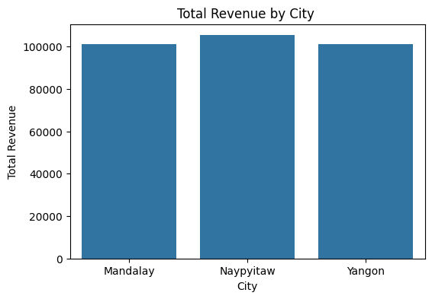 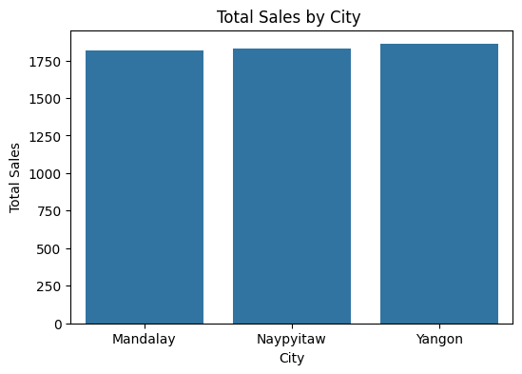

**Sales and revenue Bar charts of each branches of the city:**

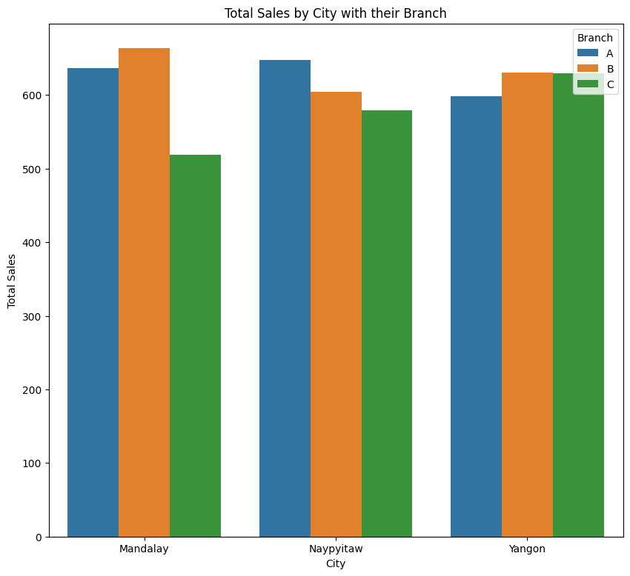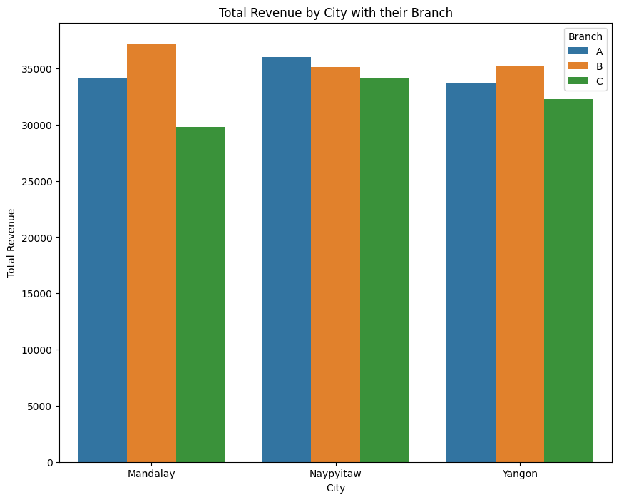

B. What is the average price of an item sold at each branch of the city,

This table contains the average price of an item sold at each branch of the city.

| **City** | **Branch** | **Electronic accessories** | **Fashion accessories** | **Food and beverages** | **Health and beauty** | **Home and lifestyle** | **Sports and travel** |
| --- | --- | --- | --- | --- | --- | --- | --- |
| **Mandalay** | A | 222.06 | 262.32 | 294.37 | 391.76 | 352.18 | 241.09 |
|  | B | 350.66 | 206.92 | 281.51 | 367.77 | 327.93 | 342.20 |
|  | C | 314.13 | 281.54 | 294.62 | 331.48 | 313.93 | 345.16 |
| **Naypyitaw** | A | 391.00 | 257.24 | 393.31 | 322.15 | 346.44 | 230.58 |
|  | B | 324.11 | 383.28 | 271.36 | 298.21 | 271.93 | 359.39 |
|  | C | 271.32 | 296.63 | 340.54 | 284.95 | 273.71 | 399.53 |
| **Yangon** | A | 293.36 | 202.40 | 270.62 | 245.07 | 341.68 | 360.56 |
|  | B | 335.62 | 337.87 | 274.43 | 241.76 | 358.14 | 242.98 |
|  | C | 225.97 | 349.45 | 297.39 | 272.41 | 240.12 | 307.07 |

C. Analyze the performance of sales and revenue, Month over Month across the

Product line, Gender, and Payment Method, and identify the focus areas to

get better sales for April 2019.

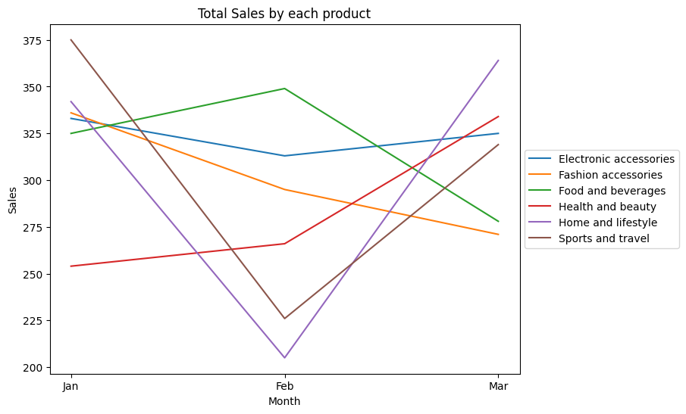

Descriptive Analysis:

Analysis reveals a decline in **Food and Beverages** sales from February to March while **Fashion Accessories** show consistent decrease since January.

However, strategic actions in February drove significant sales spikes in **Sports and Travel,** as well as **Home and Lifestyle** categories in March.**Health and beauty** got good growth in march due to some innovative actions taken in february because january and february got less sales.

**Electronics Accessories** see slight growth compared to the previous month february.

Predictive analytics:

To drive increasing sales in April, implement targeted initiatives for **food and beverages and fashion accessories**, more consumer insights, and marketing strategies while increasing promotions and product visibility.

while continuing to monitor and capitalise on growth trends in **electronics accessories.**

**Fashion accessories sales and revenue :**

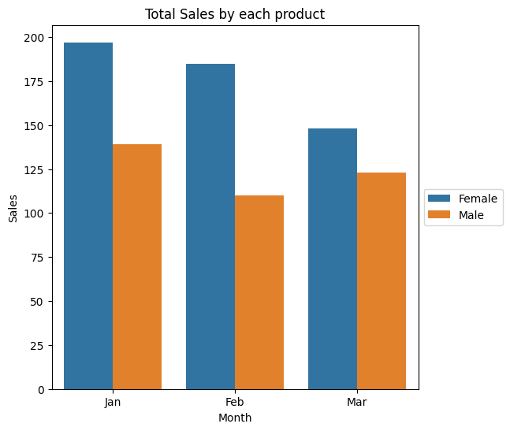

Analysis indicates a declining trend in sales by females since January.So, the company is losing female customers.

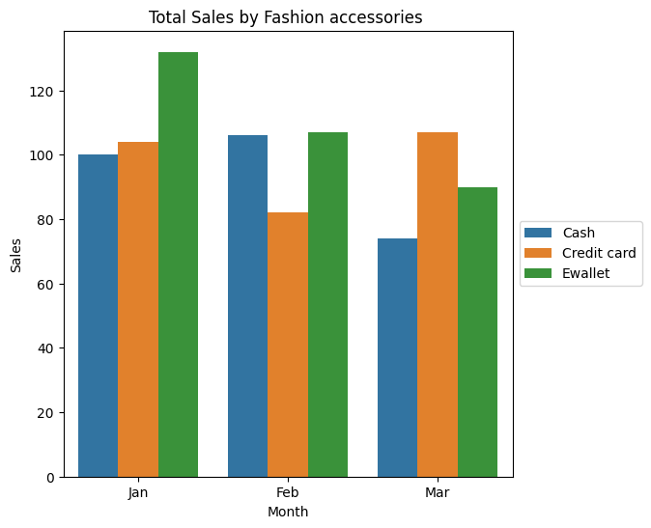

Sales through E-wallets have been constantly decreasing since January. So we need to focus on this area.

Sales by cash method increase from January to February but decrease from February to March. Cash payments by customers mean offline customers.

So, we need to focus on both of these customers who are using these two methods. and we have to make some offers related to catching more customers and sales.

Credit cards by customers are increasing in February, so the action taken in February is good and needs more monitoring and ideas to maintain and catch more customers in this section.

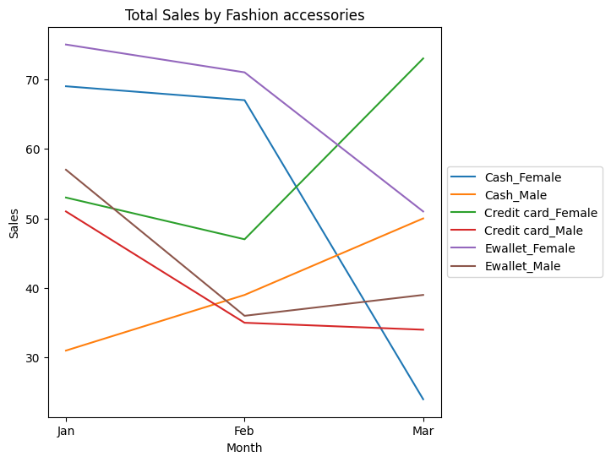

**Constantly decreasing:**

**Cash and e-wallet payment methods by females** are constantly dropping, so we have to focus mainly on that and find out what's the problem with them.

**Moderately increasing:**

E-wallet and credit card payment methods by males have been dropping since January, but after some actions initiated in February, they are slightly increasing in March. Regular monitoring and enhancing innovative ideas are needed for these two methods.

**Highly increasing:**

Cash by male and credit card payments by female showed good growth in March compared to the other two months, so it's a good sign, and regular monitoring is important for this section's customers. More offers and promotions to capture more new customers from this section**. It's an easy target section.**

STEPS TO TAKE:

1. A decline in female cash and e-wallet transactions has been observed since January.
2. Introduce buy-one-get-one offers in showrooms to attract more female customers back to offline purchases.
3. Provide extra interest incentives for E-wallet deposits to retain and attract female users.
4. More promotions and ads for cash methods and e-wallet transactions to retain customers and gain more new ones too.
5. Regular monitoring and checkups to find either a fault in the online transaction or a network issue in the E-wallet payment method.

**Food and beverages sales and revenue:**

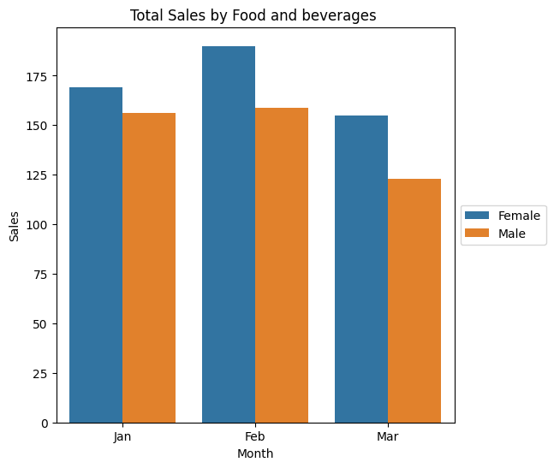

Both male and female customers have drastically decreased since February, so we have to deeply check this.

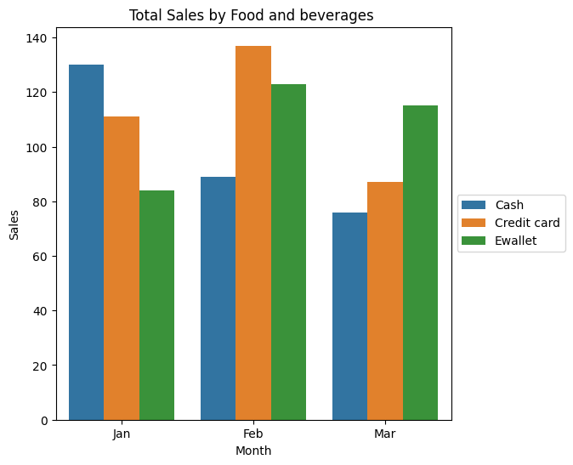

Cash method by customers is dropping from January. The company is losing this section of customers since January.

Credit card and E-wallet methods by customers increased in February due to some actions taken with the help of January, but decreased in March. So change in action is needed, and more ideas are required.

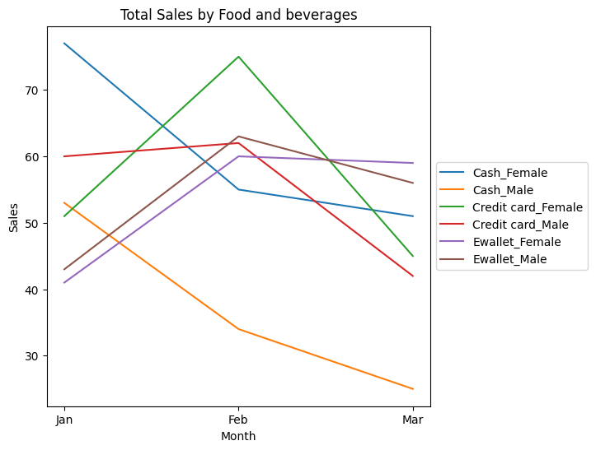

**Constantly Decreasing:**

Cash payment methods by both female and male customers have been dropping since January, so the company is losing its offline customers.

**Increases and Decreases:**

Credit cards and e-wallets for both male and female categories are losing customers from February to March.

From this, we get to know that sales by any payment method or by any gender are dropping in February, so we have to focus on the total number of sections.

STEPS TO TAKE:

1.Offer seasonal specials because summer days are coming in April. Accordingly, special beverages and foods should be added to the menu.

2.Encourage customers to leave some feedback regarding food and beverages; this helps new customers try new foods and adds trust in the brand.

3. Attract new customers by offering discounts, special deals, or loyalty rewards for both online and offline purchases.

4. Participate in community events or sponsor local festivals to attract and gain trust from offline customers.