INTERNSHIP PROJECT DOCUMENTATION
Smart Urban Mobility and
Traffic Intelligence Dashboard
Data Modeling, Geospatial Analytics, Demand Intelligence
and Mobility Access Reporting in Power BI
Student | Pinninti Sivaganesh
Project Domain | Smart Mobility & Transit Analytics
Primary Platform | Microsoft Power BI Desktop
Reporting Period | Q1 2024 (01 January – 31 March 2024)
Internship Context | Infosys Springboard Internship Program
Consolidated project documentation for Milestones 1 to 4

Contents
1. Your Name
2. Project Title
3. Project Objectives
4. Project Description
5. Tools Used
6. Milestone 1 – Dashboard Explanation
7. Milestone 2 – Output Screenshots
8. Milestone 3 – Dashboard Explanation
9. Milestone 4 – Output Screenshots
10. Conclusion
11. References

Documentation note
All dashboard and data-model screenshots in this document are the original project screenshots, included without any change. Figures and values quoted in the explanations are the values shown in those screenshots.

1. Your Name
This documentation has been prepared by the intern who built the Smart Urban Mobility and Traffic Intelligence project in Microsoft Power BI across four milestones.
Name | Pinninti Sivaganesh
Program | Infosys Springboard Internship Program
Project Type | Internship Project
Domain | Smart Urban Mobility, Transit Analytics and Business Intelligence
Scope | Milestones 1 to 4, from data collection to final dashboards

2. Project Title
Smart Urban Mobility and Traffic Intelligence Dashboard
The title describes what the dashboard does: it brings together traffic, ridership, weather, population and accessibility data for the Jakarta metropolitan area so that mobility demand, reliability and access can be studied in one place. The final milestone was delivered as the “Urban Mobility Analytics Dashboard – Mobility Access, Transport Modes and Demand Analysis”.

3. Project Objectives
The objectives grew with each milestone, from building the data foundation to analysing access and fairness.

3.1 Overall Objectives
- Consolidate traffic, ridership, weather, population and route reference data into one connected Power BI data model.
- Design the model so one set of filters (date, route, weather, area) drives every visual, including the maps, without manual re-linking.
- Deliver an interactive dashboard that summarizes trips, passengers, reliability and disruption, with drill-down by area and city.
- Understand how travel demand changes under different weather and temperature conditions.
- Compare demand across Cycling, Public Transit and Ride-Hailing, including ride-hailing indicators such as Average Surge and Average Fare.
- Measure how easily different areas and demographic groups can reach transport using the Mobility Access Index.
- Compare transport modes by trips, reliability, fare and travel time, and study demand trends over time and on a map.
- Present all findings in simple, interactive dashboards that support better planning decisions.

3.2 Objectives by Milestone
Milestone | Objective
Milestone 1 | Collect source data, design the star-schema model, clean and transform data in Power BI, and build the first dashboard.
Milestone 2 | Build the full data model and the first interactive report with KPIs, area analysis and three geographic map visuals.
Milestone 3 | Study demand intelligence: weather and temperature sensitivity, mobility modes and ride-hailing indicators.
Milestone 4 | Deliver three final dashboard pages on mobility access, transport modes and demand by date and location.

4. Project Description
Urban mobility in a large metropolitan region depends on population density, road capacity, weather and the reliability of transit. In the Jakarta metropolitan area (Jabodetabek), congestion and unpredictable travel times are a persistent concern for residents and planners. This project pulls together road-network, traffic-sensor, weather and population data so that ridership, weather and population can be viewed side by side in one Power BI dashboard, instead of working through several separate spreadsheets.
The work was built step by step over four milestones. Each milestone added a new analytical layer on top of the previous one.
Milestone | Focus | What was delivered
Milestone 1 | Data collection, star-schema modeling and first dashboard | Four source datasets cleaned and shaped into one fact table and four dimension tables, with a dashboard of KPIs, weather and population views.
Milestone 2 | Data model and geospatial dashboard | Model extended with four visual-specific tables; dashboard with four slicers, four KPI cards, a bar chart, a trend line and three maps.
Milestone 3 | Demand Intelligence & Mobility Analytics | Weather and temperature analysis, mobility-mode comparison, ride-hailing surge and fare, area and date filters.
Milestone 4 | Final three-page dashboard | Mobility Access Overview, Transport Mode and Trips Overview, and Demand by Date with a location map.

4.1 Scope
- Geography: Jakarta metropolitan area – Central, West, East, North and South Jakarta, Bogor, Depok and Tangerang.
- Period: 01 January 2024 to 31 March 2024 (Q1 2024, 91 days).
- Pipeline: source data collection → cleaning and transformation → star-schema model → dashboards.

5. Tools Used
Tool | Purpose | How it was used
Microsoft Power BI Desktop | Dashboard creation and analysis | KPI cards, charts, slicers, maps and the data model view.
Power Query | Data preparation | Cleaning, type changes, grouping hourly data to daily and shaping the tables.
DAX | Measures and calculations | Total Demand, Average Surge, Average Fare, Average Reliability and Mobility Access Index.
Excel / CSV | Data source and supporting tables | Storing, cleaning and maintaining the mobility and reference data.
Bing Maps visual (Power BI) | Location-based analysis | Heatmap, flow map, drill-down map and transport-mode map using latitude and longitude.
Microsoft Word | Documentation | Preparing this project documentation.

5.1 Key Measures Used in the Dashboards
Measure | Explanation
Total Demand | Total estimated demand in the current filter context.
Average Surge | Average surge value for ride-hailing activity in the current filters.
Average Fare | Typical fare value for the filtered data.
Average Reliability | Average reliability score across services.
Mobility Access Index | Overall score of how easily people can reach transport services.
Demand by Mobility Mode | Compares Cycling, Public Transit and Ride-Hailing demand.

All measures respond to the Region, Date, Weather and other slicers, which makes the dashboards interactive instead of showing one fixed report.

6. Milestone 1 – Dashboard Explanation
Milestone 1 was the first full pass through the pipeline: raw data was collected, a star-schema model was designed, everything was cleaned and transformed in Power BI, and a first dashboard was built on top of it.

6.1 Data Collection – Source Datasets
Six raw files were reviewed. Four fed the Milestone 1 model directly; the others were examined and deliberately left out for now.
Dataset | Rows × Cols | Grain | Used in Milestone 1
weather_conditions.csv | 21,840 × 11 | Hourly reading per weather station (10 stations) | Yes – aggregated to daily
traffic_sensor_data.csv | 218,400 × 15 | Hourly reading per traffic sensor (50 sensors) | Yes – aggregated to daily
traffic_events.csv | 2,000 × 15 | One row per traffic incident | Reviewed, not joined (different grain)
road_network.csv | 200 × 18 | One row per road segment | Yes – used to derive area/district
road_network_international.csv | 1,401 × 37 | One row per international road segment | No – outside geographic scope

6.2 Star-Schema Data Model
The four in-scope sources were reshaped into a star schema: one fact table holding the daily numbers, surrounded by four dimension tables holding the context (which route, which day, what weather, which area). This keeps the fact table small and fast and lets any measure be sliced by route, date, weather or area.
Table | Role | Rows | Grain
FACT_traffic_daily | Fact | 500 sample (full model: 4,550) | 1 row per route per day
DIM_route | Dimension | 50 | 1 row per route/corridor
DIM_date | Dimension | 91 | 1 row per calendar day
DIM_weather_daily | Dimension | 91 | 1 row per day (citywide)
DIM_area_population | Dimension | 8 | 1 row per administrative area

The fact table holds Route ID, Date, Location, Passenger Count, Temperature, Weather, Population and Population Density. The full table has 4,550 rows (50 routes × 91 days); a reproducible 500-row sample was used in the workbook.
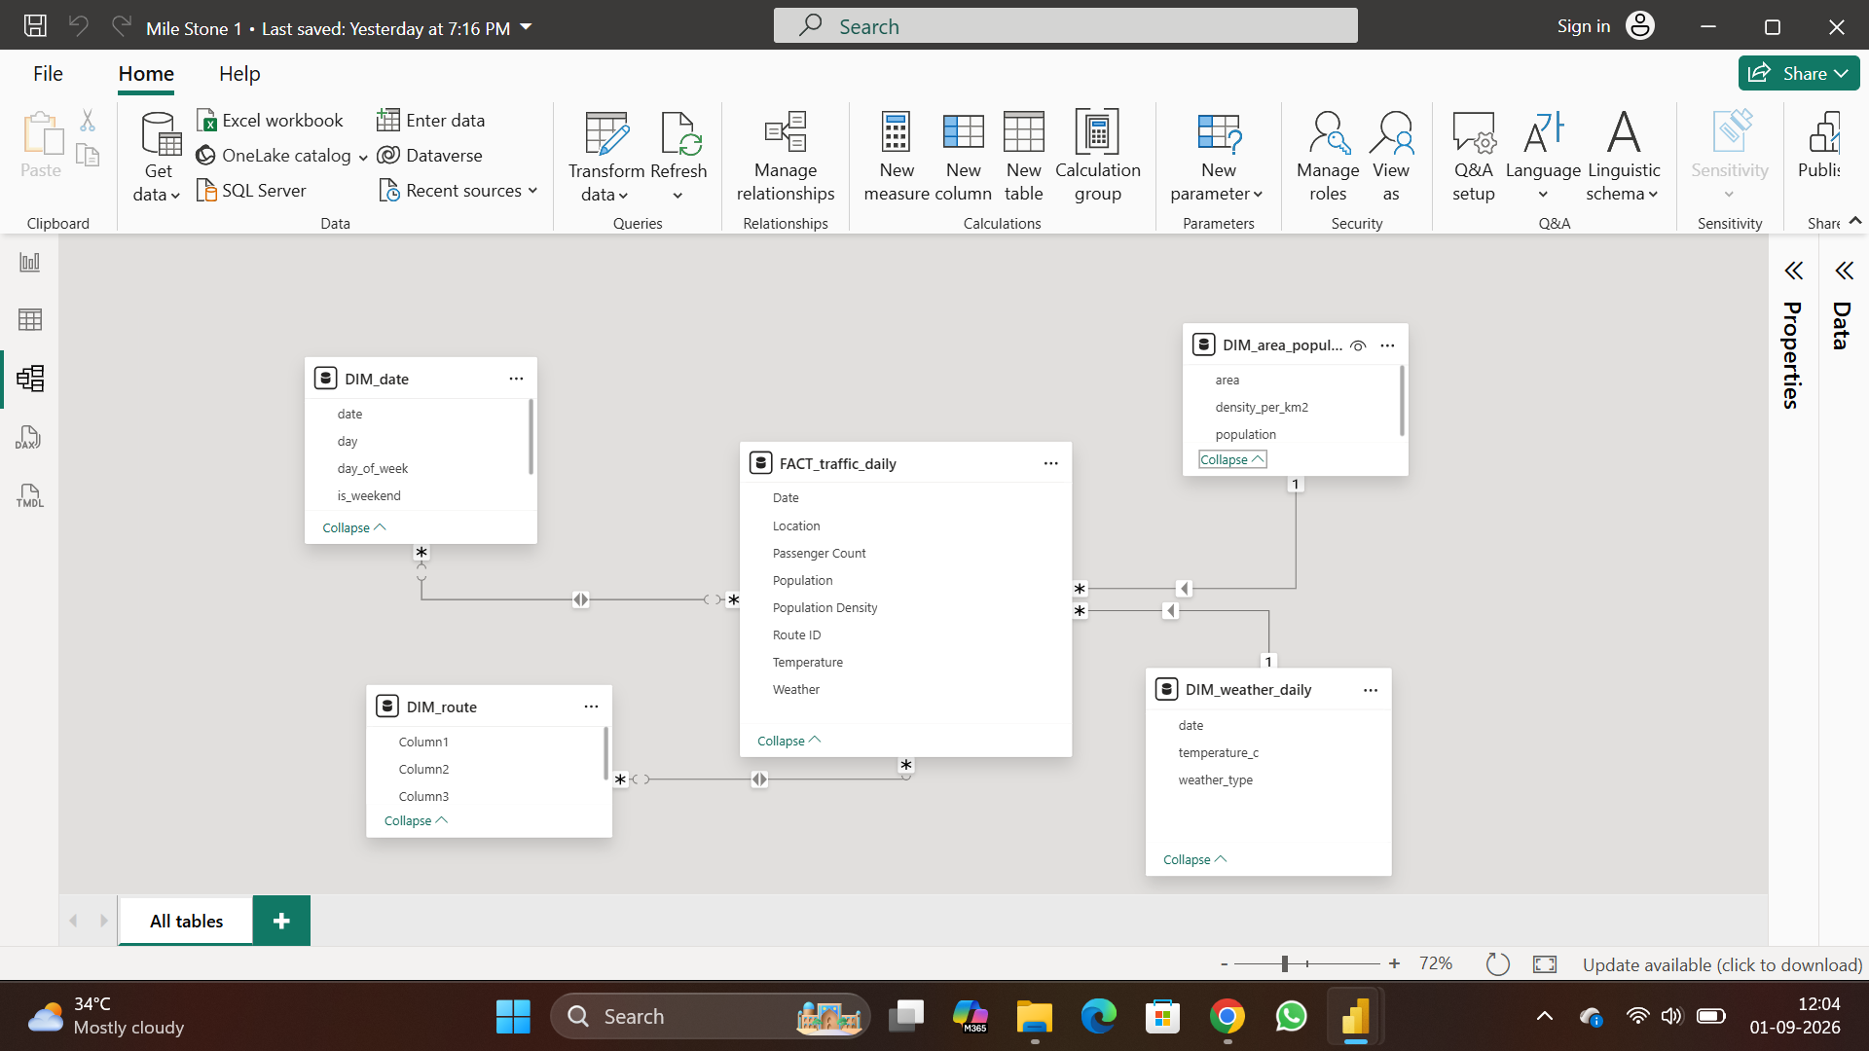
Figure 1. Power BI Model view: FACT_traffic_daily and its four dimension tables.
FACT_traffic_daily sits in the middle and every dimension joins it as the “one” side of a one-to-many relationship:
- DIM_date: joined on Date, so data can be sliced by day, month or weekday.
- DIM_weather_daily: joined on Date; supplies citywide temperature and weather type.
- DIM_route: joined on the route/location key; supplies direction and area.
- DIM_area_population: joined on the area/population fields; supplies reference population and density.

6.3 Data Transformation in Power BI (ETL)
- Extract: Get Data → Text/CSV for the weather, traffic-sensor, traffic-event and road-network files.
- Clean types and formats: correct data types, trimmed text and standardized timestamps.
- Change the grain: hourly sensor and weather rows were grouped to one row per day, turning 218,400 sensor rows and 21,840 weather rows into the 4,550-row daily fact table.
- Passenger Count: estimated by multiplying vehicle counts by average occupancy (car × 1.5, motorcycle × 1.3, bus × 25.0, truck × 1.2) and summing per route per day.
- Area mapping: road_network.csv was used to find the administrative district of each route.
- Population reference data: city-level population and density (BPS Statistics Indonesia) joined by area.
- Split into star schema: the daily dataset was split into the fact table plus four dimensions, dropping columns already used or out of scope.
- Load and relate: all five tables loaded and connected in Model view.
- Validate: duplicate and null checks on the fact table, with no issues found.

6.4 Data Cleaning – Columns Removed
Source | Columns removed and reason
traffic_sensor_data.csv | Vehicle-type counts were used to calculate Passenger Count and then dropped. Speed, occupancy and congestion were kept out of scope for later milestones. Direction moved to DIM_route; hour and timestamp were replaced by Date once the grain became daily.
weather_conditions.csv | station_id dropped after averaging 10 stations to one citywide daily value. Humidity, precipitation, wind, visibility, air quality, UV and pressure left for a later environmental enrichment.
road_network.csv | Road-engineering columns (length, lanes, capacity, surface, toll and so on) dropped because Milestone 1 only needed the district for area mapping.

6.5 Data Quality and Validation
Check | Result
Duplicate rows in FACT_traffic_daily | 0 found
Nulls in required fact columns | 0 – all fully populated
Nulls in road_network.csv | 0 across all 18 columns
Sample reproducibility | 500-row sample drawn from the 4,550-row table with a fixed random seed
Estimated field flagged | Passenger Count (derived from vehicle counts × occupancy factors)
Reference fields flagged | Population and Population Density (city-level BPS reference data)

6.6 Dashboard Output
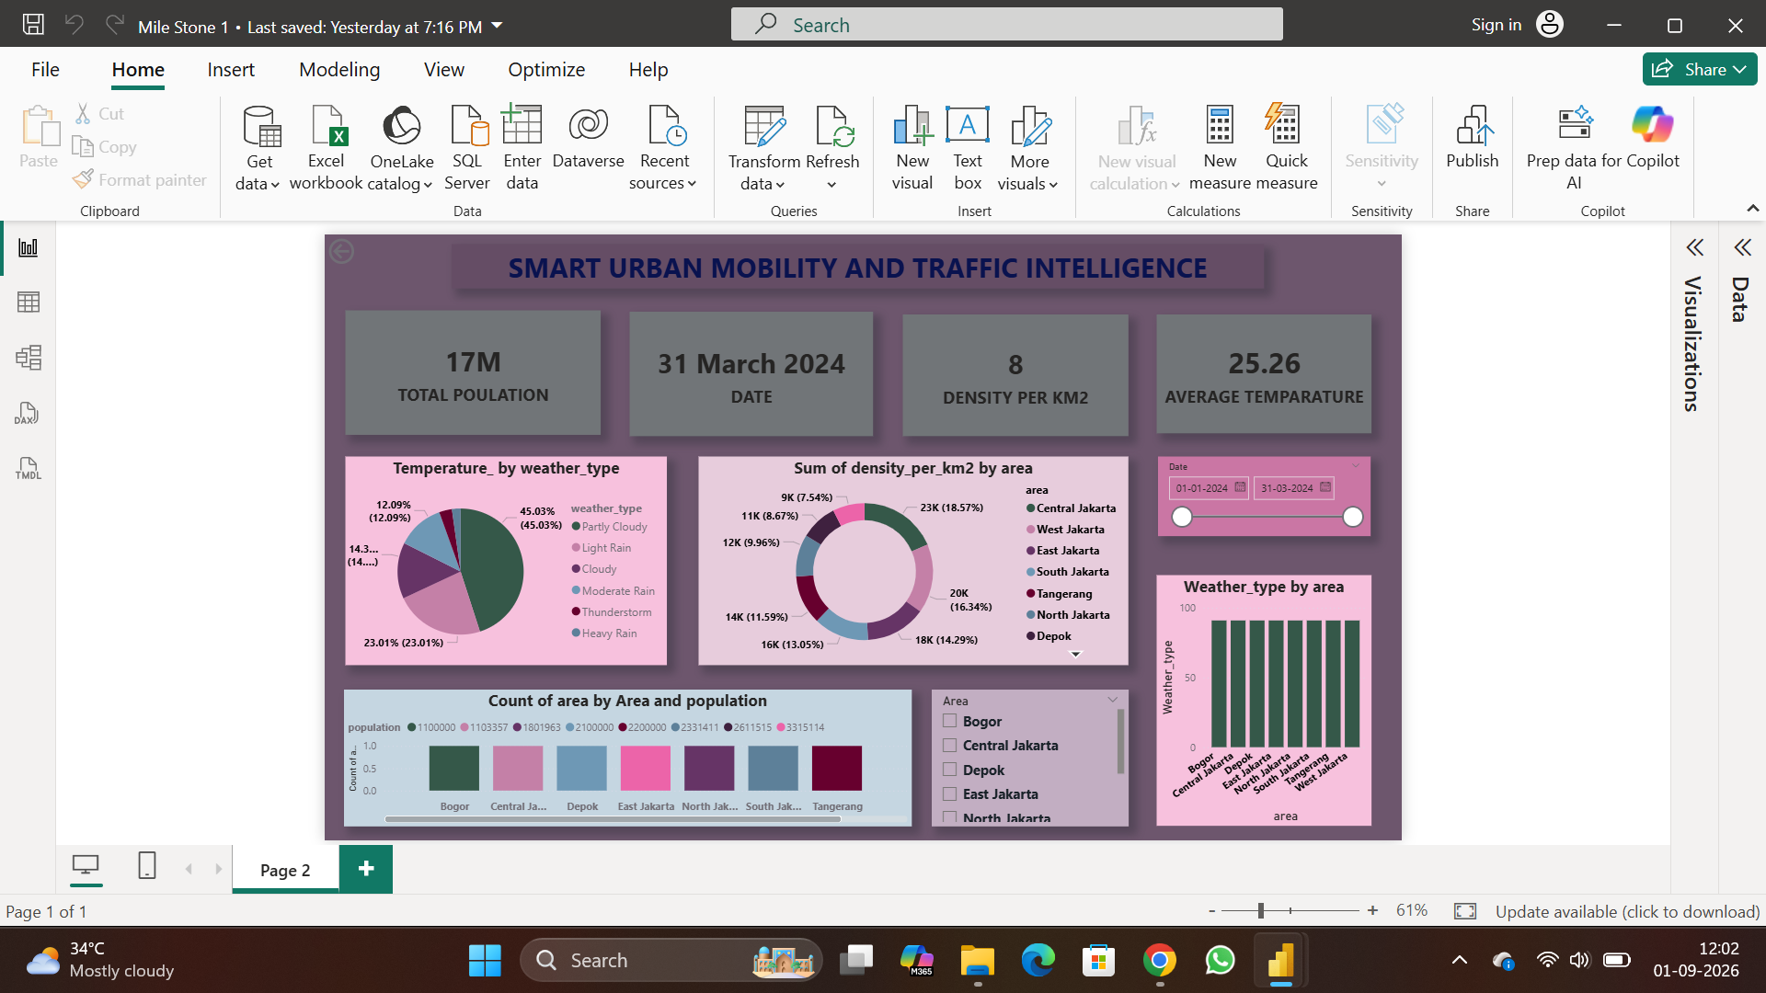
Figure 2. Milestone 1 dashboard: KPI cards, weather and population-density charts, date and area slicers.
KPI card | Value | Source
Total Population | 17M | Sum of Population across DIM_area_population
Date | 31 March 2024 | Latest date in DIM_date (end of reporting period)
Density per KM² | 8 | Count of areas in DIM_area_population
Average Temperature | 25.26 | Average of temperature_c over the selected period

- Temperature by weather_type (pie): Partly Cloudy is the largest slice (45.03%), followed by Heavy Rain (23.01%), then Light Rain, Cloudy, Moderate Rain and Thunderstorm.
- Sum of density_per_km2 by area (donut): Central Jakarta has the largest share (18.57%), followed by Tangerang (16.34%), West Jakarta (14.29%) and Bogor (13.05%), down to North Jakarta (7.54%).
- Count of area by Area and population (bubble): one marker per area, coloured by that area’s reference population value.
- Weather_type by area (bar): distribution of weather readings across the eight areas.
- Date and Area slicers: filter the whole page by date range (01-01-2024 to 31-03-2024) and by one or more areas.

6.7 Assumptions and Limitations
- Passenger Count is an estimate from vehicle-type counts, not a direct ridership measurement.
- Population and density are city-level reference figures applied to every route in an area; they are not corridor-precise.
- Weather values are citywide daily averages of 10 stations, not corridor-specific.
- traffic_events.csv and detailed road-engineering columns were collected but kept out of the model for later milestones.

Milestone 1 outcome
A validated four-source star-schema model (one fact, four dimensions) with clean data, documented assumptions and a first dashboard of KPIs, weather and population views.

7. Milestone 2 – Output Screenshots
Milestone 2 turned the Milestone 1 groundwork into a working analytical system: a structured Power BI data model and the first interactive dashboard report, “Smart Urban Mobility and Traffic Intelligence”.

7.1 Data Model Output
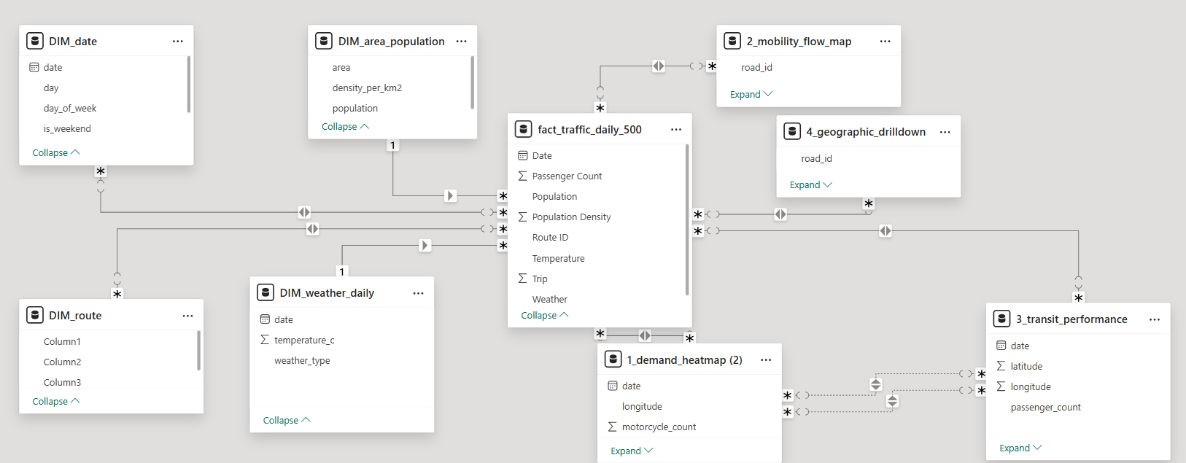
Figure 3. Milestone 2 Power BI data model view showing fact and dimension tables and their relationships.
The model has a central fact table, fact_traffic_daily_500 (Date, Passenger Count, Population, Population Density, Route ID, Temperature, Trip and Weather), four dimension tables and four visual-specific tables that feed the maps.
Table | Type | Role in the model
fact_traffic_daily_500 | Fact | Daily traffic and ridership metrics linked to every dimension and visual
DIM_date | Dimension | Calendar with day, day_of_week and is_weekend for time-based slicing
DIM_area_population | Dimension | Population and density per area, for normalizing demand
DIM_weather_daily | Dimension | Daily temperature and weather type; powers the Weather slicer
DIM_route | Dimension | Route reference attributes (column headers still to be finalized)
1_demand_heatmap | Visual data | date, longitude, motorcycle_count – Mobility Demand Heatmap
2_mobility_flow_map | Visual data | road_id – Mobility Flowmap by city
3_transit_performance | Visual data | date, latitude, longitude, passenger_count – reliability and disruption
4_geographic_drilldown | Visual data | road_id – City-to-Region drill-down map

The four dimensions join the fact table one-to-many with a single filter direction. The four visual-specific tables use many-to-many relationships on shared keys (road_id, date) so that the maps stay in sync with the same slicers. The numeric prefixes (1_ to 4_) order the tables like the visuals on the canvas.

7.2 Dashboard Output
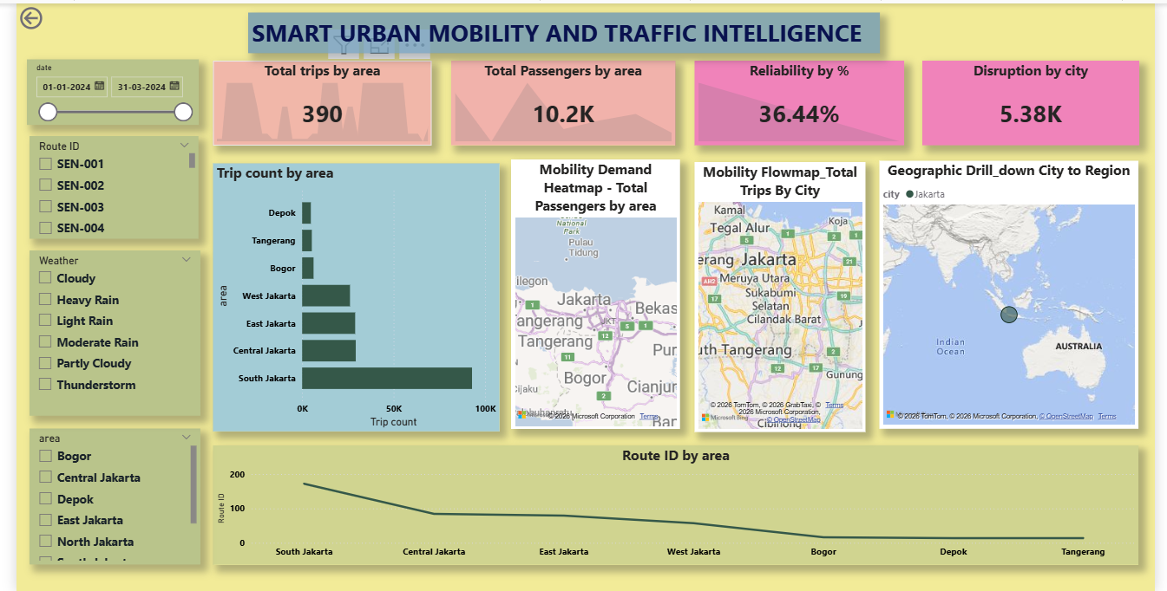
Figure 4. Milestone 2 dashboard: slicers, KPI cards, trip count by area, three maps and route trend line.

7.3 Slicers and KPI Cards
- Date slider: filters the page from 01-01-2024 to 31-03-2024.
- Route ID: multi-select list (SEN-001 to SEN-004).
- Weather: Cloudy, Heavy Rain, Light Rain, Moderate Rain, Partly Cloudy, Thunderstorm.
- Area: Bogor, Central, Depok, East, North, South Jakarta, Tangerang and West Jakarta.
KPI card | Value | Meaning
Total trips by area | 390 | Trips recorded across all areas in the selected range
Total Passengers by area | 10.2K | Passengers carried in the selected period
Reliability by % | 36.44% | Average service reliability
Disruption by city | 5.38K | Disruption events recorded across cities

7.4 Visual Explanation
- Trip count by area (bar): South Jakarta leads clearly, Central and East Jakarta follow at similar levels, then West Jakarta; Bogor, Tangerang and Depok are lowest. Demand is concentrated in core Jakarta.
- Mobility Demand Heatmap (map): total passengers by area plotted by longitude and latitude, showing which exact points generate the most demand.
- Mobility Flowmap – Total Trips by City (map): trips by city over neighborhoods such as Tegal Alur, Meruya Utara, Sukabumi Selatan and Cilandak Barat, for road-level planning.
- Geographic Drill-down: City to Region (map): a region-level view (currently Jakarta in Southeast Asia) that drills down to city and road level.
- Route ID by area (line): starts near 200 at South Jakarta, falls to roughly 50–75 across Central and East Jakarta and flattens near zero from Bogor to Tangerang, matching the bar chart.

7.5 Key Insights
- Mobility demand is highly concentrated in South, Central and East Jakarta; outer areas show little activity.
- Reliability of 36.44% suggests many trips face delay or disruption – a candidate for deeper analysis against weather.
- Disruption volume (5.38K) is large compared with trips (390), so the measure may count several events per trip or aggregate at a different grain; this should be checked against the DAX definitions.
- The model supports cross-filtering between all slicers and all visuals, including the maps.
- Added capacity would have the most impact if targeted first at South, Central and East Jakarta.

7.6 Limitations
- Only three months of data (Q1 2024), so seasonal and year-over-year patterns cannot be assessed.
- DIM_route has placeholder column headers (Column1–Column3) that need renaming.
- Many-to-many relationships need careful DAX to avoid ambiguous filtering.
- Population and density exist on both the fact table and DIM_area_population and should be kept in sync.

8. Milestone 3 – Dashboard Explanation
Milestone 3 focused on Demand Intelligence & Mobility Analytics. Instead of looking only at total traffic, the dashboard looks at why demand changes and how different mobility modes behave.

8.1 Main Analysis Areas
Area | Meaning | Dashboard use
Ride-Hailing Intelligence | Ride-hailing demand, surge and fare | Average Surge, Average Fare and demand comparisons
Cycling & Micromobility | Demand for cycling and related activity | Mode comparison and demand-level distribution
Modal Substitution | How demand is distributed between modes | Cycling vs Public Transit vs Ride-Hailing
Weather Sensitivity | How weather and temperature relate to demand | Weather demand chart and temperature–demand scatter plot
Demand Forecasting | Using historical demand to prepare for the future | Provides the historical base; forecasting is the next layer

8.2 Dashboard Output
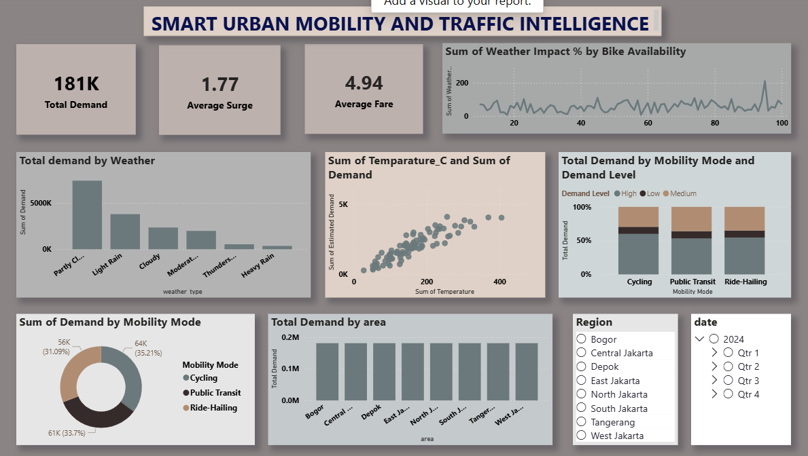
Figure 5. Milestone 3 Power BI dashboard: KPI cards, weather, temperature, mode and area analysis with filters.

8.3 KPI Cards
KPI | Value | Meaning
Total Demand | ≈181K | Total estimated demand in the current filters
Average Surge | 1.77 | Average ride-hailing surge value
Average Fare | 4.94 | Typical fare value

8.4 Weather and Temperature Analysis
- Total demand by Weather (column chart): compares demand across Partly Cloudy, Light Rain, Cloudy, Moderate Rain, Thunderstorm and Heavy Rain. Partly Cloudy has the tallest bar.
- Temperature vs demand (scatter): each point is a temperature–demand combination. The visible upward pattern suggests higher temperatures go with higher demand, but this is an observed relationship, not proof that temperature alone causes the change.
- Weather impact and bike availability (line): checks whether the weather-impact measure changes across bike-availability observations.

8.5 Mobility Mode and Ride-Hailing Analysis
- Demand Level by mode (100% stacked column): compares Low, Medium and High demand levels within Cycling, Public Transit and Ride-Hailing, showing composition rather than raw counts.
- Demand by Mobility Mode (donut): Cycling 35.21%, Public Transit 33.70% and Ride-Hailing 31.09% of total demand in the current filters.
- Ride-Hailing Intelligence: Average Surge and Average Fare give a simple view of pricing and demand pressure and can be compared with the other two modes.
- Modal substitution: here this means comparing how demand is spread between modes. It does not by itself prove that an individual passenger switched mode.

8.6 Area, Region and Date Analysis
The Total Demand by area column chart compares Bogor, Central Jakarta, Depok, East Jakarta, North Jakarta, South Jakarta, Tangerang and West Jakarta; the bars are broadly similar in height. A Region slicer restricts the analysis to one location, and a Date slicer selects the year and quarter (2024, Qtr 1 to Qtr 4).
Filter | Question it answers | Example
Region | Where is demand being studied? | Only South Jakarta
Date / Quarter | When is demand being studied? | 2024 Q3
Mobility Mode | Which transport mode is being studied? | Ride-Hailing

8.7 Analysis Flow and Findings
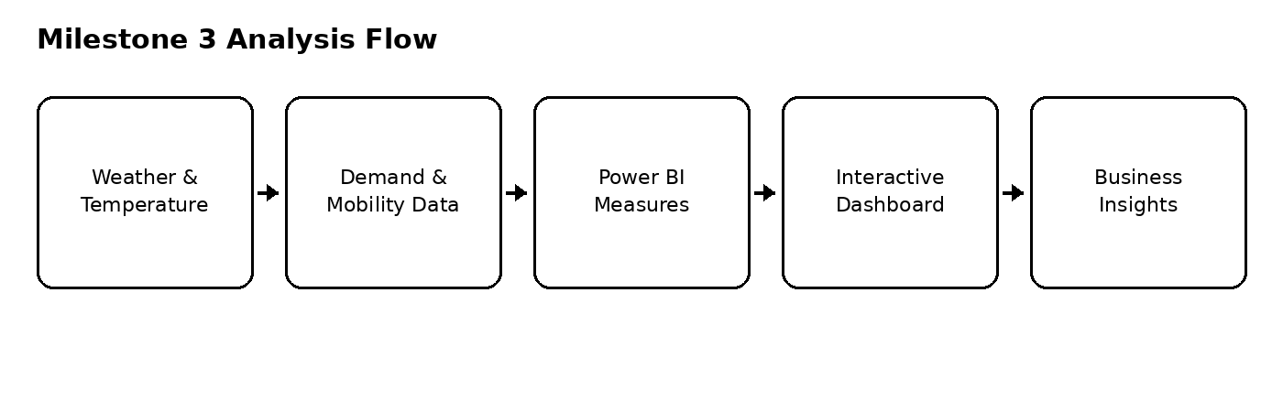
Figure 6. Milestone 3 analysis flow: from weather and mobility data to business insights.
A user can start with the overall demand KPI, then compare weather, temperature, mobility modes and areas, and finally use the Region and Date filters to investigate a specific situation.
- The dashboard reports 181K Total Demand, Average Surge 1.77 and Average Fare 4.94.
- Partly Cloudy has the tallest bar among the weather categories shown.
- The temperature–demand scatter shows a clear upward visual pattern.
- Cycling, Public Transit and Ride-Hailing each contribute a substantial share of demand.

Next analytical layer
The prepared demand history is the foundation for forecasting. A future version can add a line chart of Actual vs Forecast Demand by date with forecast error measures. These observations describe what is visible in the dashboard and should not be read as causal conclusions without further statistical testing.

9. Milestone 4 – Output Screenshots
Milestone 4 is the final stage. It turns the analysis into three interactive dashboard pages showing key indicators, area-wise and demographic-wise accessibility, transport-mode comparison, demand trends and a location map. The dataset covers trips, demand, fares, travel times, reliability scores and accessibility levels across ride-hailing, cycling, public transit, metro, bus and taxi services.
Dashboard page | What it shows
1. Mobility Access Overview | Access by area and demographic group using KPI cards, a donut chart, bar charts, a matrix table and slicers.
2. Transport Mode and Trips Overview | Modes compared by trips, reliability, travel time and demand using KPI cards, bar charts, a pie chart and a line chart.
3. Demand by Date and Location Map | Demand over time and where each transport mode operates, using line charts and a map.

9.1 Dashboard 1 – Mobility Access Overview
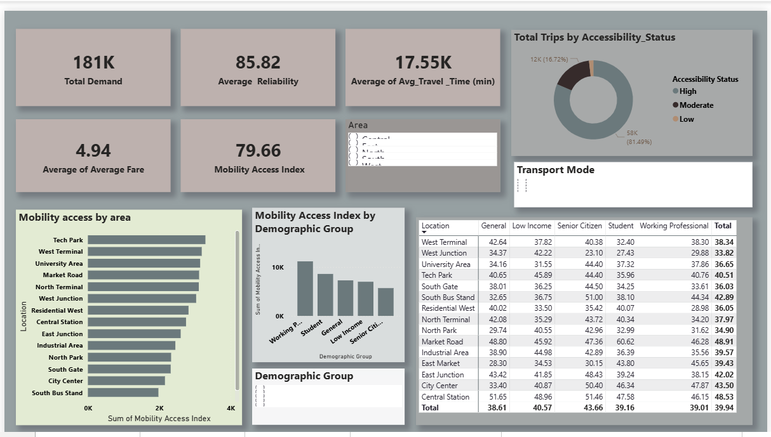
Figure 7. Milestone 4, Dashboard 1: KPI cards, accessibility status, area-wise and demographic-wise mobility access.
- KPI cards: Total Demand 181K; Average Reliability 85.82; Average of Avg_Travel_Time (min) 17.55K (aggregated travel-time value); Average Fare 4.94; Mobility Access Index 79.66.
- Donut – Total Trips by Accessibility_Status: High accessibility has about 58K trips (81.49%), the largest part. Moderate is the dark slice and Low is very small, so most trips happen in well-connected areas.
- Slicers: Area (Central, East, North, South, West) filters every chart. Transport Mode and Demographic Group (General, Low Income, Senior Citizen, Student, Working Professional) filter by mode or group.
- Bar – Mobility access by area: locations ranked by Mobility Access Index. Tech Park, West Terminal and University Area are highest; City Center and South Bus Stand are lowest.
- Column – Index by Demographic Group: Working Professional is highest, followed by Student, General and Low Income; Senior Citizen is lowest.
- Matrix – Location by Demographic Group: average index per location and group, overall total 39.94. Market Road (48.91) and Central Station (48.53) are high; West Junction (33.82) and North Park (34.90) are low.

9.2 Dashboard 2 – Transport Mode and Trips Overview
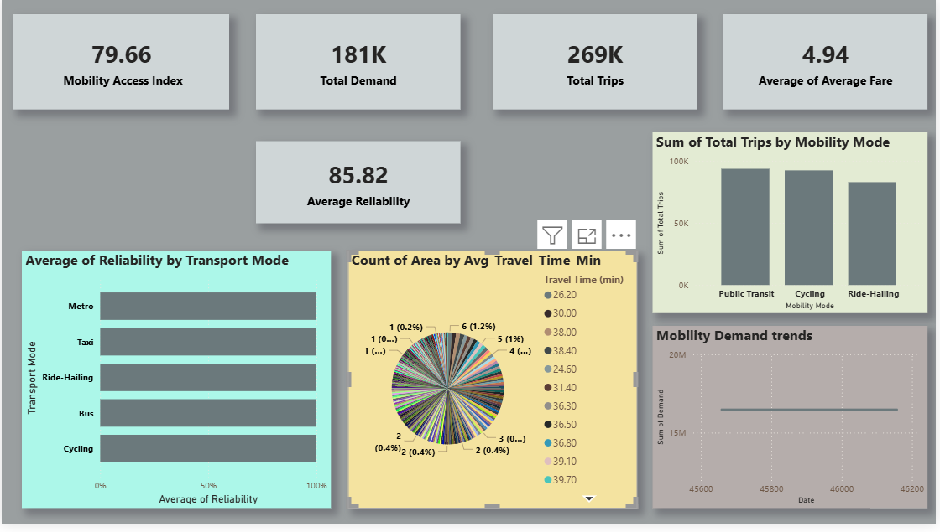
Figure 8. Milestone 4, Dashboard 2: reliability by mode, total trips by mode, travel-time distribution and demand trend.
- KPI cards: Mobility Access Index 79.66, Total Demand 181K, Total Trips 269K, Average Fare 4.94 and Average Reliability 85.82.
- Bar – Average Reliability by Transport Mode: Metro, Taxi, Ride-Hailing, Bus and Cycling all have long, almost equal bars, so every mode is highly reliable.
- Column – Total Trips by Mobility Mode: Public Transit has the most trips, Cycling is almost the same and Ride-Hailing is slightly lower.
- Pie – Count of Area by Avg_Travel_Time_Min: counts how often each average travel-time value appears across areas.
- Line – Mobility Demand Trends: the sum of demand over time is almost flat, so demand stays steady.

9.3 Dashboard 3 – Demand by Date and Location Map
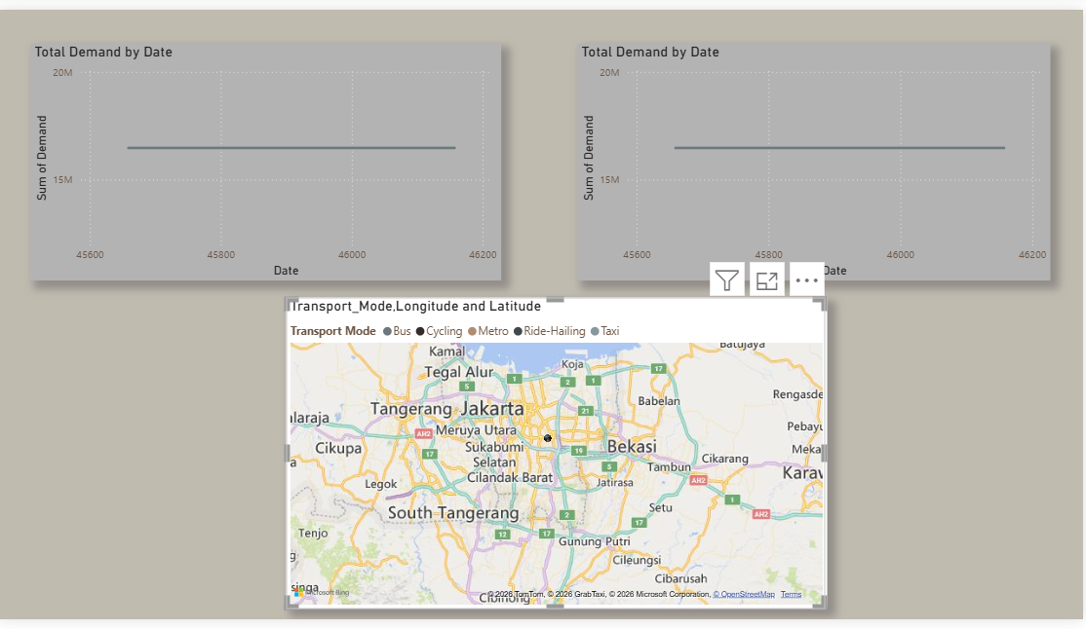
Figure 9. Milestone 4, Dashboard 3: total demand by date and transport-mode location map.
- Line charts – Total Demand by Date: two charts plot demand (about 15M to 20M) against date. Both lines are flat, showing stable demand. Two charts allow different filters or periods to be compared.
- Map – Transport Mode by Longitude and Latitude: shows where services are, coloured by mode (Bus, Cycling, Metro, Ride-Hailing, Taxi). It covers the Jakarta region (Tangerang, Bekasi and South Tangerang) with points grouped in the central part of the city, which shows which areas have transport coverage and which do not.

9.4 Key Insights
- Most trips take place in areas that already have high accessibility, so the few Low and Moderate areas need attention.
- Low Income and Senior Citizen groups have lower access than Working Professionals and Students.
- All transport modes are highly reliable, and Public Transit and Cycling carry the most trips.
- Demand is stable over time, which makes planning and forecasting easier.

9.5 Points to Improve Before Final Submission
- The Transport Mode and Demographic Group slicers look empty in the screenshot; check their fields.
- The travel-time pie chart has too many small slices. A histogram or grouped bar of travel-time ranges (for example 0–20 and 20–40 minutes) would be clearer.
- The demand-trend date axis shows serial numbers (45600 to 46200); format the field as a proper date.

10. Conclusion
The project converted raw urban mobility data into clear, interactive dashboards. Across four milestones it moved from data collection and star-schema modeling, through geospatial analysis, weather sensitivity, modal comparison and ride-hailing indicators, to a final dashboard that summarizes the whole mobility system.
The final results show a good overall Mobility Access Index of 79.66, high reliability (85.82) across all transport modes and steady demand over time. Public Transit and Cycling carry the most trips. However, some areas and groups, especially Low Income and Senior Citizen users and locations with lower index values, still have weaker access. These findings can help city planners improve services, add routes and make transport fairer for everyone.

Future Scope
- Add real-time data to the pipeline.
- Extend weather-impact analysis with the remaining weather attributes (humidity, precipitation, wind, air quality).
- Add machine-learning-based demand forecasting for more accurate planning.
- Bring in the incident data (traffic_events.csv) as a separate fact table.

Final project statement
The project bridges raw mobility data and business intelligence by structuring the data, defining reusable measures and presenting results through interactive, decision-oriented dashboards.

11. References
1. Microsoft. Power BI Documentation. https://learn.microsoft.com/power-bi/
2. Microsoft. DAX Function Reference. https://learn.microsoft.com/dax/
3. Microsoft. Microsoft Excel Support. https://support.microsoft.com/excel
4. BPS Statistics Indonesia – population and population-density reference figures for Jakarta and satellite cities (mid-2023/2024 estimates).
5. Urban mobility dataset (traffic, trips, demand, fare, reliability, travel time and accessibility) used in Milestones 1 to 4 of this project.
6. Infosys Springboard Internship Program – course material and guidelines provided for Milestones 1 to 4.

Appendix – Screenshot Index
Figure | Page | Purpose
Figure 1 | Milestone 1 – Model view | Star-schema relationships
Figure 2 | Milestone 1 – Dashboard | KPIs, weather and population views
Figure 3 | Milestone 2 – Model view | Fact, dimension and visual tables
Figure 4 | Milestone 2 – Dashboard | KPIs, area analysis and three maps
Figure 5 | Milestone 3 – Dashboard | Weather, temperature, mode and area analysis
Figure 6 | Milestone 3 – Analysis flow | From data to business insights
Figure 7 | Milestone 4 – Dashboard 1 | Mobility Access Overview
Figure 8 | Milestone 4 – Dashboard 2 | Transport Mode and Trips Overview
Figure 9 | Milestone 4 – Dashboard 3 | Demand by Date and Location Map

