UNEARTHING THE ENVIRONMENTAL

IMPACT OF HUMAN ACTIVITY

A GLOBAL CO2 EMMISION ANALYSIS

INTRODUCTION:

Carbon dioxide (CO2) is released into Earth’s atmosphere mostly by the burning of carbon-containing fuels and the decay of wood and other plant matter. Under all conditions found naturally on Earth, CO2 is an invisible, odourless gas. It is removed from the atmosphere mostly by plants, which extract carbon from CO2 to build their tissues, and by the oceans, in which CO2 dissolves.

Because CO2 is opaque to infrared radiation (the electromagnetic waves emitted by warm objects) in the atmosphere, it acts as a blanket to slow the loss of heat from Earth into space. Although other gases are also causing Earth’s climate to warm, CO2 alone is responsible for about three-fourths of global warming.

The amount of CO2 in the atmosphere has increased greatly since human beings began burning large amounts of coal and petroleum in the nineteenth century. In more recent times, this source of CO2 emissions has increased rapidly, while destruction of forests has also become a major source of CO2. Atmospheric concentrations of several other gases, including methane (CH4) and nitrous oxide (N2O), have also been increased recently by human activities and are contributing to greenhouse warming of the planet.

PROBLEM DEFINITION & DESIGN THINKING

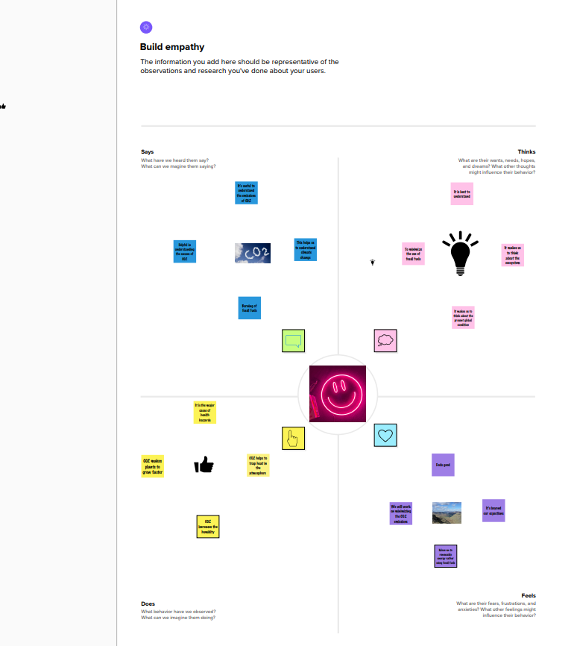

Brainstorming map

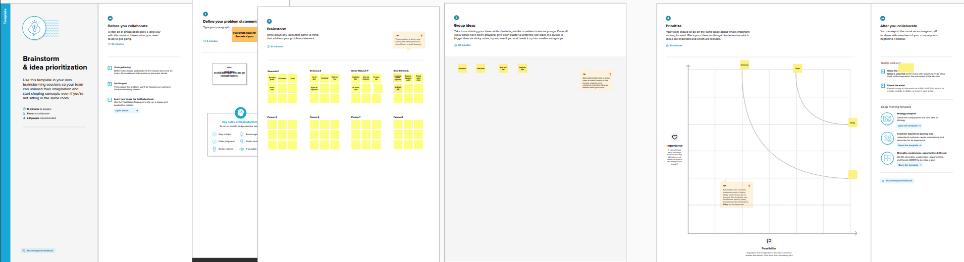

RESULT

DASHBOARD

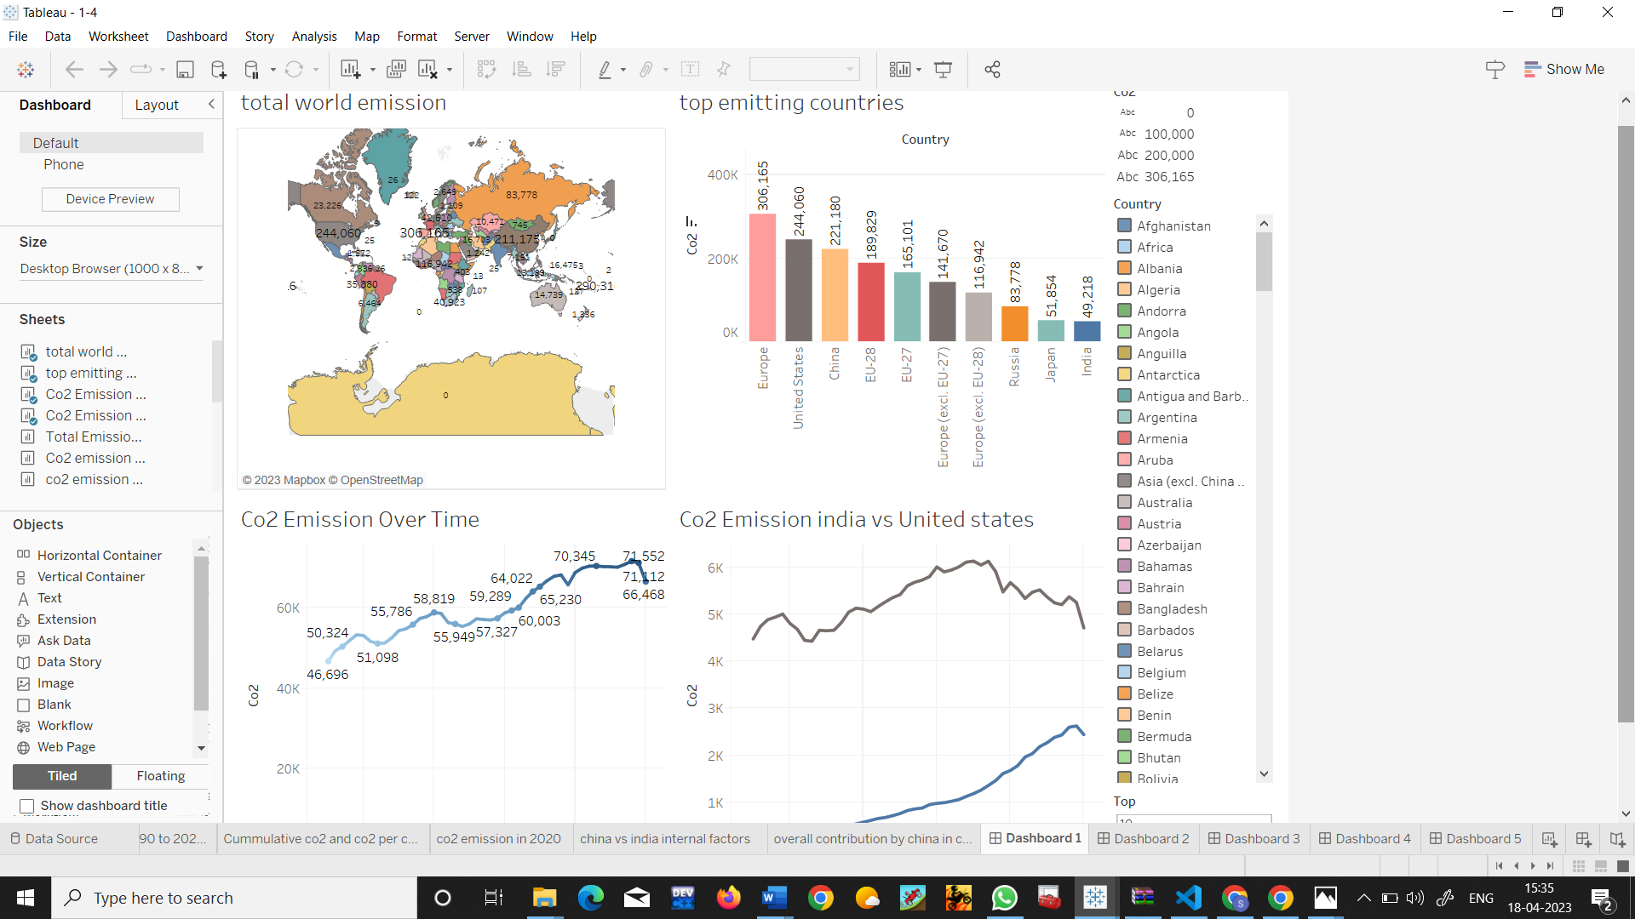

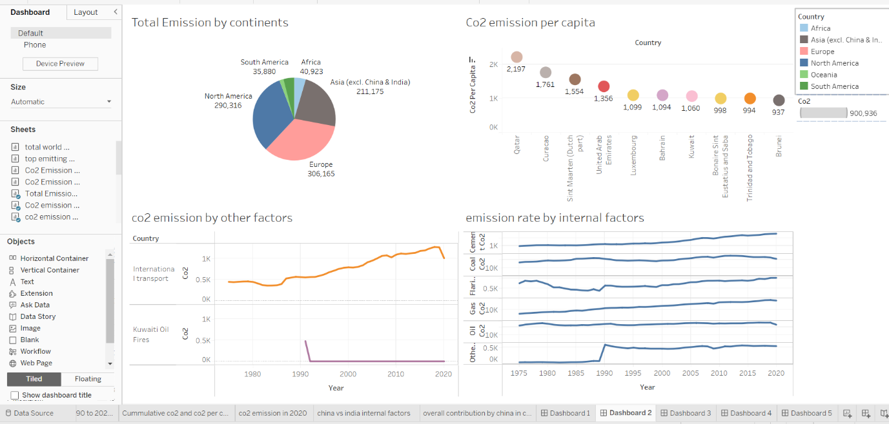

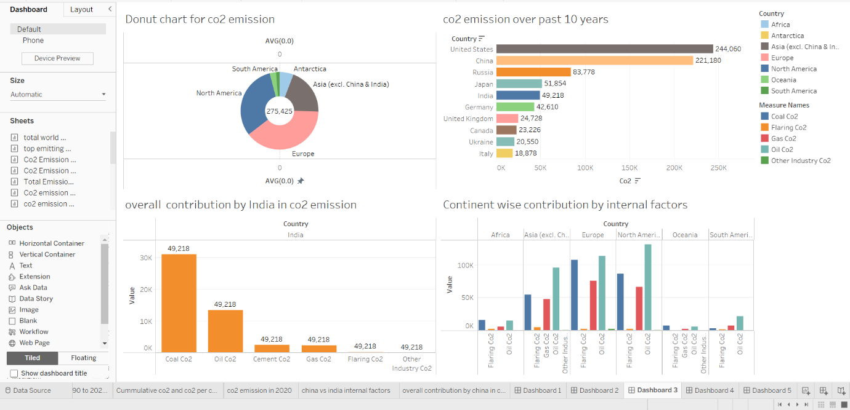

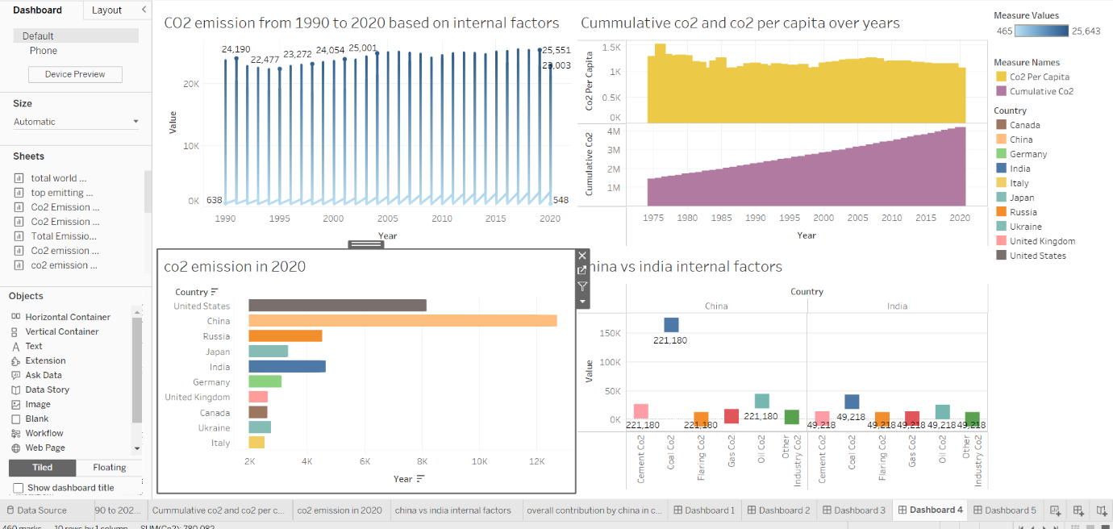

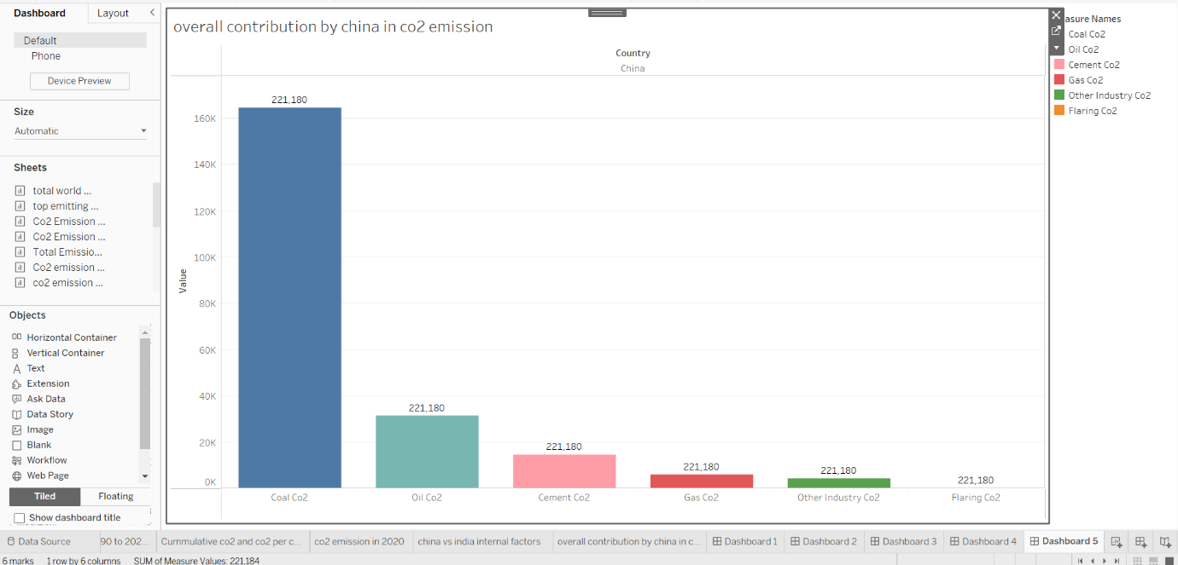

STORY

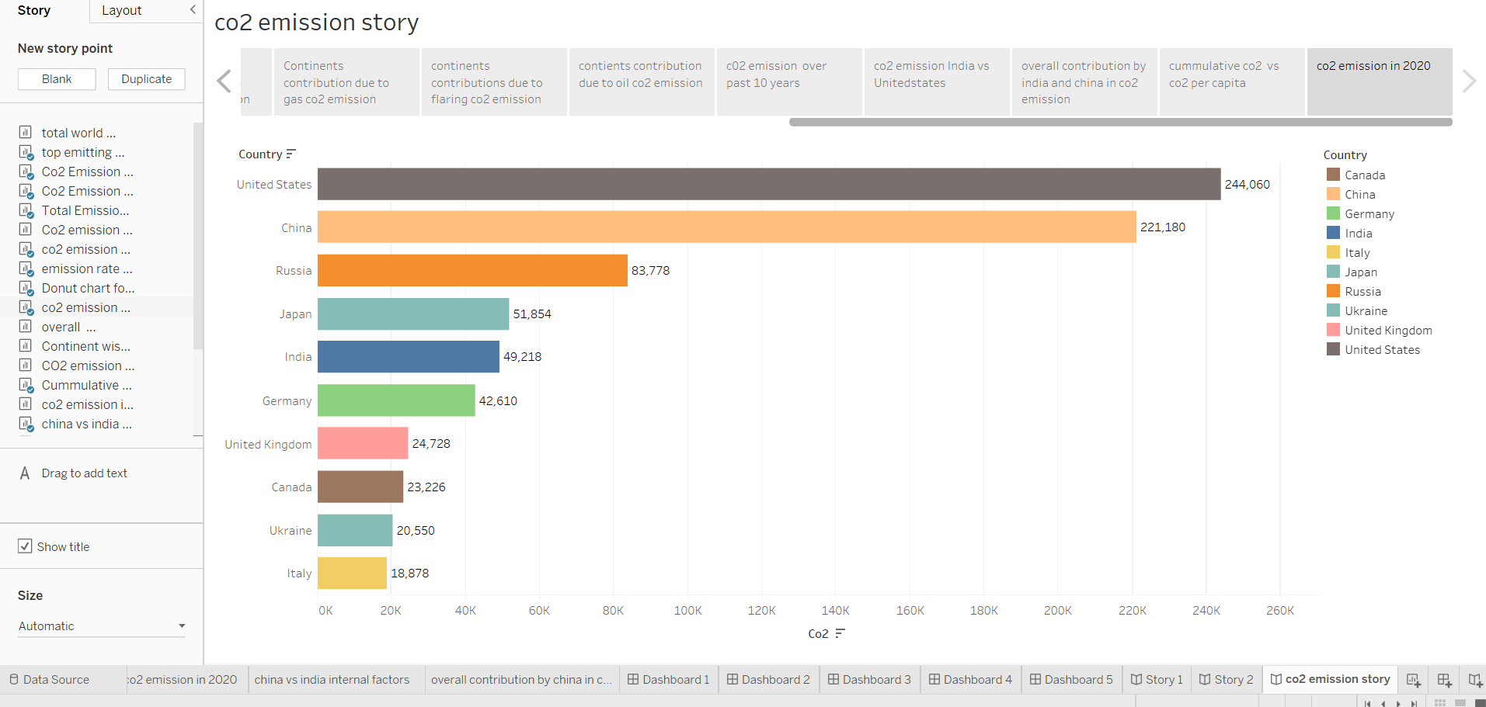

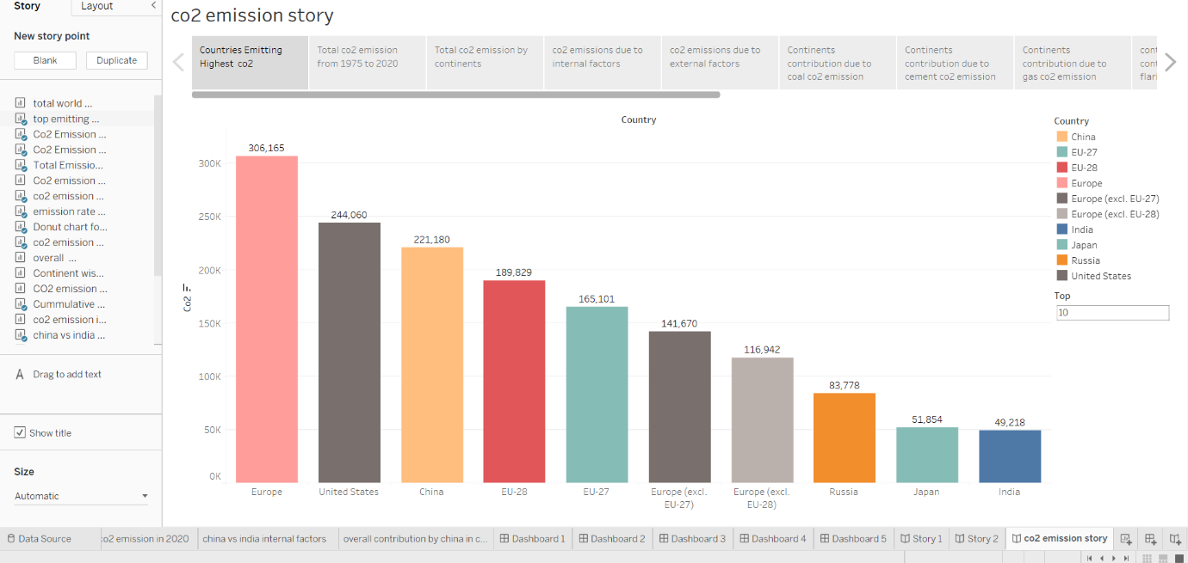

ADVANTAGES & DISADVANTAGES

CO2 plays various roles in the human body including regulation of blood pH, respiratory drive, and affinity of hemoglobin for oxygen (O2). Fluctuations in CO2 levels are highly regulated and can cause disturbances in the human body if normal levels are not maintained.

Our carbon footprint has a negative impact on the environment in multiple ways: It is the main cause of human-induced climate change, it contributes to urban air pollution, it leads to toxic acid rain, it adds to coastal and ocean The production of CO2-based fuels and chemicals is energy-intensive and requires large amounts of hydrogen. The carbon in CO2 enables the conversion of hydrogen into a fuel that is easier to handle and use, for example as an aviation fuel. CO2 can also replace fossil fuels as a raw material in and polymers.acidification, and it worsens the melting of glaciers and polar ice.

APPLICATIONS

The production of CO2-based fuels and chemicals is energy-intensive and requires large amounts of hydrogen. The carbon in CO2 enables the conversion of hydrogen into a fuel that is easier to handle and use, for example as an aviation fuel. CO2 can also replace fossil fuels as a raw material in chemicals and polymers.

CONCLUSION

The rising level of atmospheric CO2 could be the one global natural resource that is progressively increasing food production and total biological output, in a world of otherwise diminishing natural resources of land, water, energy, minerals, and fertilizer.

Nevertheless, the conclusion is that natural systems around the world are being affected by regional climate changes, particularly temperature increases, and that these temperature increases are very likely to be the result of anthropogenic emissions of greenhouse gases.

FUTURE SCOPE

Global CO2 emissions declined by 5.8% in 2020, or almost 2 Gt CO2 – the largest ever decline and almost five times greater than the 2009 decline that followed the global financial crisis. CO2 emissions fell further than energy demand in 2020 owing to the pandemic hitting demand for oil and coal harder than other energy sources while renewables increased.

The carbon (and oxygen) in CO2 can be used as an alternative to fossil fuels in the production of chemicals, including plastics, fibres and synthetic rubber. As with CO2-derived fuels, converting CO2 to methanol and methane is the most technologically mature pathway.