IMPORT DATA USING TRANSFORM MAPS (Spreadsheet)
A Project Report Submitted To
BHARATHIDASAN UNIVERSITY, TRICHIRAPPALLI
In Partial Fulfillment of the Requirements for the Award of Degree of
BACHELOR OF COMPUTER APPLICATIONS
Submitted by
NAME: REG NO:
M.SIVA 24051790500111002

Under the Guidance of
Mrs. S AKILA, M.Sc., B.Ed.,
(Assistant Professor, Department of Computer Applications)



UG GRADUATE DEPARTMENT OF COMPUTER APPLICATIONS
IMAYAM ARTS AND SCIENCE COLLEGE,
KANNANUR – 621206, THURAIYUR.
SEPTEMBER – 2026

Import Data using Transform Maps (Spreadsheet)
Description:

This micro project focuses on importing structured data from an external spreadsheet into the ServiceNow platform using Import Sets and Transform Maps. The project simulates a real-world scenario where bulk employee data is received in Excel format and must be migrated into ServiceNow efficiently and accurately. The spreadsheet data is first loaded into an Import Set table, which serves as a staging area, and a Transform Map is then configured to map source fields to the appropriate target table fields. Upon executing the transformation, records are created in the target table and validated to ensure data integrity. This project helps beginners understand the end-to-end data import process in ServiceNow, including data loading, field mapping, transformation execution, and result verification.

Step by Step process:

Phase 1: Prepare the sheets

- Open New Google Spreadsheet
- Create New Google Spreadsheet with sample data as shown below
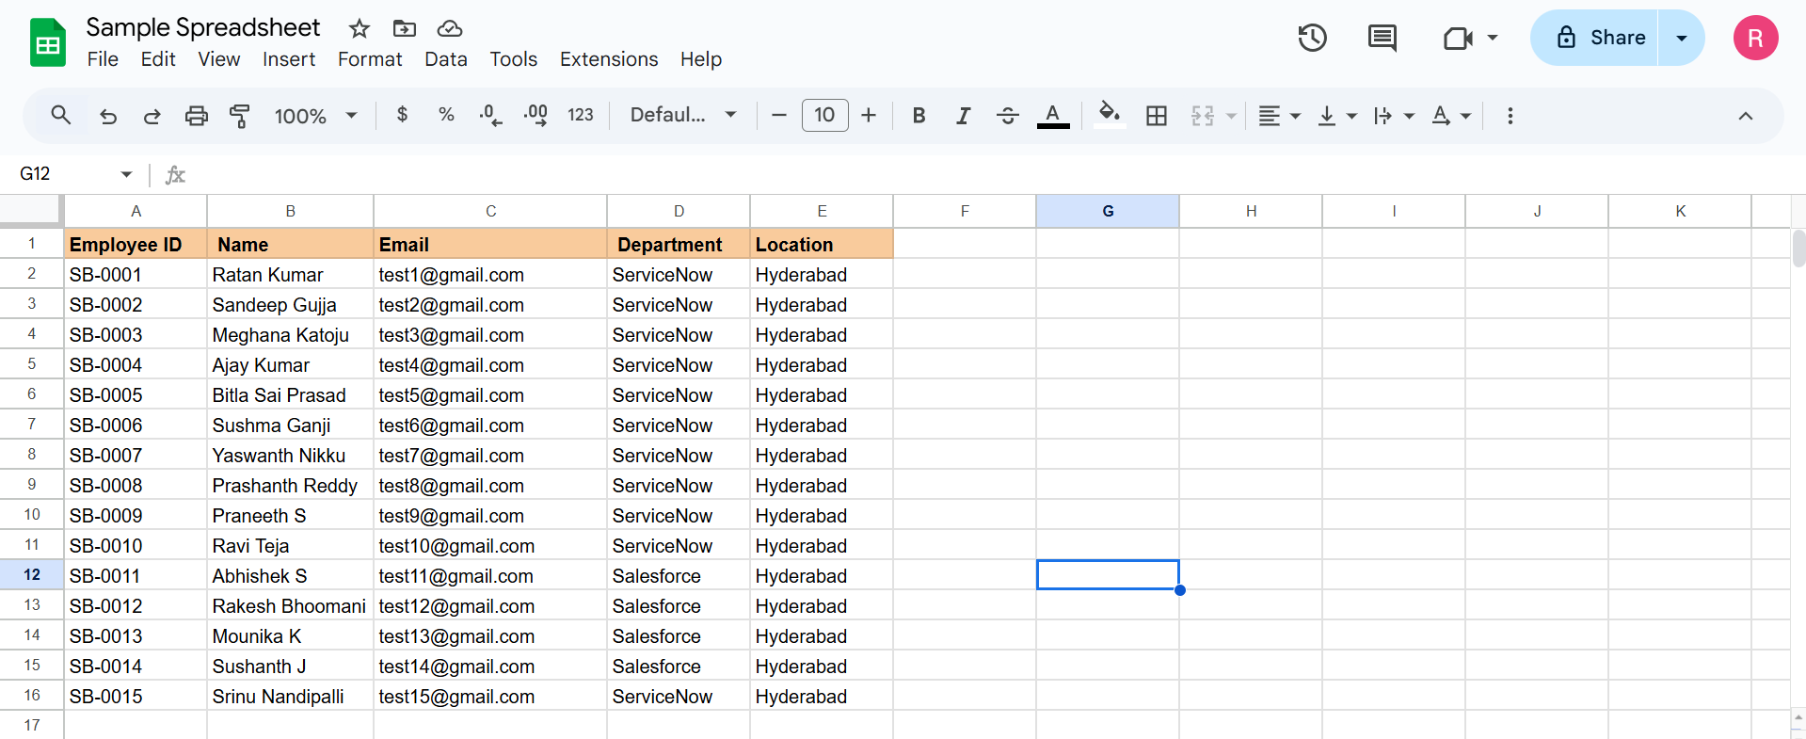

- Download the spreadsheet as Sample Spreadsheet.xlsx format.
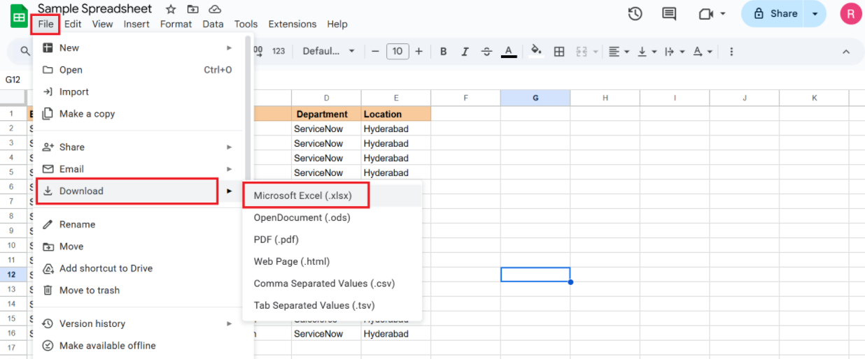

Phase 2: Create new Custom table
Navigation:
- Tables > Create New
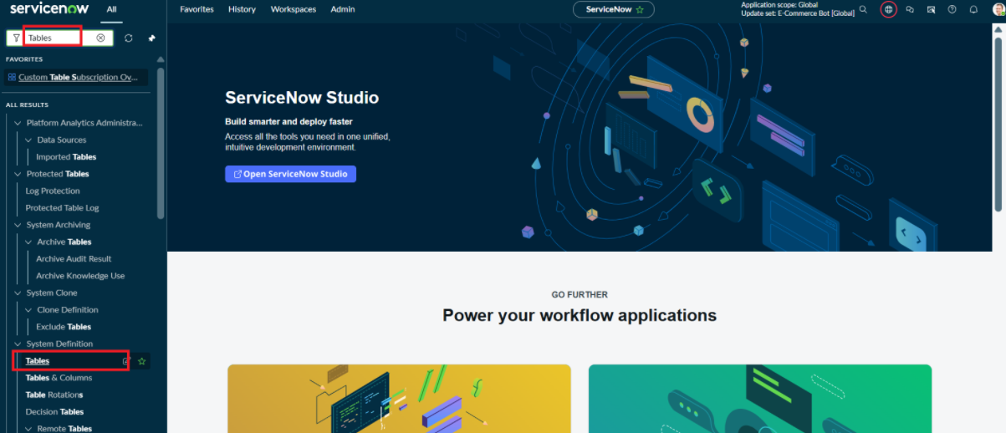
- Label: Employee Test
- Name: u_employee_test
- After creating and saving the Employee Test table, scroll down to the bottom of the table form.
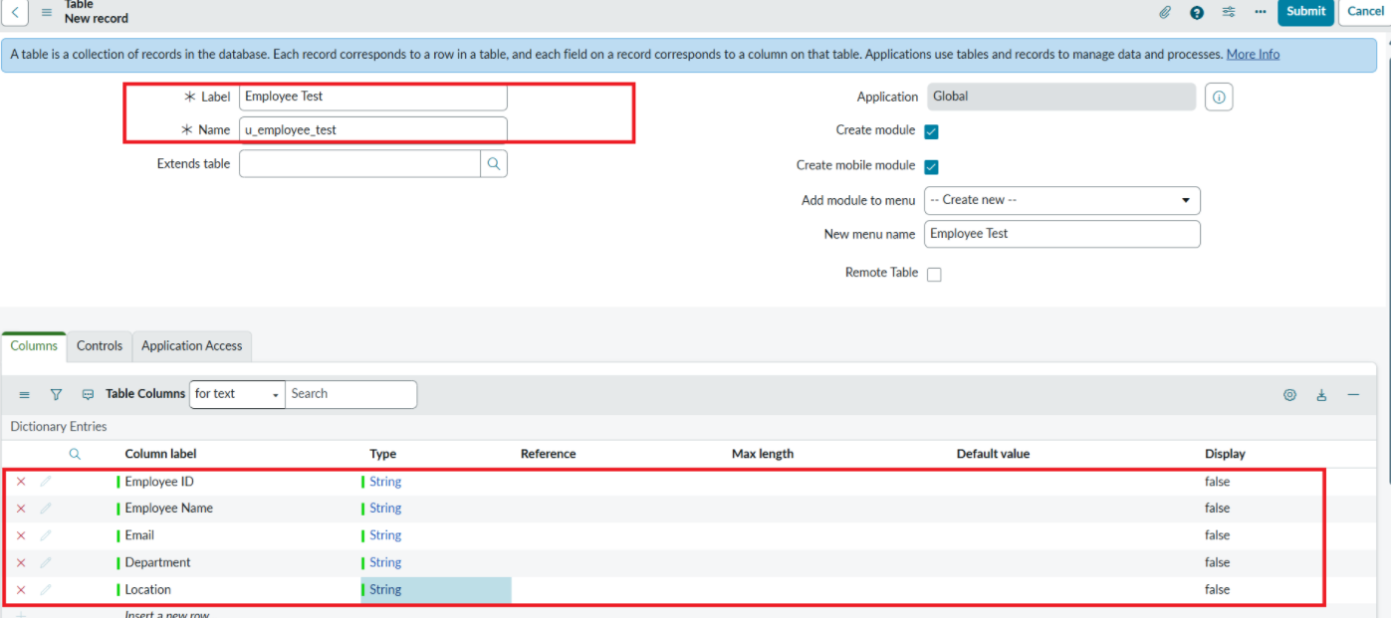
- Click Show Form to open the table form.
- On the form, locate the Form Context Menu / Additional Actions option on the left side of the form header.
- Click the Form Context Menu / Additional Actions icon.
- Click configure , select Form Layout.
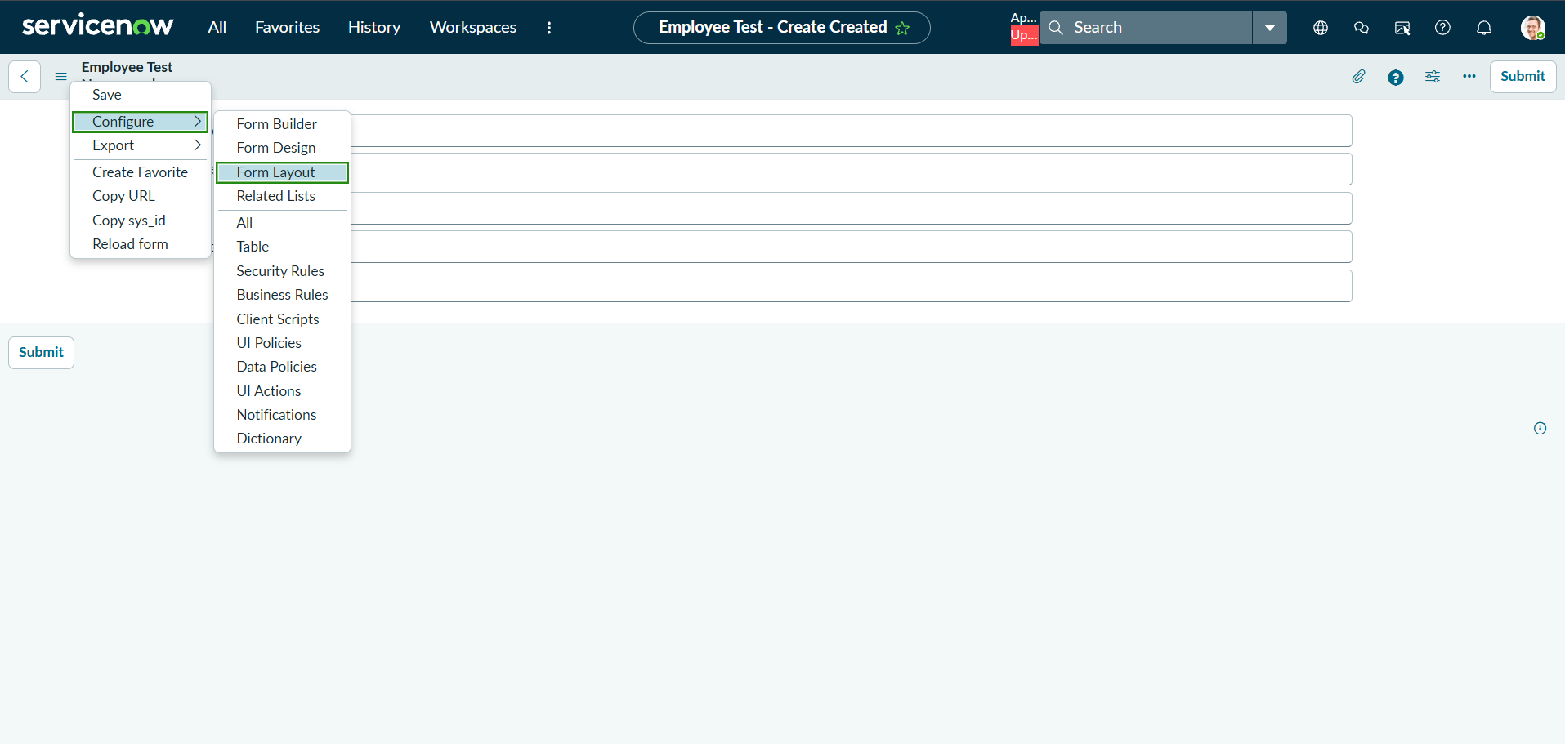
- The Form Layout page will open, where you can configure the fields displayed on the form
- After opening Form Layout, click New to create a new field.
- Enter the field details:
- Column Label: Employee ID
- Type: String
- Click Add to create the field.

- Repeat the same steps to create the following fields:
  - Employee Name – Type: String
  - Email – Type: String
  - Department – Type: String
  - Location – Type: String
- After creating all the required fields, click Save.
- Verify that the newly created fields are displayed on the Employee Test form.
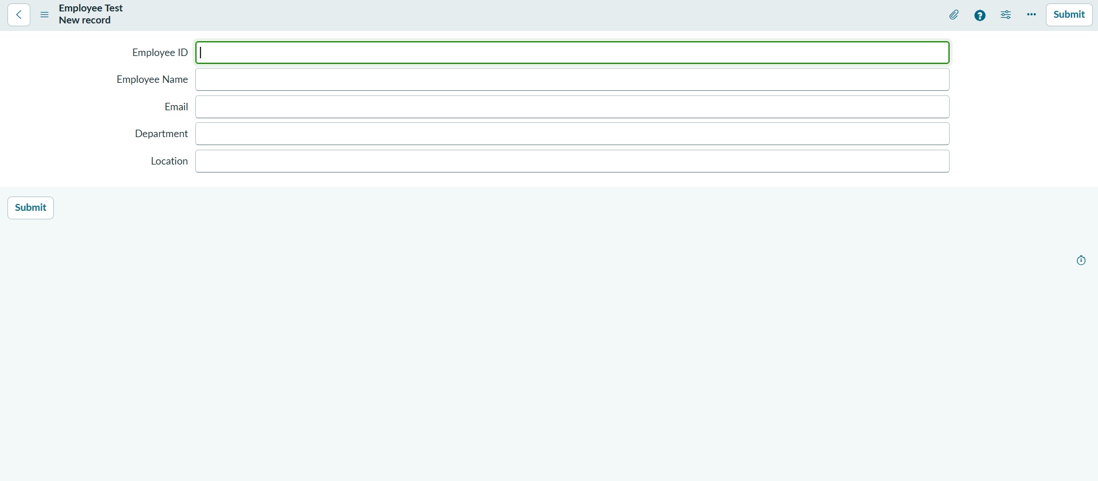

Click on Submit or Save.

Phase 3: Import Set Table
Navigation:
In Application Navigator → Load Data
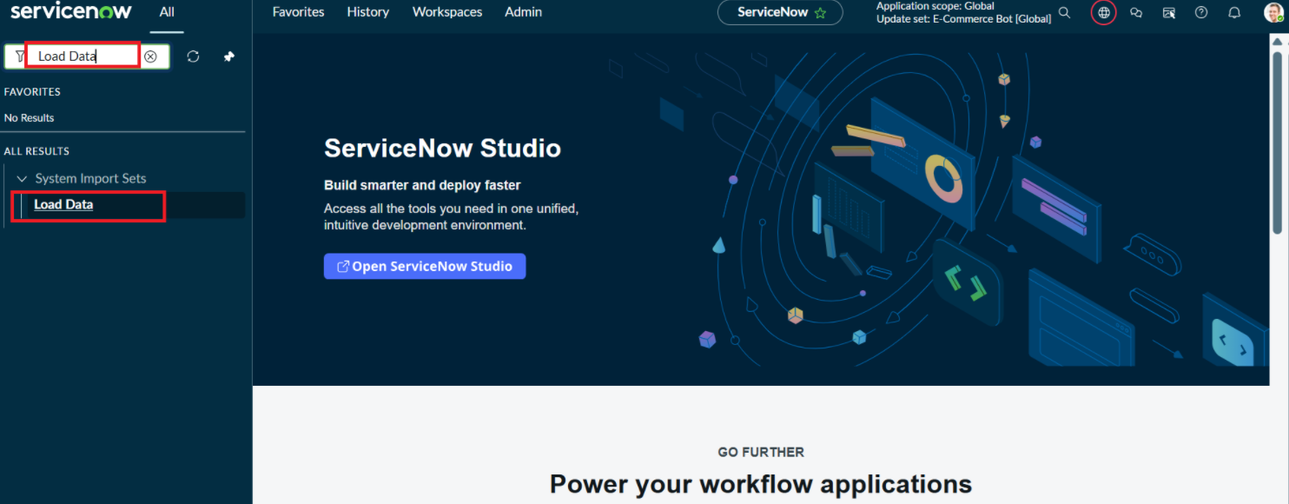
Click on Load Data and create an import table
Fill details as shown below
- Label: Employee Import
- Name: u_employee_import (auto populated)
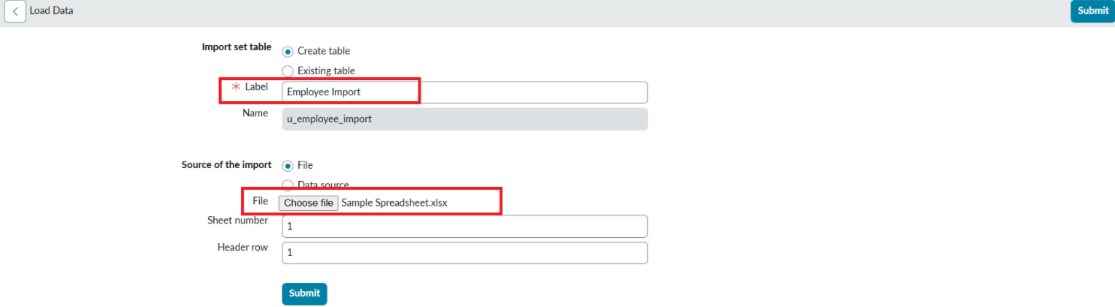

- Click on Submit
Once we click on Submit, we can see the success message as shown below.

Also we need to make sure to click on Create Transform Map.

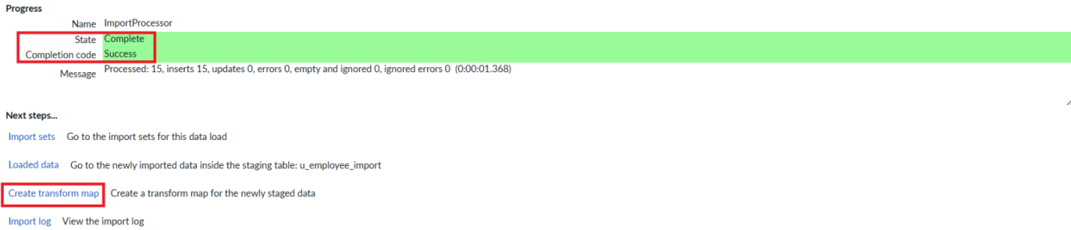

Phase 4: Create Transform Map
In this phase we need to create the Transform Map by clicking on the Create Transform Map button as shown in above screenshot.

Give inputs as shown below.
Name: Sample Spreadsheet Import
Source Table: Employee Import is auto-populated
Target Table: Employee Test - as we created earlier
Click on Auto Map Matching fields.

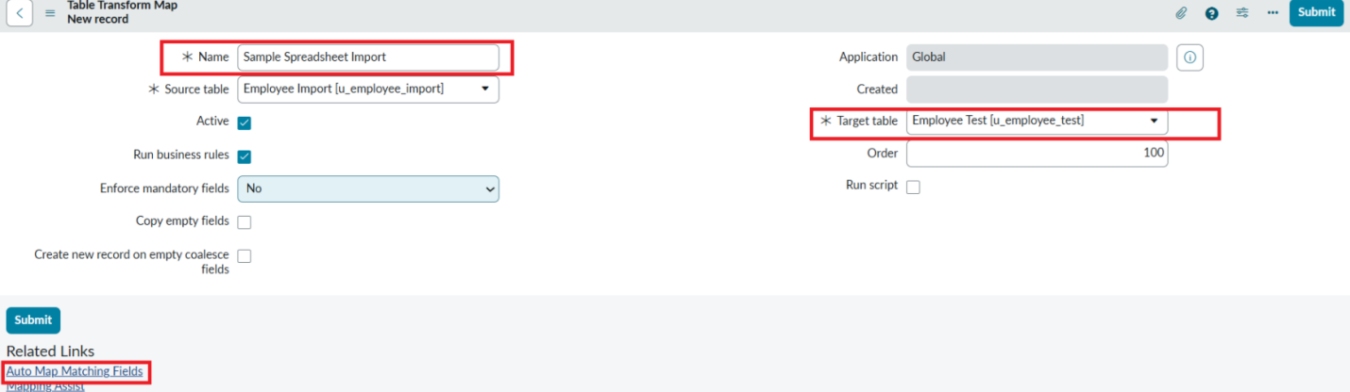

Now click on Mapping Assist and map the fields with Source & Target Table
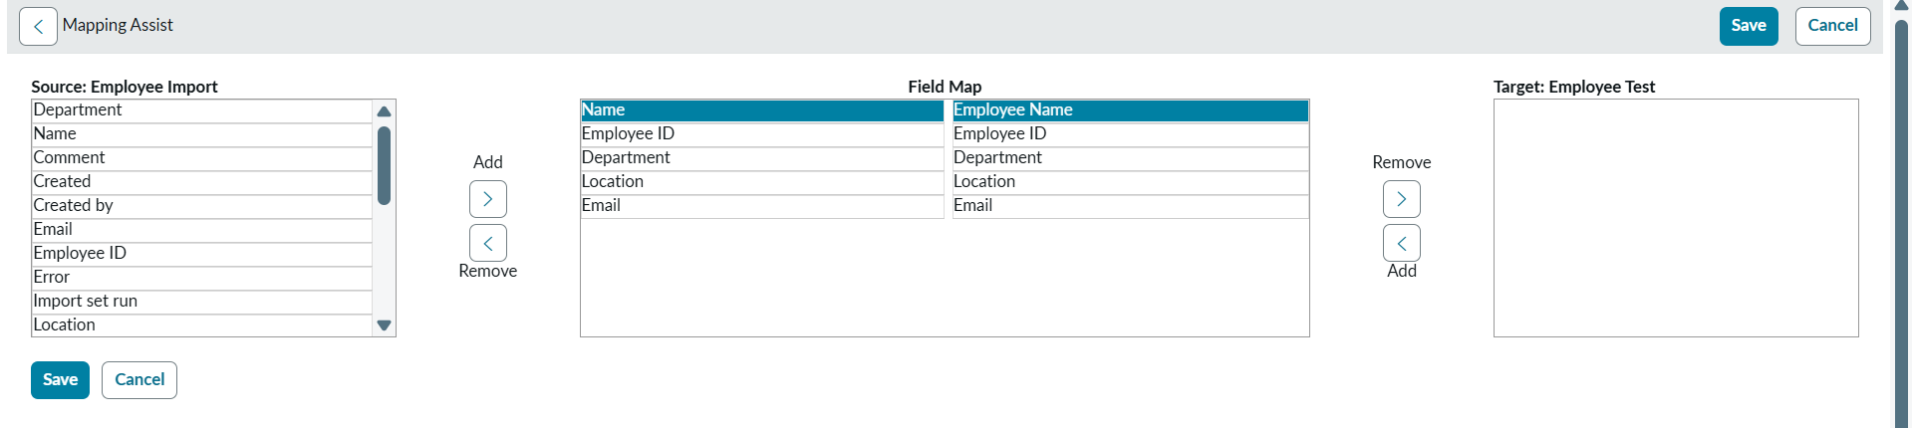
Click on Save
Make sure the both Source & Target table fields are mapped as shown below.


- Now click on Transform as shown below

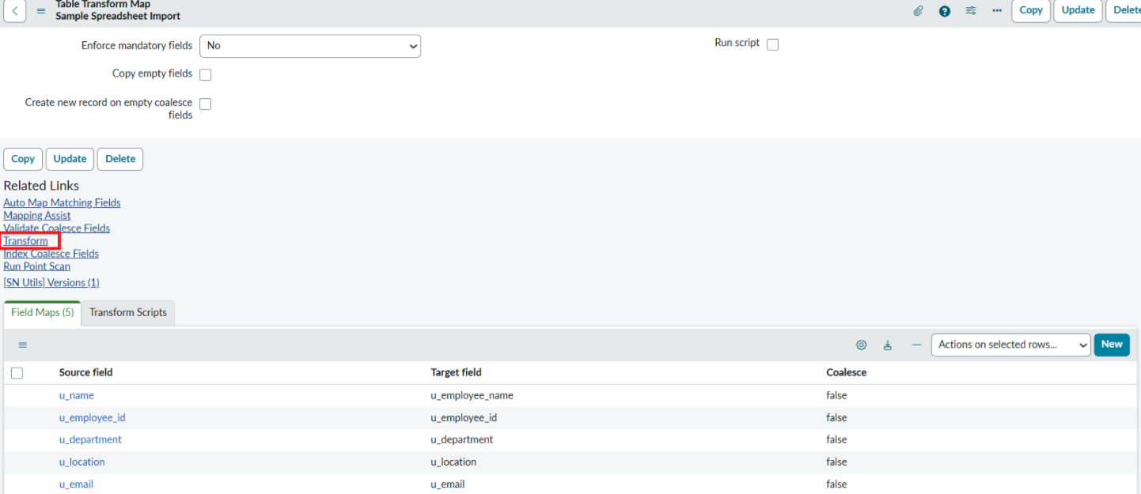

- Now click on Transform Button as shown below.

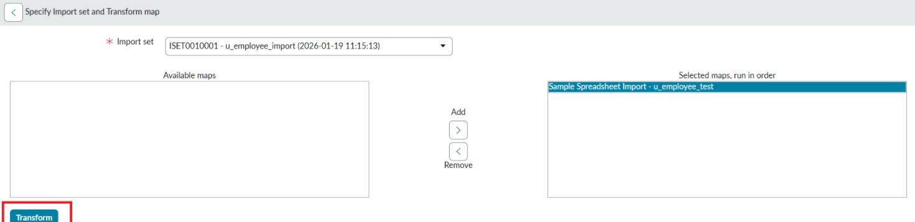

- After clicking Transform, make sure you see the success message as shown below.


Phase 5: Transform Data & Validate
Navigation:
- Open Employee Test Table from application navigator as shown below.

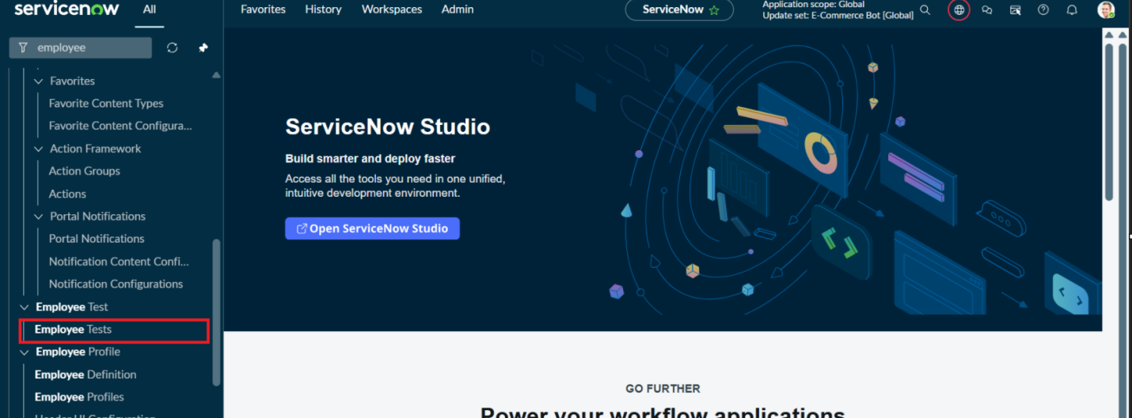

- As our import got succeeded, all the records are created in the Employee Test Table.

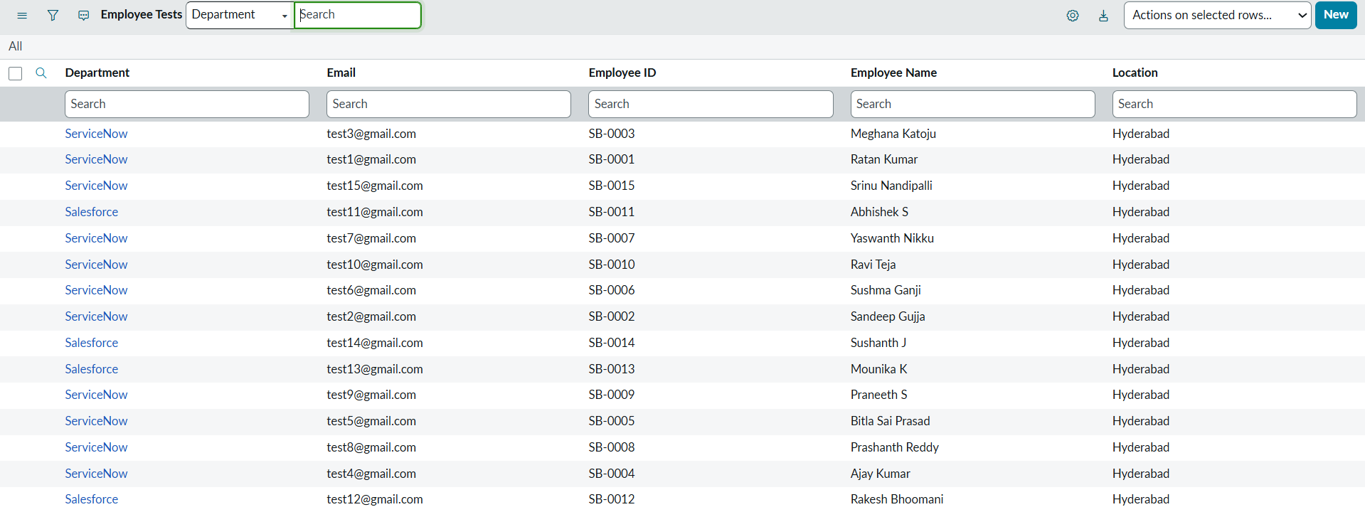

- Make sure you rearrange the fields accordingly by using Personalised List Columns
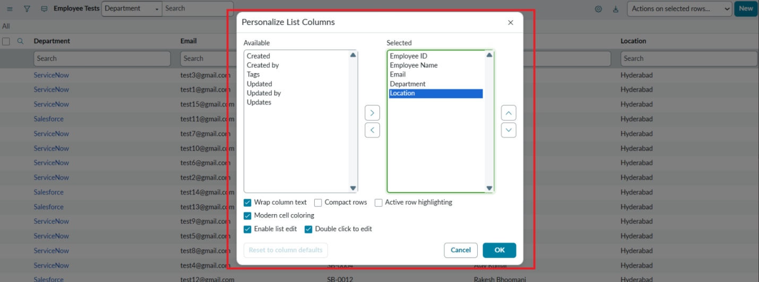

Click on OK

Final Result:
All the records are successfully imported into the ServiceNow system with Import Set, Transform Map.



Phase 6: Enable Coalesce to Avoid Duplicate Records
- In real projects, the same employee data may be imported multiple times.
- To prevent duplicate employee records, we use Coalesce.
- The Coalesce will update the same records with new values if we add and the duplicate values are not inserted.
Steps:
- Open Transform map Under System LDAP On All menus.
- Open the Created Transform map , Name is Sample Spreadsheet Import.
- Under Related list, select the Field maps Section and Make any one field Coalesce True which appears in False.
- Now save the form.
- Then again add some data which is in Excel format.

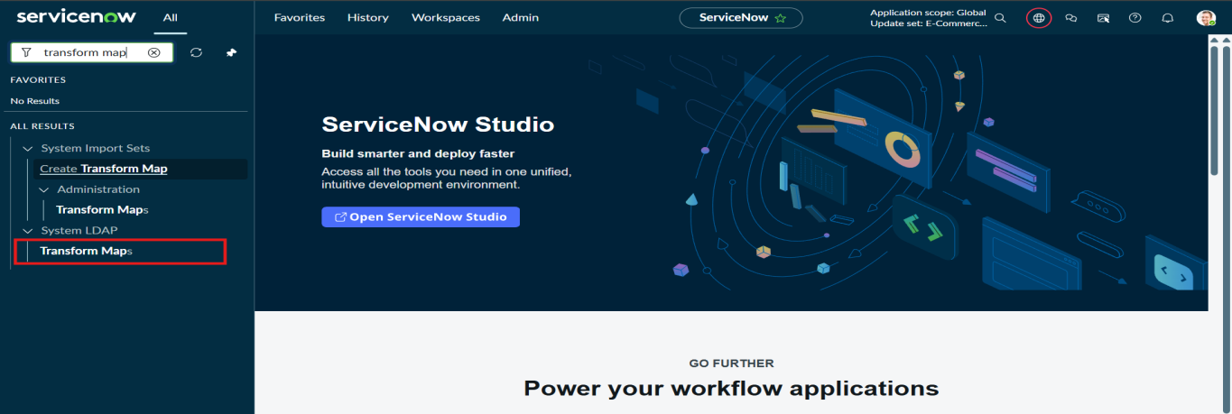
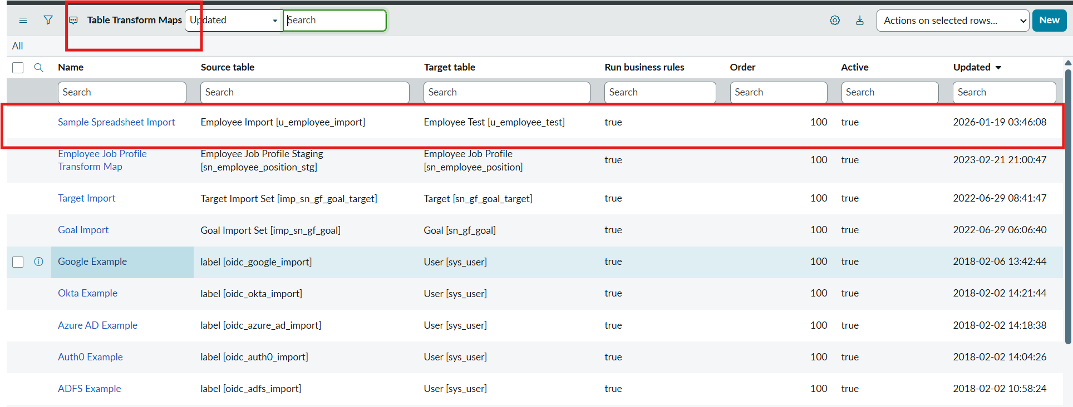

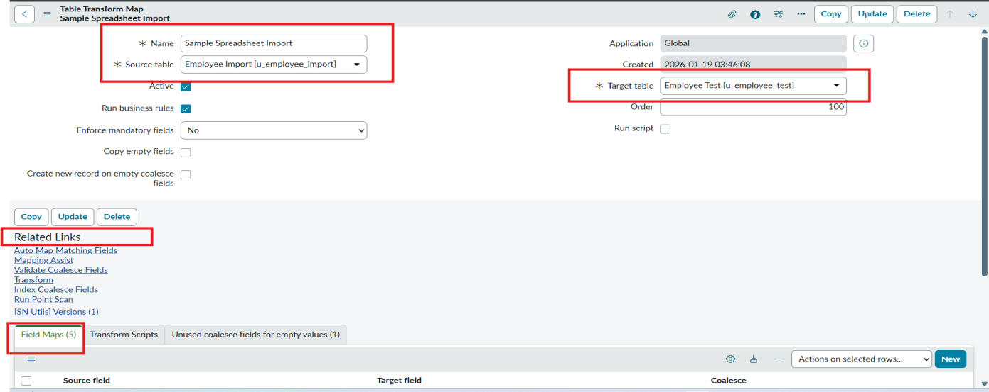


PHASE 7 : Inserting New Data In Excel Format

Steps :
- Navigate to All menus.
- Search for Load data Under System Import set Open Load Data.
- Fill the details as
- Import set table as select Existing table {Employee Import}.
- Source of Import is Select File and choose the file from Files.
- Sheet number : 1, Header row : 1.
- Now Click submit.
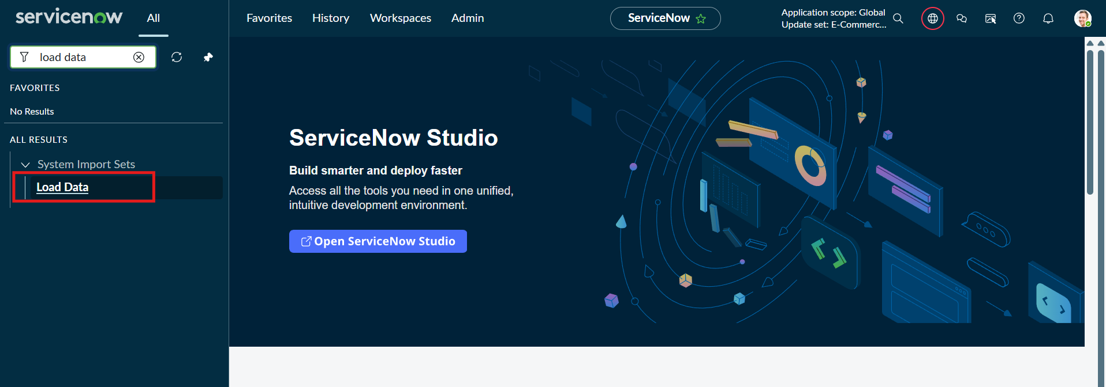
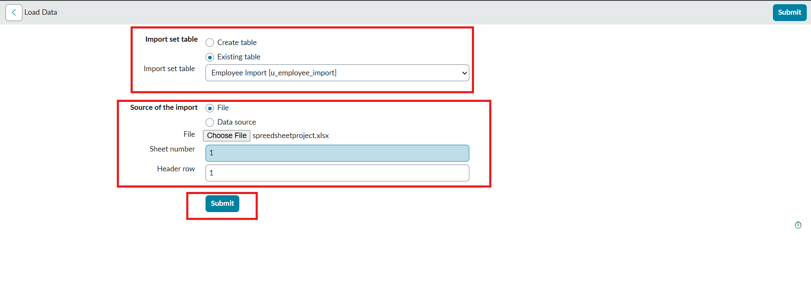

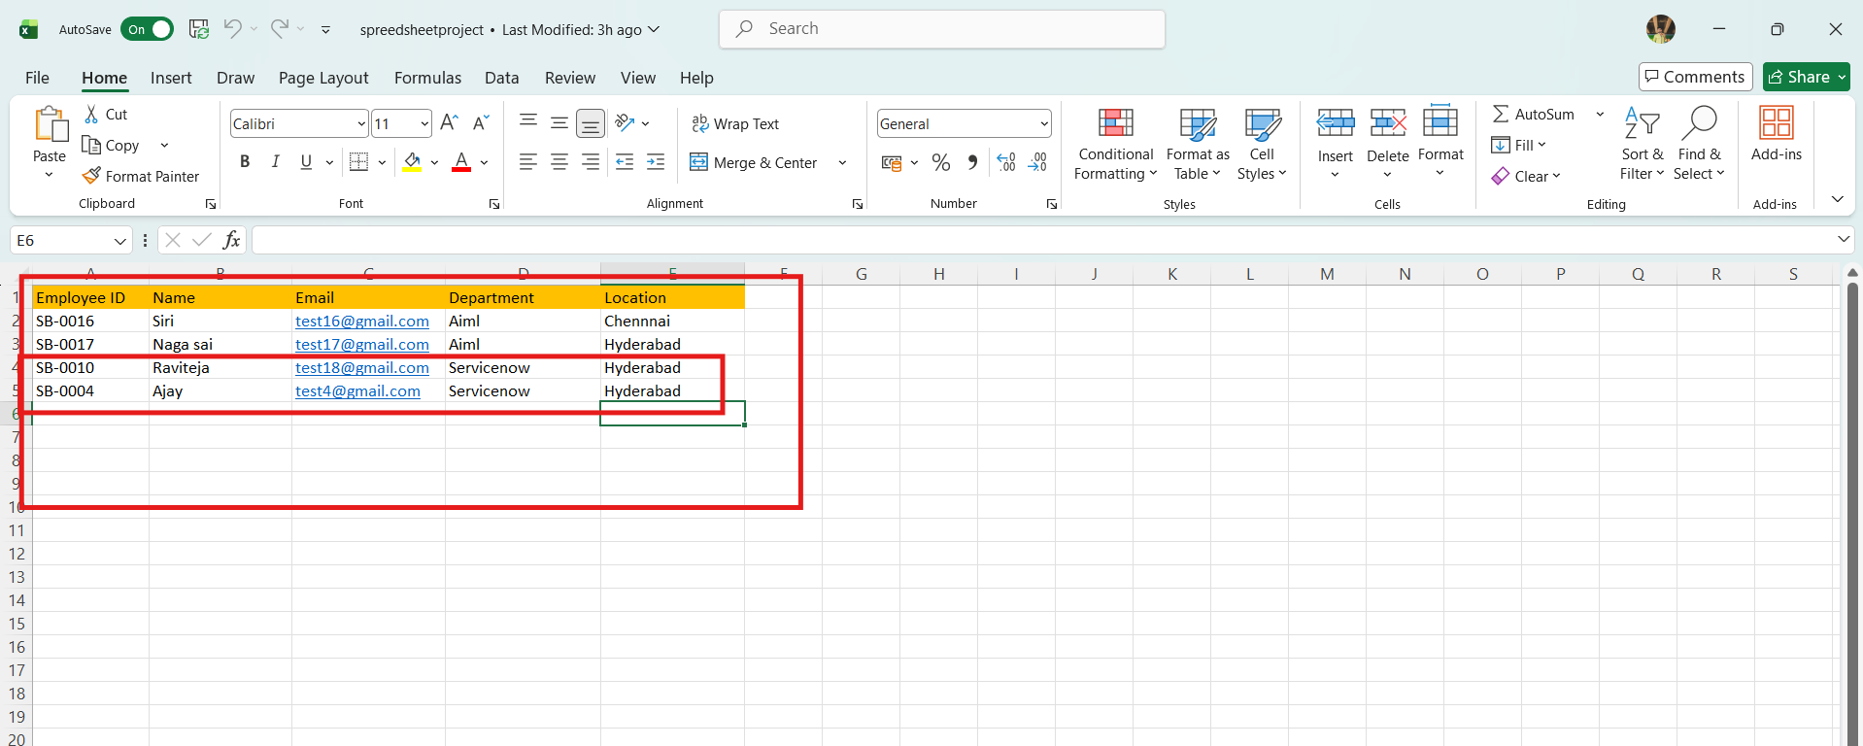
- Newly Created Excel Data is this.
- It is the previously added data.
- Now, In this new data we added 4 rows of the 2 rows with the same existing data with different Name changed and Email changed.
- That Raviteja Employee Email was Changed to
[test10@gmail.com → test18@gmail.com ].
- And Employee ID with SB-OOO4 name was changed to
[Ajay kumar → Ajay].
- And two other new Employee ID’s are added.
- Now after submitting the form it appears as State Completed and Success.


- Now Click the Run transform Under the next steps.
- Then it opens Specify Import set and transform map which is previously selected transform map then Click Transform button.

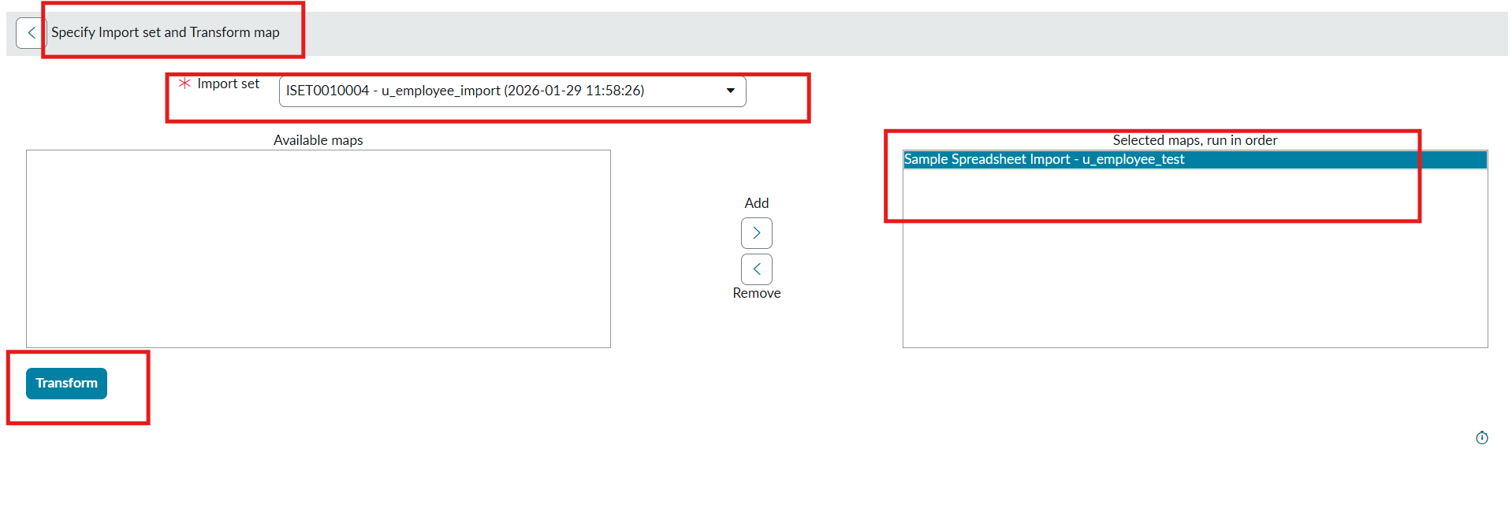
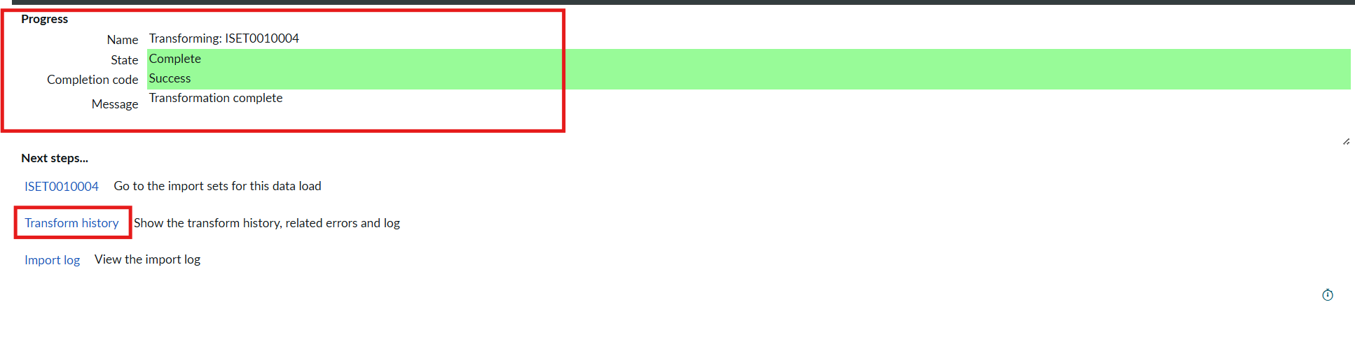
- Now the State is completed and Success.
- Now again click on the Transform history then it shows the newly added data and its status of Inserted and Skipped values out the given data.

- From the above figure : total 4 rows are uploaded out of 2 are Inserted that are two new ID’s.
- And 2 rows are updates that are Same ID’s with different Name and different Email that we changed.
- Then Open the Employee Tests table and see the rows updated and inserted.
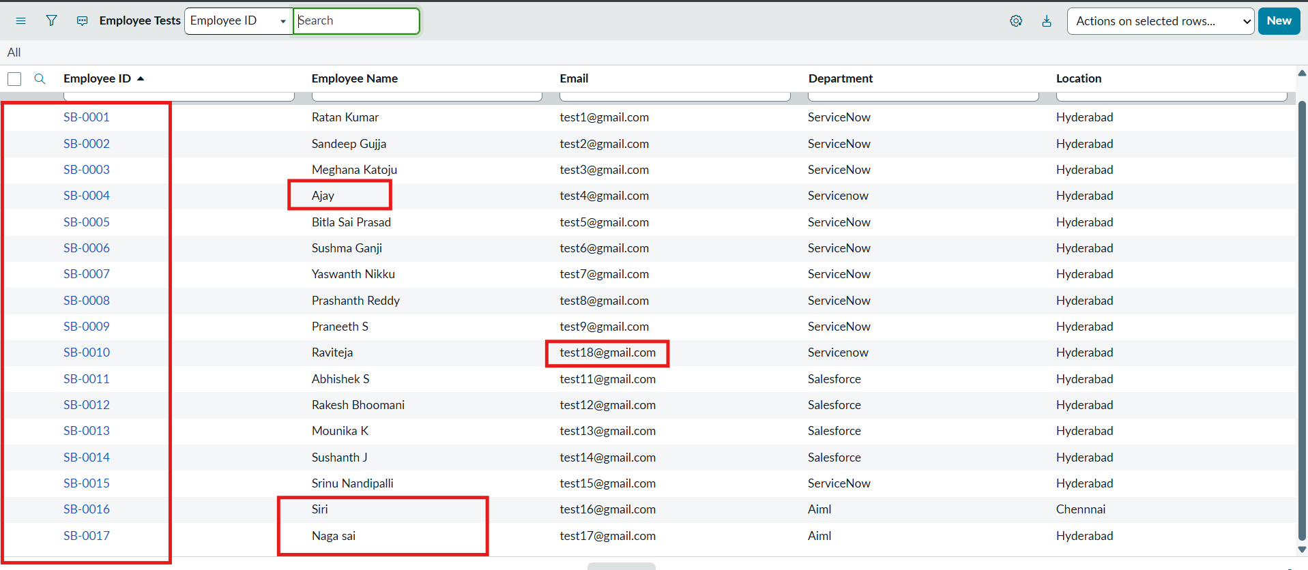

- Now Repeat the Phase 7 with the same steps and same Excel sheet and Submit to check how many rows are updated and Inserted with the same data.
- Then Open the Transform history to check.

- Here we can see the total 4 are uploaded.
- On that 0 rows are Inserted and updates 0 and Ignored 4 rows.
- That same sheet we uploaded to the same transform map we created.
PHASE 8 : Create Reports on Employee Test Table
Navigation Steps :
- Open All menus, Search for Reports.
- Under Usage and governance Select Reports.
- Click the New button to create a new report.
- Create 3 Reports as follows.
Report 1: Employees by Department
- In Data
- Report name : Employees by Department.
- Source Type : Table.
- Table : Employee Test, Now click the Next button.
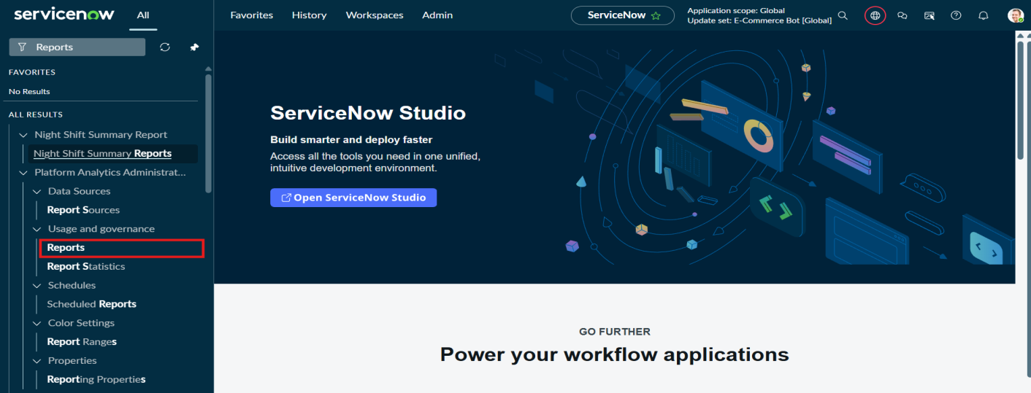
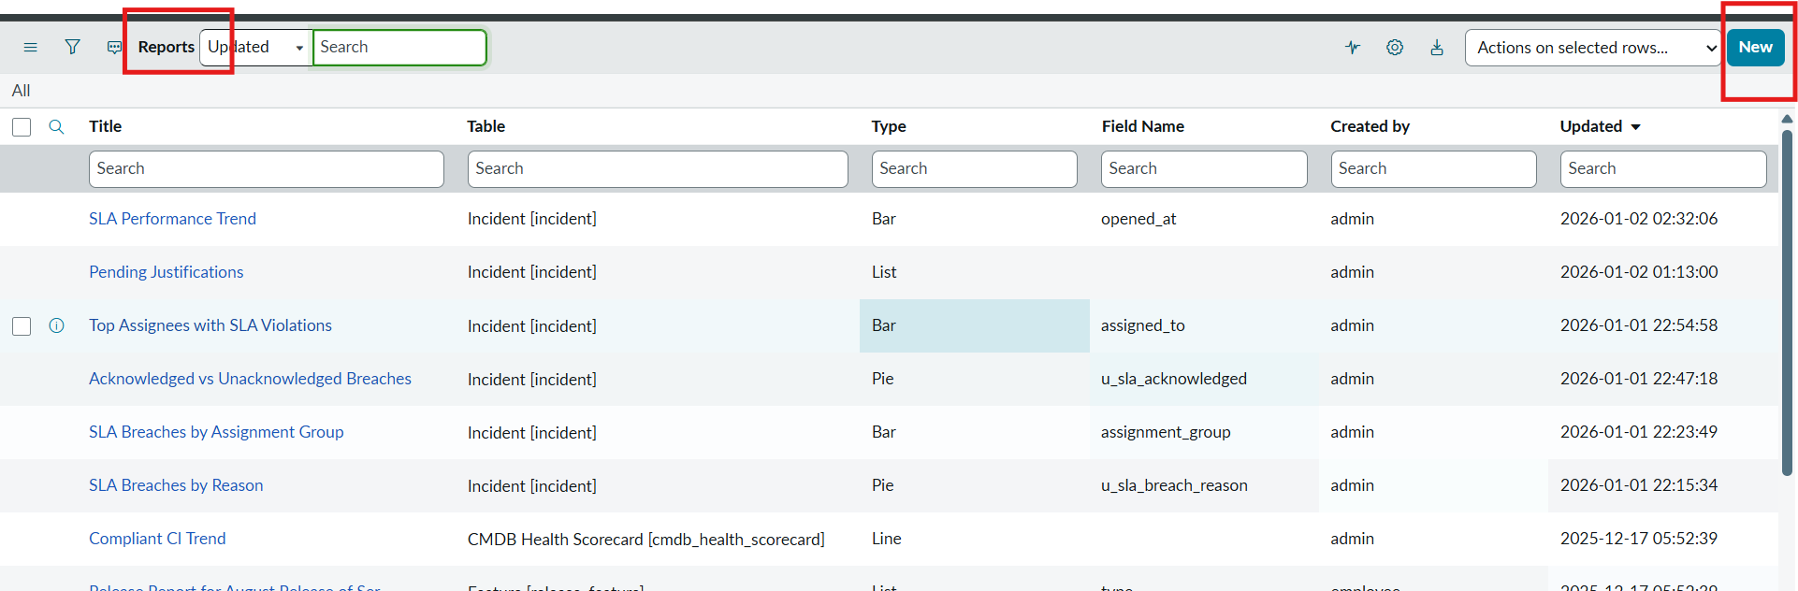

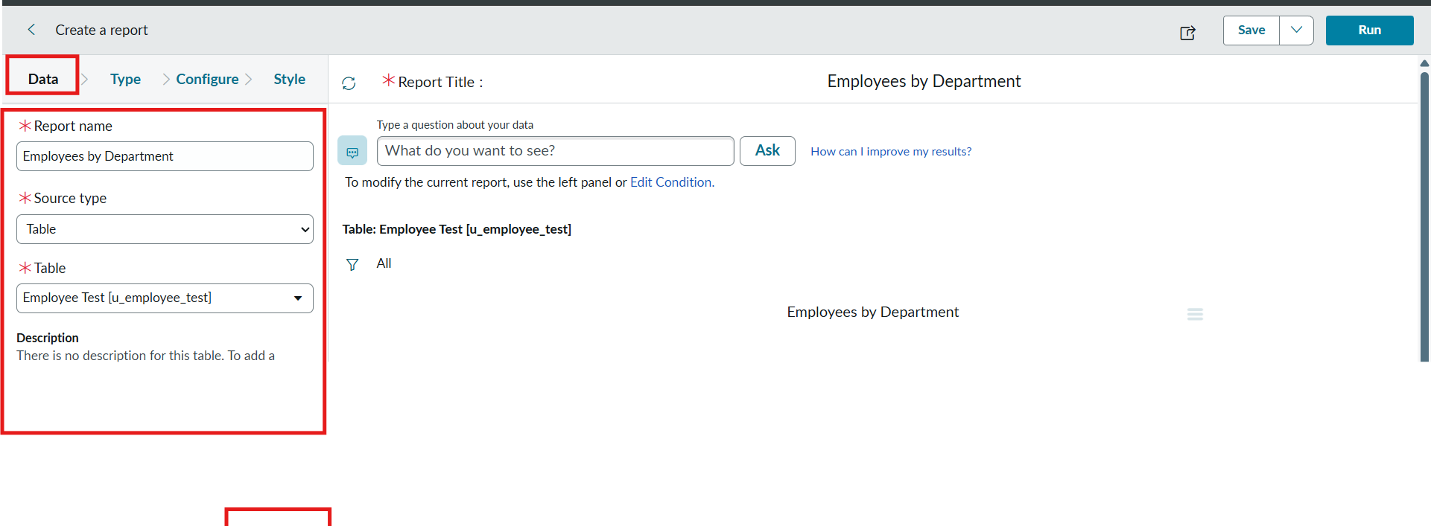
- Now after Clicking next in type Select Pie chart .
- And click the next button.
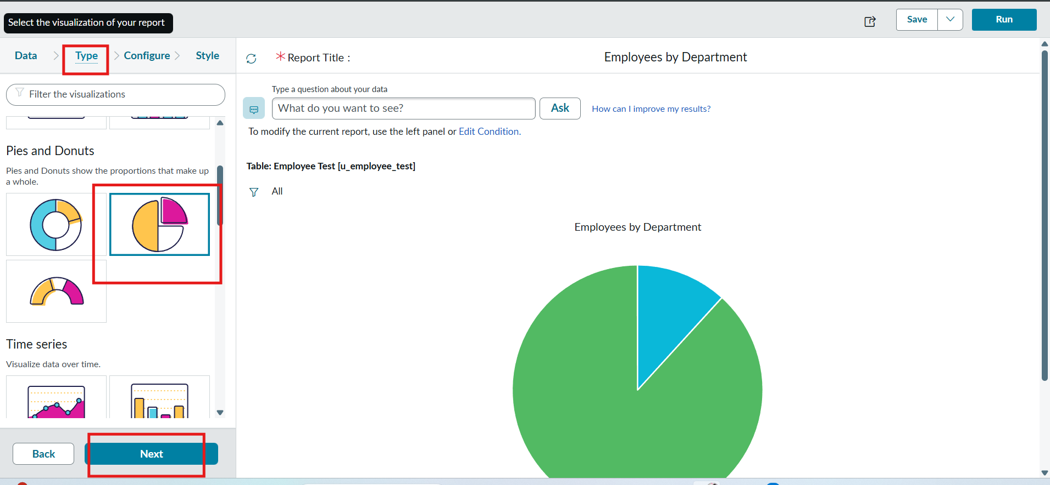
- Now In Configure Select Group by Department Field.
- In the Aggregation Field Select Count.
- Then Click next.

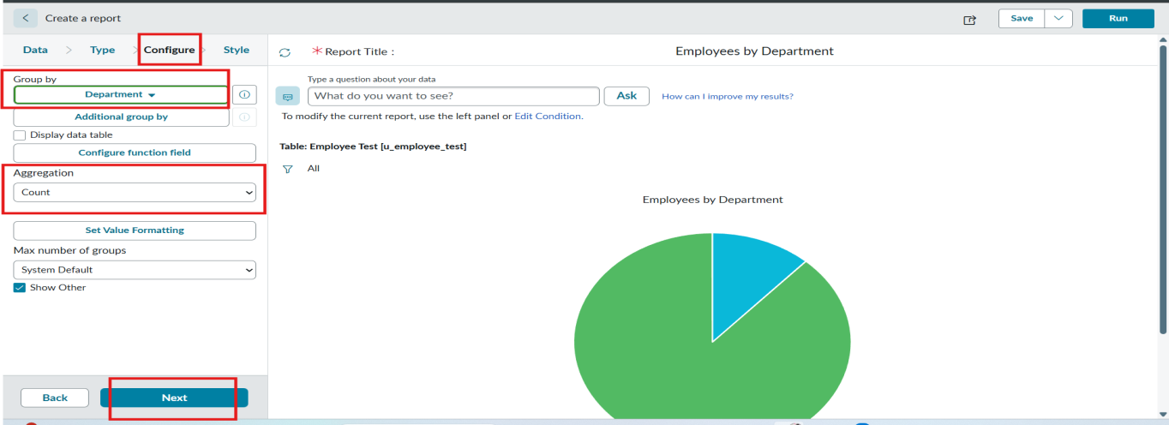
- Now In Style Leave the Chart color by default.
- And Click the Run button to Execute the given data Report.
- And Click save button to Save the Report.
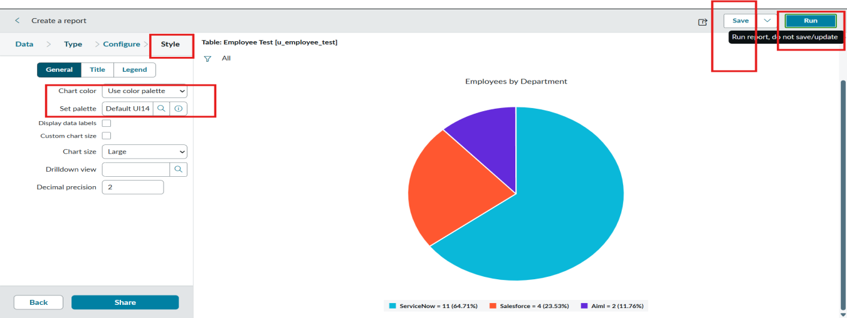

Report 2: Employees by Location
Configuration
- Table: Employee Test
- Type: Bar Chart
- Aggregation: Count
- Group By: Location
Steps :
- Create a New Report.
- Report name : Employees by Location.
- Table Select : Employee Test.
- Select Type : Bar Chart.
- In Configure Select Group by Field : Location.
- And Aggregation is Count.
- Now Click Run to Execute the Report and Click the Save to save the Report.
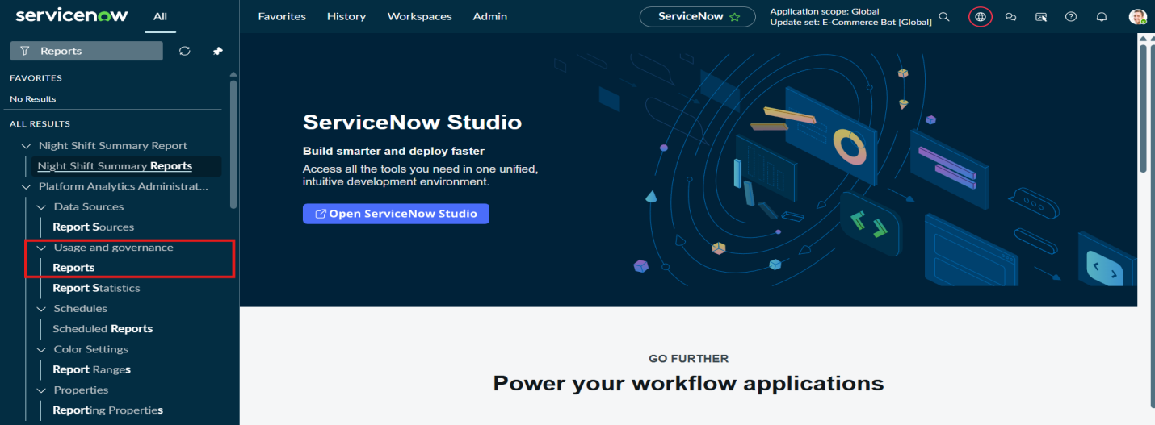
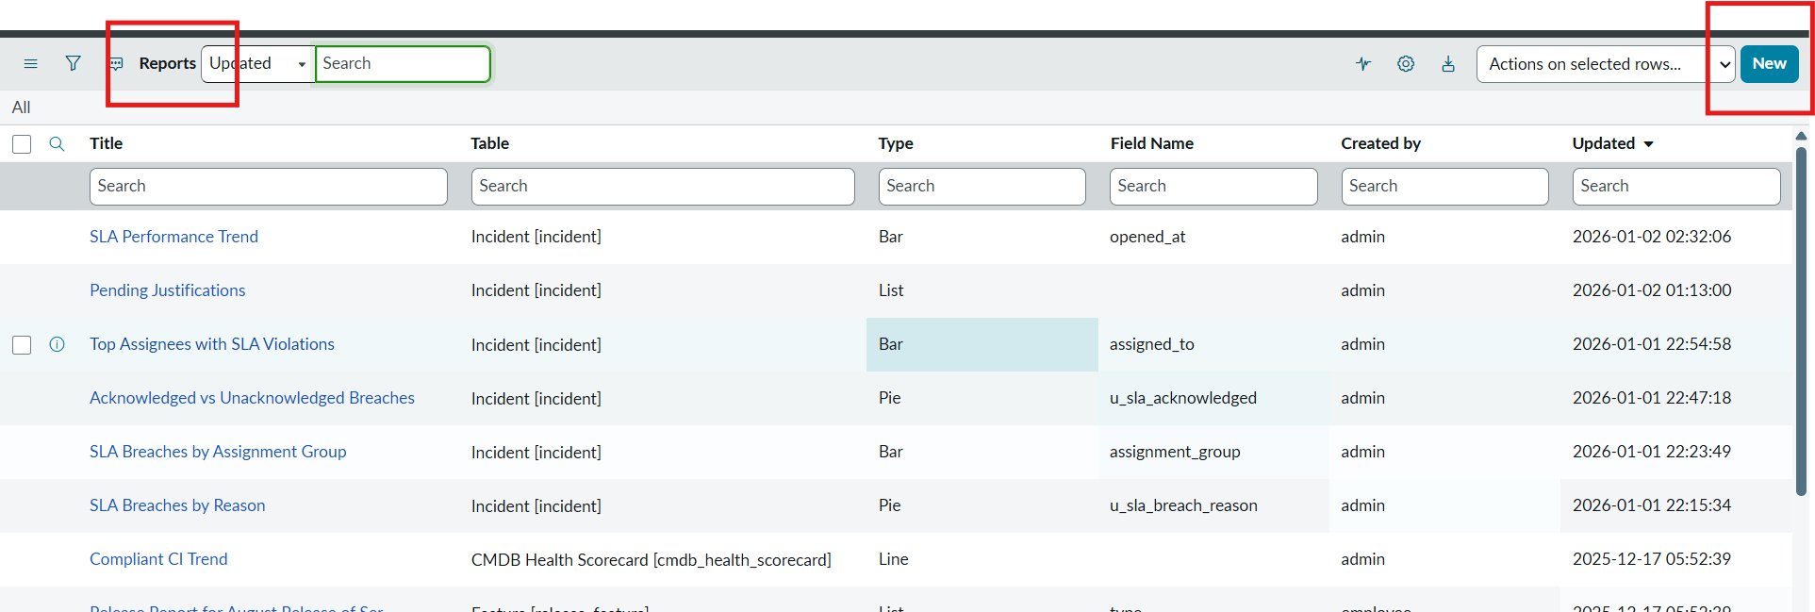

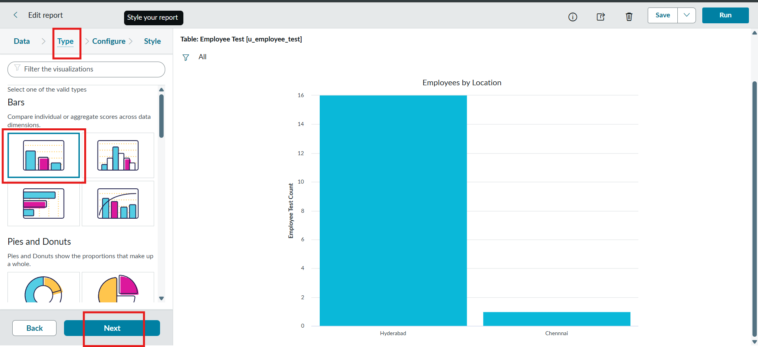
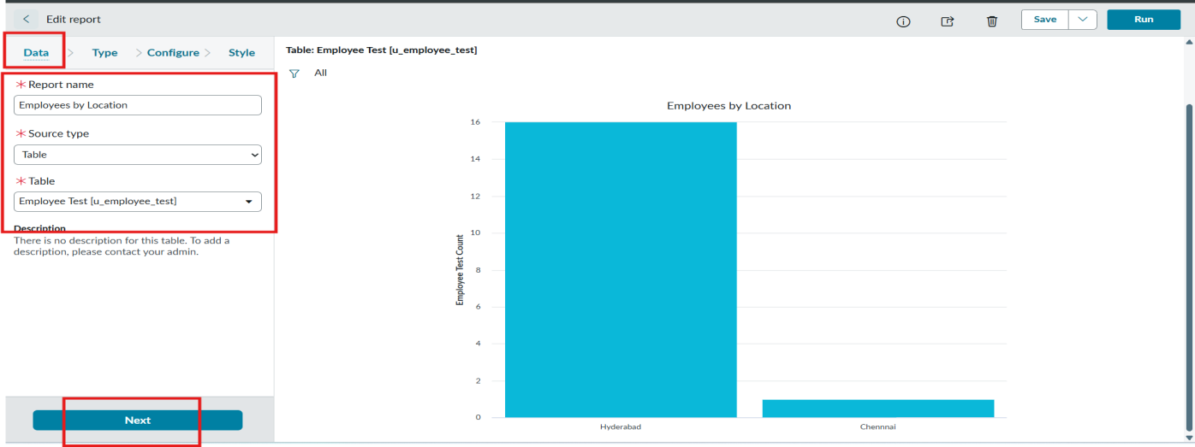
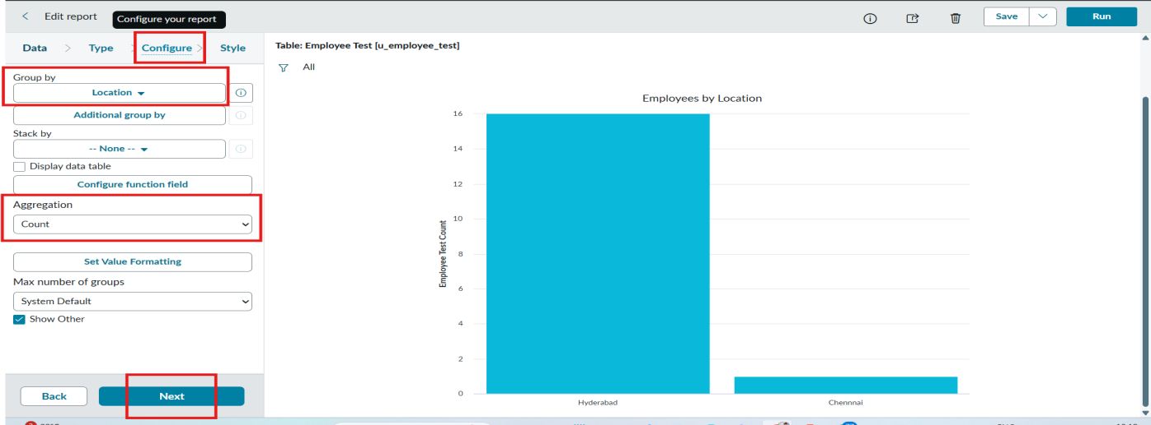

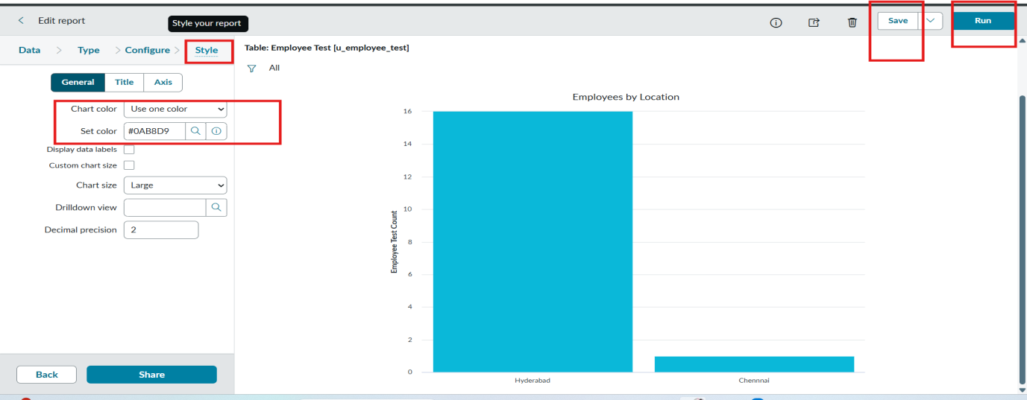

Report 3: Employee List Report.
Configuration
- Create a New Report name : Employee List Report.
- Table: Employee Test.
- Select Type: List.
- In Configure Select Columns:
  - Employee ID.
  - Employee Name.
  - Email.
  - Department.
  - Location.
- Now Select next and no required to choose anything in Style.
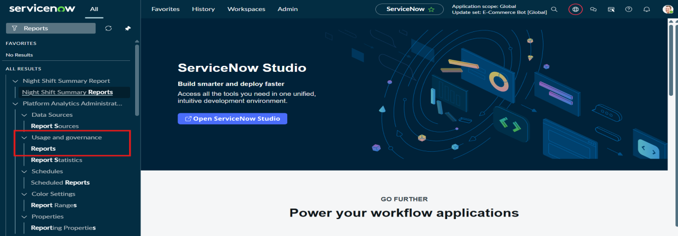
- Now Click Run to Execute the Report and Click Save to Save the Report.
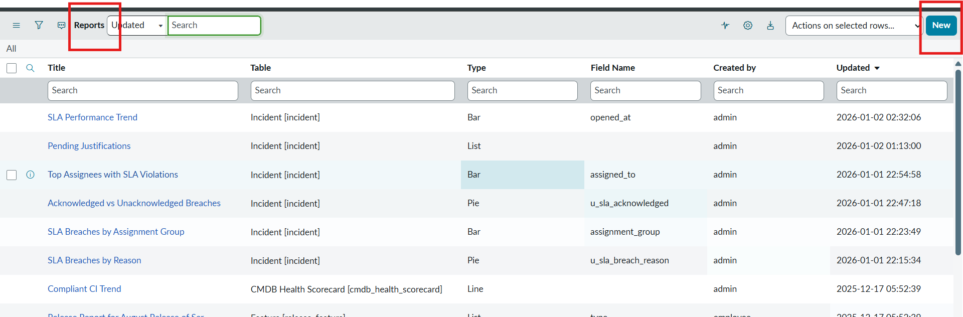
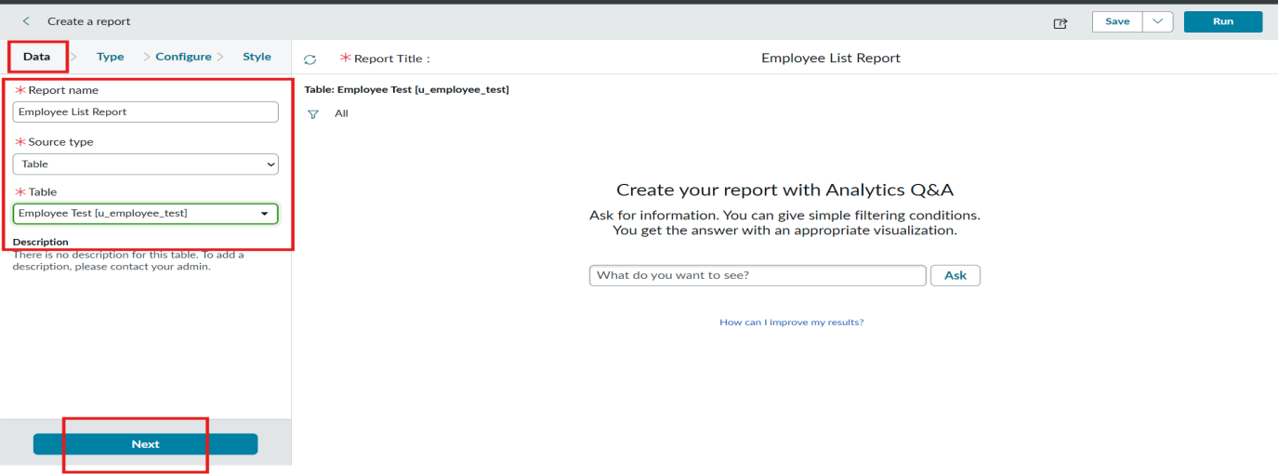
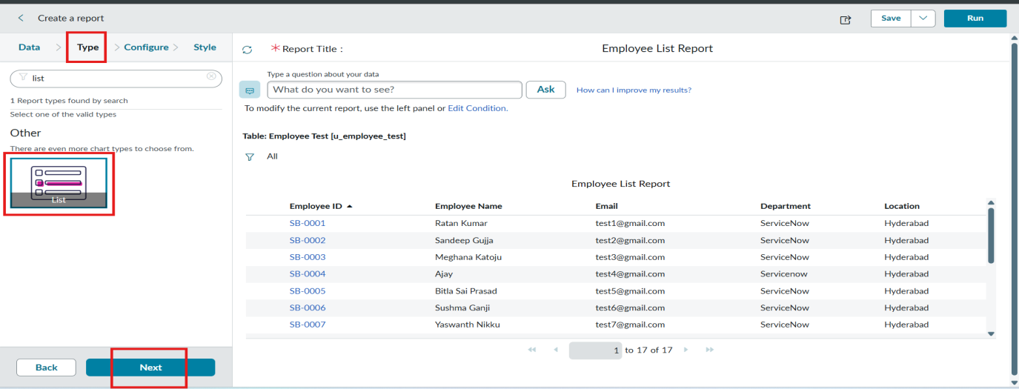

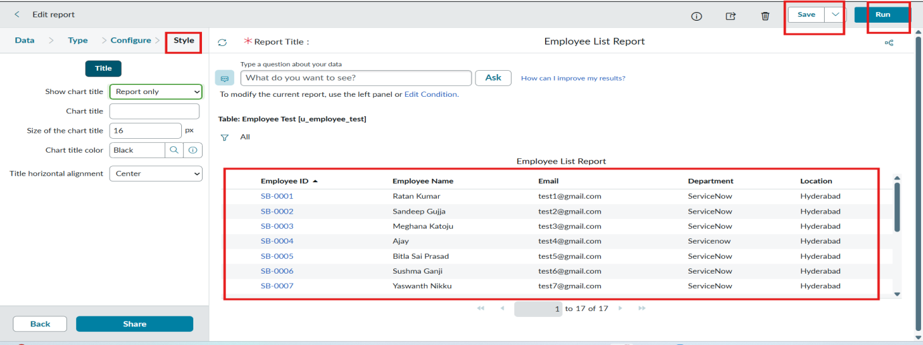
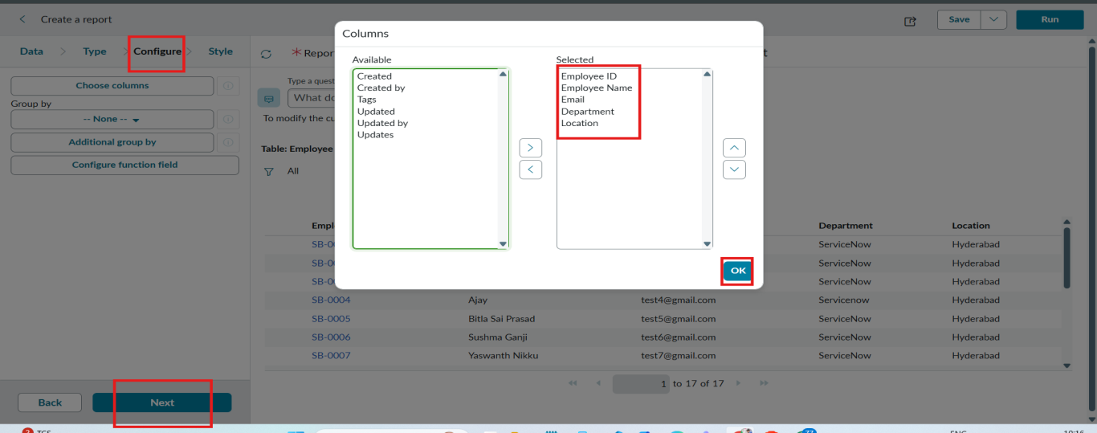

PHASE 9 : Add Reports to Dashboard

Create Dashboard

Navigation :
- Open All menus → Search for Dashboards.
- Under Self Service → Click Dashboards.
- On the top right corner Click Create Dashboards or /
- You can create Directly by using the backend name [ PA_DASHBOARDS.FORM ].
- Then Click New to Create new Dashboards.
- Only the backend name will open the form if the ACL has the pa_dashboards access to Admin Overrides True only.
- Then only we have access to the form.
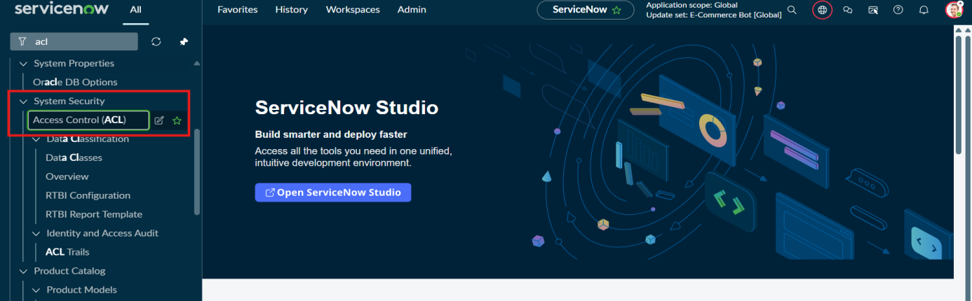
- After Opening the ACL Search the pa_dashboards on Name Column.
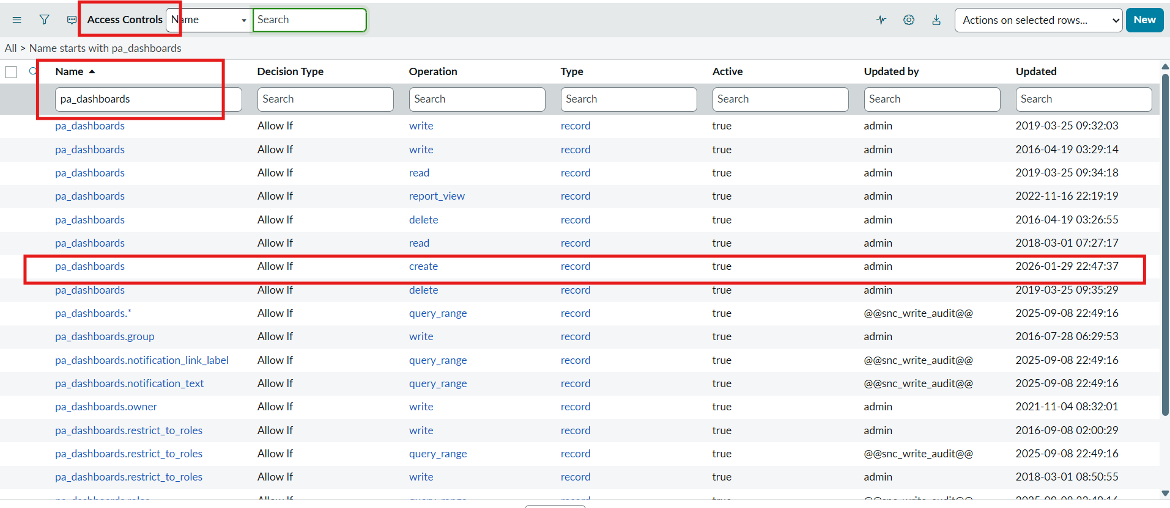
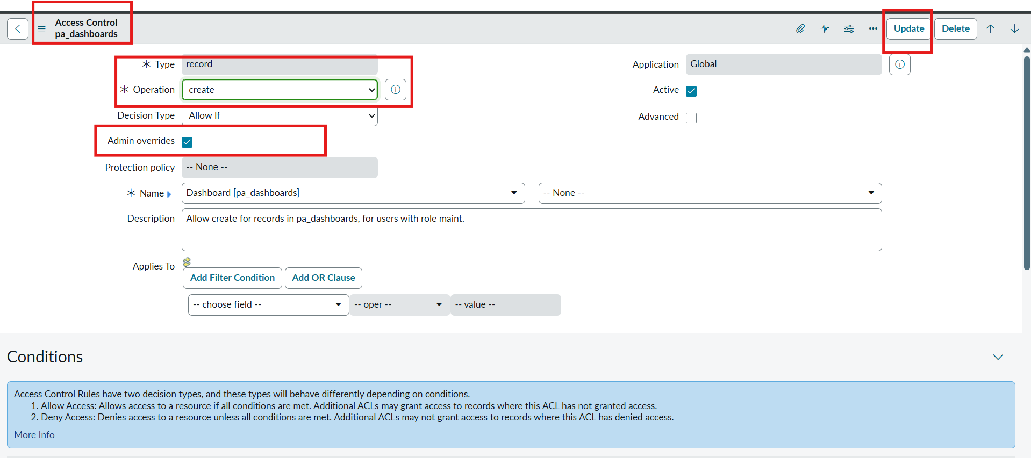
- Now Open the Create Operation row.
- Then Click Enable the True for Admin Overrides and Update the Form.
- Then the creation of dashboards will be possible by using the backend name.
- Now Open the PA_DASHBOARDS.FORM create dashboard.
- Dashboard name : Employee Analytics Dashboards.
- Save the Form.
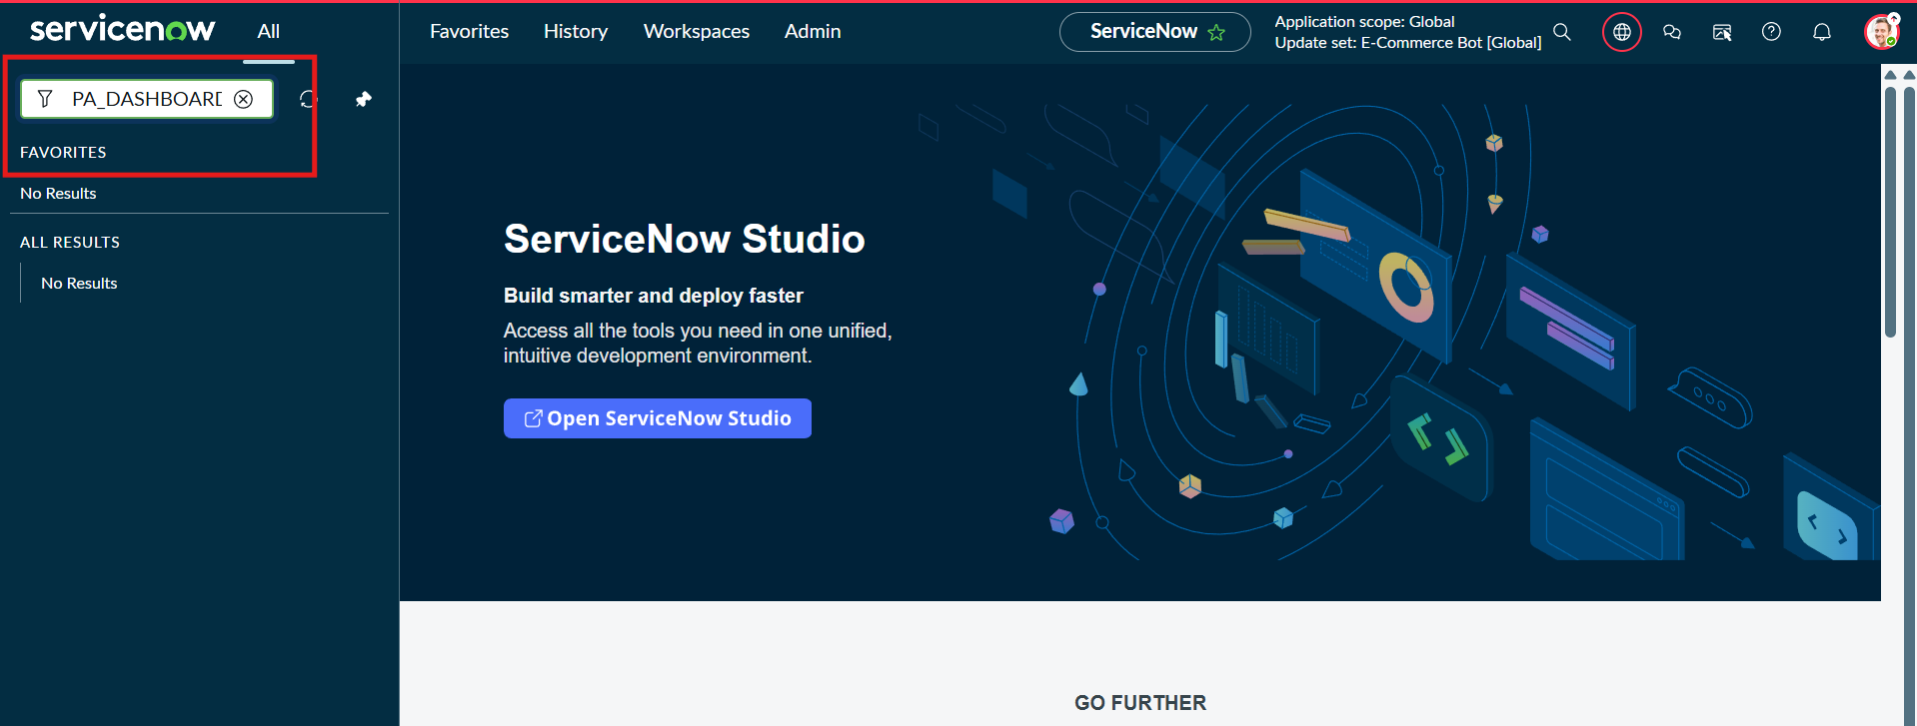
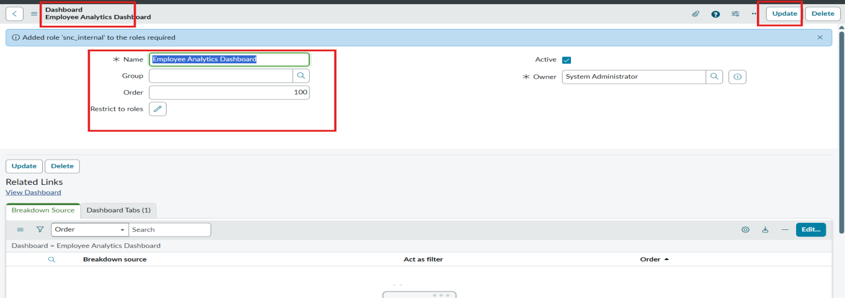

Add Reports to Dashboards.
Navigation Steps:
- Open the Previously Created Reports.
- On All menus → type Reports Under Usage and Governance select reports.
- Open the Employees by Department.
- Select the Edit Report and Click the Share button then the right top corner Select the Add to Dashboards Option.
- Then Choose the Created dashboard name and Click Add button.
- Same Like that do the remaining 2 reports in the same navigation how we added Employees by Department.
- The Employees by Location and Employee List Report these two reports are also added to the created dashboard.
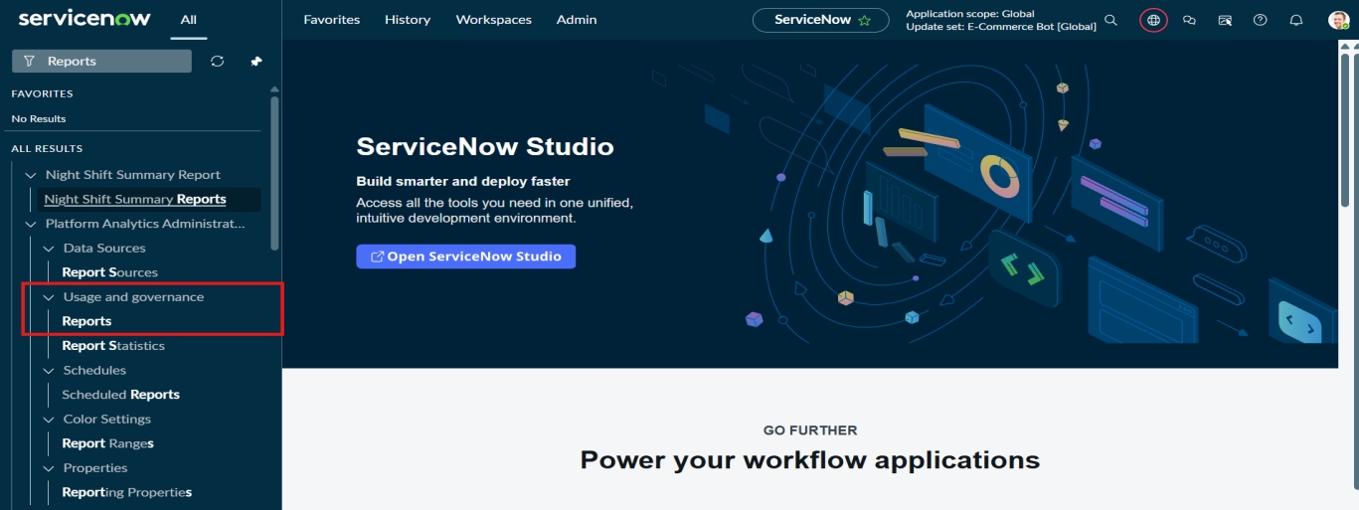
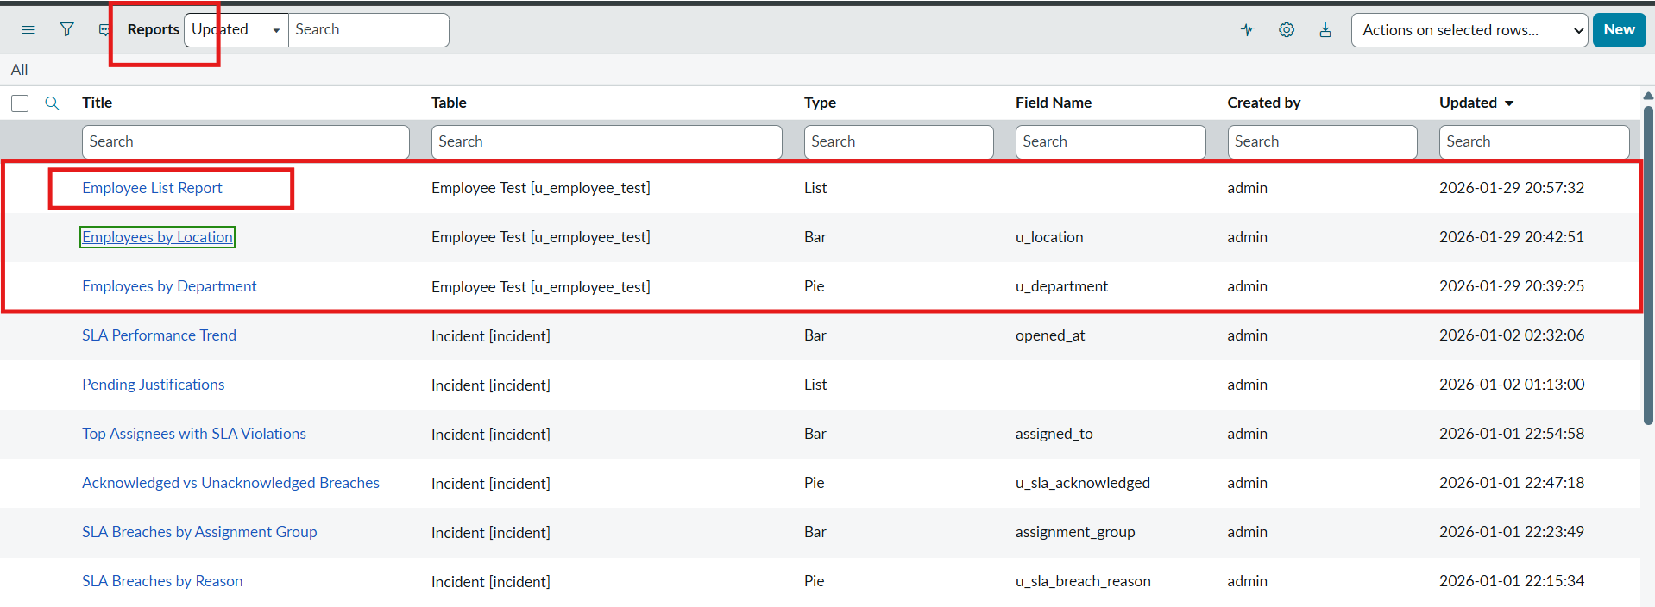
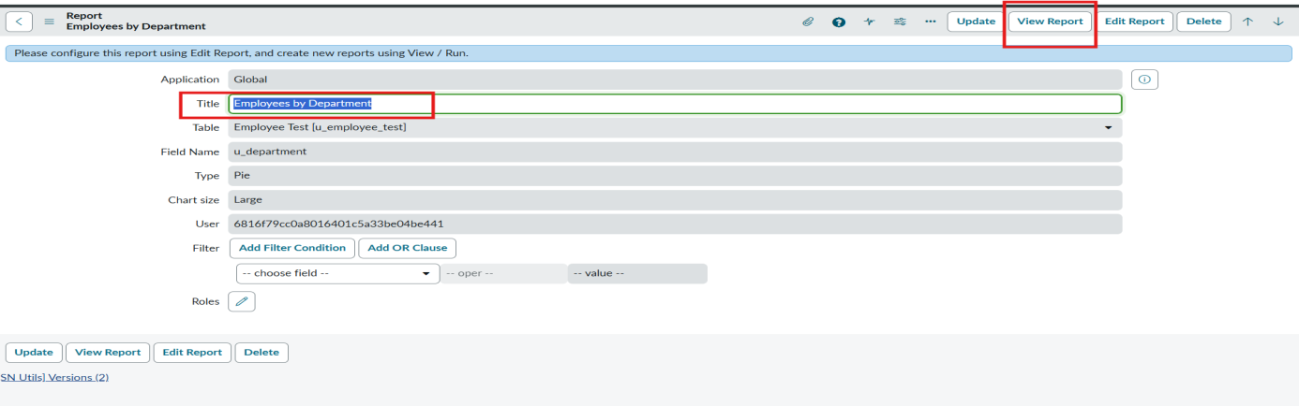
- After Opening the Report Click the View Report Button on the right side of the Context menu.
- After Clicking the View Report button, Now Click the Share button and then share options are visible on the right side.
- Now click the Add to Dashboards.
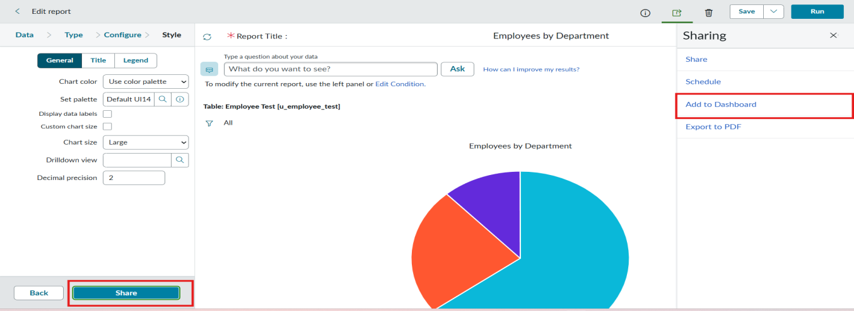
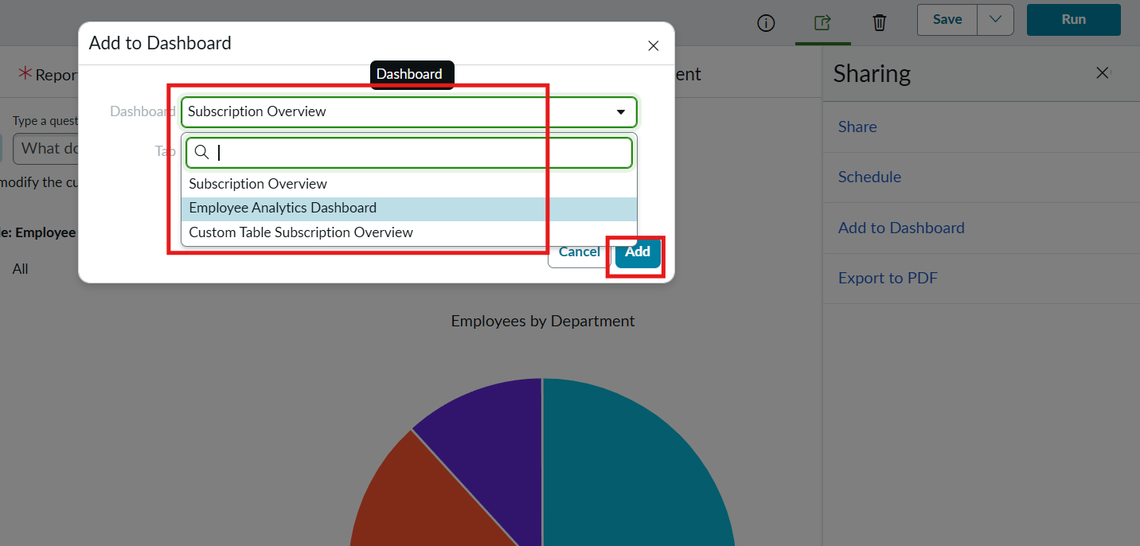
- Now Add the Dashboard that you created called Employee Analytics Dashboards.
- Then Click Add button.
- Now the Report is added to the dashboards.
- Now, Same in the process, add the remaining two reports to the dashboard.

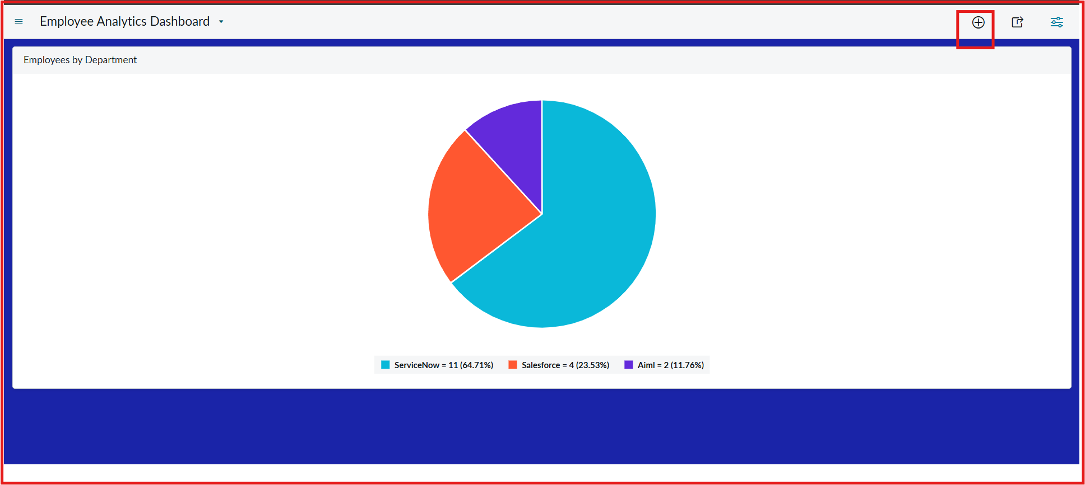

- From the + icon also we add widgets that our reports from there.
- If we want we can also configure the background color.

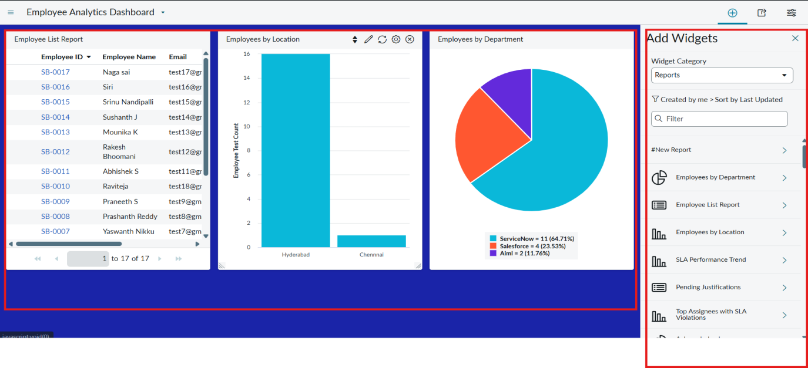

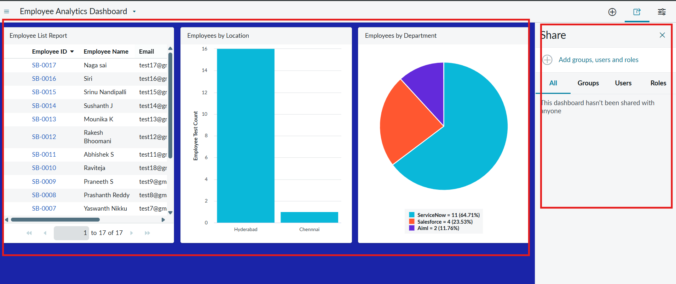

- Here the three Reports are added successfully by varying Department , Location and List Report.
- We can also restrict the Users,Groups and Roles From Share Option.

Conclusion:
- This project successfully implemented an automated employee data management solution using ServiceNow Import Sets and Transform Maps, ensuring accuracy, efficiency, and data integrity throughout the employee onboarding and update process.
- A key enhancement in this project was the use of Coalesce in the Transform Map. By enabling Coalesce on the Employee ID field, the system intelligently identifies existing employee records during every import. This prevents the creation of duplicate records and ensures that repeated imports update existing data instead of inserting redundant entries. As a result, the employee database remains clean, reliable, and consistent, which is critical in real-world enterprise environments where data may be imported multiple times from external systems.
- In addition to data integrity, the project was extended with Reports and Dashboards to provide meaningful insights and real-time visibility into employee data and import activities. Custom reports were created to track:

- Total employee records.
- Newly added employees.
- Updated employee records.
- Department-wise employee distribution.
- Import success and error counts.
- These reports were then consolidated into a Dashboard, allowing administrators and HR teams to monitor employee data trends, import performance, and data quality from a single centralized view. Dashboards improved decision-making by presenting information visually through charts and graphs, reducing the need for manual analysis.

