HTML TO PDF CONVERTOR

VERSION 0.2

Document History

|  |  |  |  |
| --- | --- | --- | --- |
| **Version** | **Date** | **Author** | **Description of Release** |
| v0.1 | 16-Aug-2021 | Sivanesan M | Genesis |
| v0.1 | 17-Aug-2020 | Shajin V A | Review: Added Flow chart and API |
| v0.2 | 01-Oct-2021 | Ganesh B | Reviewed and modified the content |

Contents

**1.** **Objective** 3

**2.** **Flowchart** 3

**3.** **Functionalities offered** 4

**4.** **Other Highlights** 4

**5.** **Comparison between our conversion engine & PDFCrowd services** 5

**5.1** **Our conversion engine** 5

**5.2** **Converted sample of the same page with PDFCrowd:** 6

# **Objective**

* + - To create a scalable high-quality HTML/CSS rendering engine that allows us to convert rich web content into PDFs
    - To overcome the disadvantages of services provided by PDFCrowd vendor

# **Flowchart**

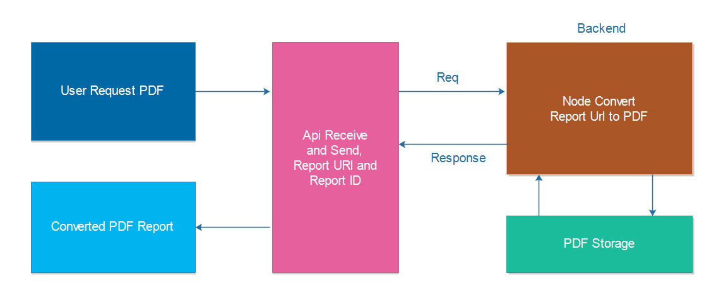

# **Functionalities offered**

* + 1. We can generate PDFs from:
* HTML files
* URLs
* Images
  + 1. Direct UI based HTML to PDF conversions.

<http://design.emfcwl.com/>

The above link hosts the application which gives UI option to download a target URL in PDF format

* + 1. Convert raw HTML or URL to PDF (with the POST method)

**API details:**

The API is implemented using Nodejs and the app is currently hosted in Heroku free tier.

**Service endpoint:** <https://reportg.herokuapp.com/reportUrlApi>

**Parameters:**

|  |  |  |  |
| --- | --- | --- | --- |
| **S.no** | **Name** | **Parameter** | **Data Type** |
| 1 | Report URL | report_url | varchar |
| 2 | Report ID | report_id | varchar |

# **Other Highlights**

* + **Platform independent - Works on all devices**
* The online PDF converter works perfectly on all devices and popular browsers.
* Supports Internet Explorer, Mozilla Firefox, Chrome & Opera.
  + **Automated file retention policy**
    - Once a web page is converted to PDF, it will be retained for a period of 3 hours.
    - The file can be downloaded and can be manually deleted.
    - If the files are not manually deleted, they will be deleted from the server automatically after three hours.

# **Comparison between our conversion engine & PDFCrowd services**

## **Our conversion engine**

* + Supports HTML5
  + Supports CSS3
  + Supports SVG & CANVAS
  + Supports modification of the background colours, margins, and paddings
    - Unique among HTML to PDF rendering: Creates compact PDF document that retains original text and hyperlinks.
    - Has no rate limits or file size restrictions.

Converted PDF sample with all the features mentioned above:

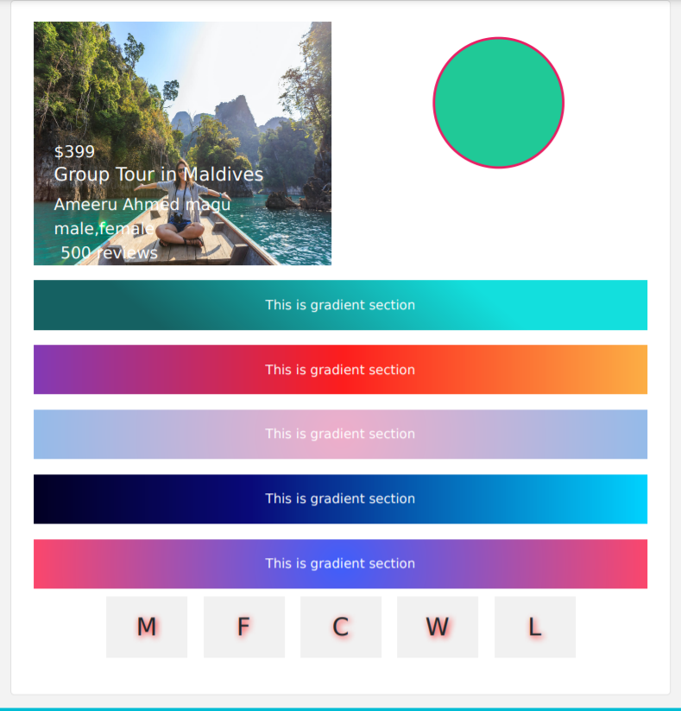

## **Converted sample of the same page with PDFCrowd:**

* + - * Does not support HTML5
      * Does not support CSS3
      * Does not support SVG & CANVAS
      * Does not support the background colour, margin, and padding modifications.

