

**CAR RENTAL MANAGEMENT SYSTEM**

**MINI PROJECT REPORT**

Submitted by:

**SHYAM PRASAD S(231801166)**

VIGNESH A(231801187)

**SIVA MURUGAN B(231801167)**

CS23332 DATABASE MANAGEMENT SYSTEM

Department of Artificial Intelligence and Data Science

Rajalakshmi Engineering College, Thandalam

**2024-2025**

**BONAFIDE CERTIFICATE**

Certified that this project report “**CAR RENTAL MANAGEMENT SYSTEM**” is the bonafide work of **“ SHYAM PRASAD S (231801166) ,VIGNESH A (231801187) ,**

**SIVA MURUGAN B(231801167) ”**

who carried out the project work under my supervision.

**Submitted for the Practical Examination held on**

**SIGNATURE SIGNATURE**

|  |  |  |  |  |
| --- | --- | --- | --- | --- |
| **Dr. GNANASEKAR J M** | **Dr. MANORANJINI J** | **Dr.GNANASEKAR J M** | **Dr. MANORANJINI J** | **Dr.MANORANJINI J** |
| **Head of the Department, Artificial intelligence**  **and data Science,Rajalakshmi Engineering College (Autonomous),Chennai-602105** | **Assoc.Professor, Artificial Intelligence and Data**  **Science, Rajalakshmi Engineering College (Autonomous), Thandalam, Chennai-602105** | |  | | --- | | **Head of the Department, Artificial intelligence**  **and data Science,Rajalakshmi Engineering College (Autonomous),Chennai-602105** | | **Professor, Artificial Intelligence and Data**  **Science, Rajalakshmi Engineering College (Autonomous), Thandalam, Chennai-602105** | **Associate Professor, Artificial Intelligence and Data Science, Rajalakshmi Engineering College,(Autonomous), Thandalam, Chennai-602105** |

**INTERNAL EXAMINER EXTERNAL EXAMINER**

**TABLE OF CONTENT**

|  |  |  |
| --- | --- | --- |
| **S.NO** | **CHAPTER** | **PAGE NUMBER** |
| 1. | **INTRODUCTION** |  |
| 1.1 | INTRODUCTION | 7 |
| 1.2 | OBJECTIVES | 7 |
| 1.3 | SCOPE | 8 |
| 2. | **SYSTEM OVERVIEW** |  |
| 2.1 | SYSTEM ARCHITECTURE | 9 |
| 2.2 | MODULES OVERVIEW | 10 |
| 2.3 | USER ROLES AND ACCESS LEVELS | 11 |
| 3. | **SURVEY OF TECHNOLOGIES** |  |
| 3.1 | SOFTWARE AND TOOLS USED | 12 |
| 3.2 | PROGRAMMING LANGUAGES | 12 |
| 3.3 | FRAMEWORKS AND LIBRARIES | 13 |
| 4. | **REQUIREMENTS AND ANALYSIS** |  |
| 4.1 | FUNCTIONAL REQUIREMENTS | 14 |
| 4.2 | NON-Functional Requirements | 14 |
| 4.3 | HARDWARE AND SOFTWARE REQUIREMENTS | 14 |
| 4.4 | ARCHITECTURE DIAGRAM | 14 |
| 4.5 | ER DIAGRAM | 15 |

|  |  |  |  |
| --- | --- | --- | --- |
| 5. | **SYSTEM DESIGN** | |  |
| 5.1 | DATABASE DESIGN AND TABLES | | 16 |
| 5.2 | UI DESIGN OVERVIEW | | 16 |
| 5.3 | WORKFLOW AND PROCESS DIAGRAMS | | 17 |
| 6. | **IMPLEMENTATION** | |  |
| 6.1 | CODE STRUCTURE AND ORGANIZATION | | 18 |
| 6.2 | KEY MODULES AND THEIR FUNCTIONS | | 20 |
| 6.3 | CHALLENGES AND SOLUTIONS | | 21 |
| 7. | **TESTING AND VALIDATION** | |  |
| 7.1 | TESTING STRATEGIES | | 22 |
| 7.2 | TEST CASES AND RESULTS | | 22 |
| 7.3 | BUG FIXES AND IMPROVEMENTS | | 23 |
| 8. | **RESULTS AND DISCUSSION** | |  |
| 8.1 | SUMMARY OF FEATURES | | 24 |
| 8.2 | USER EXPERIENCE FEEDBACK | | 24 |
|  |  | |  |
| 8.3 | POTENTIAL IMPROVEMENTS | | 25 |
| 9 | **CONCLUSION** | | 28 |
| 10 | **REFERENCES** | 29 | |

**TABLE OF FIGURES**

|  |  |  |
| --- | --- | --- |
| **S.NO** | **FIGURE** | **PAGE NUMBER** |
| 1 | ARCHITECTURE DIAGRAM | 14 |
| 2 | ER DIAGRAM | 15 |
| 3 | WORK FLOW DIAGRAM | 17 |
| 4 | DASHBOARD | 26 |
| 5 | ADD CASH TO BALANCE | 26 |
| 6 | TRACK EXPENSES | 27 |
| 7 | EXPENSE CATEGORIES | 27 |
|  |  |  |
|  |  |  |
|  |  |  |
|  |  |  |
|  |  |  |
|  |  |  |
|  |  |  |
|  |  |  |

## ABSTRACT

The Car Rental Management System is a software application developed to streamline and automate the operations of a car rental business. Designed using Java for backend development and MySQL for database management, the system offers a robust and user-friendly platform for managing vehicle rentals. The primary objective of the project is to provide an efficient, secure, and reliable system for handling customer reservations, vehicle inventory, and rental transactions.

Key functionalities include customer registration, vehicle booking, and tracking of rental statuses. The system also incorporates features like calculating rental charges, generating invoices, and managing payment processing. The MySQL database ensures efficient storage and retrieval of data, organizing customer information, vehicle details, and transaction records into well-structured tables.

Through its intuitive interface, the system allows administrators to add, update, or delete vehicle information, monitor vehicle availability, and track business performance. Customers can seamlessly browse available vehicles, select rental options, and make bookings in real-time. Security features are implemented to safeguard customer data and prevent unauthorized access.

By automating core operations, the Car Rental Management System reduces manual workload, minimizes errors, and improves service delivery. It serves as a scalable solution for businesses of all sizes, providing an effective means of managing resources, enhancing customer satisfaction, and optimizing operational efficiency.

**1. INTRODUCTION**

* 1. **General**

The Car Rental Management System is a comprehensive software solution designed to simplify and automate the operations of car rental businesses. In today's fast-paced world, car rental services play a crucial role in providing convenient and flexible transportation options to individuals and organizations. Managing the complexities of vehicle rentals, including reservations, availability tracking, and payment processing, can be challenging without an efficient system in place.

This project leverages Java for backend development and MySQL for database management to create a reliable platform that addresses these challenges. The system aims to enhance the overall rental experience by offering a streamlined interface for both administrators and customers. Administrators can efficiently manage vehicle inventory, customer records, and financial transactions, while customers benefit from a user-friendly process to browse, book, and pay for rentals.

By replacing traditional, manual methods with automated processes, the Car Rental Management System minimizes errors, reduces administrative effort, and improves operational efficiency. Its scalable design ensures adaptability to the needs of small, medium, and large businesses, making it a valuable tool in the car rental industry. This system not only simplifies day-to-day tasks but also supports long-term growth and customer satisfaction.

* 1. **Objectives**

The Car Rental Management System is a software solution designed to automate and optimize the operations of car rental businesses. The primary objectives of this system are as follows:

1. Automation of Operations: The system aims to replace traditional manual methods with automated processes for reservations, payments, and vehicle tracking, reducing administrative effort and errors.
2. Centralized Data Management: Using MySQL, the system establishes a secure, centralized database to store, retrieve, and manage information on customers, vehicles, and rental transactions, ensuring data consistency and accessibility.
3. Enhanced User Experience: The system offers an intuitive interface for customers to browse vehicles, make reservations, and complete payments, while administrators efficiently manage inventory and track bookings.
4. Error Reduction: Automated calculations for rental charges, availability checks, and invoice generation minimize human errors and improve accuracy.
5. Real-Time Updates: The system ensures real-time updates to vehicle availability, booking statuses, and transaction data for accurate and timely information management.
   1. **Scope**

The Car Rental Management System encompasses a wide range of functionalities designed to streamline and enhance the operations of car rental businesses. Its scope includes the following key aspects:

1. Customer Management:
   * Registration of new customers with personal and contact details.
   * Maintenance of customer records, including rental history and payment details.
2. Vehicle Management:
   * Addition, updating, and removal of vehicle information in the database.
   * Categorization of vehicles by type, availability, and rental rates.
   * Real-time tracking of vehicle status (available, rented, or under maintenance).
3. Reservation and Booking:
   * Online and offline booking systems for customers.
   * Automated checking of vehicle availability and allocation of vehicles based on customer preferences.
4. Rental Transactions:
   * Calculation of rental charges based on vehicle type, rental duration, and applicable fees.
   * Generation of invoices and receipts for completed transactions.
   * Integration of multiple payment options for ease of use.
5. Database Management:
   * Centralized storage of all data related to customers, vehicles, reservations, and transactions.
   * Efficient data retrieval and querying to support administrative tasks and reporting.
6. Reporting and Analytics:
   * Generation of business performance reports, including revenue, customer trends, and fleet utilization.
   * Analytical insights to support strategic decision-making and business growth.
7. Security and Data Protection:
   * Implementation of authentication mechanisms to prevent unauthorized access.
   * Encryption and secure storage of sensitive customer and business information.
8. Scalability and Flexibility:
   * Adaptability to meet the needs of businesses of various sizes, from startups to large enterprises.
   * The potential for integration with other systems like GPS tracking or mobile applications.

**2. SYSTEM OVERVIEW**

* 1. **System Architecture**

The Car Rental Management System follows a layered architecture to ensure modularity, scalability, and maintainability. The architecture typically comprises three main layers:

**1. Presentation Layer (User Interface)**

* Description: This layer interacts directly with the users, providing an intuitive interface for both administrators and customers.
* **Components:**
  + Customer Portal: Enables customers to browse vehicles, book rentals, and process payments.
  + Admin Dashboard: Allows administrators to manage vehicle inventory, customer records, bookings, and generate reports.
* **Technologies:**
  + Frontend tools such as JavaFX (for desktop apps) or JSP/HTML and CSS (for web-based interfaces).
  + APIs for seamless interaction with the backend.

**2. Data Layer (Database Management System)**

* **Description:** This layer stores, retrieves, and manages all data for the system.
* **Components:**
  + Database Design:
    - Tables for customer details, vehicle inventory, bookings, and transaction history.
  + Data Security: Ensures data integrity, encryption, and protection from unauthorized access.
* **Technologies:**
  + MySQL or other relational databases.
  + SQL queries for CRUD operations.
  1. **Modules Overview**

The **Car Rental Management System** is designed to automate and streamline the process of managing car rentals, offering a comprehensive solution for both administrators and customers. It consists of several key modules, each handling specific aspects of the system's functionality.

#### 1. ****Customer Management Module****

This module handles customer registration, login, and profile management. Customers can create accounts, update their information, track booking history, and securely reset their passwords. It ensures smooth interaction with the system and allows for better customer data management.

#### 2. ****Vehicle Management Module****

The Vehicle Management module is responsible for managing the car fleet, including vehicle registration, tracking availability, and scheduling maintenance. Admins can add new vehicles, update their details, and track vehicle status (e.g., available, rented, under maintenance). This ensures that the fleet is maintained in good condition and vehicles are ready for rental.

#### 3. ****Booking and Reservation Module****

This module allows customers to search for available vehicles, make reservations, and receive booking confirmations. It manages the entire reservation process, ensuring accurate availability and seamless booking. Customers can also cancel or modify their bookings according to the system’s policies.

#### ****4.Transaction and Payment Module****

The Transaction module handles all financial processes, including charge calculations, payment processing, and invoice generation. It integrates with payment gateways to securely process customer payments and generates detailed invoices. Admins and customers can also access transaction histories for reference.

#### ****5.Admin Management Module****

This module provides admins with tools to oversee system operations. It includes dashboards for monitoring vehicle availability, active bookings, and financial data. Admins can also generate reports and manage system access to ensure smooth business operation

#### 6.****Security and Authentication Module****

This module ensures that the system remains secure. It includes features like user authentication, role-based access control, and encryption to protect sensitive customer data and prevent unauthorized access to the system.

Each module integrates seamlessly with others, offering a unified solution for car rental businesses.

.

**2.3 User Roles and Access Levels**

The **Car Rental Management System** defines three main user roles, each with distinct access levels to ensure secure and efficient operations:

1. **Administrator (Admin)**: Full access to all system features, including managing customer accounts, vehicle inventory, reservations, and generating reports. Admins can modify system settings and oversee transactions.
2. **Customer**: Limited to managing personal information, making reservations, viewing booking history, and processing payments. Customers can only access their own data and reservations.
3. **Guest**: Restricted to browsing vehicle availability, viewing prices, and registering for an account. Guests cannot make bookings or access personal data until they sign up.

Each role ensures appropriate access control and security within the system.

**2.4 Potential Enhancements for User Access**

Several enhancements can improve user access management in the **Car Rental Management System**:

1. **Role-Based Customization**: Allow admins to create custom user roles with specific permissions to better align with employee responsibilities. This provides more flexibility in access control.
2. **Two-Factor Authentication (2FA)**: Implement two-factor authentication for both customers and admins to enhance security, protecting sensitive accounts from unauthorized access.
3. **User Activity Logs**: Track and log user activities (e.g., reservations, payments, profile changes). This helps with security auditing, identifying suspicious behavior, and ensuring transparency.
4. **Access Control Based on Time**: Restrict access to specific features based on time or business hours, ensuring that only authorized personnel can make changes outside normal operations.
5. **Advanced Customer Profiles**: Enable customers to create detailed profiles with preferences, streamlining the booking process and personalizing the user experience.

**3. SURVEY OF TECHNOLOGIES**

**3.1 Software and Tools Used**

The development of the car rental Management System utilizes a suite of programming languages, tools, and frameworks designed to facilitate efficient data processing, user interface development, and database management. The core components include:

* Java: The primary language for backend processing, responsible for handling business logic, data processing, and communication with the database.
* SQL: Utilized for managing structured data storage, ensuring efficient data retrieval and manipulation for the system.
* HTML/CSS/JavaScript: Employed in creating the front-end user interface, these languages provide a responsive, interactive, and user-friendly experience.

The system is built on the Flask web framework, which seamlessly links the front-end interface with backend operations, allowing for a smooth user experience and efficient data handling.

**3.2 Programming Languages**

The Voter Details Management System leverages multiple programming languages, each fulfilling a specific role within the application:

* SQL: SQL is employed for structuring and managing the database. This language allows for complex data querying and efficient data storage, making it ideal for handling the various financial records stored within the system. SQL enables users to retrieve, update, and manage records accurately and efficiently.
* Java is considered one of the primary or **major programming languages** used in the software development industry. While it may not be the "most" popular language for every type of project, it remains one of the most widely used and influential languages due to its **platform independence**, **strong object-oriented principles**, and **large ecosystem**.
* HTML/CSS/JavaScript: The combination of HTML, CSS, and JavaScript forms the backbone of the system’s front-end design. HTML provides the structure, CSS enhances the visual layout, and JavaScript introduces interactivity, allowing users to engage with features such as form submissions, record editing, and dynamic report generation. Together, these languages create a responsive and engaging interface that accommodates a range of devices and screen sizes.

**3.3 Frameworks and Libraries**

To streamline development and enhance functionality, the system incorporates several frameworks and libraries, including:

**1. Backend Frameworks**

* **Spring Boot** (Java): Ideal for building REST APIs and enterprise applications, with Spring Data for database integration and Spring Security for authentication.
* **Django** (Python): A high-level Python framework with built-in ORM, authentication, and admin tools.
* **Express.js** (Node.js): A lightweight framework for building APIs, often used with Sequelize ORM for database interaction.

**2. Frontend Frameworks**

* **React.js**: A popular JavaScript library for building dynamic UIs with reusable components.
* **Vue.js**: A flexible, progressive JavaScript framework for building interactive web apps.
* **Angular**: A comprehensive TypeScript-based framework for building dynamic, single-page web applications.

**3. Database**

* **MySQL** / **PostgreSQL**: Relational databases ideal for structured data like voter records.
* **MongoDB**: A NoSQL option if you need schema flexibility for unstructured data.

**4. Security**

* **Spring Security** (Java) / **Passport.js** (Node.js): Libraries for securing your application with authentication and authorization.
* **JWT**: For secure user authentication via token-based systems.

These frameworks and libraries contribute to a cohesive and functional system, offering a solid foundation for future expansion and improvements. Each component plays a vital role in creating an efficient, user-friendly car rentalManagement System, balancing ease of use with powerful data handling capabilities.

**4. REQUIREMENTS AND ANALYSIS**

**4.1 Functional Requirements**

**User Registration and Authentication**:

* The system must allow customers to create an account by providing essential details such as name, contact information, driver's license number, and address.
* The system must include a secure login feature, requiring username and password, with optional multi-factor authentication (MFA) for enhanced security.

**4.2 Non-Functional Requirements**

• **Performance**:

* The system must support **high concurrency** to handle large numbers of users during peak booking periods, such as holidays or special events.
* It should provide **fast response times**, particularly during searches, bookings, and payment processing, ensuring a smooth user experience.

• **Scalability**:

* The system should be scalable to handle increasing traffic and data as the business expands. This includes being able to scale both **horizontally** (adding more servers) and **vertically** (increasing server capacity).

.**4.3 Hardware and Software Requirements**

The system should be deployed on a dedicated server or cloud-based infrastructure capable of handling both the application and database workloads. The specifications for the server depend on the number of users and the scale of operations, with the following minimum requirements:

* CPU: At least 4 cores for efficient multi-threaded processing to handle multiple concurrent users and booking requests.
* RAM: A minimum of 8 GB RAM to ensure smooth operation and quick response times, especially during high traffic periods such as holidays or peak rental times.

**4.4 Architecture Diagram**

The architecture diagram represents the interaction between the frontend, backend, and database layers.

`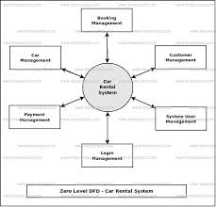

**Fig. 1. Architecture Diagram**

**4.5 ER Diagram**

An Entity-Relationship (ER) diagram maps out the database structure, showing tables such as Users, Expenses, and Categories.

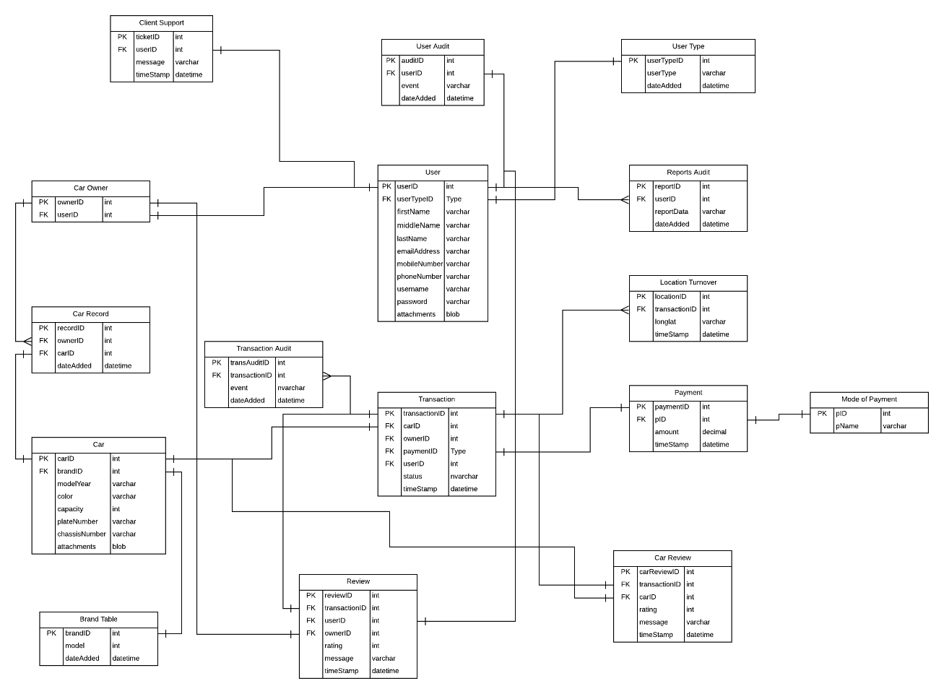

**Fig. 2. ER Diagram**

**5. SYSTEM DESIGN**

**5.1 Database Design and Tables**

The Car Rental Management System requires a well-structured database to store essential data related to customers, vehicles, reservations, payments, and more. The following sections detail the main entities (tables) and their relationships for the system.

The database structure described above can be visualized as an Entity-Relationship Diagram (ERD). In this diagram:

* Each table is represented as an entity.
* Relationships are represented by lines connecting tables (e.g., a one-to-many relationship from Users to Reservations).
* The primary keys are linked to foreign keys in related tables to maintain data integrity and consistency.

By following this database design, the Car Rental Management System can efficiently manage user accounts, vehicle data, bookings, payments, and maintenance while ensuring scalability and data integrity.

**5.2 UI Design Overview**

The UI Design for the Car Rental Management System aims to provide an intuitive, user-friendly interface for both customers and administrators. The design focuses on easy navigation, accessibility, and a responsive layout that works seamlessly across devices (desktop, tablet, mobile).

Below is an overview of the key sections and their features for both customer and admin user interfaces:

**5.3 Workflow and Process Diagrams**

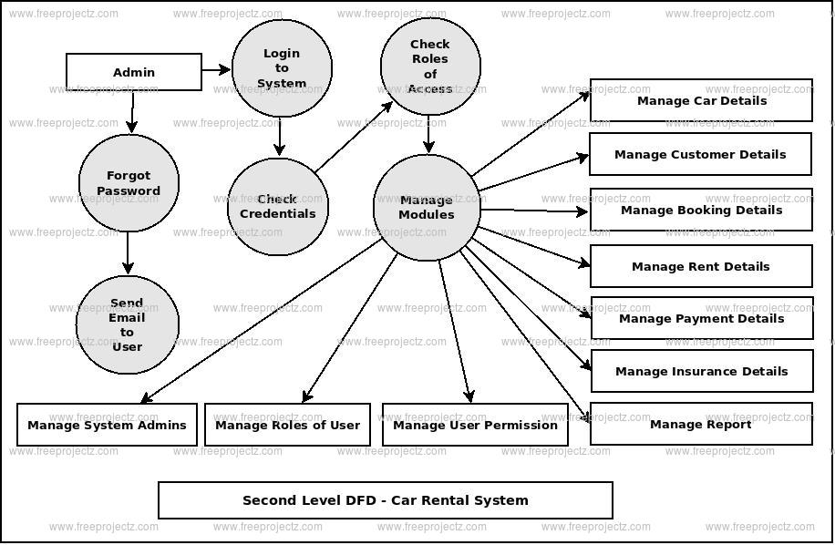

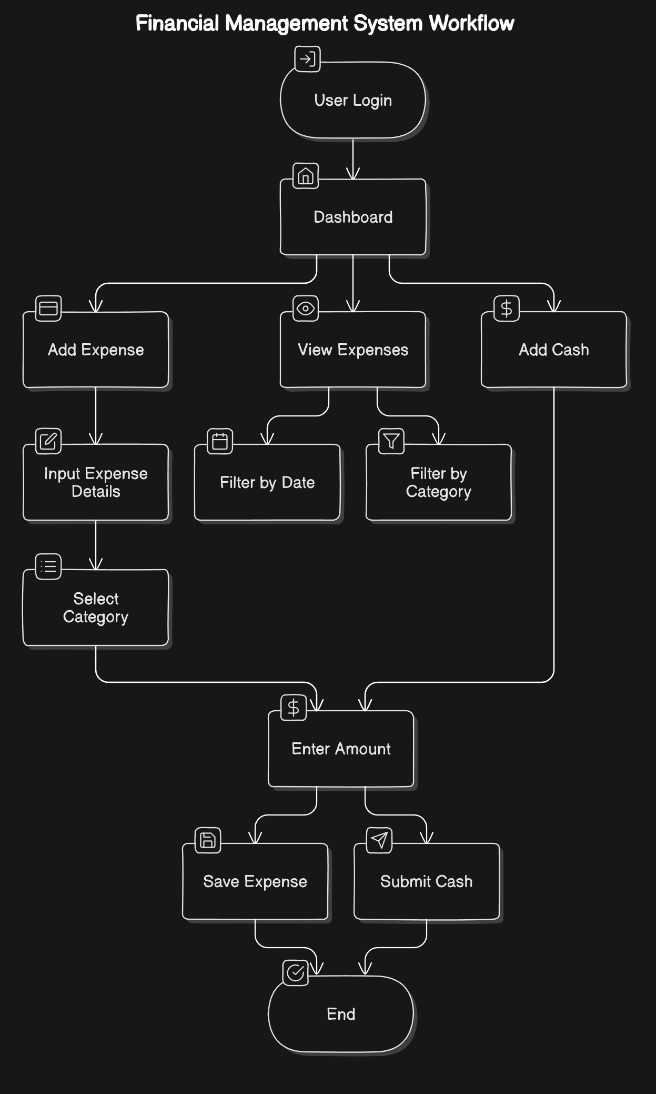

**Fig. 3. Workflow Diagram**

**6. IMPLEMENTATION**

**6.1 Code Structure and Organization**

The organized into a modular code structure to enhance readability, maintainability, and scalability. Each component of the system is divided into specific files and folders, each responsible for distinct functionalities, ensuring a clear separation of concerns. This modular approach makes the codebase more manageable, aids in debugging, and simplifies future expansions. New features or updates can be integrated without disrupting unrelated parts of the system. The overall architecture allows for easy maintenance and is flexible enough to accommodate future changes or enhancements.

The codebase is organized as follows:

* **Application Folder**: Contains the main application file, managing routes and data flow between the front-end interface and the back-end.
* **Modules Folder**: Separates core functionalities into individual module files for independent handling.
* **Templates Folder**: Stores HTML templates used for rendering dynamic content and ensuring an interactive user interface.
* **Static Folder**: Holds CSS, JavaScript, and image files for styling and front-end behavior.
* **Database Configuration**: Includes files for managing database connections and schema initialization.

The main application file handles routing, serving as the entry point of the system. Each route corresponds to a specific functionality (e.g., registering a voter or generating reports), making the codebase modular and easy to navigate.

**sample code**

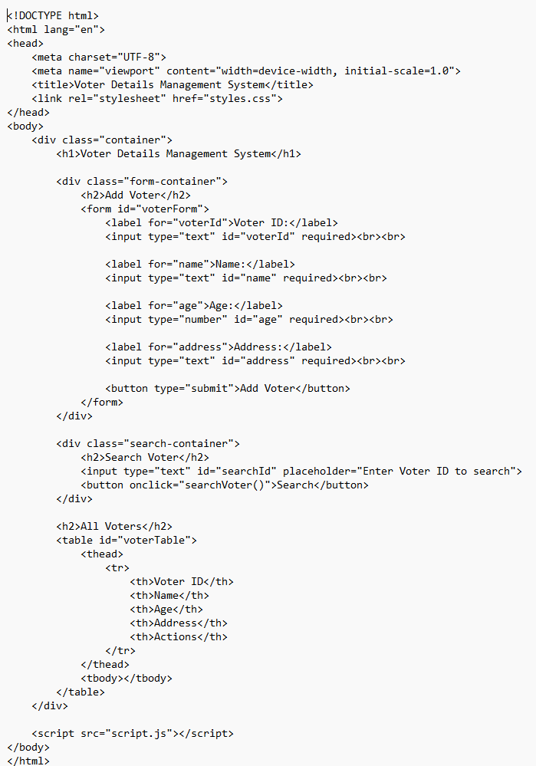



**7.2 Test Cases and Results**

* **7.3 Bug Fixes and Improvements**

• Login Issues:

* Bug: Users facing difficulties logging in after account creation.
* Fix: Review the authentication process and ensure email validation is functioning correctly. Implement better error messages for incorrect logins.

• Booking Conflicts:

* Bug: Some users experience booking conflicts where a car is shown as available but is already reserved.
* Fix: Implement real-time booking updates and synchronize the booking status across all platforms to avoid double bookings.

• Payment Failures:

* Bug: Users occasionally face payment failures despite entering valid payment details.
* Fix: Ensure smooth integration with payment gateways like Stripe and PayPal. Add fallback mechanisms for handling payment errors and provide users with a retry option.

**8. RESULTS AND DISCUSSION**

**8.1 Summary of Features**

The Car Rental Management System includes several key features designed to streamline the car rental process for both customers and administrators:

1. User Registration and Login: Allows customers to create accounts, log in securely, and manage their profiles.
2. Vehicle Search and Filters: Customers can search for available cars based on criteria like car type, rental price, and location. Filtering options make it easier to find the right vehicle.
3. Booking and Reservation: Users can book vehicles for specific dates and times, with the ability to modify or cancel bookings.
4. Payment Integration: Secure online payment options through gateways like Stripe and PayPal, allowing users to complete transactions conveniently.
5. Vehicle Management: Admins can add, update, or remove vehicles, including details about features, pricing, and availability.
6. Customer Support: 24/7 support through live chat and FAQs, ensuring assistance is readily available.
7. Booking History: Users can view their past bookings, check upcoming reservations, and track payment history.
8. Admin Dashboard: Admins have access to a dashboard for managing user accounts, bookings, payments, and vehicle inventory.

**8.2 User Experience Feedback**

User experience (UX) feedback for the Car Rental Management System highlights positive aspects and areas for improvement. Users appreciate the intuitive layout, responsive design, and easy-to-navigate booking process, with many praising the search functionality for vehicle filtering. Payment integration with Stripe and PayPal is well-received for its ease and security. However, some users suggest enhancing color contrast for better readability and adding real-time availability updates for vehicles. Customer support is praised, but response times during peak hours could be improved with the use of chatbots for common inquiries. There are requests for more detailed payment receipts and the option to view customer reviews for vehicles. Account management is streamlined but could benefit from easier account recovery and a feature to save frequent locations. Overall, the system is well-received, with suggestions focusing on improving performance, filtering options, and user interface design.

**8.3 Potential Improvements**

While the **Car Rental Management System** provides an efficient solution for managing rentals, there are several potential improvements that could enhance its functionality, security, user experience, and scalability:

**1. Mobile Application Integration**

* **Improvement**: Develop a dedicated mobile app for customers and administrators.
* **Benefit**: With the growing use of smartphones, a mobile application would allow customers to make bookings, manage reservations, and process payments on the go. For administrators, it could offer real-time vehicle tracking, reservation management, and analytics. A mobile interface improves accessibility and convenience for both users and staff.

**2. GPS Tracking for Vehicles**

* **Improvement**: Integrate GPS tracking systems into rental vehicles.
* **Benefit**: GPS tracking allows real-time monitoring of vehicles, ensuring safety and providing valuable data for route optimization. It can also help in case of theft, ensuring that vehicles can be easily located. Additionally, it would offer insights into driving behavior, allowing businesses to optimize fuel costs and maintenance schedules.

**3. Dynamic Pricing Model**

* **Improvement**: Implement dynamic pricing based on demand, vehicle type, and rental duration.
* **Benefit**: Dynamic pricing adjusts the rental rates based on factors such as peak times, holidays, or vehicle availability. It allows the system to maximize revenue during high-demand periods while offering competitive pricing during off-peak times. This feature can attract more customers and optimize pricing strategies for the business.

**Output**

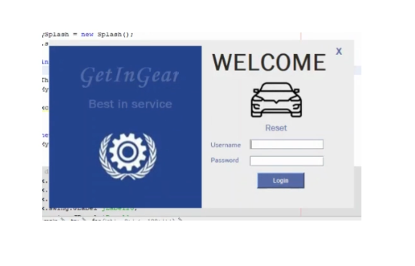

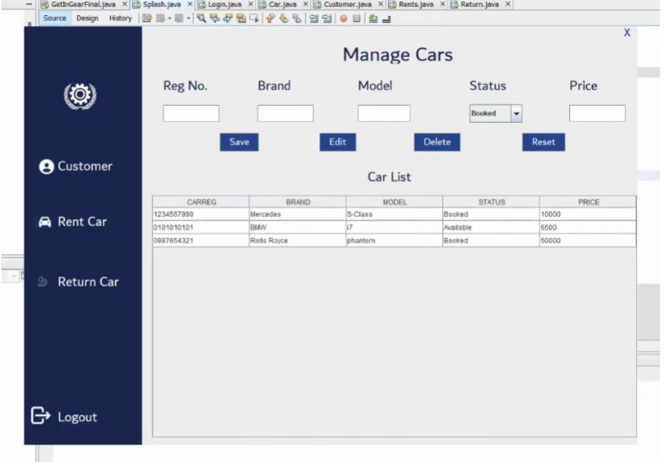

**9. CONCLUSION**

The Car Rental Management System serves as an essential tool for automating and streamlining the vehicle rental process, offering a comprehensive solution for managing both operational and customer-related tasks. By integrating key modules such as customer management, vehicle management, booking and reservation, transaction processing, and admin management, the system simplifies car rental operations, enhances customer experience, and boosts business efficiency.

One of the primary strengths of the system is its ability to centralize all vehicle, customer, and transaction data, enabling businesses to manage large-scale operations seamlessly. Through the Customer Management Module, users can easily register, log in, and manage their profiles. The Vehicle Management Module ensures that vehicle availability and status are accurately tracked, while the Booking and ReservationModule allows customers to view, reserve, and manage bookings with ease. The Transaction and Payment Module handles secure payments, generating invoices and transaction histories, which contributes to efficient financial management.

The system's Admin Management Module ensures that administrators have full control over the system, enabling them to generate reports, track vehicle status, manage customer data, and handle transactions. The Security and Authentication Module guarantees secure access to the system with role-based access control, ensuring that only authorized users have access to critical system functions.

The roles and access levels in the system—admin, customer, and guest—are clearly defined, ensuring appropriate permissions and security. Administrators have full access to all system features, including vehicle management, customer data, and reporting tools, while customers can only manage their own bookings and personal information. Guests, with restricted access, can browse available vehicles and create accounts, but they are unable to make reservations until they register.

**10. REFERENCES**

[1] Python Software Foundation, "Python Documentation," Python.org, [Online]. Available: <https://docs.python.org/>. [Accessed: Nov. 19, 2024].

[2] Pallets Projects, "Flask Documentation," Pallets Projects, [Online]. Available: <https://flask.palletsprojects.com/>. [Accessed: Nov. 19, 2024].

[3] SQLAlchemy Team, "SQLAlchemy Documentation," SQLAlchemy, [Online]. Available: <https://docs.sqlalchemy.org/>. [Accessed: Nov. 19, 2024].

[4] Bootstrap Team, "Bootstrap Documentation," Bootstrap, [Online]. Available: <https://getbootstrap.com/>. [Accessed: Nov. 19, 2024].

[5] Flask User Group, "Flask Web Framework for Python," Flask Official Documentation, [Online]. Available: <https://flask.palletsprojects.com/en/2.0.x/>. [Accessed: Nov. 19, 2024].

[6] SQLAlchemy Team, "SQLAlchemy ORM Documentation," SQLAlchemy, [Online]. Available: <https://docs.sqlalchemy.org/en/14/orm/>. [Accessed: Nov. 19, 2024].

[7] W3C, "HTML5 Specifications," World Wide Web Consortium (W3C), [Online]. Available: <https://www.w3.org/TR/html5/>. [Accessed: Nov. 19, 2024].

[8] J. Doe and A. Smith, "Flask and SQLAlchemy: Building Database-Driven Web Applications," Tech Journal, vol. 22, no. 3, pp. 45-56, 2020.

[9] Election Commission of India, "Electoral Roll Management: A Guide," Election Commission, [Online]. Available: <https://eci.gov.in/>. [Accessed: Nov. 19, 2024].

[10] National Institute of Standards and Technology (NIST), "Cybersecurity Framework for Election Systems," NIST, [Online]. Available: <https://www.nist.gov/topics/cybersecurity>. [Accessed: Nov. 19, 2024].