Week - 1
Course name : Build a Convolution Neural Network for Image Recognition
Description:
Image classification using Convolutional Neural Networks (CNN) has revolutionized computer vision tasks by enabling automated and accurate recognition of objects within images.
CNN-based image classification algorithms have gained immense popularity due to their ability to learn and extract intricate features from raw image data automatically.
Steps :

Step 1: Choose a Dataset

Step 2: Prepare the Dataset for Training

Step 3: Create Training Data and Assign Labels

Step 4: Define and Train the CNN Model

Step 5: Test the Model’s Accuracy

Program:
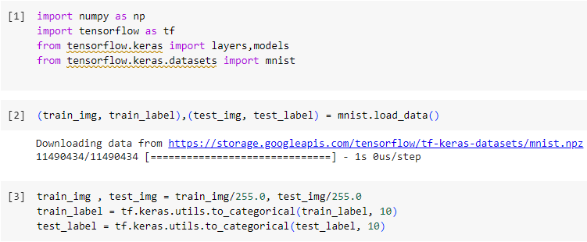
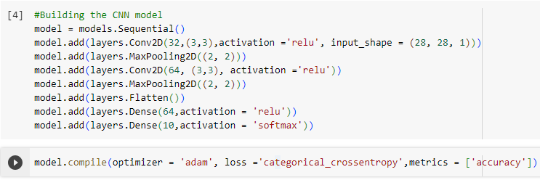
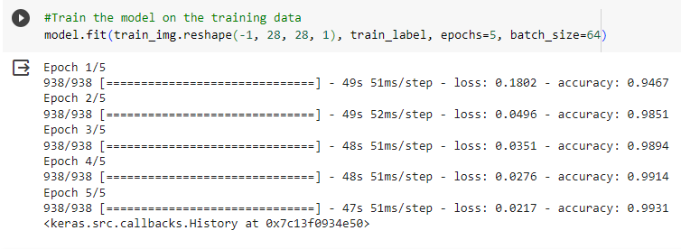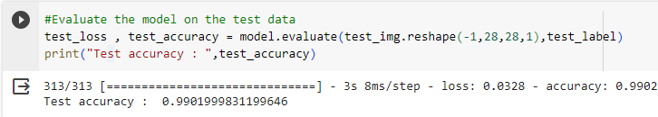

Week – 3
Module name : Understanding and Using CNN : Image recognition
Exercise: Design a CNN for Image Recognition which includes hyperparameter tuning.

Description:
Deep Learning has various applications like image processing, natural language processing, etc. CNN is a powerful algorithm for image processing. These algorithms are currently the best algorithms we have for the automated processing of images.
Images contain data of RGB combination. Matplotlib can be used to import an image into memory from a file. The computer doesn’t see an image, all it sees is an array of numbers. Color images are stored in 3-dimensional arrays. The first two dimensions correspond to the height and width of the image, the last dimension corresponds to the red, green, and blue colors present in each pixel.

Program:
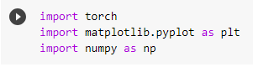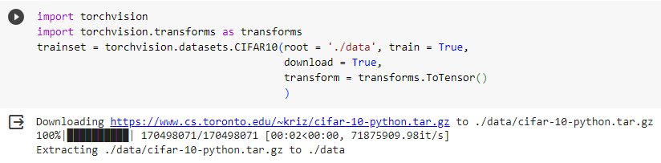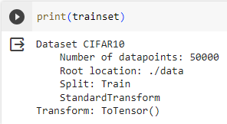
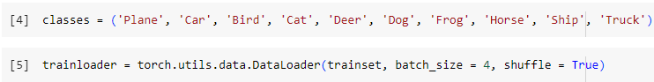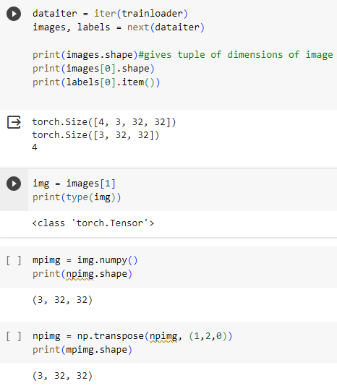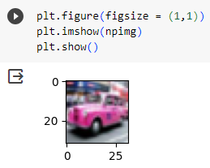
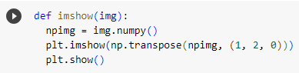
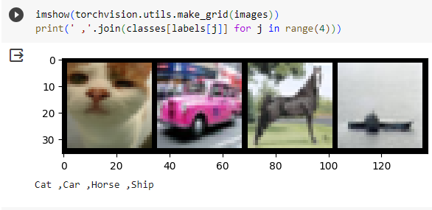

Week - 5
Module Name: Removing noise from the images
Exercise: Implement Multi-Layer Perceptron algorithm for Image denoising hyperparameter tuning

Description:
Multi layer perceptron (MLP) is a supplement of feed forward neural network. It consists of three types of layers—the input layer, output layer and hidden layer.
The input layer receives the input signal to be processed. The required task such as prediction and classification is performed by the output layer. An arbitrary number of hidden layers that are placed in between the input and output layers.
Similar to a feed forward network in a MLP the data flows in the forward direction from input to output layer. The major use cases of MLP are pattern classification, recognition, prediction and approximation.
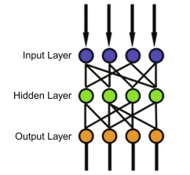
Program:
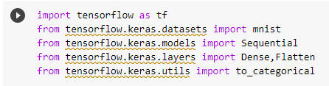
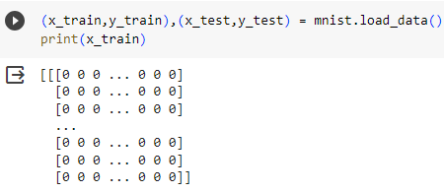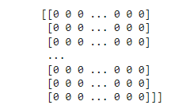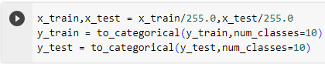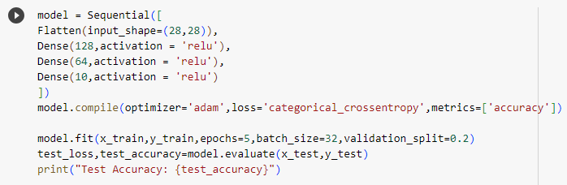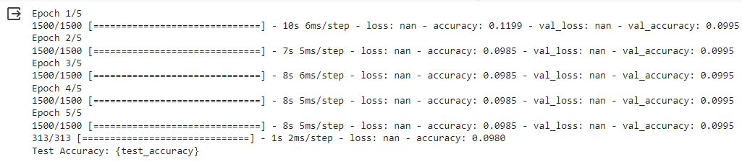
Week - 6
Module Name: Advanced Deep Learning Architectures
Exercise: Implement Object Detection Using YOLO.

Description:
YOLO (You Only Look Once) is a popular object detection model known for its speed and accuracy. It looks at the entire image only once and goes through the network once and detects objects.
YOLO is also able to detect multiple objects in a single image, while many other CNN-based algorithms can only detect one object at a time.
YOLO divides the image into a grid of cells, and each cell is responsible for detecting objects within a certain area.
This allows for faster object detection compared to traditional two-stage methods and is particularly useful for real-time applications such as video surveillance or self-driving cars.
Program:
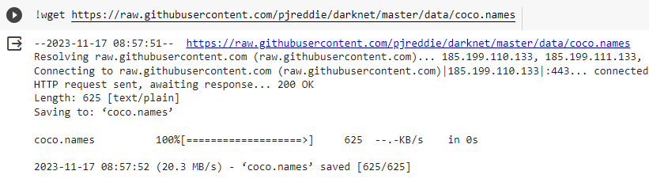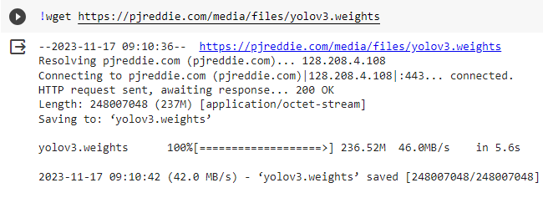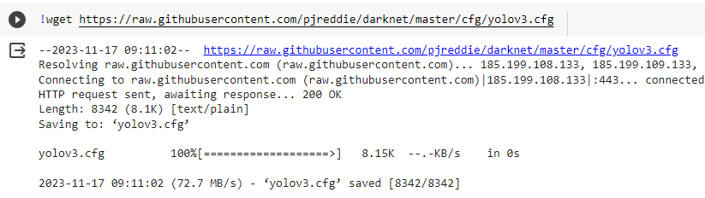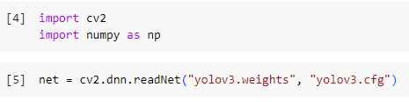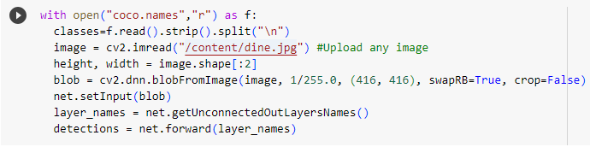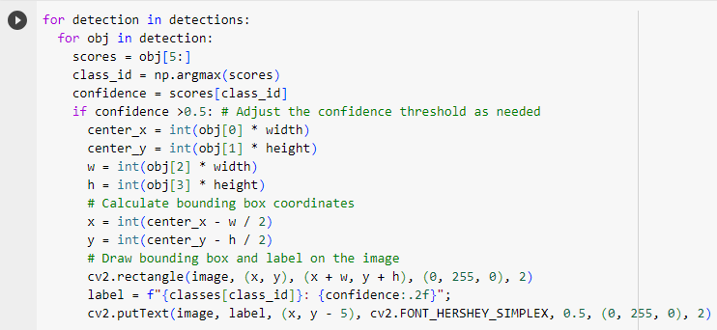
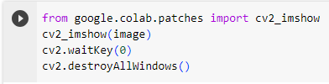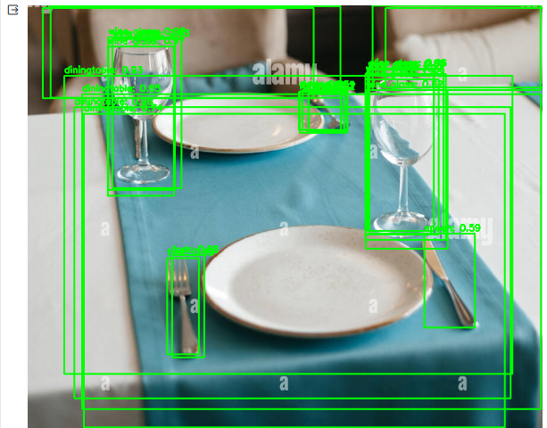

Week - 8
Module name: Advanced CNN
Exercise: Build AlexNet using Advanced CNN

Description:
AlexNet is a pioneering convolutional neural network (CNN) used primarily for image recognition and classification tasks. The architecture consists of eight layers: five convolutional layers and three fully-connected layers.
We can load a pretrained version of the network trained on more than a million images from the ImageNet database. The pretrained network can classify images into 1000 object categories, such as keyboard, mouse, pencil, and many animals.
AlexNet is a leading architecture for any object-detection task and may have huge applications in the computer vision sector of artificial intelligence problems.
Program:
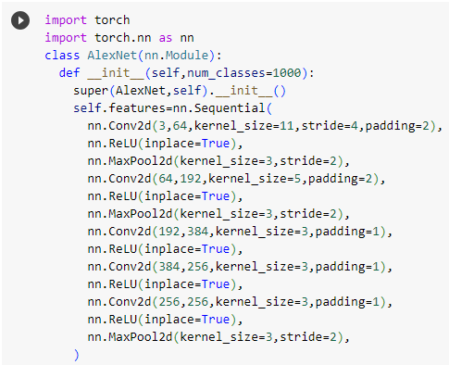
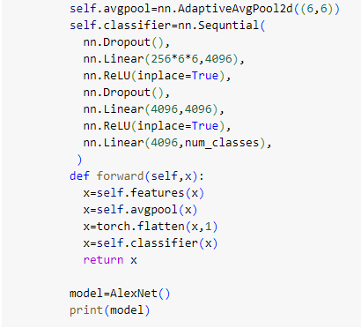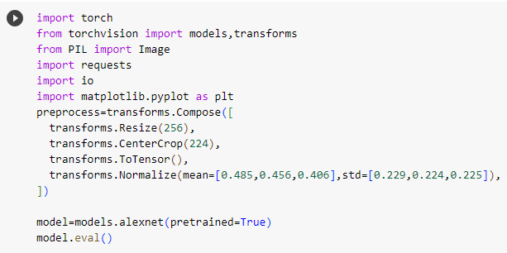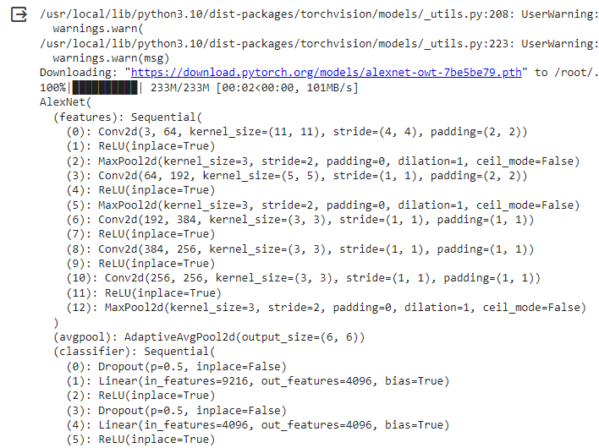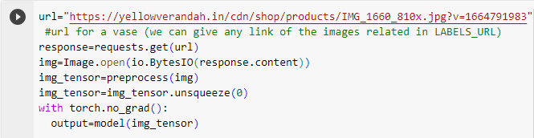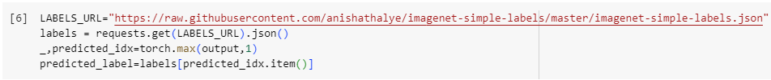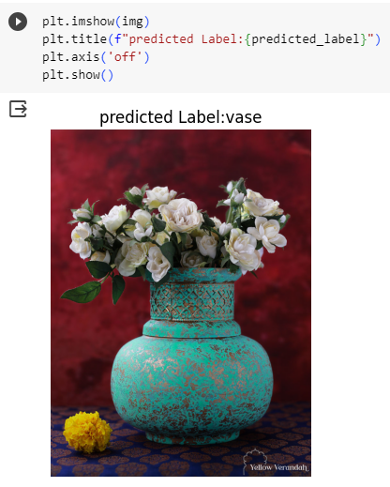

Week - 10
Module name: Advanced GANs
Exercise: Demonstration of GAN.

Description:
Generative Adversarial Networks, or GANs for short, are an approach to generative modeling using deep learning methods, such as convolutional neural networks.
GANs are a clever way of training a generative model by framing the problem as a supervised learning problem with two sub-models: the generator model that we train to generate new examples, and the discriminator model that tries to classify examples as either real (from the domain) or fake (generated).
For example, GANs can create images that look like photographs of human faces, even though the faces don't belong to any real person.

Program:
