Docker

VM:
A Virtual Machine (VM) is a software-based emulation of a physical computer. It allows you to run multiple operating systems on a single physical machine. Each VM acts as an independent system with its own resources like CPU, memory, and storage, provided by the host machine.

Hypervisor
A hypervisor is software or firmware that creates and manages virtual machines (VMs) on a physical computer (called the host). It allows multiple VMs, each running their own operating system, to share the hardware resources of the host machine
VM and Docker:

Virtual Machines (VMs)

Advantages:
- Isolation: Each VM is fully isolated, so issues in one VM don't affect others.
- Compatibility: Can run any OS on any host machine.
- Mature Technology: Well-established and widely supported.

Disadvantages:
- Resource Intensive: Requires more CPU, memory, and storage as each VM runs a full OS.
- Slower Startup: VMs take longer to boot compared to containers.
- Less Portability: Moving VMs between systems is slower and more complex.

Docker (Containers)
- What: Lightweight virtualization using the host OS to share resources.

Advantages:
- Lightweight: Uses less CPU, memory, and storage since it shares the host OS.
- Fast Startup: Containers start almost instantly.
- Portability: Easy to move and deploy across environments.

Disadvantages:
- Less Isolation: Containers share the host OS kernel, so issues can affect others.
- Limited OS Support: Can’t run different OS types on the same host (e.g., no Windows container on Linux host).
- Newer Technology: May have less support in legacy systems.

Docker
Docker is a platform for creating, running, and managing containers. Containers are lightweight, portable environments that package an application and all its dependencies, so it runs the same on any system.
Why docker container light wight:
Docker containers are lightweight because they package only the application and necessary dependencies, while sharing the host OS kernel, making them more efficient than traditional virtual machines.
Docker container, only the application-related libraries and dependencies are typically included. This is one of the key principles of Docker containers: they package everything that the application needs to run, but nothing more.
Docker containers are logically isolated from each other and from the host system.
VM and Docker architectural:

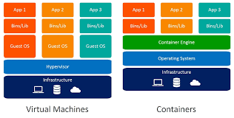

Example of Folder Structure on the Docker Host
On the Docker host, Docker stores its data, images, volumes, and other related configurations. The typical default directory for Docker’s files on a Linux-based host is /var/lib/docker/
/var/lib/docker/
├── containers/ # Container-specific data (logs, config, etc.)
│ ├── [container-id]/
│ │ ├── config.v2.json # Container configuration file
│ │ ├── hostconfig.json # Host configuration for the container
│ │ ├── mounts/ # Mounted volumes or bind mounts
│ │ ├── resolv.conf # Container DNS resolver settings
│ │ ├── container-log # Container logs
│ │ └── ... # Other container-specific data
├── images/ # Docker images (layers stored as directories)
│ ├── [image-id]/ # Individual image layers
│ ├── layerdb/ # Metadata for image layers
│ ├── repositories.json # JSON file storing image references
├── volumes/ # Volumes (persistent data)
│ ├── [volume-id]/ # Volume data and metadata
├── networks/ # Docker network configuration
│ ├── [network-id]/ # Network settings (e.g., bridge network config)
├── tmp/ # Temporary Docker files
├── trust/ # Docker content trust data
├── aufs/ # File system layers (if using AUFS storage driver)
├── devicemapper/ # Device mapper data (if using devicemapper storage driver)
└── ... # Other internal data for Docker
/etc/docker/ # Docker daemon configuration files (e.g., `daemon.json`)
/var/log/docker.log # Logs for Docker daemon

Example of Folder Structure Inside a Docker Container (Container-based)
Inside the Docker container, the file system is isolated and consists of the necessary components for running the application, based on the image it was created from. A typical Docker container file system can look similar to a minimal Linux environment, depending on the base image used (e.g., Alpine, Ubuntu, Node.js).
/bin/ # Essential binaries (e.g., /bin/bash, /bin/ls)
/boot/ # Boot-related files (not always present in minimal images)
/dev/ # Device files (e.g., /dev/tty1)
/etc/ # Configuration files (e.g., /etc/hostname, /etc/hosts)
/home/ # User home directories (rarely used in minimal images)
/lib/ # System libraries for binaries (e.g., /lib/ld-linux.so)
/libexec/ # Utility programs for the system (sometimes)
/mnt/ # Mount points for storage devices
/proc/ # Process information (like /proc/cpuinfo)
/root/ # Root user’s home directory (if not using non-root user)
/run/ # Runtime data, usually contains PID files
/sbin/ # System binaries (e.g., /sbin/init, /sbin/reboot)
/srv/ # Service-related files (not always used)
/sys/ # Kernel-related information (e.g., /sys/fs)
/tmp/ # Temporary files (e.g., /tmp/tempfile)
/usr/ # User binaries, libraries, documentation
├── bin/ # Non-essential binaries
├── lib/ # User libraries
├── local/ # Local programs and packages
├── share/ # Shared data (e.g., /usr/share/doc)
/var/ # Variable files, logs, caches
├── log/ # Logs (e.g., /var/log/)
├── lib/ # Application data (e.g., /var/lib/mysql/)

Docker Architecture:

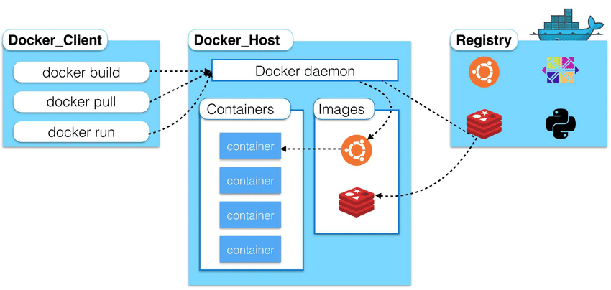

Summary:
- Docker Client: User interface for commands.
- Docker Daemon: Manages containers and images.
- Docker Images: Templates for creating containers.
- Docker Containers: Running instances of images.
- Docker Registries: Storage for images.
- Docker Volumes: Persistent storage for containers.
- Docker Networks: Communication between containers.
Docker registry:
Docker registry is a storage and distribution system for Docker images. Docker images are stored in a registry, and the registry allows users to pull images to create containers or push images to share them

Docker Client:
The Docker Client is the command-line tool (CLI) or graphical interface you use to interact with Docker

Docker Daemon
The Docker Daemon (also called dockerd) is the background service that manages Docker containers, images, and networks.

Docker Desktop, both the Docker Client and Daemon work together to provide a seamless environment for developing and managing containers locally.

Docker Container Lifecycle
The Docker container lifecycle refers to the different stages a container goes through from creation to deletion
Pulling an Image: Download the image from a registry.
Command: docker pull <image_name>
Creating a Container: Create a container from an image (without running it yet).
Command: docker create <image_name>
Starting a Container: Start the container from the created image.
Command: docker run <image_name> or docker start <container_id>
Running the Container: The container runs and executes the application defined in the image.
Command: docker run -d --name <container_name> <image_name>
Pausing a Container: Temporarily suspend all processes in the container.
Command: docker pause <container_id>
Stopping a Container: Stop the container, halting all its processes.
Command: docker stop <container_id>
Restarting a Container: Stop and start the container again.
Command: docker restart <container_id>
Removing a Container: Remove the container to free up resources (must be stopped first).
Command: docker rm <container_id>
Viewing Logs: View the logs generated by a running container.
Command: docker logs <container_id>

docker file:

A Dockerfile is a plain text file containing a set of instructions used to build a Docker image. It automates the process of creating Docker images by specifying everything needed to set up the environment for an application, such as the base image, dependencies, commands, and configurations.

Structure of a Dockerfile
- FROM:
  - Specifies the base image to use (e.g., a Linux OS or an application runtime).
FROM ubuntu:20.04
- RUN:
  - Executes a command during the image build process (e.g., installing software or updating packages).
RUN apt-get update && apt-get install -y python3
- COPY or ADD:
  - Copies files from the host machine to the container's filesystem.
COPY app.py /app/
- WORKDIR:
  - Sets the working directory inside the container.
WORKDIR /app
- CMD:
  - Specifies the default command to run when the container starts.
CMD ["python3", "app.py"]
- EXPOSE:
  - Indicates the port the container will listen on.
EXPOSE 8080
- ENV:
  - Sets environment variables inside the container.
ENV APP_ENV=production

- ENTRYPOINT:
  - Similar to CMD, but allows adding arguments during docker run.
ENTRYPOINT ["python3"]
- VOLUME:
  - Creates a mount point for persistent data storage.
VOLUME /data
- LABEL:
  - Adds metadata to the image (e.g., version, description).
LABEL maintainer="you@example.com"

Docker Multi-Stage Builds
Docker multi-stage builds help create lightweight and efficient Docker images by separating the build process into multiple stages. This approach allows you to copy only the necessary files from one stage to the next, reducing the final image size.

How Multi-Stage Builds Work
- Stages: Each stage in the Dockerfile is defined by a FROM statement.
- Intermediate Build: Intermediate stages can include dependencies, tools, or build processes, but they don't end up in the final image.
- Copy Artifacts: Use the COPY --from=<stage> instruction to copy only the needed files to the final stage.

Distroless Images
A distroless image is a minimalist container image that excludes package managers, shells, and other unnecessary utilities. It focuses only on the application and its runtime dependencies, making the image smaller and more secure.

Key Features
- No OS Packages:
  - Doesn't include tools like bash, curl, or apt.
- Security:
  - Smaller attack surface due to fewer components.
- Lightweight:
  - Minimal image size reduces storage and deployment time.

Final Comparison:
Feature | Multistage Build | Distroless Image
Purpose | To build and copy only necessary files | To provide minimal, secure runtime environments
Base Image | Can use any image for the build stage | Uses distroless base images for runtime
Build Tools | Full build tools in the first stage | No build tools at all in the final image
Shell/Utilities | Can include shell and debugging utilities | No shell or debugging utilities
Image Size | Smaller than a single-stage build, but can be larger than distroless | Very small, minimal size for production
Security | Depends on the base image, but can be more secure than a single-stage build | Highly secure due to minimal components
Use Case | General use, both for development and production | Primarily for running production applications

In summary:
- Multistage builds use multiple stages to optimize the image by copying only necessary files, which can lead to smaller images.
- Distroless images are designed to run applications with minimal components, which leads to small, efficient, and secure images but without the ability to build or interact with the container.

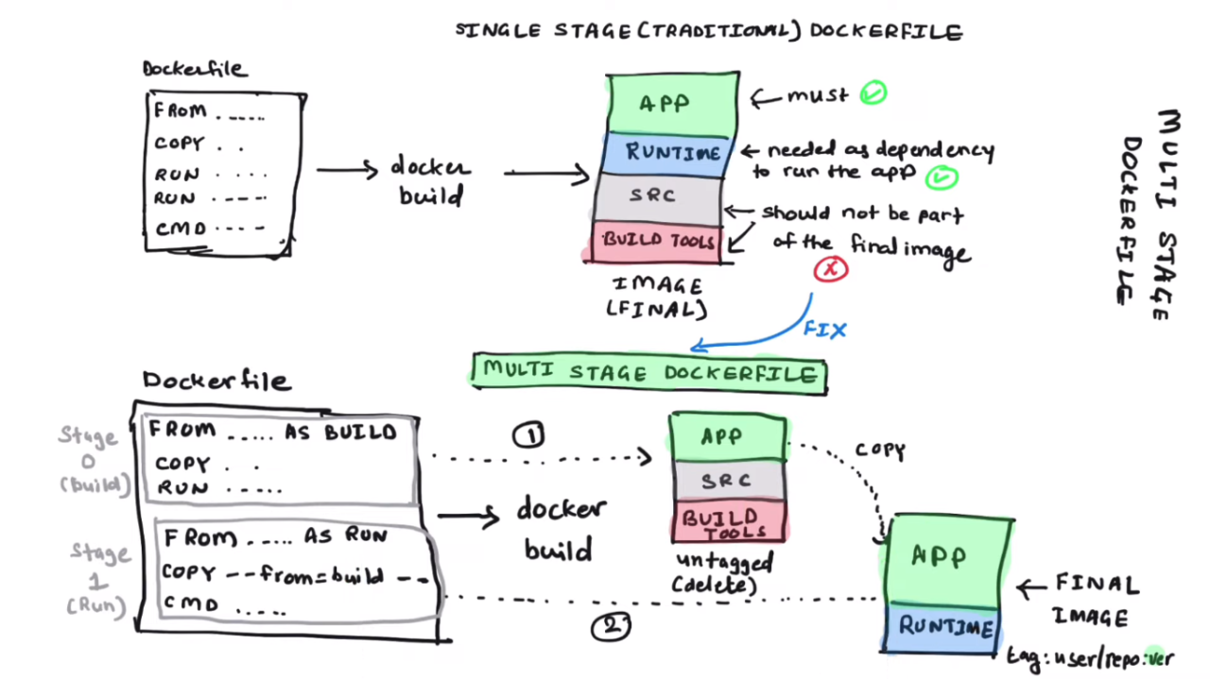

Docker Volumes:
A volume is a Docker-managed storage mechanism. Volumes are stored and managed by Docker outside the container filesystem.

Bind Mounts (Host Mounts):
A bind mount allows you to mount a specific file or directory from the host filesystem into the container. This gives the container access to files or directories on the host system.

Comparison: Volumes vs Bind Mounts
Feature | Volumes | Bind Mounts (Host Mounts)
Storage Location | Managed by Docker (in /var/lib/docker/volumes) | Directly on the host filesystem
Persistence | Data persists even after the container is removed | Data is tied to the host system (can be lost if container is removed)
Management | Docker manages the lifecycle of volumes | The user manages the host directory
Use Case | Ideal for production environments and sharing data between containers | Ideal for development environments (live file syncing)
Performance | Docker optimizes performance for volumes | May offer better performance as it directly accesses the host filesystem
Security | More isolated, as it does not directly expose the host filesystem | Less isolated, container can access the host filesystem directly

Example for docker volume :

# Create a volume
docker volume create my_volume

# Run a container with the volume mounted
docker run -d -v my_volume:/data my_image

Example for binary mount:
# Run a container with a bind mount
docker run -d -v /host/path:/container/path my_image

Docker Network - Simple Explanation
Docker networks allow containers to communicate with each other, the host system, and the outside world. By default, Docker creates several networks, but you can also create your own custom networks.
Bridge Network (Default)
- Description: The default network type used by Docker when no other network is specified. It is a private internal network used by containers on the same host.
- Use Case: Ideal for containers that need to communicate with each other on the same host but don't need to be accessible externally.
- Example: When you run a container without specifying any network, it is automatically attached to the bridge network.
How to use:
docker run -d --name container_name --network bridge my_image

Host Network
- Description: With this network, the container shares the network stack of the host machine. The container doesn't get its own IP address; it uses the host’s IP address.
- Use Case: Used when the container needs to have the same network interface as the host, for example, when dealing with performance-sensitive applications.
- Example: If you want a container to access the host machine's network directly, use the host network.
How to use:
docker run -d --name container_name --network host my_image

None Network
- Description: This network mode disables networking for the container entirely. The container won't be able to communicate over the network unless additional configuration is done.
- Use Case: Useful when the container does not require any network access, such as running isolated jobs.
Example:

docker run -d --name container_name --network none my_image

Overlay Network
- Description: Overlay networks allow containers running on different Docker hosts to communicate with each other. This is typically used in Docker Swarm or Kubernetes, which involve multiple Docker hosts.
- Use Case: Ideal for multi-host networking where containers need to communicate across different Docker nodes.
- Example: In a Docker Swarm cluster, you use an overlay network to ensure services running on different nodes can communicate.
How to use:
docker network create -d overlay my_overlay_network

Macvlan Network
- Description: The Macvlan network driver allows you to assign a MAC address to each container, making it appear as a physical network device on the network.
- Use Case: Typically used when containers need to appear as individual devices on the network, or when you need to assign an IP address outside of Docker’s default bridge network.

How to use:

docker network create -d macvlan --subnet=192.168.1.0/24 my_macvlan_network

Custom Networks
- Description: Custom networks allow you to define specific networking configurations between containers. By using a custom bridge network, for example, you can control DNS, subnets, and IP allocation.
- Use Case: Useful when you need more granular control over the network configurations.

How to use:

docker network create --driver bridge my_custom_network

interview questions:
1, what is docker?
Docker is a tool that helps you run applications in isolated environments called containers. A container packages an application and everything it needs to run (like libraries and dependencies) into a single unit. This makes the application portable, so it can run the same way on any computer, whether on a developer’s machine or in the cloud."
2, how container is different from vm?
Containers and virtual machines both help isolate applications, but they do so differently.
- Containers are lightweight and share the host machine's operating system (OS). They only include the application and its dependencies, making them smaller and faster to start.
- Virtual machines (VMs), on the other hand, run a full operating system inside each VM, which includes its own OS and kernel. This makes VMs more resource-heavy and slower to start compared to containers.
3, docker life cycle?
The Docker lifecycle consists of the following stages:
- Create: A container is created from an image but not started yet.
- Start: The container is started, and the application inside it begins running.
- Running: The container is actively running.
- Pause/Unpause: The container can be paused to temporarily stop its processes and unpaused to resume them.
- Stop: The container is stopped, and the application inside it is no longer running.
- Kill: The container is forcibly stopped immediately.
- Restart: The container stops and then starts again.
- Remove: The container is deleted permanently."

4, what are the different components of Docker?
- Docker Engine: The core of Docker, which includes:
  - Docker Daemon: Runs in the background and manages containers.
  - Docker CLI (Command-Line Interface): Used to interact with the Docker daemon and manage containers.
- Docker Images: Blueprints for containers that include the application and its dependencies.
- Docker Containers: Lightweight, portable environments created from Docker images.
- Docker Registries: Repositories where Docker images are stored and shared, like Docker Hub or private registries.
- Docker Compose: A tool for defining and running multi-container Docker applications.
- Docker Swarm: A native orchestration tool for managing clusters of Docker containers."
5, what is different between docker add and copy?
COPY and ADD are both instructions in a Dockerfile used to copy files into an image, but they have some differences:
- COPY:
  - Copies files or directories from the local filesystem to the image.
  - Simple and straightforward.
- ADD:
  - Does everything COPY does.
  - Additionally, it can:
    - Automatically extract compressed files (like .tar.gz).
    - Copy files from remote URLs (not recommended for security reasons).
Best Practice: Use COPY unless you specifically need ADD for its additional features.

6, What is differences between CMD and entrypoint?
CMD and ENTRYPOINT are both used to specify the command that runs when a container starts, but they work differently:
- CMD:
  - Provides default arguments or commands for the container.
  - Can be overridden by arguments passed during docker run.
- ENTRYPOINT:
  - Defines the main process that runs in the container.
  - Cannot be overridden, but arguments can be appended to it during docker run.
Key Difference:
- Use CMD when you want a default command that users can easily override.
- Use ENTRYPOINT when you want the container to always execute a specific command."
7, what are the network type in docker what is the default?
1. Bridge (Default):
  - Used for standalone containers.
  - Containers on the same bridge can communicate with each other.
  - Default network type for containers.
- Host:
  - Shares the host machine's network stack.
  - No isolation; the container uses the host's network directly.
- None:
  - Completely disables networking.
  - Used for security or testing purposes.
- Overlay:
  - Used for multi-host communication in Docker Swarm.
  - Connects containers across different hosts.
- Macvlan:
  - Assigns a MAC address to the container for direct communication with the physical network.
- Custom User-Defined:
  - Allows creation of custom bridge or overlay networks with specific configurations.
Default Network: Bridge is the default network type in Docker."

8, can you explain how to isolate network between containers?
Isolate networks between containers in Docker, you can use user-defined networks. Containers connected to different networks cannot communicate with each other
9, what is multi stage build in docker?
multi-stage build in Docker is a technique where multiple stages are used in a single Dockerfile to create lightweight and efficient images. It allows you to:
- Use intermediate stages to build your application.
- Copy only the necessary files into the final image.
- Keep the final image small by excluding build tools and unnecessary files.
10, what are distroless image in docker?
distroless image is a minimal Docker image that does not include an operating system package manager, shell, or other unnecessary tools. It only contains the application and its runtime dependencies.
11, real time challenges with docker?
1. Single Daemon Process:
  - The Docker Daemon is a single point of failure. If it crashes, all running containers stop.
- Root Privileges:
  - Docker Daemon runs with root access by default, which can lead to significant security risks if a container is compromised.
- Resource Constraints:
  - By default, containers can use all available host resources (CPU, memory, disk). Without proper limits, a single container can starve others, causing performance issues.
- Shared Kernel:
  - Containers share the host's kernel. A kernel-level vulnerability or misconfiguration can impact all containers on the host.
- Limited Isolation:
  - Although logically isolated, containers are not as isolated as virtual machines, leading to potential risks when running untrusted workloads.
- Image Management:
  - Managing and updating container images without bloating disk space or risking outdated dependencies can be challenging."
12. What steps would you take to secure the container?
1. Run Containers with Least Privileges:
  - Avoid running containers as the root user. Use a non-root user for better security isolation.
  - Use the USER directive in the Dockerfile to specify a non-root user.
- Use Official and Trusted Images:
  - Always use official or well-maintained images from trusted sources like Docker Hub or private repositories to avoid vulnerabilities.
- Regularly Update Images:
  - Keep container images up to date by regularly pulling the latest version and rebuilding your containers. This ensures that you get the latest security patches.
- Limit Container Resources:
  - Set CPU and memory limits to avoid a container consuming all host resources and impacting other containers. Use --memory and --cpu options.
- Use Docker Content Trust (DCT):
  - Enable Docker Content Trust (DOCKER_CONTENT_TRUST=1) to sign and verify images, ensuring that the image you’re using hasn’t been tampered with.
- Enable SELinux or AppArmor:
  - Use SELinux (Security-Enhanced Linux) or AppArmor to enforce security policies for containers, adding an extra layer of protection.
- Isolate Containers with User-Defined Networks:
  - Use user-defined networks for better isolation between containers. Avoid using the default bridge network if possible.
- Scan for Vulnerabilities:
  - Regularly scan your images for vulnerabilities using tools like Clair, Trivy, or Anchore.
- Limit Container Capabilities:
  - Remove unnecessary capabilities using Docker's --cap-drop option, limiting what the container can do at the OS level.
- Use Read-Only File Systems:
- Mount container file systems as read-only to prevent containers from modifying their file system unless absolutely necessary.
- Keep the Docker Daemon Secure:
- Restrict Docker Daemon access to trusted users and avoid exposing the Docker API over an unencrypted network.
- Enable Docker Audit Logs:
- Enable Docker’s audit logging to monitor container activity and detect unusual behavior or potential attacks.
- Network Segmentation:
- Use Docker's network modes (such as overlay, bridge, or macvlan) to control traffic flow between containers and protect sensitive workloads."

13. What is Docker Compose?
- Answer: Docker Compose is a tool for defining and running multi-container Docker applications. With Compose, you define a multi-container environment in a docker-compose.yml file and then use a single command (docker-compose up) to spin up all the services defined in the file. It helps manage complex applications that require multiple services to work together, such as a web server, database, and caching system.

- What is the difference between Docker volumes and bind mounts?
- Answer:
  - Volumes: Volumes are stored in a Docker-managed directory on the host machine. They are managed by Docker, and their location on the host is abstracted. Volumes are the preferred method for persistent data in Docker because they are easier to back up and restore.
  - Bind Mounts: Bind mounts are directly tied to specific paths on the host system. They give more control over the storage location and can be useful for specific needs (e.g., development), but they can be harder to manage than volumes.

- What is a Docker Registry?
- Answer: A Docker Registry is a system for storing and distributing Docker images. The most common registry is Docker Hub, but organizations can also set up private registries. Docker images are pushed to and pulled from a registry. It serves as a central repository for managing container images.

- What is the purpose of a Dockerfile?
- Answer: A Dockerfile is a script that contains a series of instructions on how to build a Docker image. It defines the base image, environment variables, dependencies, commands, and configuration required to run an application inside a container.

- What are some best practices for writing Dockerfiles?
- Answer:
  - Use official base images when possible for better security and compatibility.
  - Minimize the number of layers in the image by combining commands in a single RUN statement.
  - Always specify a specific tag for images rather than latest to ensure predictable behavior.
  - Use .dockerignore to exclude unnecessary files from the image.
  - Set a non-root user in the Dockerfile to improve security.
  - Clean up temporary files after installation to reduce image size.

18. How can you monitor Docker containers?
- Answer: Docker provides several ways to monitor containers:
  - docker stats: Provides real-time statistics on resource usage (CPU, memory, etc.) for running containers.
  - docker logs: Fetches logs for a container to monitor its output and diagnose issues.
  - Third-party tools: Tools like Prometheus, Grafana, and Datadog can provide more advanced monitoring and alerting for Docker containers.
19. What are Docker secrets and how are they used?
- Answer: Docker secrets are a way to securely manage sensitive information, such as passwords, API keys, or database credentials, inside a Docker Swarm cluster. Secrets are encrypted and only made available to containers that need them. This helps ensure that sensitive data is not exposed in plaintext within the containers or the Dockerfile.

20. What is Docker Swarm and how does it work?
- Answer: Docker Swarm is Docker's native clustering and orchestration tool. It allows you to manage a group of Docker engines (nodes) as a single cluster. Swarm handles the deployment, scaling, and load balancing of containers across multiple nodes. It enables high availability and fault tolerance by replicating services across multiple nodes in the cluster.

21. What are the use cases for Docker in real-time applications?
- Answer: Docker is commonly used for:
  - Development and Testing: Developers use Docker to create consistent environments across different stages (development, testing, production).
  - Microservices: Docker helps in deploying microservices as isolated, scalable units.
  - CI/CD Pipelines: Docker is used to build, test, and deploy applications in automated CI/CD workflows.
  - Cloud Environments: Docker helps in running containers on cloud services (AWS, Azure, GCP) for scalable and isolated application environments.

Docker composer:
Docker Compose is a tool used for defining and running multi-container Docker applications. It allows you to describe the services, networks, and volumes your application requires in a YAML file (docker-compose.yml), making it easier to manage complex environments.

Key Features of Docker Compose:
- Multi-Container Applications: Simplifies defining and running applications with multiple containers.
- Configuration as Code: Describes the application environment in a single file (docker-compose.yml).
- Isolation: Allows creating isolated environments for development, testing, and production.
- Easier Deployment: Use the same Compose file for various stages (dev, staging, prod).
- Scaling: Easily scale services up or down using simple commands.
Typical docker-compose.yml Structure:
version: '3.8'
services:
app:
image: my-app:latest
build:
context: .
ports:
- "3000:3000"
volumes:
- ./app:/usr/src/app
environment:
- NODE_ENV=development
depends_on:
- db
db:
image: mysql:latest
environment:
MYSQL_ROOT_PASSWORD: rootpassword
MYSQL_DATABASE: mydb
volumes:
- db_data:/var/lib/mysql
volumes:
db_data:

Commands Used in Docker Compose:
- Start Services:
docker-compose up
Add -d for detached mode:
docker-compose up -d
- Stop Services:
docker-compose down
- Build Images:
docker-compose build
- Scale Services:
docker-compose up --scale app=3
- View Logs:
docker-compose logs
- Check Running Services:
docker-compose ps

Differences Between Docker Desktop and CLI-Only Docker:
Feature | Docker Desktop | CLI-Only Docker
GUI Dashboard | Available | Not available
Kubernetes Integration | Built-in | Requires manual setup
Automatic Updates | Yes | Manual
Resource Management | Simplified | Requires manual tuning
Multi-Platform Builds | Seamless (via QEMU) | Requires configuration

Docker init:
The docker init command is not a standard Docker CLI command. However, Docker Desktop introduced a "docker init" feature in some contexts to simplify starting a new project. It helps users create a basic configuration for a containerized application by generating a Dockerfile and optionally a docker-compose.yml file.

Purpose of docker init:
- Automatically generates Docker-related configuration files for your project.
- Helps you quickly containerize your application without manual setup.
- Makes it easier for beginners to get started with Docker.

What is Multi-Arch in Docker?
Multi-arch images let you run the same Docker image on different platforms like Linux/AMD64 (x86_64) and Linux/ARM64. This is useful for supporting devices like servers and Raspberry Pi.

