|  |
| --- |
| Domain Name: Data Analytics with Cognos |
| Project Title: Customer Churn Prediction |

IBM Naan Mudhalvan

|  |  |
| --- | --- |
| Team Members and Register Number | Prakash V - 420421104052  Rohith T - 420421104064  Siva M - 420421104072  Gokulnath M - 420421104022 |

**Table of Contents**

1. **Introduction**
2. **Loading the Dataset**
3. **Data Preprocessing**
4. **Exploratory Data Analysis (EDA)**
5. **Split the dataset into training and testing sets**
6. **Model Building**
7. **Model Evaluation**
8. **Data Visualization**
9. **Conclusion**

**1. Introduction**

The Telco Customer Churn dataset provides information about customers' churn behavior in a telecommunications company. It includes various features that can be used to predict customer churn. We will use IBM Cognos for loading and preprocessing the data and Python for data analysis , visualization,Split the dataset into training and testing sets, Model Building, Model Evaluation.

Download the Telco Customer Churn dataset from the Kaggle link provided and save it in a directory of your choice.

**2. Loading the Dataset**

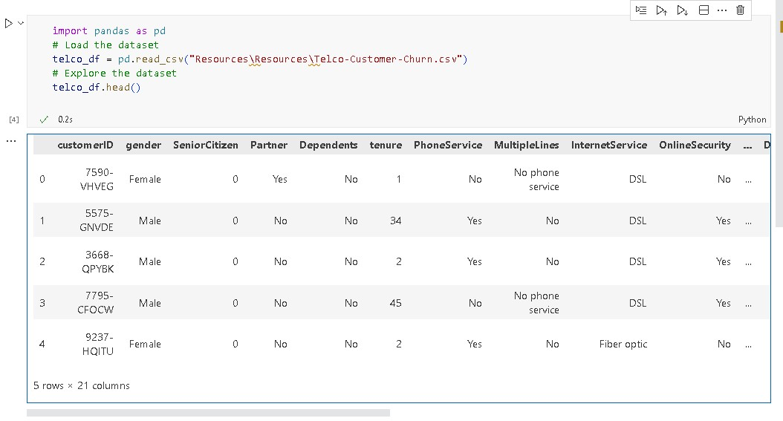

**3. Data Preprocessing**

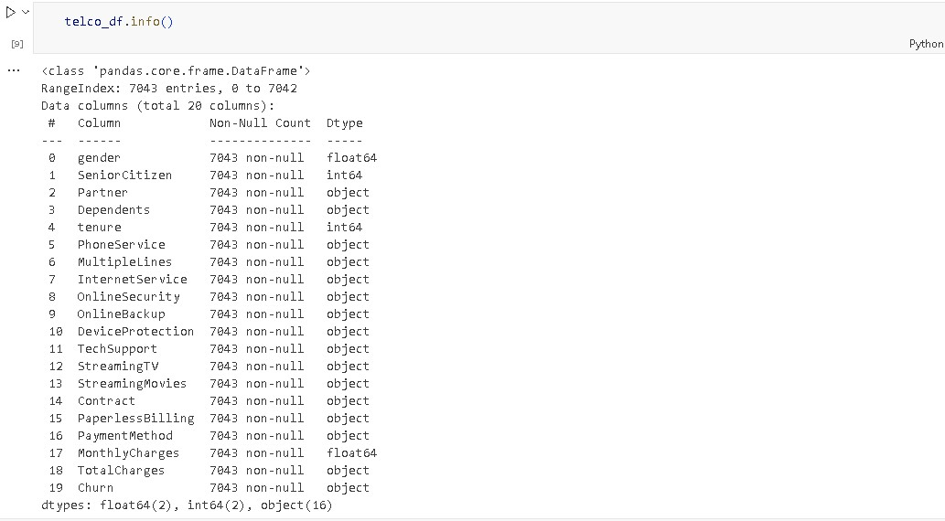

# Check for missing values

telco_df.isnull().sum()

# Handle missing values

telco_df.fillna(0, inplace=True)

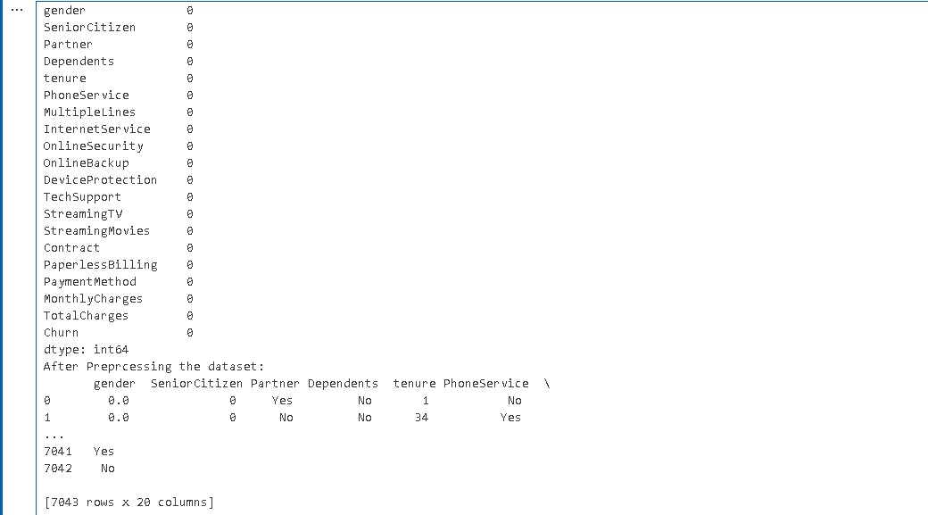

**4. Exploratory Data Analysis (EDA)**

Perform exploratory data analysis to gain insights into the dataset. Some EDA tasks you can perform include:

* Summary statistics: **telco_df.describe()**

telco_df.describe()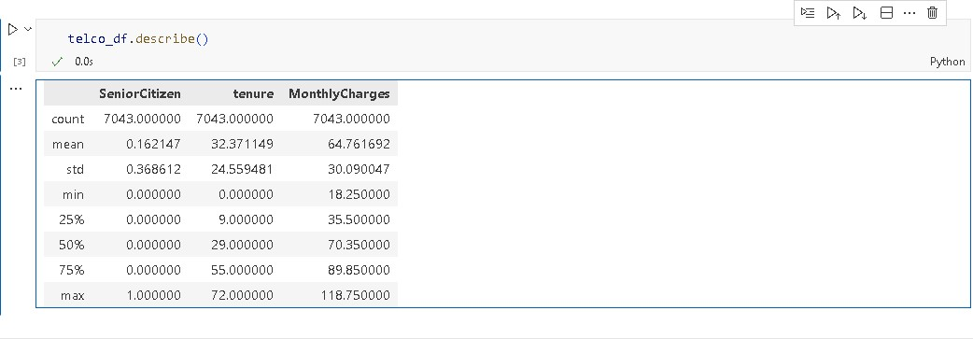

#data splitting

x=telco_df.drop(columns=['Churn'], axis=1)

y=telco_df["Churn"]

print(x) 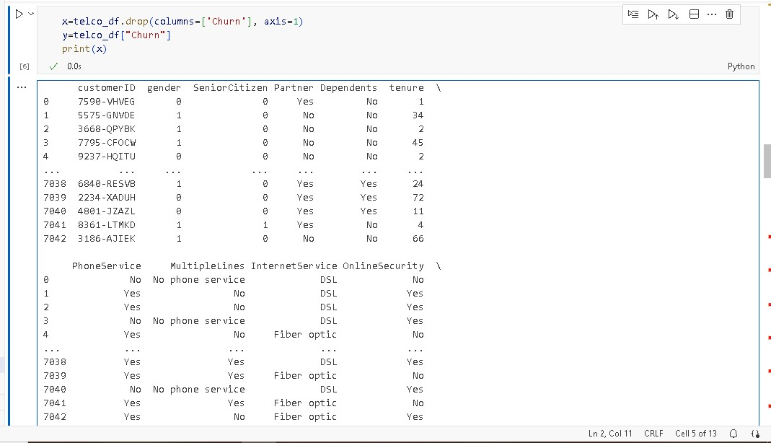

print(y)

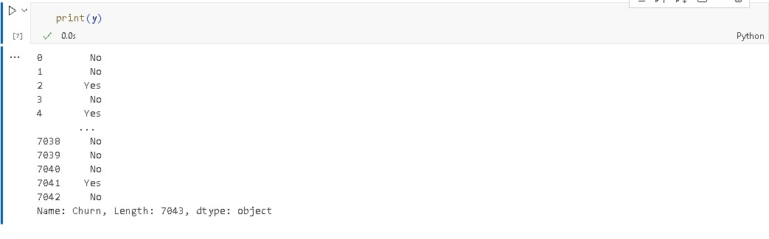

**#Convert all categorical data to numerical data.**

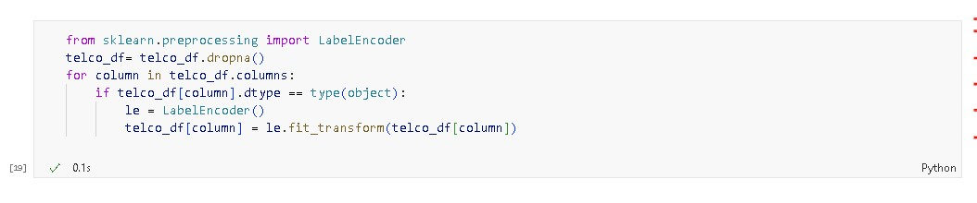

**#Checking all categorical data to numerical data.**

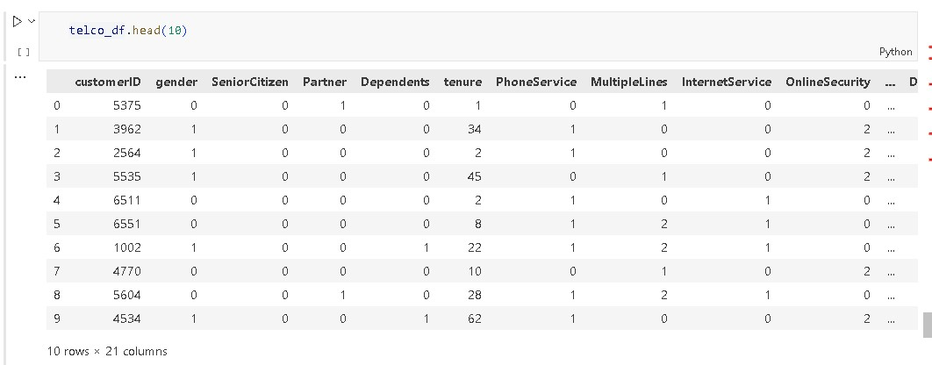

**5.Split the dataset into training and testing sets**

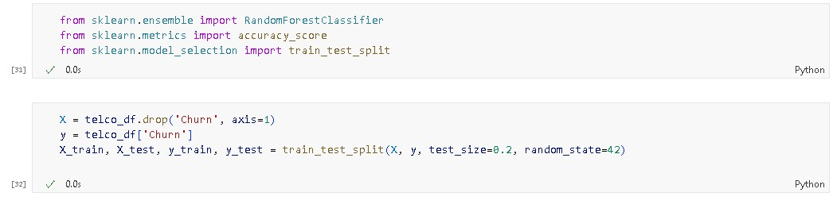

**6.Model Building**

**Here we use a Random Forest Classifier**

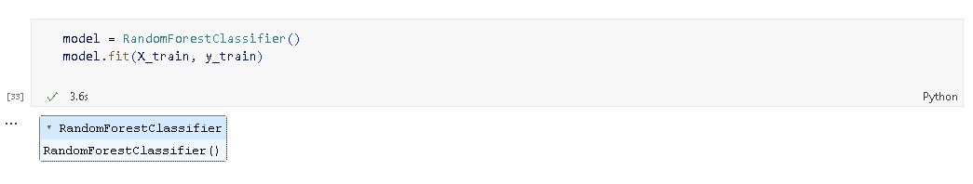

**7.Model Evaluation**

**Evaluate the model using the test data**

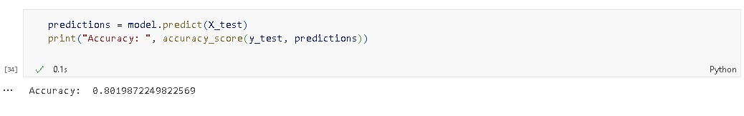

**8. Data Visualization**

Now that we've completed data preprocessing and some initial EDA using Python, let's switch to IBM Cognos for more advanced visualization, reporting, and analysis.

1. **Data Preparation**: Export the preprocessed dataset from Python to a format compatible with IBM Cognos (e.g., CSV).
2. **IBM Cognos**: Sign in to IBM Cognos and create a new project. Import the dataset into the project.
3. **Visualization**: Use the Cognos dashboard and reporting tools to create visualizations based on your analysis. You can create charts, graphs, and interactive dashboards to showcase key insights.
4. **Export**: Export the visualizations or dashboards as needed for sharing or presentation.

**By using python for data visualization**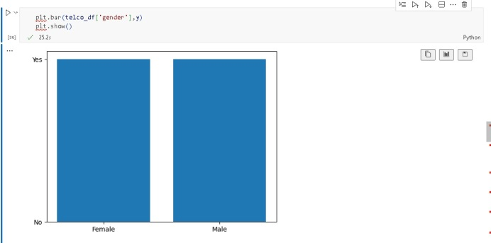

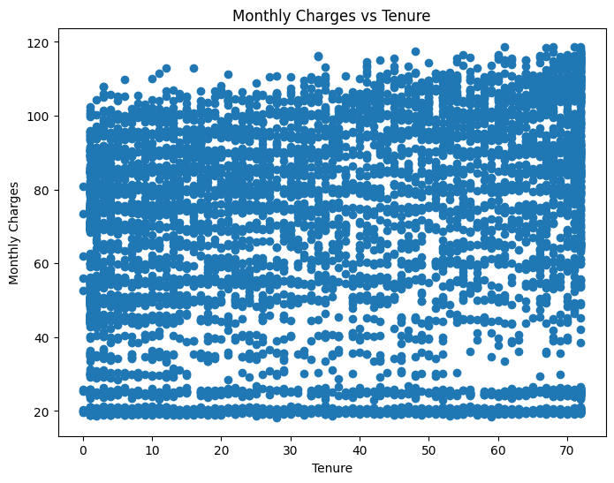 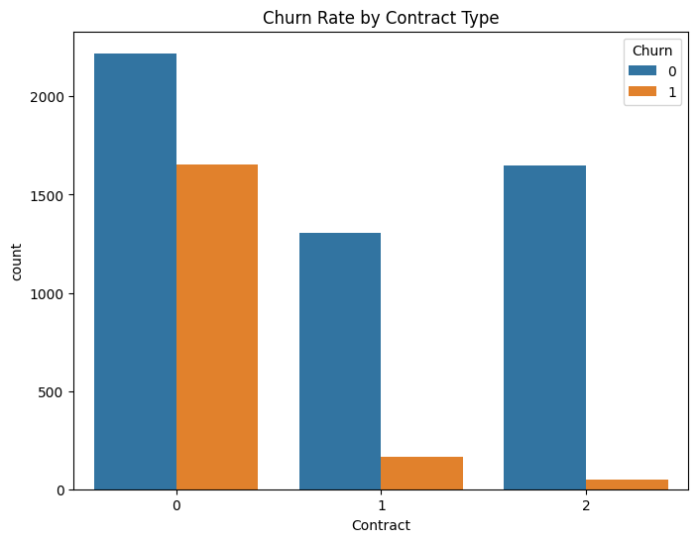

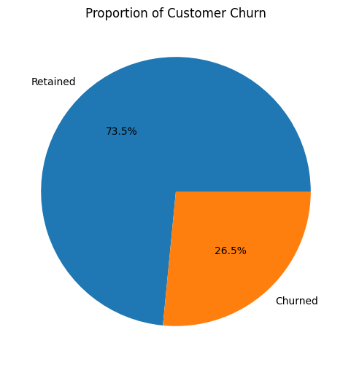 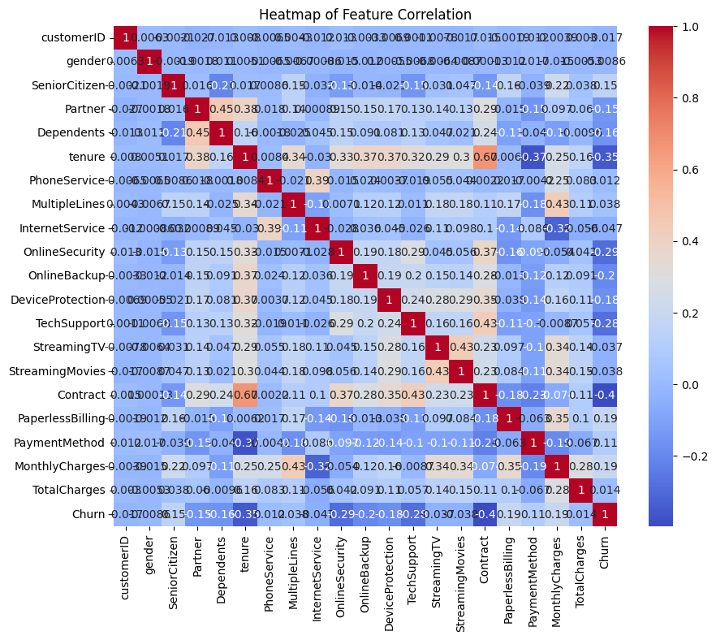

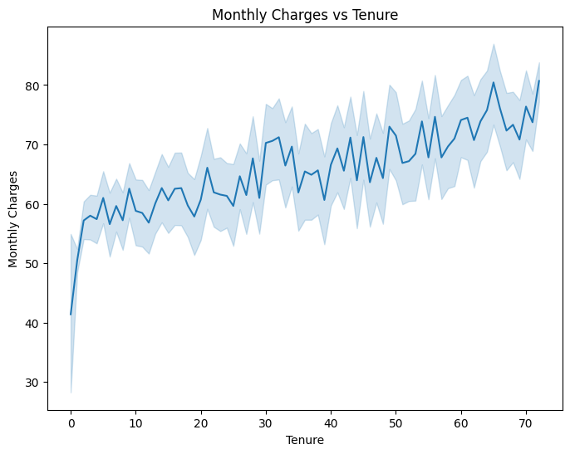 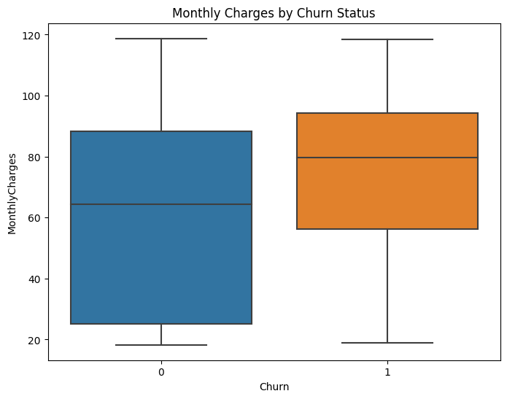

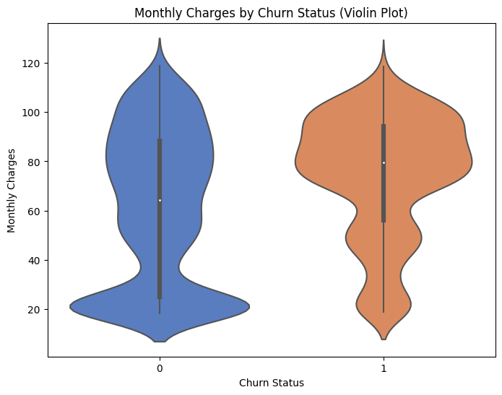 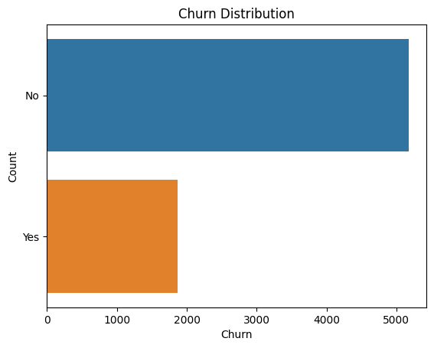

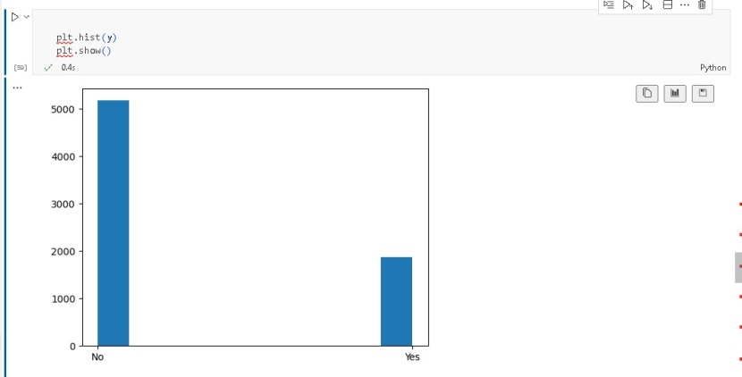

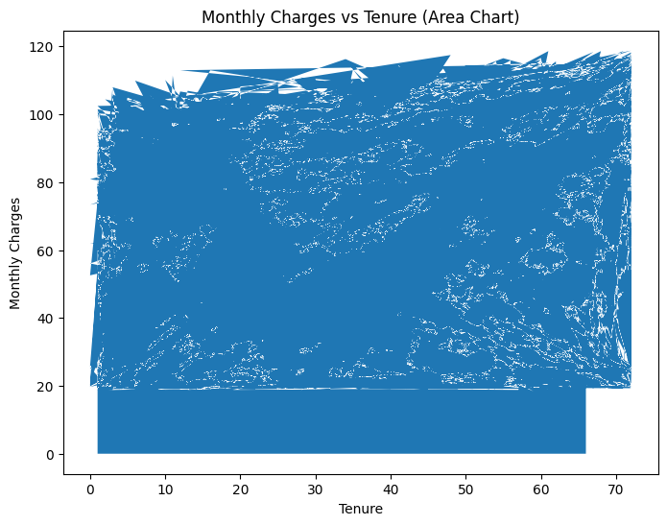

**9.Conclusion**

In this project, we successfully loaded and preprocessed Python for data analysis , visualization, Split the dataset into training and testing sets, Model Building, Model Evaluation.,the Telco Customer Churn dataset using Python. We then performed various analysis and visualization tasks using IBM Cognos. This document outlines the key steps and provides a starting point for conducting more in-depth analysis and creating insightful reports using the dataset and IBM Cognos.