**Transducer and Instrumentation – Assignment 02**

1. A mass M on a frictionless surface can move only along a line. What is the impulse response of this system for the following choice of system input and output? Based on the impulse response, indicate which are static and dynamic systems.
   1. Force $f\left(t\right)$ acting on the mass is the input and its acceleration $a\left(t\right)$ is the output.
   2. Force $f(t)$ acting on the mass is the input, and its velocity $v(t)$ is the output.
   3. Force $f(t)$ acting on the mass is the input, and its position $x(t)$ is the output.
2. Derive the mathematical expression relating the input and output of the following systems. What is the order of these systems? Derive the transfer function of each system and plot the corresponding magnitude and phase responses (using Matlab or Python).

|  |  |
| --- | --- |
|  |  |
| 1. Voltage divider circuit | (b) RC circuit |
|  |  |
| (c) RLC circuit | (d) LC circuit |

1. Consider the following mechanical system with force $f$ as the input and the velocity $v$ of the mass $M$ as the output. Plot the magnitude and phase response of this LTI system.

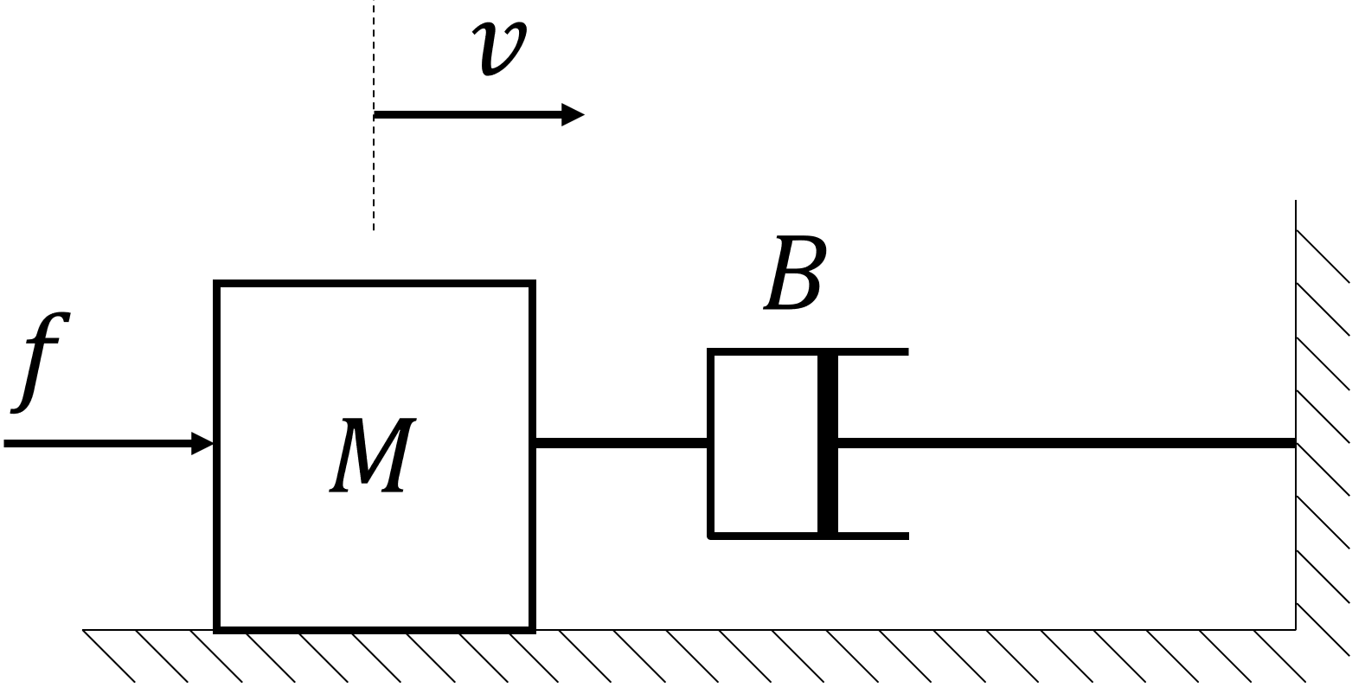

1. Consider the following linear force sensor where $f$ is the input force in Newtons and $v$ is the output voltage of the senor in. The parameter $k$ is the sensor’s static sensitivity with units ${mV}/N$. The actual output of the sensor consists of contribution from the input force, and measurement noise $ϵ$.

$$v=k∙f+ ε$$

If the measurement noise voltage $ε$ is normally distributed with mean $0$ and variance $9{mV}^{2}$, and $k=0.3{mV}/N$. What is the expected uncertainty (variance) in the force measured using this sensor assuming that $ϵ$ includes the contribution of all the possible sources of error in the sensing system. If you are interested in measuring forces in an application with variance of $1N^{2}$ would you recommend the use of this sensor? Explain your answer.

*Hint:* If the random variable $x$ is normally distributed with mean $μ$ and variance $σ^{2}$, then the random variable $\frac{x}{α}$ is normally distributed with mean $\frac{μ}{α}$ and variance $\frac{σ^{2}}{α^{2}}$, where $α$ is a real number.

You have a few of these sensors with you and all of them have the same sensitivity $k=0.05{mV}/N$ at your disposal, and you are able to use several of these to parallely measure the applied force in an application. Let’s assume that you have decided to use $N$ such sensors to make measurement of this single applied force $f$, such that,

$$\left.\begin{matrix}v_{1}=k∙f+ε_{1} \\ v_{2}=k∙f+ε_{2} \\ v_{3}=k∙f+ε_{3} \\ ⋮ \\ v_{N}=k∙f+ε_{N}\end{matrix}\right\}⟹v=Af+ε$$

What is the sensitivity matrix $A$? Given a measurement vector $v$, derive the expression for the force $f$ estimate using the $N$ measurements. How is noise affected by this estimation procedure? How many sensors would you need to use to get an estimate of the force $f$ with a variance less than or equal to $1N^{2}$?

*Hint:* If we have $L$ statistically independent random variables $x_{1},x_{2},…, x_{L}$ all of which are normally distributed with mean $μ$ and variance $σ^{2}$. Then the random variable $\frac{1}{L}\sum_{i=1}^{L}{x_{i}}$ has a mean $μ$ and variance $\frac{σ^{2}}{L}$.