**Transducer and Instrumentation – Assignment 03**

1. A particular sensor gives you output from 0 to 5V for a given range of values of the measurand. The output of this sensor is to be connected to another circuit (Processing Circuit in the figure below) which can strictly take inputs only in the range 0 to 3.3V. You need to attenuate your sensor output from 0-5V to a range 0-3.3V. Come up with a circuit for the box with ‘?’ shown below such that this circuit has high input impedance and low output impedance.

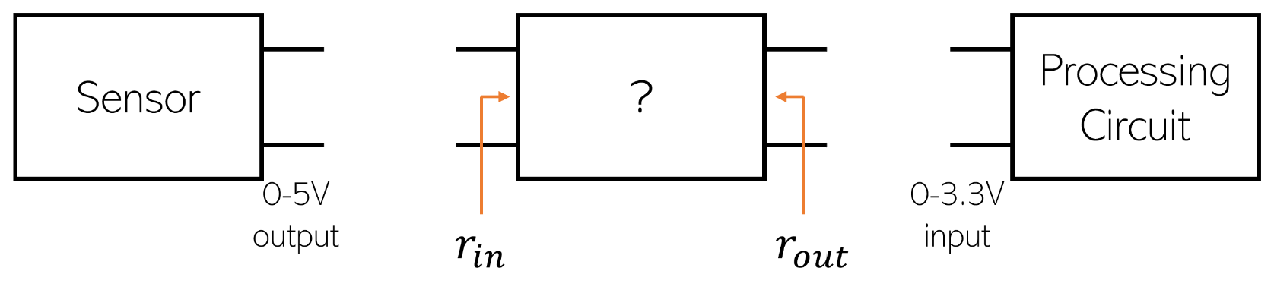

*Hint: Voltage divider, voltage follower*

1. Consider the following op-amp circuits. Assuming an ideal op-amp, derive the relationship between the input and the output for the following circuits.

|  |  |
| --- | --- |
| (a) | Find the relationship between , , and and the output voltage . |
|  | What is the input resistance seen by each input , , and ?  What is the output resistance of this circuit? |
| (b) | Find the relationship between , and and the output voltage . |
|  | Diagram, schematic  Description automatically generated  What is the input resistance seen by each input and ?  What is the output resistance of this circuit? |
| (c) | Find the relationship between the input and output . |
| (d) | Find the relationship between the input and output . |

1. Derive the differential gain of the three op-amp instrumentation amplifier.

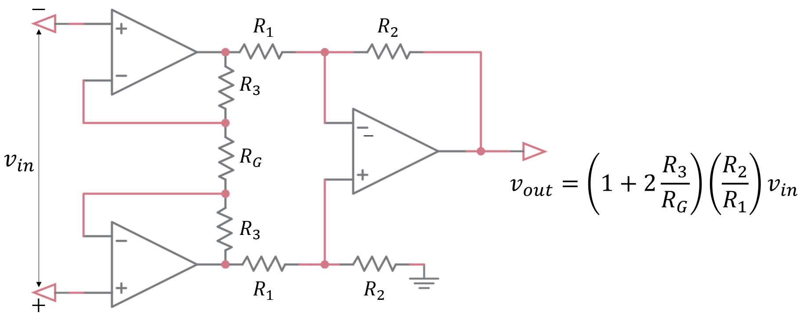

1. Voltage amplifiers are two-port systems whose output voltage is proportional to the input voltage. An ideal voltage amplifier must have infinite input impedance and zero output impedance to prevent any loading at the input and output ports. A current amplifier is a two-port system whose current flowing between its output terminals is proportional to current flowing through its input terminals. The equivalent circuit for a real current amplifier is shown below.

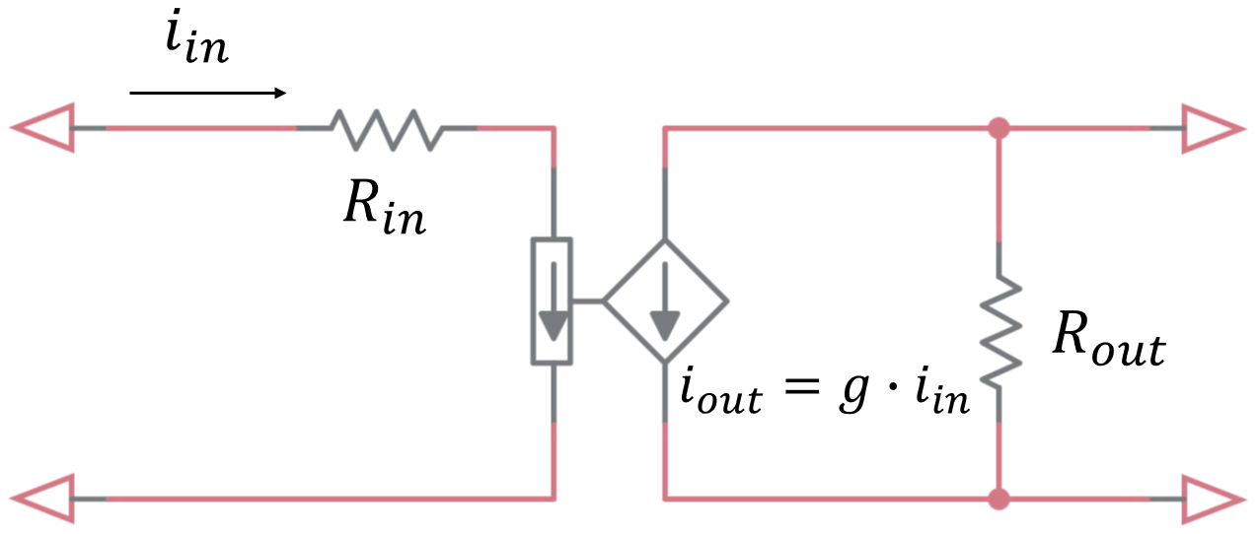

What should be the input and output impedance of a current amplifier to avoid loading at its input and output ports?