**Transducer and Instrumentation – Assignment 05**

Measuring Movements

1. With an incrementation encoder with a quadrature output, the angular resolution of the sensor is increased by four times. Is it possible to further increase the resolution of the incremental encoder by increasing the number of output channels? If we want to resolution of the encoder to be four times that of an encoder with quadrature output, how many output channels will we need and how far apart should the detectors for the individual outputs be? Propose an algorithm for measuring angle and the direction of rotation in this case.
2. We are interested in using the following sensor $S$ for measuring the angular velocity of a motor $M$ that is expected to rotate as a fixed angular rate. There is a circular opaque disc with a single slot and two detectors. Plot the output from detectors A and B as a function of time when the disc is rotating at a fixed angular velocity $ω$. Explain how we can use this sensor for measuring the magnitude and direction of the angular velocity $ω$.

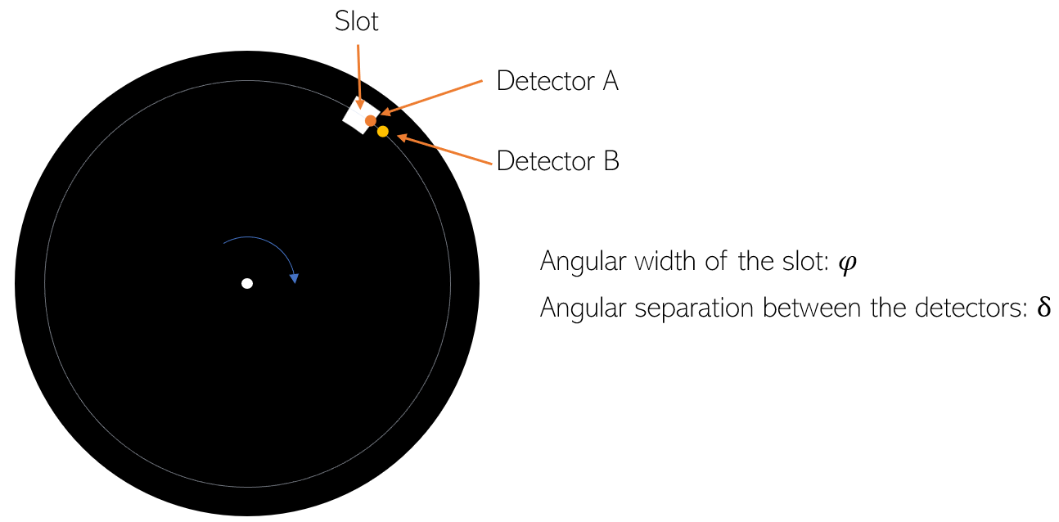

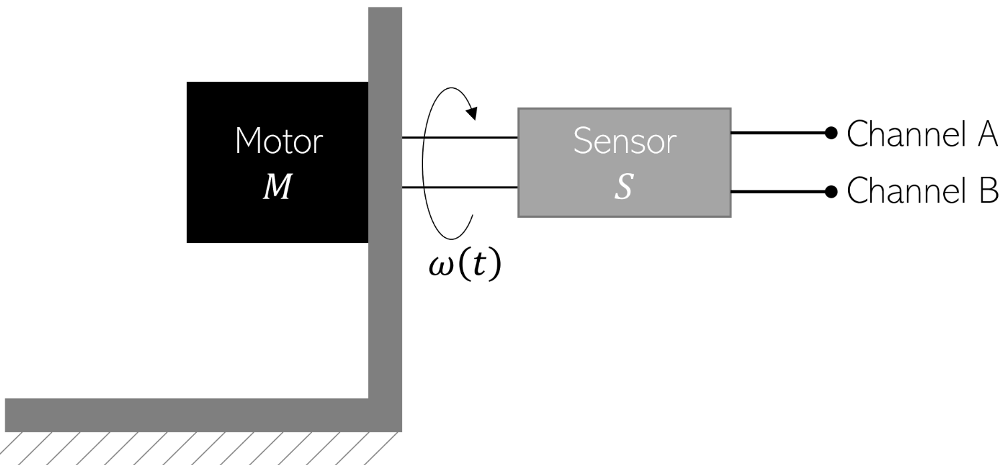

Unfortunately, the motor M’s angular velocity is not fixed and changes with time in the according to the following relationship,

$$ω\left(t\right)=ω_{0}+∆ω∙\sin\left(ω_{v}t\right)$$

Assuming $φ=5°$, $δ=2.5°$, $ω_{0}=400π rad.s^{-1}$, $∆ω=10π rad.s^{-1}$ and $ω_{v}=2π rad.s^{-1}$, write a computer program to plot the angular velocity estimate $\hat{ω}\left(t\right)$ using the sensor as a function of time. Compare this output with that of the true angular velocity profile $ω\left(t\right)$.

s

1. Consider the following accelerometer sensor.

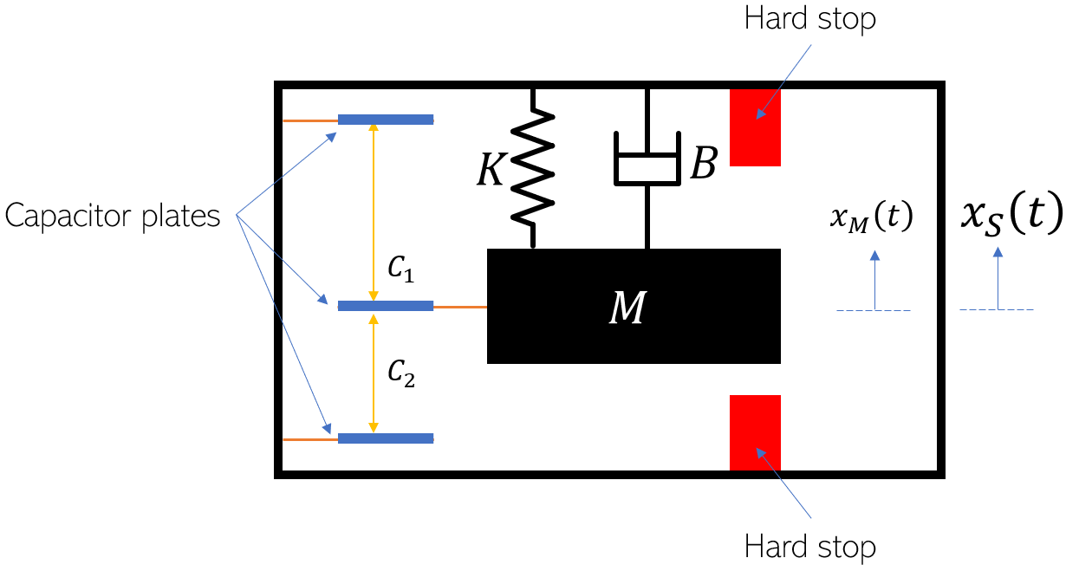

The dimensions of the different components of this sensor are depicted in the following figure. Note, $d>L$, and when there is zero sensor acceleration, ${\ddot{x}}_{s}\left(t\right)=0$, the mass is located at the centre in between the two hard stops.

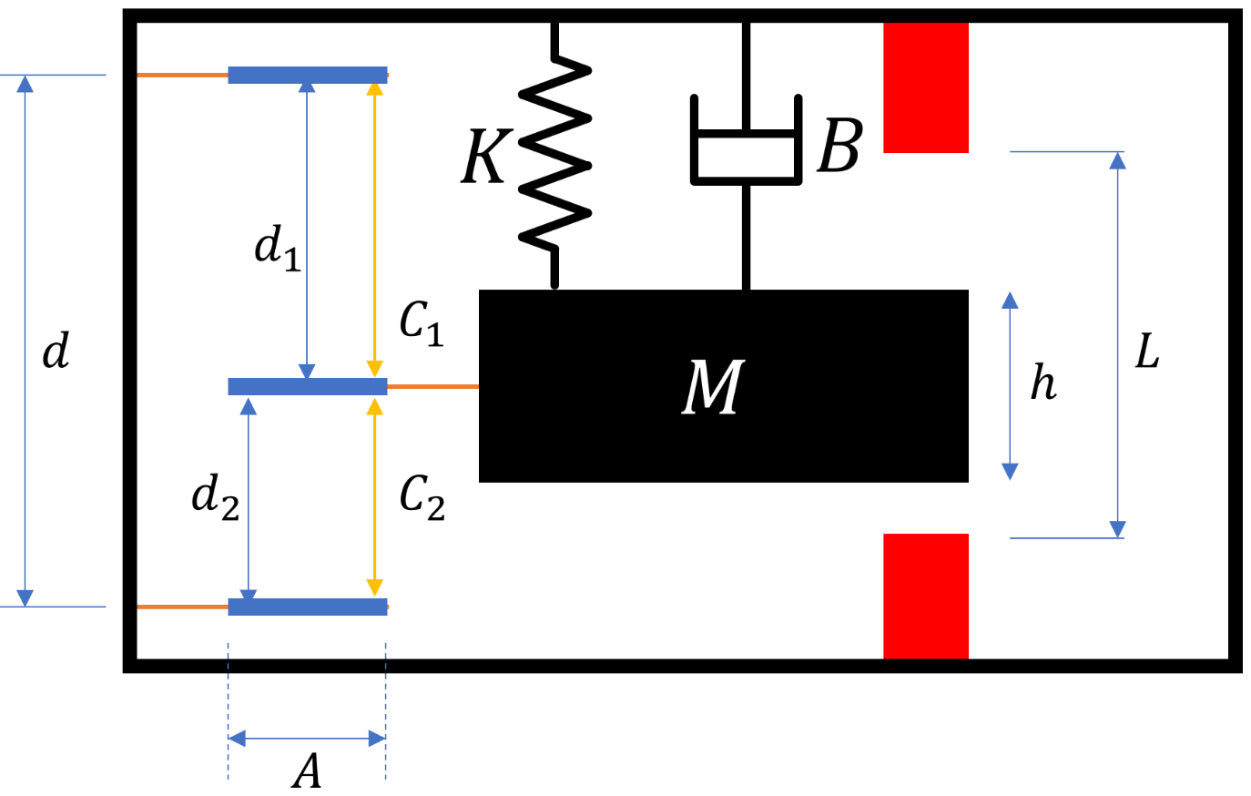

Derive the expression relating the variables $d_{1}$ and $d_{2}$ as a function of the fixed sensor acceleration ${\ddot{x}}_{s}\left(t\right)$.

Derive the expression for the maximum $a_{max}$ and minimum $a_{min}$ acceleration that can be detected using this sensor. Verify if $a_{max}=-a_{min}$.

Plot the different possible time profiles of the capacitances $C_{1}$ and $C_{2}$ when a step acceleration input of magnitude within $a_{min}$ and $a_{max}$.

Come up with an appropriate signal condition circuit that can be used to sense the differential capacitance of this sensor to produce and output voltage that is proportional to the input acceleration.

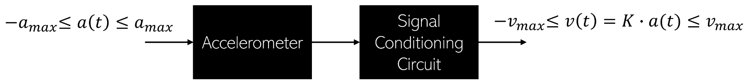

Derive the expression for $K$ in terms of the components used in the conditioning circuit. How will you choose $K$ such that $v_{max}=1.55V$.

Does the response of this accelerometer depend on the frequency of the input acceleration signal? What is the shape of the frequency response of the sensor? For what frequencies can this sensor be used for measuring the input acceleration.