**Transducer and Instrumentation – Assignment 07**

1. Derive the expression for the gain for the following amplifier circuit assuming all three op-amps are ideal.

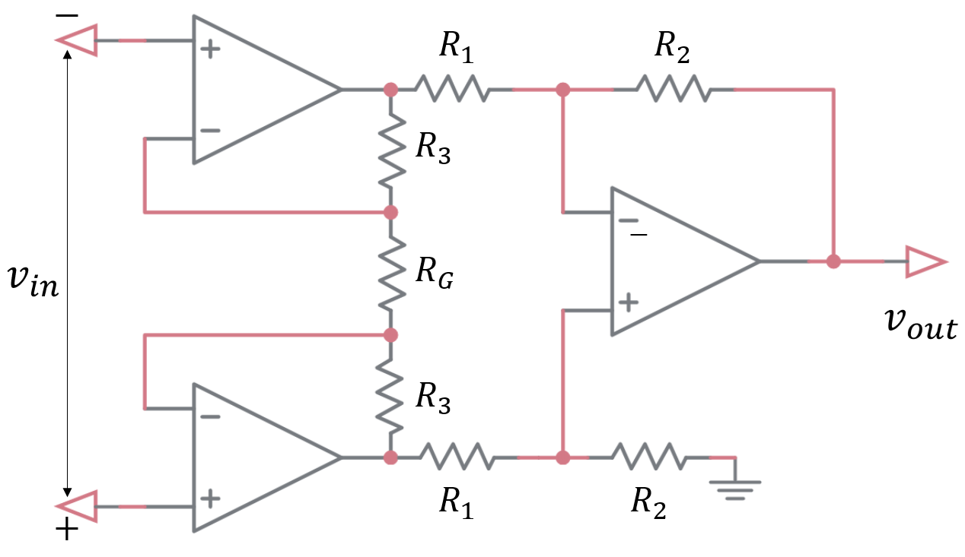ss

We have a reason to the believe that the op-amp – in the last stage from which is output is taken – is not ideal and has a finite input impedance $r_{in}$, non-zero output impedance $r_{out}$, and a finite gain $G$. What is the expression for the gain of this circuit with this non-ideal op-amp?

In the limiting case when $r_{in},G→∞$ and $r_{out}→0$, does the expression for the gain lead to the same expression as when all op-amps were ideal?

1. Consider the following sensor where a cantilever has a mass M attached at its free end inside a box. This box can undergo accelerations in the x and y directions as shown in then figure.

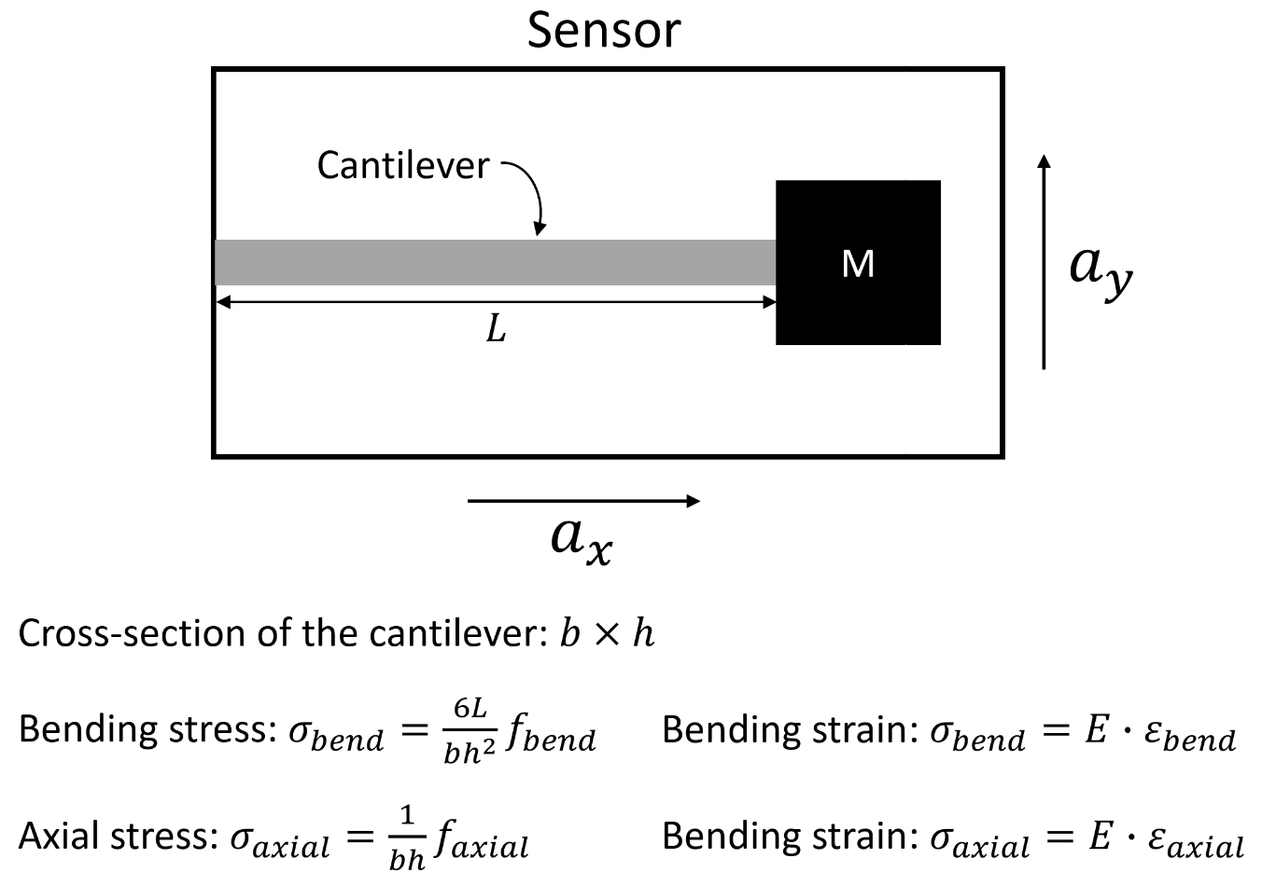

Assume that the strains on the cantilever surface due to bending and axial stresses can be analysed independently without worrying about their interactions.

Using strain gauges come up with a way to measure accelerations along the x and y directions. You need to come up with number of strain gauges you’ll need, the locations where the strain gauges will be bonded on the cantilever, and the necessary instrumentation to sense the accelerations in the x and y directions.

You need to clearly explain how the measurements from the different strain gauges can be used to compute the accelerations $a_{x}$ and $a_{y}$. You must derive the relationship between the accelerations $a_{x}$ and $a_{y}$ and the output voltage(s) you’re your instrumentation.

What are all the sources of uncertainty in this sensor?

Is your proposed sensor sensitive to temperature variations? Demonstrate this by deriving how variations in temperature will affect the output voltage signal you obtain from the sensor.