**Transducer and Instrumentation – Assignment 08**

1. Consider the following temperature measurement system. The body has mass $M_{B}$, has a specific heat capacity $C_{B}$, and the sensor has a mass $M_{S}$, has a specific heat capacity $C_{S}$. If the sensor has been in contact with the body for a long enough time derive the expression for the final temperature of the body and the sensor. Assume that the environment has infinite specific heat capacity, and its temperature remains the same. Also, that there is no direct loss of heat from the body to the environment.

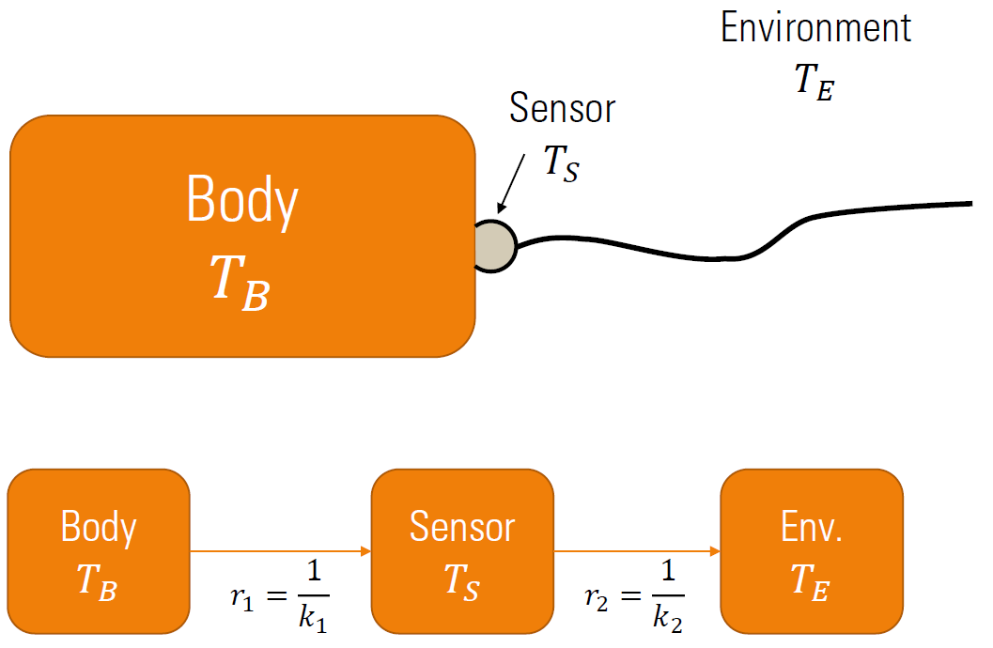

1. In the system described above, we are interested in knowing the dynamics of the temperature of the body and the sensor. Assume that the body and sensor temperatures at time $t$ is given by $T_{B}\left(t\right)$ and $T_{s}\left(t\right)$. If the sensor is placed on the body at time $t=0$, derive the expression for the temperatures of the body and the sensor as a function of time for $t>0$.
2. A Wheatstone bridge can be used for measuring the changes in resistance of an RTD as a function of temperature. Assuming the following linear model for the RTD resistance,

$$R_{T_{1}}=R_{T_{0}}\left[1+α_{0}\left(T_{1}-T_{0}\right)\right]$$

Assume that we know $R_{T_{0}}$ at temperature $T_{0}$. We are interested in measuring $T_{1}$. Consider the following two Wheatstone bridges with two and three lead wires. The lead wires are also affected by temperature the sensor is exposed to. Assume that the resistance $R_{1},$ $R_{2}$ and $R_{4}$ is chosen such that the bridge is balanced at temperature $T_{0}$. When the temperature of the sensor changes, the bridge will be unbalance. Derive the expression for the voltage $V_{0}$. Assume that the change in the lead wire resistance for wires A and B is the same as the temperature changes from $T_{0}$. Find the expression for estimating the temperature from $V_{0}$.

Derive the expression for $V_{0}$, assuming the bridge was balanced at $T_{0}$. Find the expression for estimating the temperature from $V_{0}$. What is the advantage of the three-lead wire arrangement, compared to the two lead wire arrangement?



1. Consider the following sensing system consisting of a linear elastic band, with its two ends attached to the ends of a beam containing strain gauges, at the top and bottom surfaces, oriented along the length of the beam.

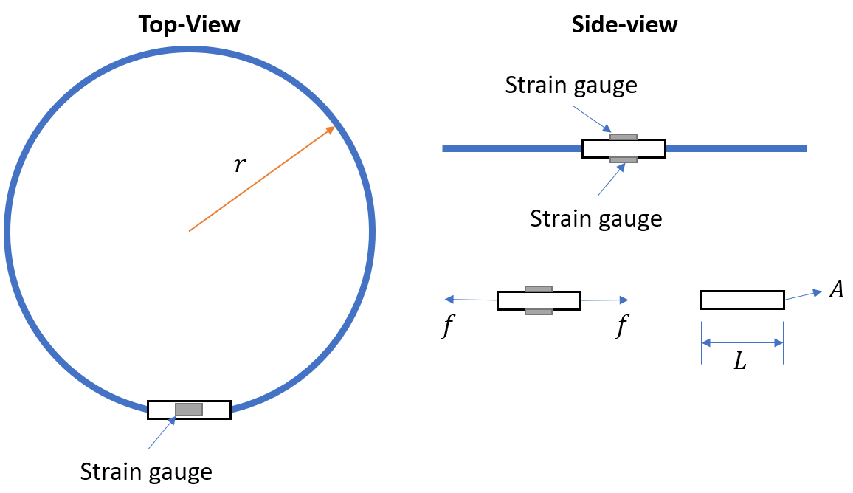

The force acting on the two ends of the beam is given as the following,

$$f=k∙2π∙\left(r-r_{0}\right)$$

where, $r_{0}$ is the radius of the elastic band at where there is no force acting on the beam, and $r≥r_{0}$. Assuming the cross-sectional area, length, and the Young’s modulus of the beam are $A, L$, and $E$, respectively. The gauge factor of the two strain gauges is $S_{s}$.

If you have five of these sensing systems with the same characteristics, explain how you can use them to measure the change in volume of an object that as circular cross-section, with possibly varying radius of cross-section along its length. This object can undergo a change in its cross-section radium. Discuss the details of the sensing circuit you will need to measure change in radium of cross section of the object. How can you use this change to compute the change in the volume of the object.