Transducers and Instrumentation for Physiological Measurement
Mid Term-II, 30th March, 2021

Answer all questions. Use diagrams and algebra to illustrate your answers. The questions carry 8-6-6 marks.

1. Screening people in crowds for fever can be useful in the current pandemic. This can be done by using an infra-red thermal camera used simultaneously with a visible light (RGB) camera. The visible light (RGB) camera is used to detect faces of people, and the temperature in the corresponding infra-red thermal camera is read (in the forehead region taken as the upper one-third of the face).
The following critical properties of camera system are given: The visible light (RGB) camera has 2000x2000 pixels and the thermal camera has 200x200 pixels. The face detection algorithm requires each face to have at least 50x50 pixels (visible light RGB camera). The thermal camera’s dynamic response requires at least 1 second for the reading to be taken – i.e., the image should move by less than 0.5 pixel/second for correct temperature reading.
The following are the design questions: (a) What should be optical-digital scaling (mm/pixel) if the size of an average human face is 250mmx200mm ? (b) How fast can the individuals move orthogonal to the camera for correct thermal measurement? (c) The emissivity of the forehead of individuals in the crowd ranges from 0.94-0.98; the thermal camera is calibrated for blackbody radiators with ε=1. Note: Emissivity, where T_{b} is the reading for a black body and T_{s} is the reading for the sample being measured, in Kelvins. If the criteria for fever is forehead temperature above 37.0ºC, what is the minimum reading in the thermal camera that can be taken as normal?

2. A single crystal ultrasound system is used to observe blood flow in the radial artery (in the wrist). The probe is kept at an angle of 30º to the vessel. The vessel wall expands about 0.5mm in every heart beat (i.e., speed about 0.5mm/s), and blood flow has maximum velocity of 300mm/s. If the ultrasound frequency is 4MHz, what is the Doppler shift due to blood flow and vessel wall movement (velocity of sound in blood is 1500m/s)? Can M-mode ultrasound be used along with Doppler calculation? Briefly describe M-mode ultrasound.

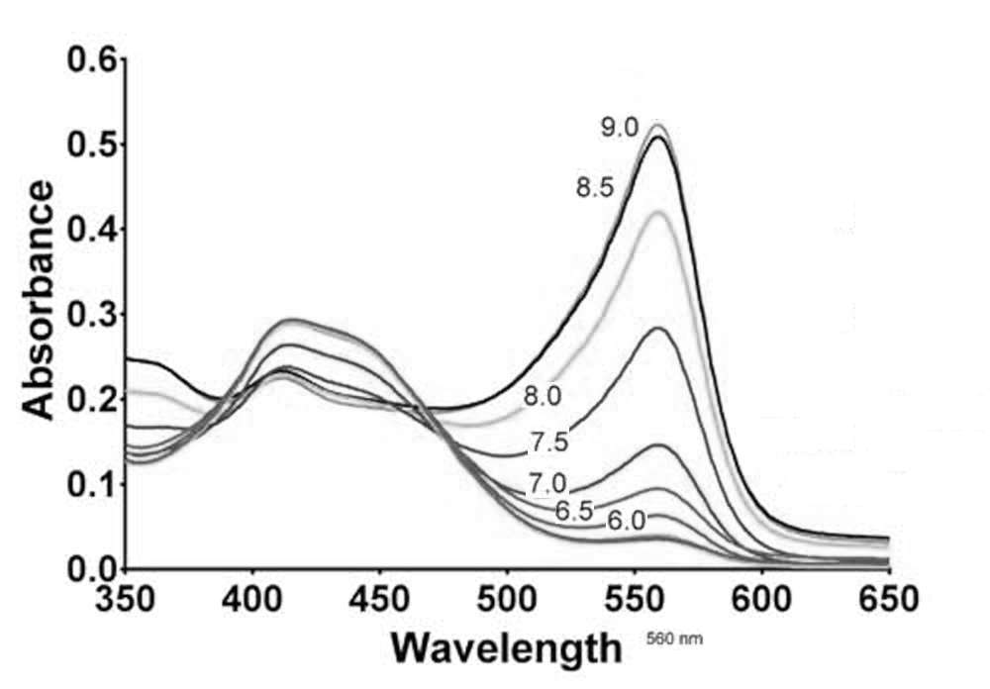
3. Give brief answers: (a) what is difference between sampling and quantization? (b) a single axis accelerometer is held in the hand and then dropped on the ground; draw the measured signal. (c) The attached figure shows the absorption spectrum of phenol red at different pH values (pH values are written on each curve). Two LEDs with wavelength 560nm and 650nm are used with a broad spectrum photodetector. The ratio of absoption of a sample of tissue culture with Phenol Red added to it, is found to be: .What is the approximate pH of the sample?

Solution

1. (a) Visible light RGB camera: 50x50 pixels corresponds to at least 250mmx200mm. Therefore, 1 pixel = 5mm or 1 pixel=4mm. Minimum resolution is 5mm/pixel for face recognition.
In the thermal camera, the corresponding resolution is 50mm/pixel.
(b) Thermal camera data should move at a speed less than 0.5pixel per second. This corresponds to actual motion speed of 25mm/second.
(c) Minimum emissivity=0.94. Reading corresponding to 37C or 310K: or 32.2C
Maximum emissivity=0.98. Reading corresponding to 37C or 310K: or 35.4C
Therefore, any reading above 32.2C must be taken for additional screening.

2. Peak velocity of blood as seen by the ultrasound sensor= =259.8mm/s=0.2598 m/s
Doppler shift due to blood flow:
Peak velocity of the vessel wall as seen by the ultrasound sensor==0.1mm/s=0.0001 m/s
Doppler shift due to vessel wall movement:
The Doppler shift due to blood flow can be easily detected, but the Doppler shift due to vessel wall movement is extremely small.
M-mode can be used to observed the vessel wall movement. If the depth of the vessel from the surface (skin) is about 10mm, the maximum movement of the vessel wall is 1/20 of this value. The time delay for the vessel wall reflection is (2x10mm)/(1500m/s)=13 microsecond. The change in time delay due to wall movement = 0.67 microsecond.

3. (a) Sampling=> frequency of conversion to digital numbers, sampling theorem, aliasing, loss of information; Quantization=> apparent addition of noise, quantization noise.
(b) Initial reading is g=9.8m/s; during free-fall reading is 0; upon contact with the ground reading returns to 9.8m/s, but the transition depends on the properties of the sensor – there may be a second order response.
(c) From the graph at a pH about 7, the ratio of the absorption is 0.125/0.025=5. The pH is about 7.0

