**Transducer and Instrumentation – Assignment 01**

1. A digital voltmeter can measure voltages in the ranges, 0-2V, 0-20V, 0-200V, and 0-2000V. The voltmeter has an accuracy of 1% of the full-scale reading.
   1. What is the maximum possible absolute error in the measurements for each of the ranges?
   2. This voltmeter is used to measure 10 V by setting voltmeter in the four different ranges. What is the maximum possible relative error (error with respect to 10V) expected from the measurements using these different ranges?
   3. This voltmeter has a parallel resistance of 100K Ohms, and it is used to measure the voltage across the resistance R3. What is the error in the voltage measurement due to loading effects?

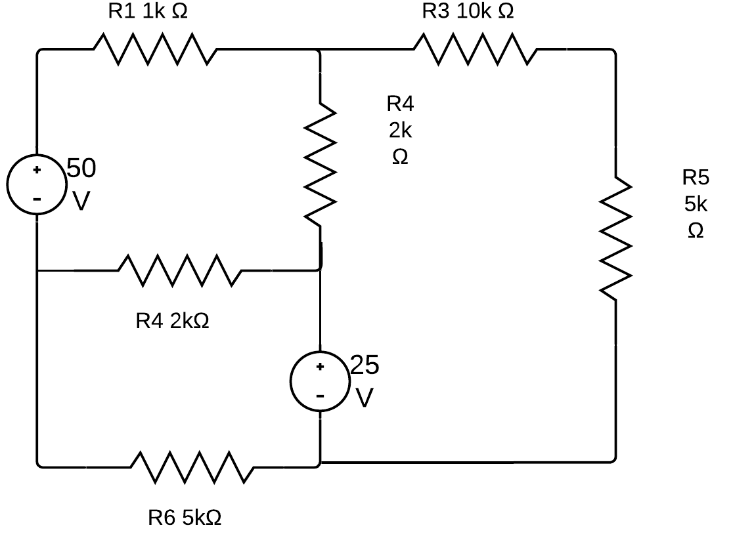

Fig. 1: Circuit of interest. We are interested in measuring the voltage across the resistor R3.

You can either use Kirchoff’s laws to solve this problem or derive the Thevenin equivalent circuit for the above circuit across the terminals to which the resistor R3 is connected. The Thevenin equivalent circuit allows us to find the equivalent representation of a linear circuit as a voltage source and series resistance as shown in the following figure.

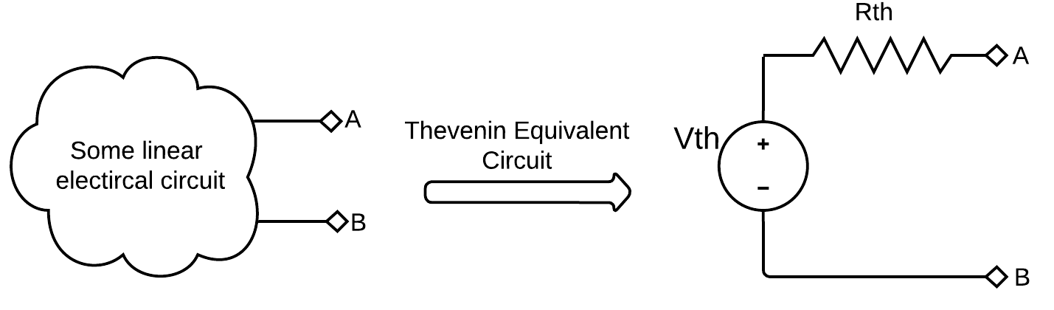

Fig. 2: Thevenin equivalent circuit.

You can find the Thevenin equivalent circuit by first removing R3 from the circuit in Fig. 1 and following the procedure [here](https://en.wikipedia.org/wiki/Th%C3%A9venin%27s_theorem). You can then reattach R3 to find the actual voltage across R3. Then find the voltage read by the voltmeter by correcting the voltmeter across R3.

1. The output voltage of a sensor is given by the following static input-output relationship,

$$v_{o}=k∙m^{\frac{1}{2}}, 0.2≤m≤10$$

Where, $m$ is the input measurand of interest, $v_{o}$ is the output voltage of the sensor, and $k$ is some fixed constant. What can you say about the static sensitivity of this sensors over the range of values of the measurand $m$? Find the expression for the static sensitivity of the sensor as a function of $m$. Would you recommend the sensor for measuring smaller values of $m$ or for larger values?

1. The accuracy of a sensor is computed using the maximum deviation of the measured values from the true value of the measurand. Because of random errors in measurement, one can possibly get outliers in the measured value of the measurand by chance. In that case, the computed accuracy is likely to be very poor. For examples, consider a force sensor used for measuring forces $f_{i}$ in the range of 0 to 100N. The output voltage $v_{o}$ of this sensor for the full scale value of the input force is 0 to 100mV. The following model is a good model for the static behaviour of the sensor,

$$v_{o}=K∙f_{i}+ϵ$$

Where, $ϵ$ is random error which is normally distributed with zero mean and variance $σ^{2}=2.5{mV}^{2}$, $K=1mV∙N^{-1}$ is the fixed static sensitivity of the sensor. A calibration of the sensor the estimated the accuracy of the sensor to be $4.6\%$. If this sensor is used to measure an unknow force $f$ and the sensor’s output is $52.3mV$, what is the value if the measured force and the associated uncertainty in the force measurement?

After some additional experiments it was found that this sensor had both *zero drift* and *sensitivity drift*. Every time the sensor was powered on the sensor would have a zero drift with the sensor reading some non-zero value when no force is applied on the sensors. This zero drift was always found to be between $±3mV$. The sensor is also sensitive to the ambient temperature $T$, with a sensitivity drift of $\frac{∂K}{∂T}=0.2mV∙N^{-1}∙℃^{-1}$. The calibration of the sensor was carried out at $25℃$ after correcting for zero drift and was found to have $K=1.1mV∙N^{-1}$ and accuracy of $4.9\%$. An engineer used this sensor to measure the force in his application. He switched on sensor and noted down the reading from the sensor for zero force and had used a thermometer to note down the ambient temperature on a piece of paper. She carried out a series of experiments and recorded the following reading from the sensor without switching off the sensor during the entire course of her experiment. The follow are the reading she had recorded,

|  |  |  |  |  |  |  |
| --- | --- | --- | --- | --- | --- | --- |
| Experiment | A | B | C | D | E | F |
| Sensor reading (mV) | 2.1 | 10.5 | 67.0 | 34.3 | 11.3 | 88.9 |

Unfortunately, she loses the piece of paper with the zero force reading and the ambient temperature. She finds out from another source that ambient temperature during her experiment is was in the range $36±3℃$. Based on this information what are the forces measured from the 6 experiments and their associated uncertainties?