**Transducer and Instrumentation – Assignment 08**

1. Consider the following temperature measurement system. The body has mass $M_{B}$, has a specific heat capacity $C_{B}$, and the sensor has a mass $M_{S}$, has a specific heat capacity $C_{S}$. If the sensor has been in contact with the body for a long enough time derive the expression for the final temperature of the body and the sensor. Assume that the environment has infinite specific heat capacity, and its temperature remains the same. Also, that there is no direct loss of heat from the body to the temperature.

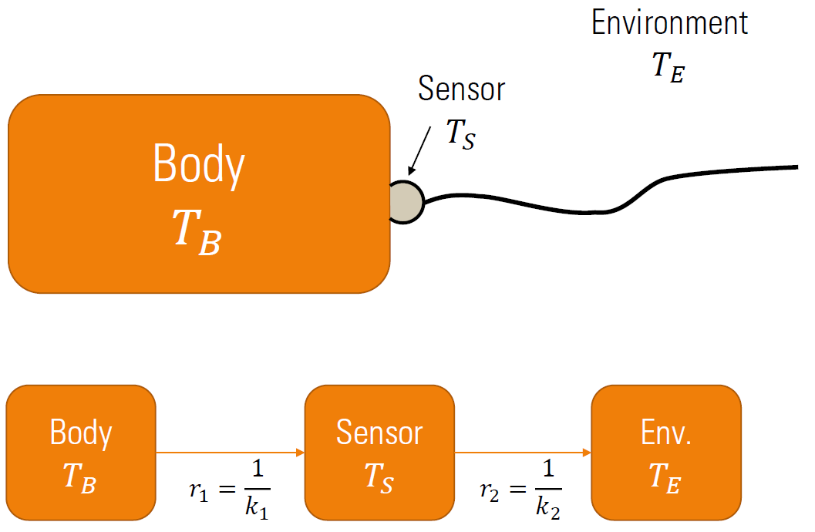

1. In the system described above, we are interested in knowing the dynamics of the temperature of the body and the sensor. Assume that the body and sensor temperatures at time $t$ is given by $T_{B}\left(t\right)$ and $T_{s}\left(t\right)$. If the sensor is placed on the body at time $t=0$, derive the expression for the temperatures of the body and the sensor as a function of time for $t>0$.
2. A Wheatstone bridge can be used for measuring the changes in resistance of an RTD as a function of temperature. Assuming the following linear model for the RTD resistance,

$$R_{T_{1}}=R_{T_{0}}\left[1+α_{0}\left(T_{1}-T_{0}\right)\right]$$

Assume that we know $R_{T_{0}}$ at temperature $T_{0}$. We are interested in measuring $T_{1}$. Consider the following two Wheatstone bridges with two and three lead wires. The lead wires are also affected by temperature the sensor is exposed to. Assume that the resistance $R_{1},$ $R_{2}$ and $R_{4}$ is chosen such that the bridge is balances at temperature $T_{0}$. When the temperature of the sensor changes, the bridge will be unbalance. Derive the expression for the voltage $V_{0}$. Assume that the change in the lead wire resistance for wires A and B is the same as the temperature changes from $T_{0}$. Find the expression for estimating the temperature from $V_{0}$.

Derive the expression for $V_{0}$, assuming the bridge was balanced at $T_{0}$. Find the expression for estimating the temperature from $V_{0}$. What is the advantage of the three lead wire arrangement, compared to the two lead wire arrangement?



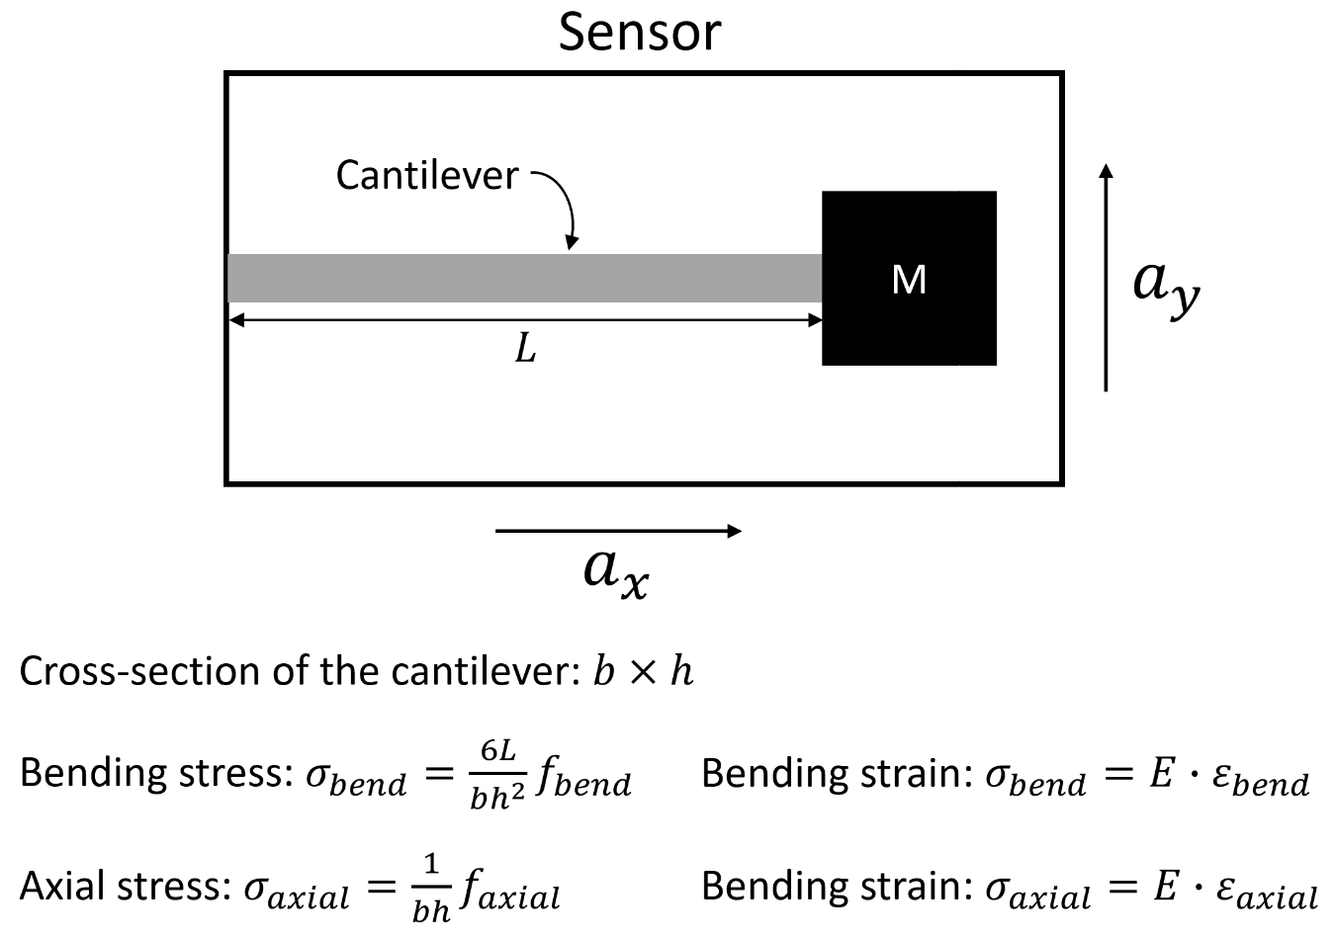

Assume that the strains on the cantilever surface due to bending and axial stresses can be analysed independently without worrying about their interactions.

Using strain gauges come up with a way to measure accelerations along the x and y directions. You need to come up with number of strain gauges you’ll need, the locations where the strain gauges will be bonded on the cantilever, and the necessary instrumentation to sense the accelerations in the x and y directions.

You need to clearly explain how the measurements from the different strain gauges can be used to compute the accelerations $a_{x}$ and $a_{y}$. You must derive the relationship between the accelerations $a_{x}$ and $a_{y}$ and the output voltage(s) you’re your instrumentation.

What are all the sources of uncertainty in this sensor?

Is your proposed sensor sensitive to temperature variations? Demonstrate this by deriving how variations in temperature will affect the output voltage signal you obtain from the sensor.