EXPERIMENT8

1.

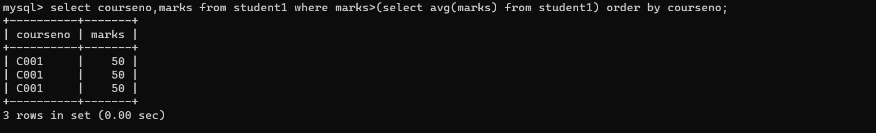

2.

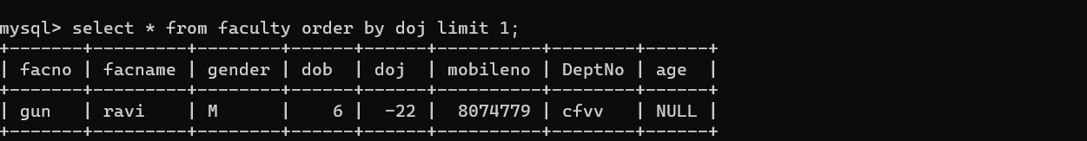

3.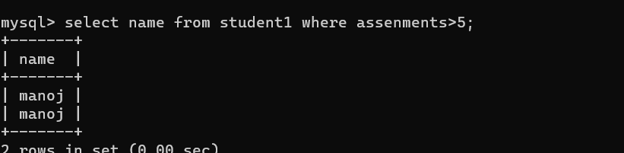

4.

