This document contains the results/output of the Question 2 of Cloud Computing course Assignment.

1. Screen capture listing the input file (named inputWords.txt) along with the contents of that file:

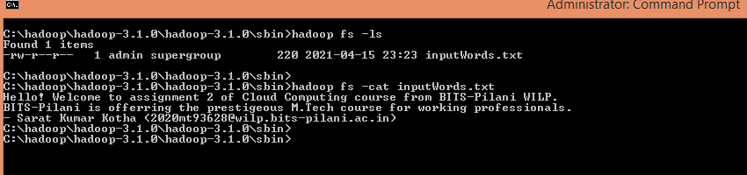

2. Screen captures listing the execution of mapreduce based Jar:

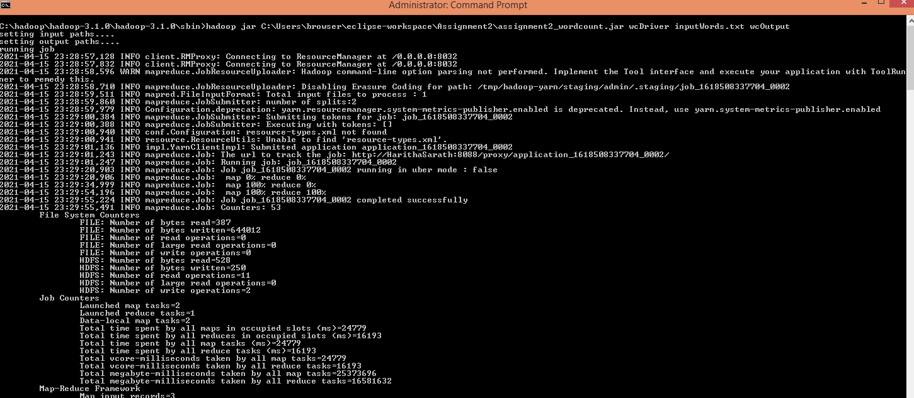

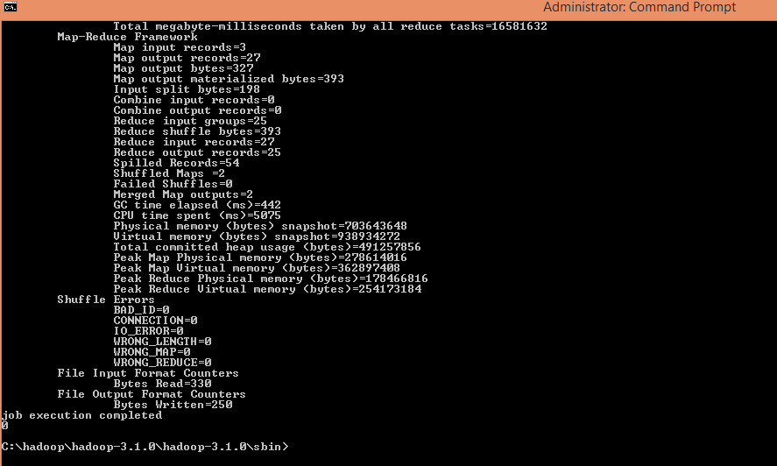

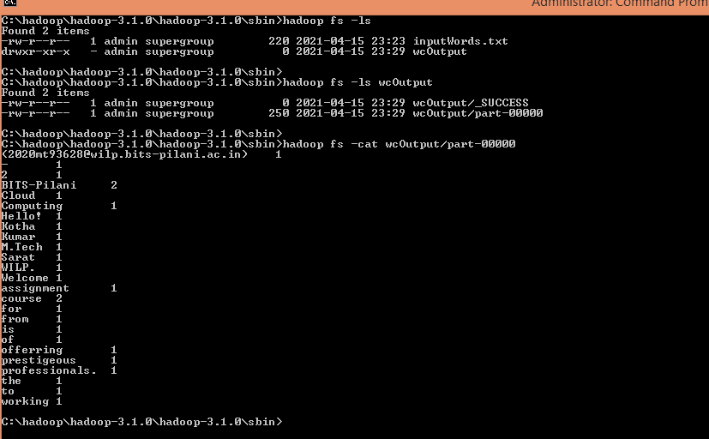3. Screen capture listing the generated folder in hadoop and the content of the output file: