PL/SQL
Schema Creation
CREATE TABLE CUSTOMERS (
CUSTOMERID NUMBER PRIMARY KEY,
NAME VARCHAR2(100),
DOB DATE,
BALANCE NUMBER,
LASTMODIFIED DATE
);

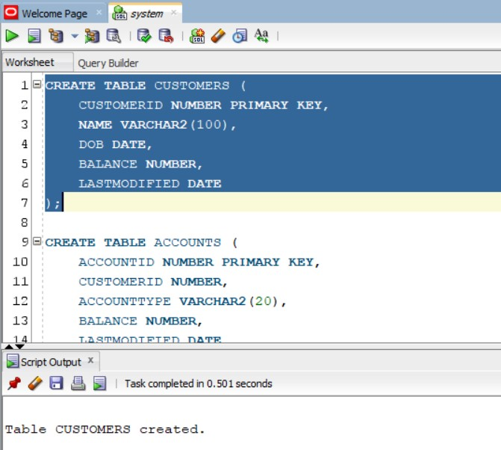

CREATE TABLE ACCOUNTS (
ACCOUNTID NUMBER PRIMARY KEY,
CUSTOMERID NUMBER,
ACCOUNTTYPE VARCHAR2(20),
BALANCE NUMBER,
LASTMODIFIED DATE,
FOREIGN KEY ( CUSTOMERID )
REFERENCES CUSTOMERS ( CUSTOMERID )
);
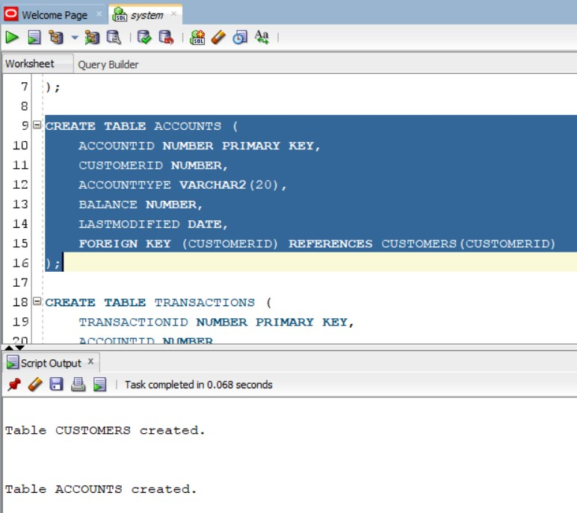

CREATE TABLE TRANSACTIONS (
TRANSACTIONID NUMBER PRIMARY KEY,
ACCOUNTID NUMBER,
TRANSACTIONDATE DATE,
AMOUNT NUMBER,
TRANSACTIONTYPE VARCHAR2(10),
FOREIGN KEY ( ACCOUNTID )
REFERENCES ACCOUNTS ( ACCOUNTID )
);

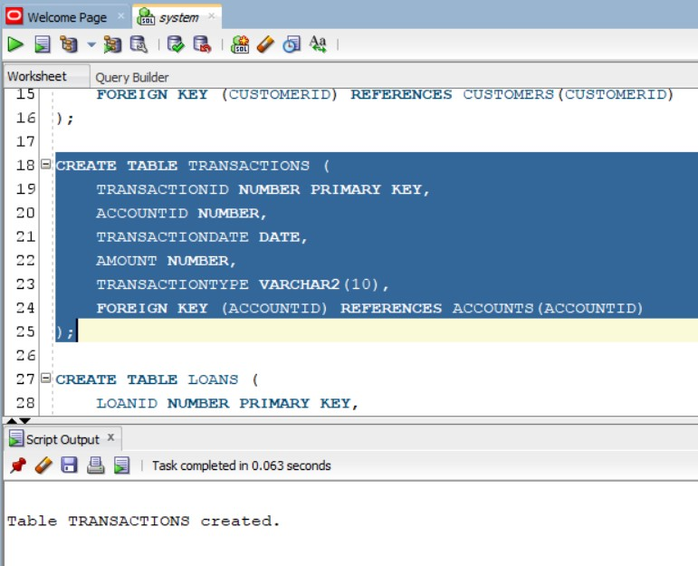

CREATE TABLE LOANS (
LOANID NUMBER PRIMARY KEY,
CUSTOMERID NUMBER,
LOANAMOUNT NUMBER,
INTERESTRATE NUMBER,
STARTDATE DATE,
ENDDATE DATE,
FOREIGN KEY ( CUSTOMERID )
REFERENCES CUSTOMERS ( CUSTOMERID )
);
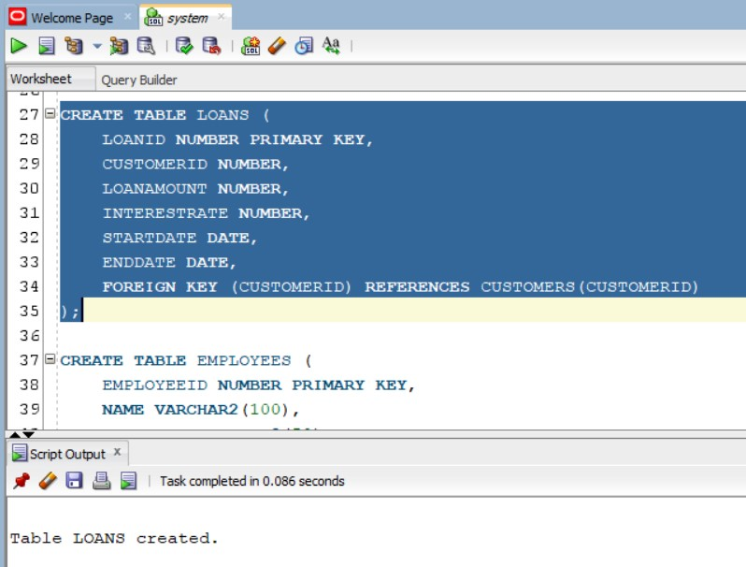

CREATE TABLE EMPLOYEES (
EMPLOYEEID NUMBER PRIMARY KEY,
NAME VARCHAR2(100),
POSITION VARCHAR2(50),
SALARY NUMBER,
DEPARTMENT VARCHAR2(50),
HIREDATE DATE
);
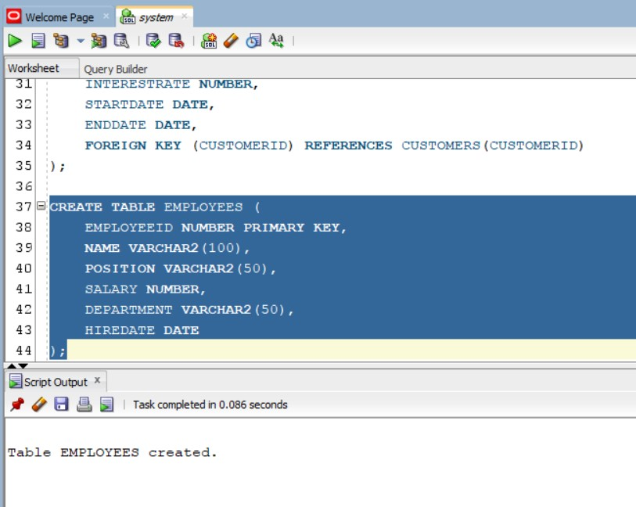

INSERT INTO CUSTOMERS (CUSTOMERID, NAME, DOB, BALANCE, LASTMODIFIED)
VALUES (1, 'John Doe', TO_DATE('1985-05-15', 'YYYY-MM-DD'), 1000, SYSDATE);
INSERT INTO CUSTOMERS (CUSTOMERID, NAME, DOB, BALANCE, LASTMODIFIED)
VALUES (2, 'Jane Smith', TO_DATE('1990-07-20', 'YYYY-MM-DD'), 1500, SYSDATE);
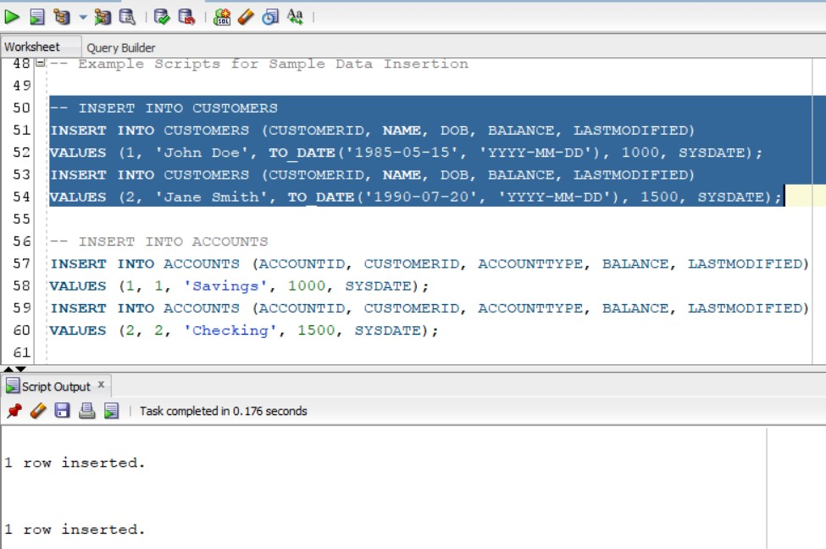

-- INSERT INTO ACCOUNTS
INSERT INTO ACCOUNTS (ACCOUNTID, CUSTOMERID, ACCOUNTTYPE, BALANCE, LASTMODIFIED)
VALUES (1, 1, 'Savings', 1000, SYSDATE);
INSERT INTO ACCOUNTS (ACCOUNTID, CUSTOMERID, ACCOUNTTYPE, BALANCE, LASTMODIFIED)
VALUES (2, 2, 'Checking', 1500, SYSDATE);
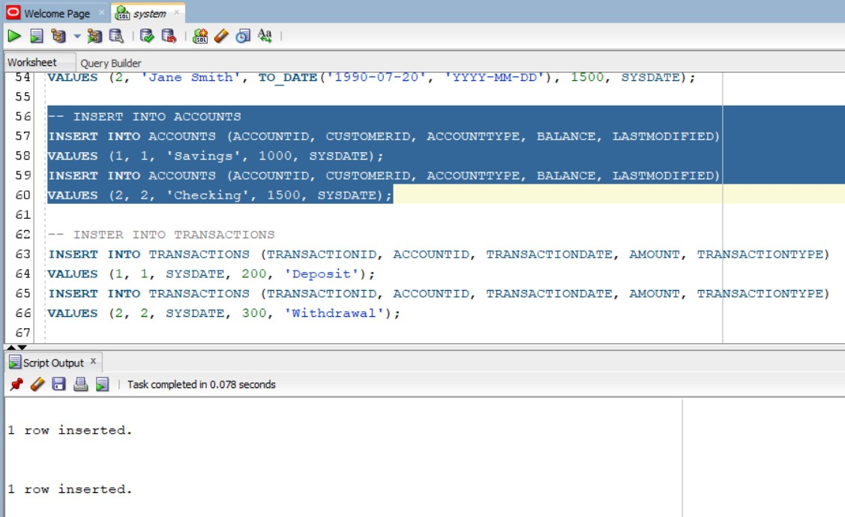

-- INSTER INTO TRANSACTIONS
INSERT INTO TRANSACTIONS (TRANSACTIONID, ACCOUNTID, TRANSACTIONDATE, AMOUNT, TRANSACTIONTYPE)
VALUES (1, 1, SYSDATE, 200, 'Deposit');
INSERT INTO TRANSACTIONS (TRANSACTIONID, ACCOUNTID, TRANSACTIONDATE, AMOUNT, TRANSACTIONTYPE)
VALUES (2, 2, SYSDATE, 300, 'Withdrawal');

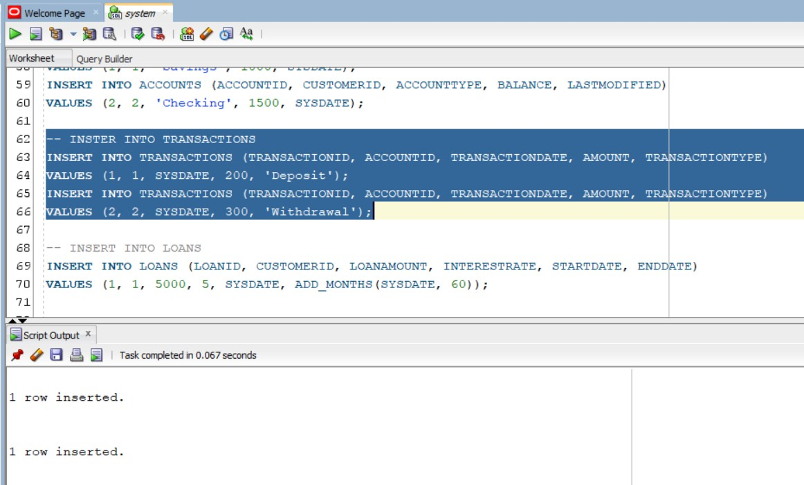

-- INSERT INTO LOANS
INSERT INTO LOANS (LOANID, CUSTOMERID, LOANAMOUNT, INTERESTRATE, STARTDATE, ENDDATE)
VALUES (1, 1, 5000, 5, SYSDATE, ADD_MONTHS(SYSDATE, 60));
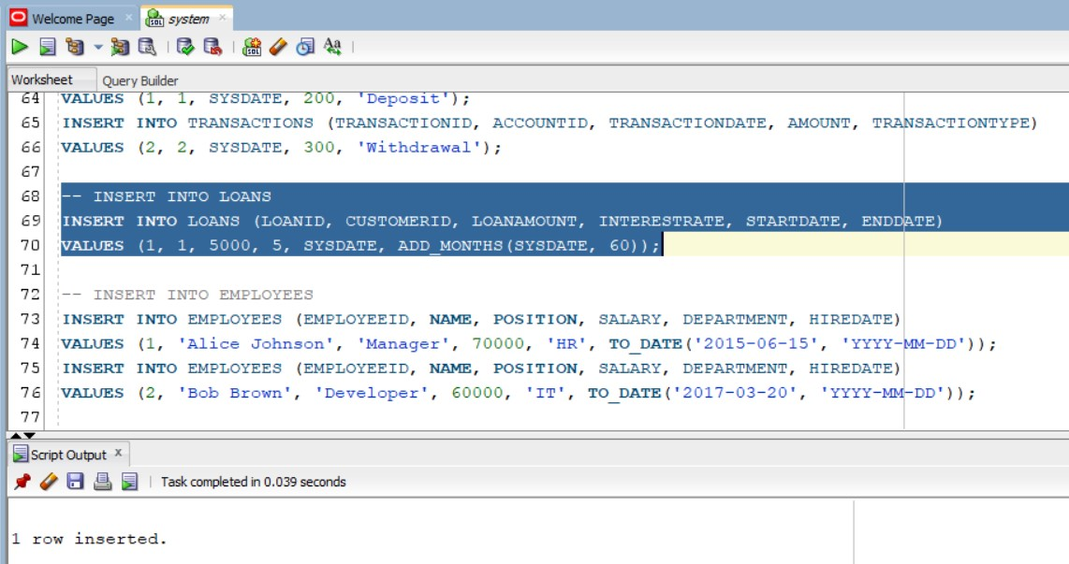

-- INSERT INTO EMPLOYEES
INSERT INTO EMPLOYEES (EMPLOYEEID, NAME, POSITION, SALARY, DEPARTMENT, HIREDATE)
VALUES (1, 'Alice Johnson', 'Manager', 70000, 'HR', TO_DATE('2015-06-15', 'YYYY-MM-DD'));
INSERT INTO EMPLOYEES (EMPLOYEEID, NAME, POSITION, SALARY, DEPARTMENT, HIREDATE)
VALUES (2, 'Bob Brown', 'Developer', 60000, 'IT', TO_DATE('2017-03-20', 'YYYY-MM-DD'));
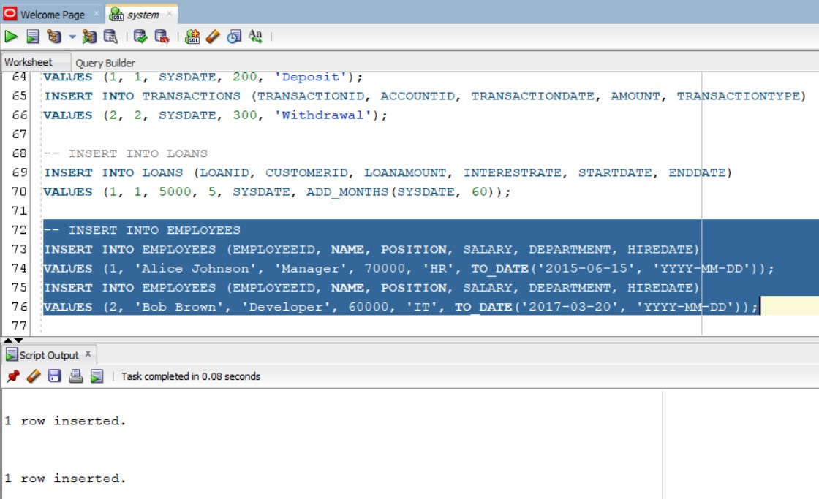

Exercise 1: Control Structures

Scenario 1: The bank wants to apply a discount to loan interest rates for customers above 60 years old.
  - Question: Write a PL/SQL block that loops through all customers, checks their age, and if they are above 60, apply a 1% discount to their current loan interest rates.
Scenario 2: A customer can be promoted to VIP status based on their balance.
  - Question: Write a PL/SQL block that iterates through all customers and sets a flag IsVIP to TRUE for those with a balance over $10,000.
Scenario 3: The bank wants to send reminders to customers whose loans are due within the next 30 days.
  - Question: Write a PL/SQL block that fetches all loans due in the next 30 days and prints a reminder message for each customer.

-- SCENARIO 1

SELECT * FROM CUSTOMERS;
SELECT * FROM LOANS;

SET SERVEROUTPUT ON;
DECLARE
CURSOR CUSTOMER_CURSOR IS
SELECT CUSTOMERID, EXTRACT(YEAR FROM SYSDATE) - EXTRACT(YEAR FROM DOB) AS AGE
FROM CUSTOMERS;
VAR_CUSTOMER_ID CUSTOMERS.CUSTOMERID%TYPE;
VAR_AGE NUMBER;
BEGIN
FOR CUSTOMER_RECORD IN CUSTOMER_CURSOR LOOP
VAR_CUSTOMER_ID := CUSTOMER_RECORD.CUSTOMERID;
VAR_AGE := CUSTOMER_RECORD.AGE;
IF VAR_AGE > 60 THEN
UPDATE LOANS
SET INTERESTRATE = INTERESTRATE - 1
WHERE CUSTOMERID = VAR_CUSTOMER_ID;
ELSE
DBMS_OUTPUT.PUT_LINE('CUSTOMER WITH CUSTOMER ID : ' || VAR_CUSTOMER_ID || ' IS OF AGE : ' || VAR_AGE);
DBMS_OUTPUT.PUT_LINE('NO CHANGE IN LOAN');
END IF;
END LOOP;
COMMIT;
END;
/

SELECT * FROM LOANS;

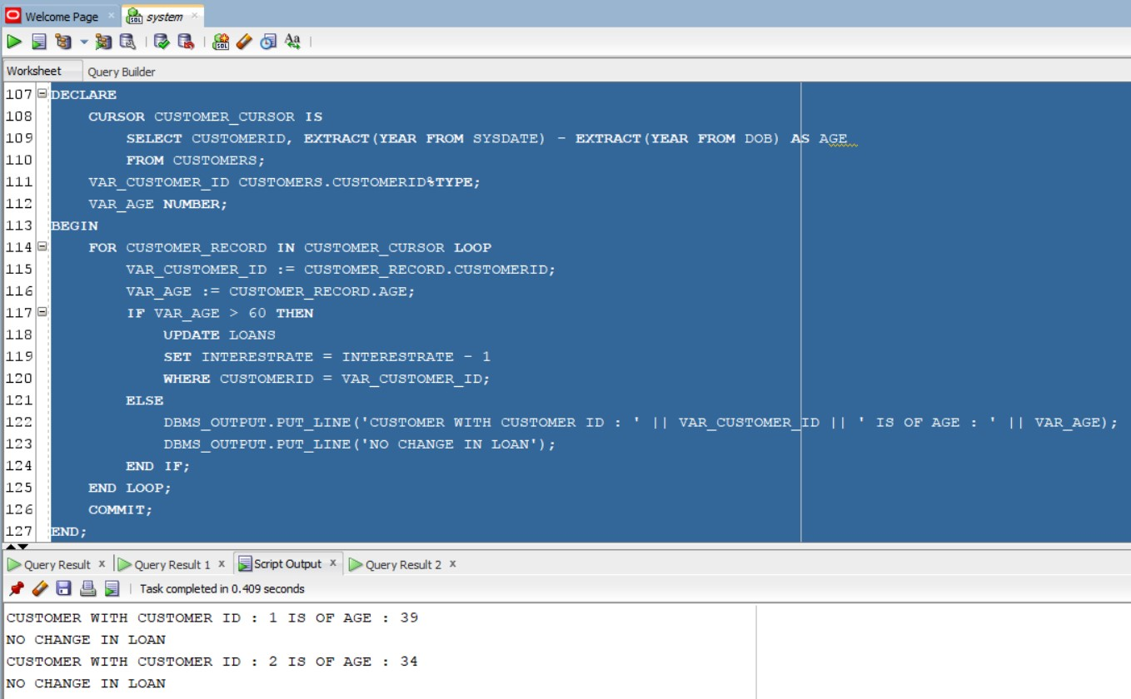

-- SCENARIO 2

DESC CUSTOMERS;
ALTER TABLE CUSTOMERS ADD ISVIP CHAR(10) CONSTRAINT CHK1 CHECK(ISVIP IN ('TRUE','FALSE')) ;

SELECT * FROM CUSTOMERS;
SET SERVEROUTPUT ON;
DECLARE
CURSOR CUSTOMER_CURSOR IS
SELECT CUSTOMERID, BALANCE
FROM CUSTOMERS;
VAR_CUSTOMER_ID CUSTOMERS.CUSTOMERID%TYPE;
VAR_BALANCE CUSTOMERS.BALANCE%TYPE;
BEGIN
FOR CUSTOMER_RECORD IN CUSTOMER_CURSOR LOOP
VAR_CUSTOMER_ID := CUSTOMER_RECORD.CUSTOMERID;
VAR_BALANCE := CUSTOMER_RECORD.BALANCE;
IF VAR_BALANCE > 10000 THEN
DBMS_OUTPUT.PUT_LINE('CUSTOMER ID : ' || VAR_CUSTOMER_ID || ' HAS BALANCE GREATER THAN 10000');
UPDATE CUSTOMERS
SET ISVIP = 'TRUE'
WHERE CUSTOMERID = VAR_CUSTOMER_ID;
ELSE
DBMS_OUTPUT.PUT_LINE('CUSTOMER ID : ' || VAR_CUSTOMER_ID || ' HAS BALANCE LESSER THAN 10000');
UPDATE CUSTOMERS
SET ISVIP = 'FALSE'
WHERE CUSTOMERID = VAR_CUSTOMER_ID;
END IF;
END LOOP;
COMMIT;
END;
/
SELECT * FROM CUSTOMERS;
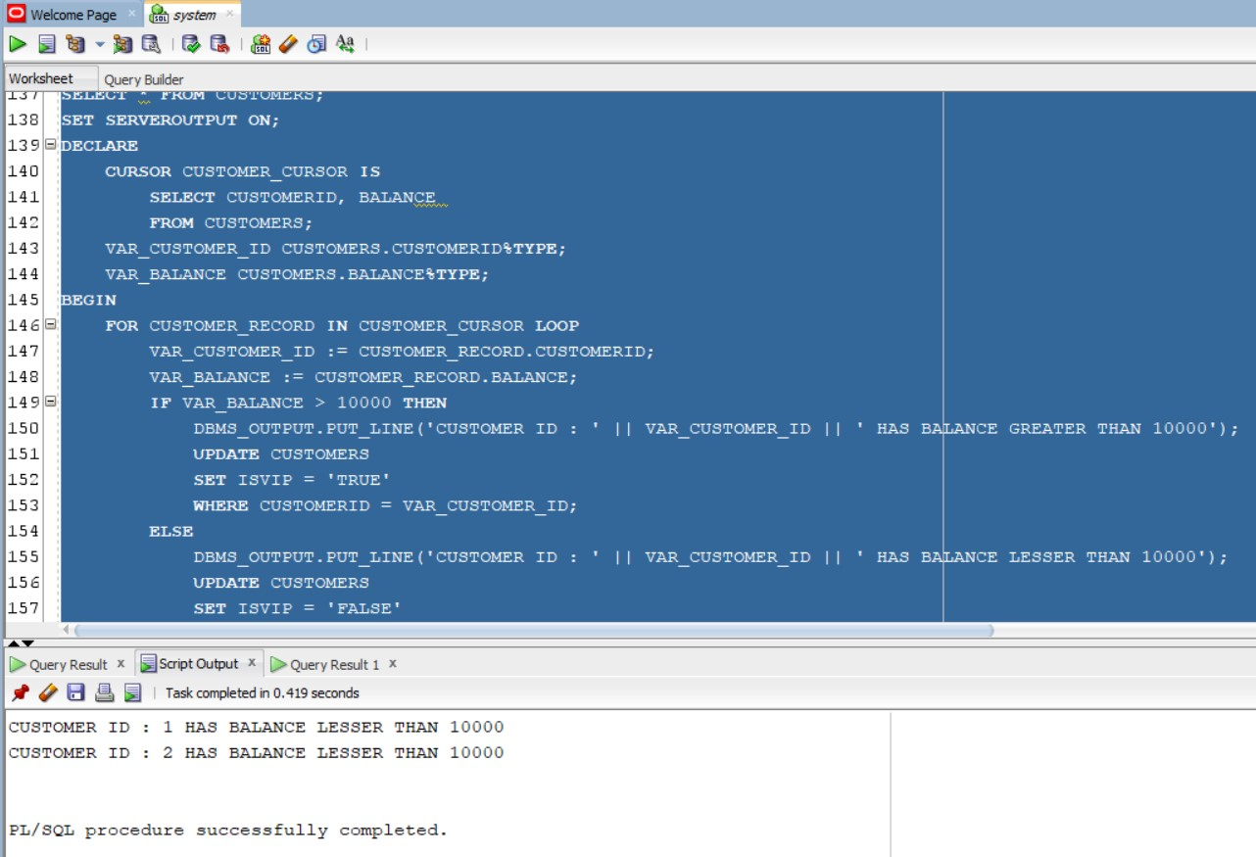

-- SCENARIO 3

SET SERVEROUTPUT ON;
DECLARE
CURSOR CUR_LOANS IS
SELECT L.LOANID, L.CUSTOMERID, C.NAME, L.ENDDATE
FROM LOANS L
JOIN CUSTOMERS C ON L.CUSTOMERID = C.CUSTOMERID
WHERE L.ENDDATE BETWEEN SYSDATE AND SYSDATE + 30;

V_LOAN_ID LOANS.LOANID%TYPE;
V_CUSTOMER_ID LOANS.CUSTOMERID%TYPE;
V_CUSTOMER_NAME CUSTOMERS.NAME%TYPE;
V_END_DATE LOANS.ENDDATE%TYPE;
V_FOUND BOOLEAN := FALSE;
BEGIN
OPEN CUR_LOANS;
LOOP
FETCH CUR_LOANS INTO V_LOAN_ID, V_CUSTOMER_ID, V_CUSTOMER_NAME, V_END_DATE;
EXIT WHEN CUR_LOANS%NOTFOUND;

V_FOUND := TRUE;
DBMS_OUTPUT.PUT_LINE('Reminder: Loan ' || V_LOAN_ID || ' for customer ' || V_CUSTOMER_NAME || ' (ID: ' || V_CUSTOMER_ID || ') is due on ' || TO_CHAR(V_END_DATE, 'YYYY-MM-DD'));
END LOOP;
CLOSE CUR_LOANS;

IF NOT V_FOUND THEN
DBMS_OUTPUT.PUT_LINE('No loans are due within the next 30 days.');
END IF;
END;
/
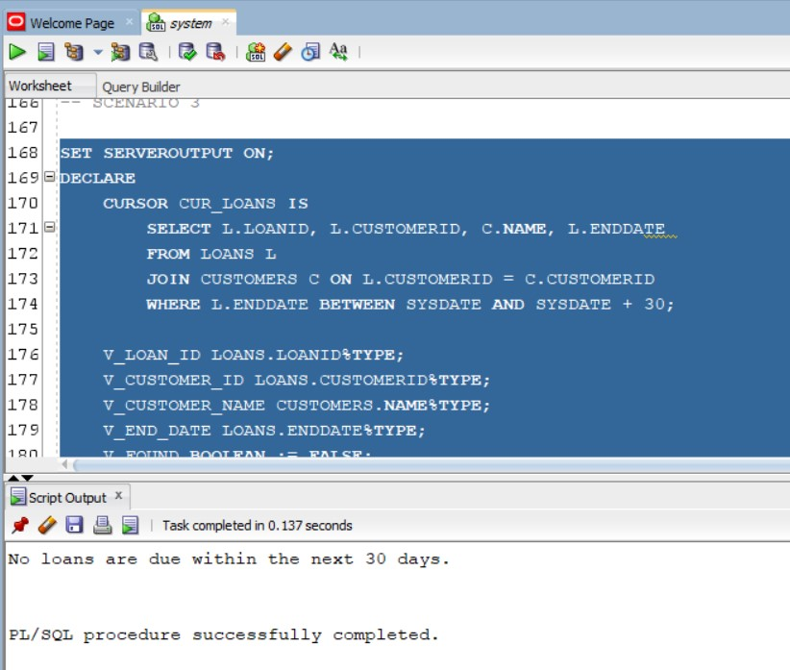
Exercise 3: Stored Procedures

Scenario 1: The bank needs to process monthly interest for all savings accounts.
  - Question: Write a stored procedure ProcessMonthlyInterest that calculates and updates the balance of all savings accounts by applying an interest rate of 1% to the current balance.

Scenario 2: The bank wants to implement a bonus scheme for employees based on their performance.
  - Question: Write a stored procedure UpdateEmployeeBonus that updates the salary of employees in a given department by adding a bonus percentage passed as a parameter.

Scenario 3: Customers should be able to transfer funds between their accounts.
  - Question: Write a stored procedure TransferFunds that transfers a specified amount from one account to another, checking that the source account has sufficient balance before making the transfer.

-- SCENARIO 1

SELECT * FROM ACCOUNTS;
SET SERVEROUTPUT ON;
CREATE OR REPLACE PROCEDURE PROCESSMONTHLYINTEREST AS
BEGIN
UPDATE ACCOUNTS
SET BALANCE = BALANCE * 1.01,
LASTMODIFIED = SYSDATE
WHERE ACCOUNTTYPE = 'Savings';

COMMIT;
DBMS_OUTPUT.PUT_LINE('Monthly interest processed for all savings accounts.');
EXCEPTION
WHEN OTHERS THEN
ROLLBACK;
DBMS_OUTPUT.PUT_LINE('Error processing monthly interest: ' || SQLERRM);
END PROCESSMONTHLYINTEREST;
/

EXEC PROCESSMONTHLYINTEREST();

SELECT * FROM ACCOUNTS;

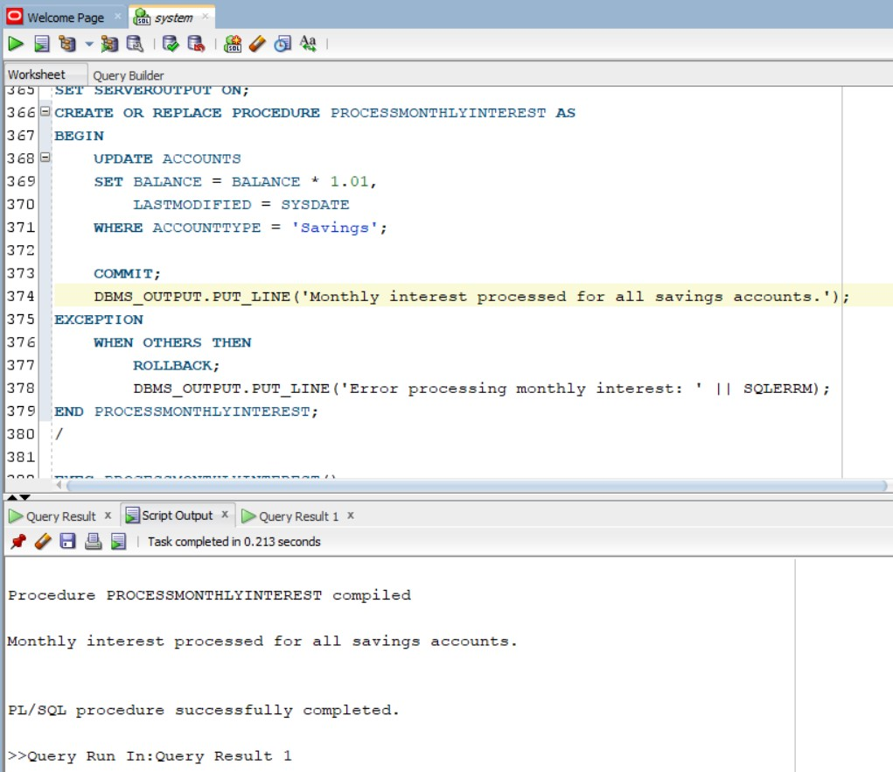

-- SCENARIO 2

SELECT * FROM EMPLOYEES;

SET SERVEROUTPUT ON;
CREATE OR REPLACE PROCEDURE UPDATEEMPLOYEEBONUS(
P_DEPARTMENT IN EMPLOYEES.DEPARTMENT%TYPE,
P_BONUS_PERCENTAGE IN NUMBER
) AS
BEGIN
UPDATE EMPLOYEES
SET SALARY = SALARY * (1 + P_BONUS_PERCENTAGE / 100),
HIREDATE = SYSDATE
WHERE DEPARTMENT = P_DEPARTMENT;

COMMIT;
DBMS_OUTPUT.PUT_LINE('Bonus applied to employees in the ' || P_DEPARTMENT || ' department.');
EXCEPTION
WHEN OTHERS THEN
ROLLBACK;
DBMS_OUTPUT.PUT_LINE('Error updating employee bonuses: ' || SQLERRM);
END UPDATEEMPLOYEEBONUS;
/

EXEC UPDATEEMPLOYEEBONUS('IT',5);
EXEC UPDATEEMPLOYEEBONUS('HR',3);

SELECT * FROM EMPLOYEES;

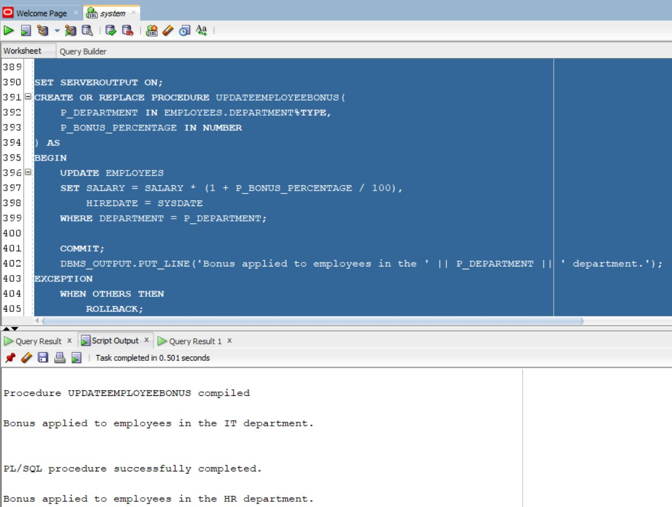
-- SCENARIO 3

SELECT * FROM ACCOUNTS;
SET SERVEROUTPUT ON;

CREATE OR REPLACE PROCEDURE TRANSFERFUNDS(
P_FROM_ACCOUNT_ID IN ACCOUNTS.ACCOUNTID%TYPE,
P_TO_ACCOUNT_ID IN ACCOUNTS.ACCOUNTID%TYPE,
P_AMOUNT IN NUMBER
) AS
V_FROM_BALANCE ACCOUNTS.BALANCE%TYPE;
BEGIN

SELECT BALANCE INTO V_FROM_BALANCE
FROM ACCOUNTS
WHERE ACCOUNTID = P_FROM_ACCOUNT_ID
FOR UPDATE;

-- Check for sufficient funds
IF V_FROM_BALANCE < P_AMOUNT THEN
RAISE_APPLICATION_ERROR(-20001, 'Insufficient funds in the source account.');
END IF;

-- Perform the transfer
UPDATE ACCOUNTS
SET BALANCE = BALANCE - P_AMOUNT,
LASTMODIFIED = SYSDATE
WHERE ACCOUNTID = P_FROM_ACCOUNT_ID;

UPDATE ACCOUNTS
SET BALANCE = BALANCE + P_AMOUNT,
LASTMODIFIED = SYSDATE
WHERE ACCOUNTID = P_TO_ACCOUNT_ID;

COMMIT;
DBMS_OUTPUT.PUT_LINE('Transfer of ' || P_AMOUNT || ' from account ' || P_FROM_ACCOUNT_ID || ' to account ' || P_TO_ACCOUNT_ID || ' completed successfully.');
EXCEPTION
WHEN OTHERS THEN
ROLLBACK;
DBMS_OUTPUT.PUT_LINE('Transfer failed: ' || SQLERRM);
END TRANSFERFUNDS;
/

EXEC TRANSFERFUNDS(1,2,100);

SELECT * FROM ACCOUNTS;

