

**Deploy to container**

Step 1 : Create Ant or Maven Job

Configure Source Code and Invoke Ant :

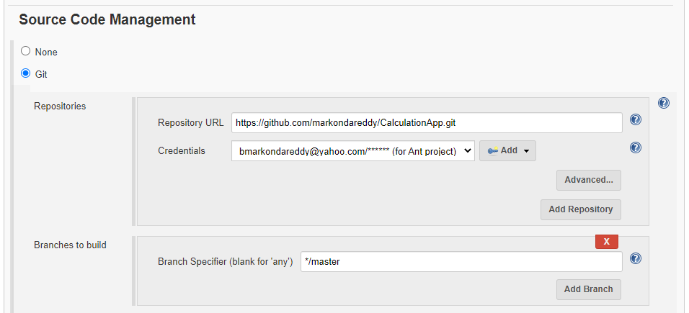

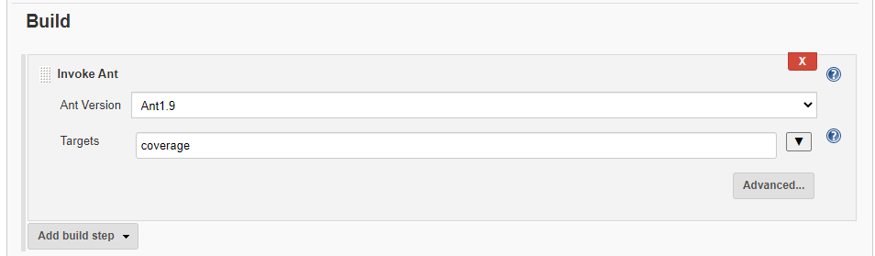

Step 2 : Manage Jenkins -> Manage PlugIn -> Install ([Deploy to container Plugin](https://plugins.jenkins.io/deploy))

Step 3: Select Job -> Configure -> Add Post build Actions -> Deploy war/ear to Container

Adding users: Add -> Jenkins

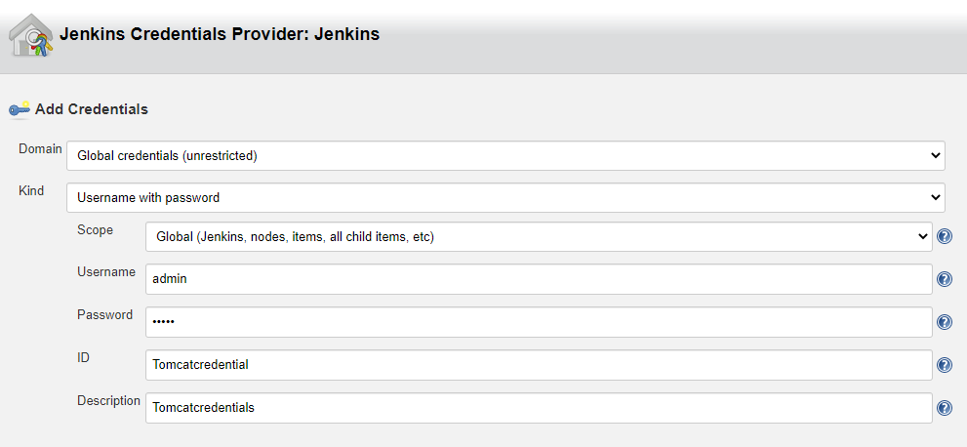

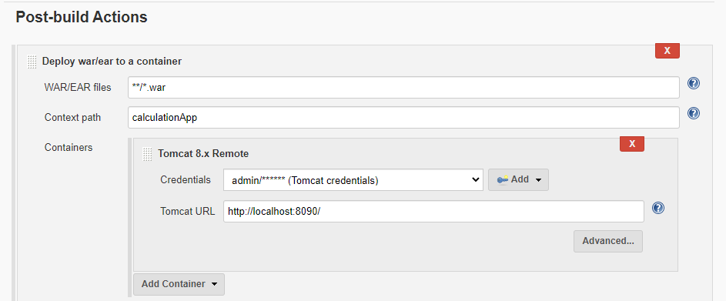

Save it.

Step 4: Build the Job.

Step 5: Goto to your Tocamcat server

[**http://localhost:8090**](http://localhost:8090)

Note: Make sure that in tomcat-users.xml below roles are added or not. If not added ,please add like below roles.

<user username="admin" password="admin" roles="admin-gui,manager-gui,manager-script,manager-status" />

Step 6: Check your Application is deployed or not

