How to create Instance in AWS:

Step 1: Login to AWS account

Step 2: Service -> Compute -> EC2

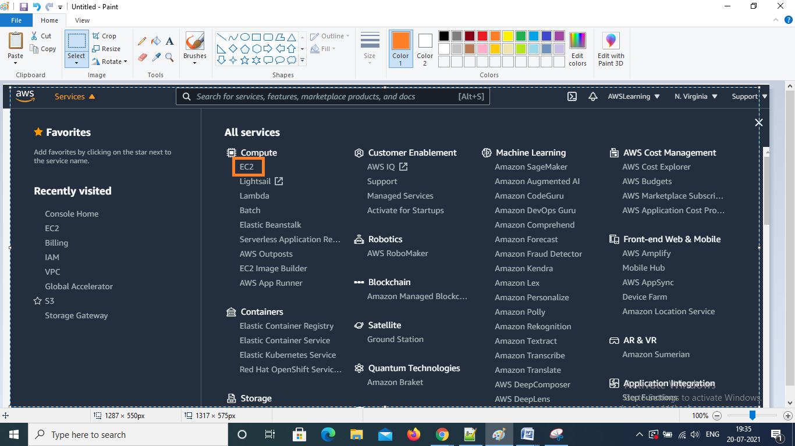

Step 3: Goto Instances – launch Instance

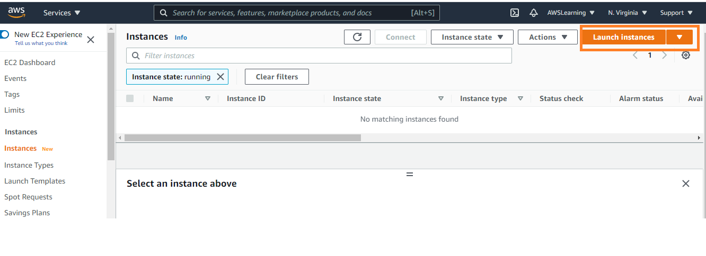

Step 4: Select AMI

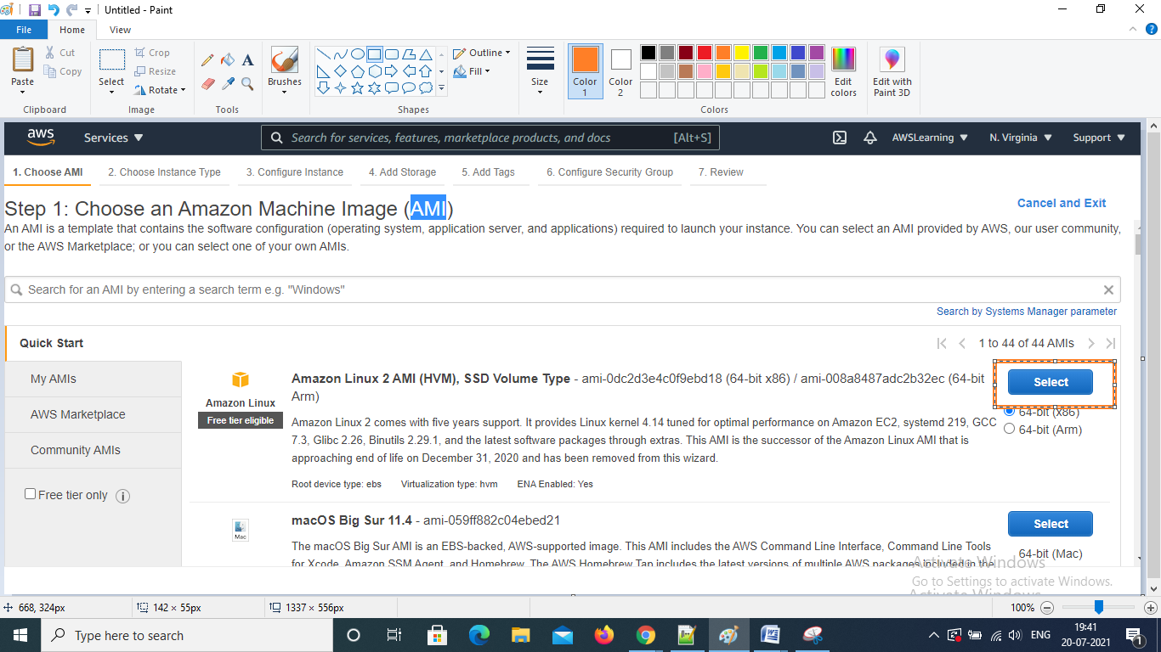

Step 5: Instance Type

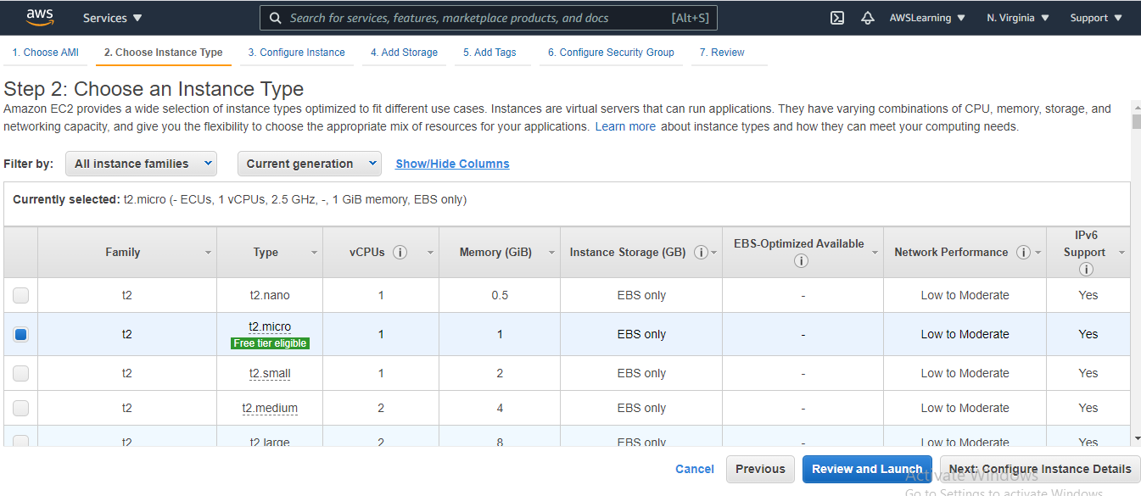

Step 6: Configure Instance Details

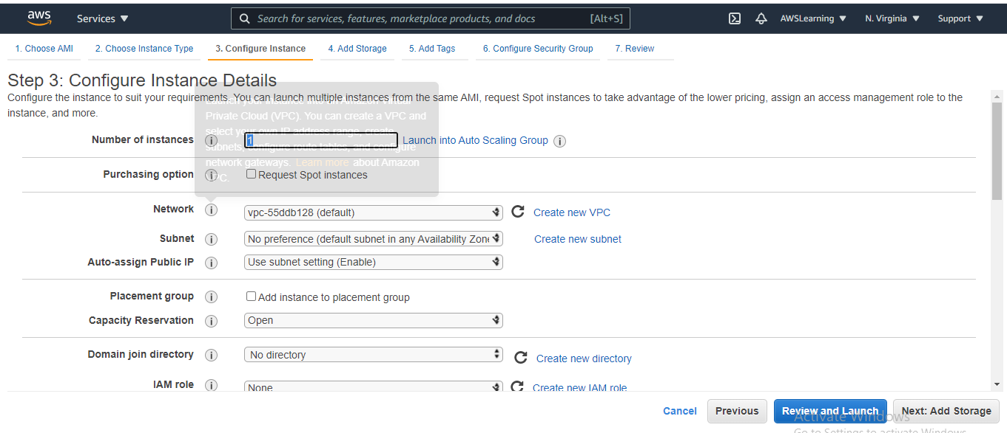

Step 7: Add storage details

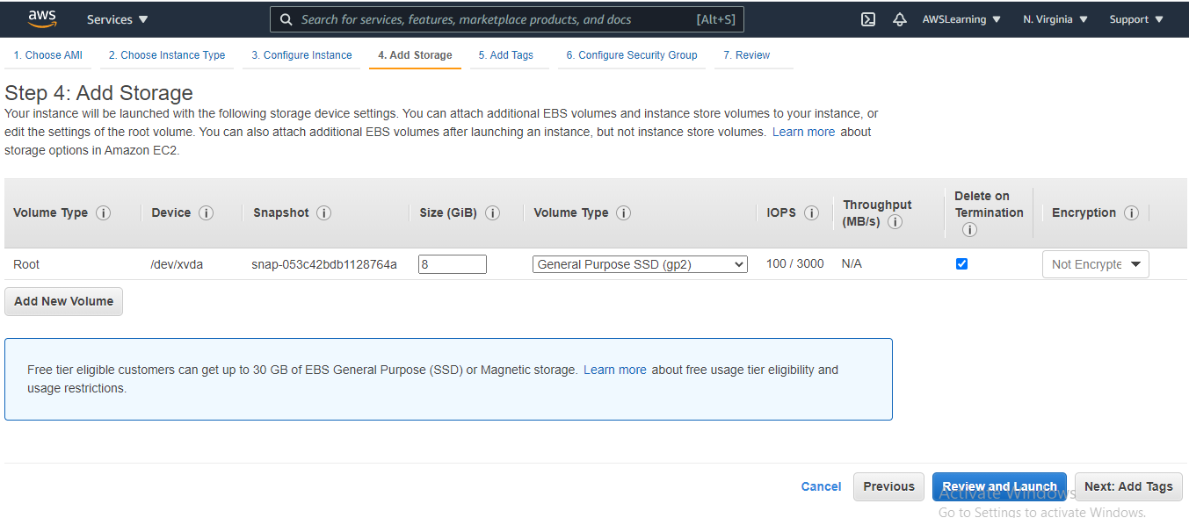

Step 8: Add tags

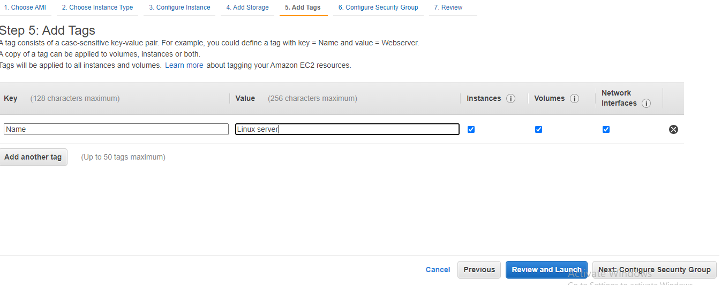

Step 9: Select Security Groups

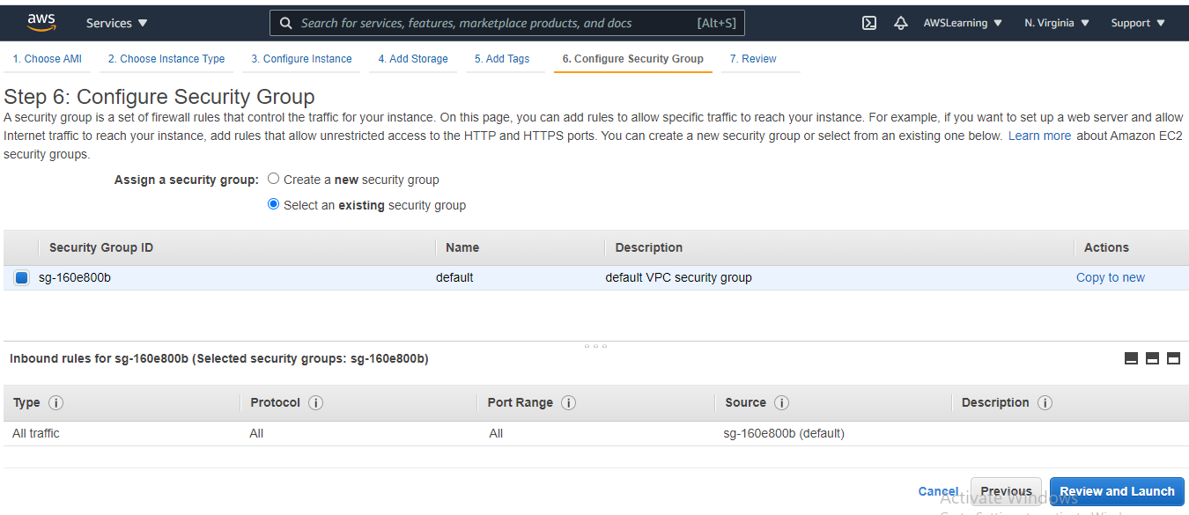

Step 10: Launch Instance

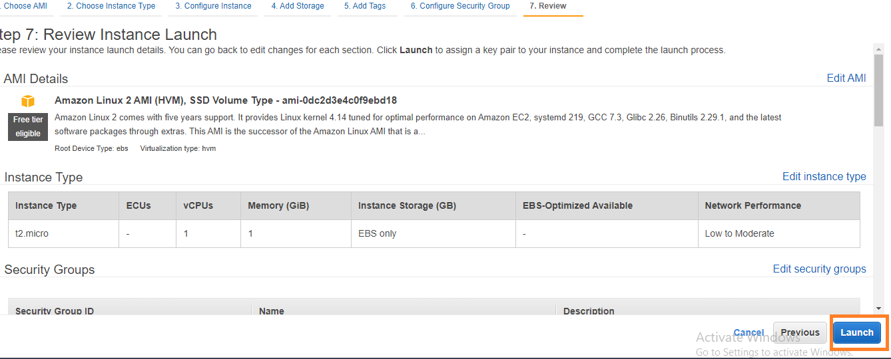

Step 11: Create Key pair

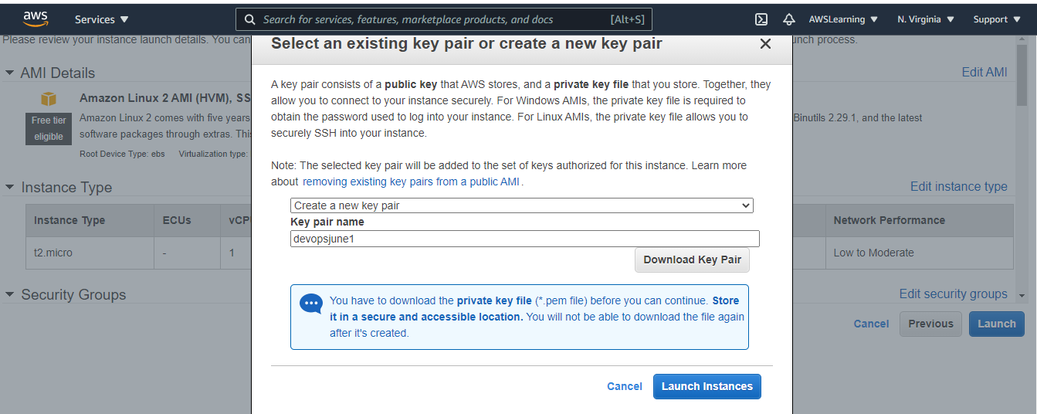

How to check your instance:

Goto Service -> EC2 -> Instances (Running)

How to connect AWS Instance:

Step 1: Click on the Instance -> Connect

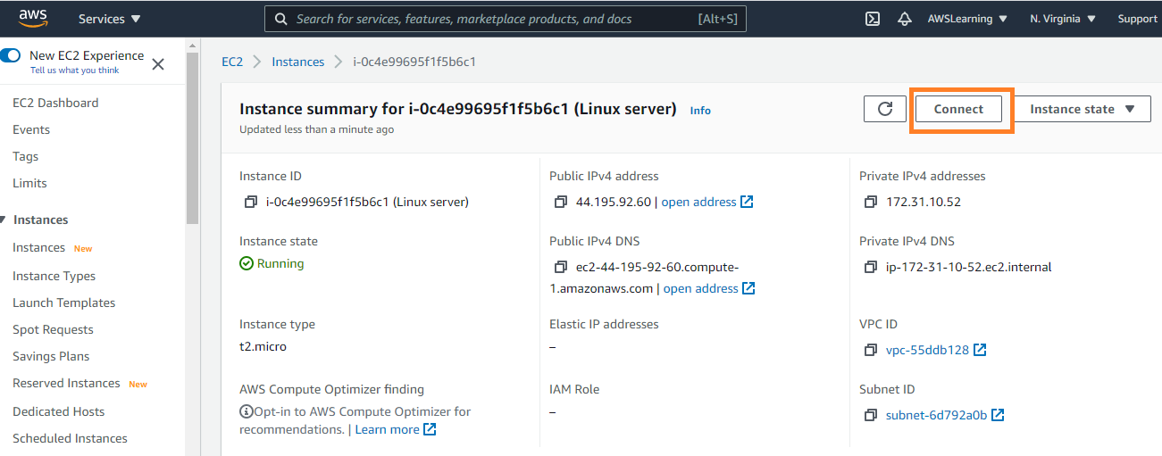

Step 2: Goto SSH Client Tab -> Copy below command

Example:

1. ssh -i "devopsjune1.pem" [ec2-user@ec2-44-195-92-60.compute-1.amazonaws.com](mailto:ec2-user@ec2-44-195-92-60.compute-1.amazonaws.com)

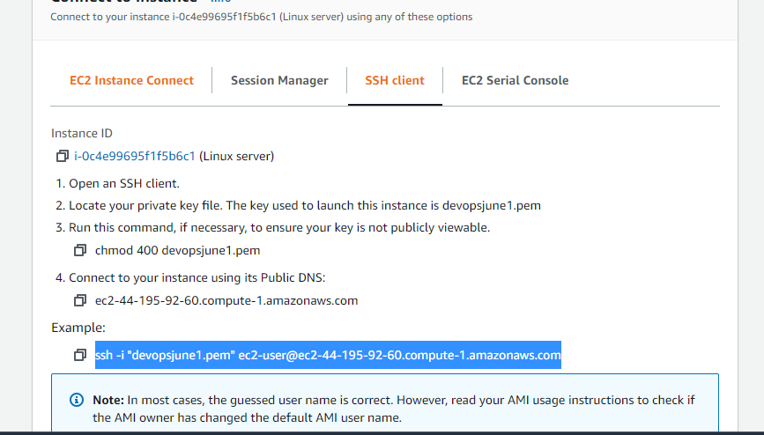

Step 3: Goto your download PEM file -> open in Git bash prompt

Markonda@DESKTOP-M4182DS MINGW64 ~/Desktop/Pemfiles

$ ssh -i "devopsjune1.pem" [ec2-user@ec2-44-195-92-60.compute-1.amazonaws.com](mailto:ec2-user@ec2-44-195-92-60.compute-1.amazonaws.com)

$