Jenkins Email Notifications

Step 1: First check [**Email Extension Plugin**](https://plugins.jenkins.io/email-ext) and **Mailer PlugIn**

Step 2: Goto Job -> Configure -> E-mail Notification

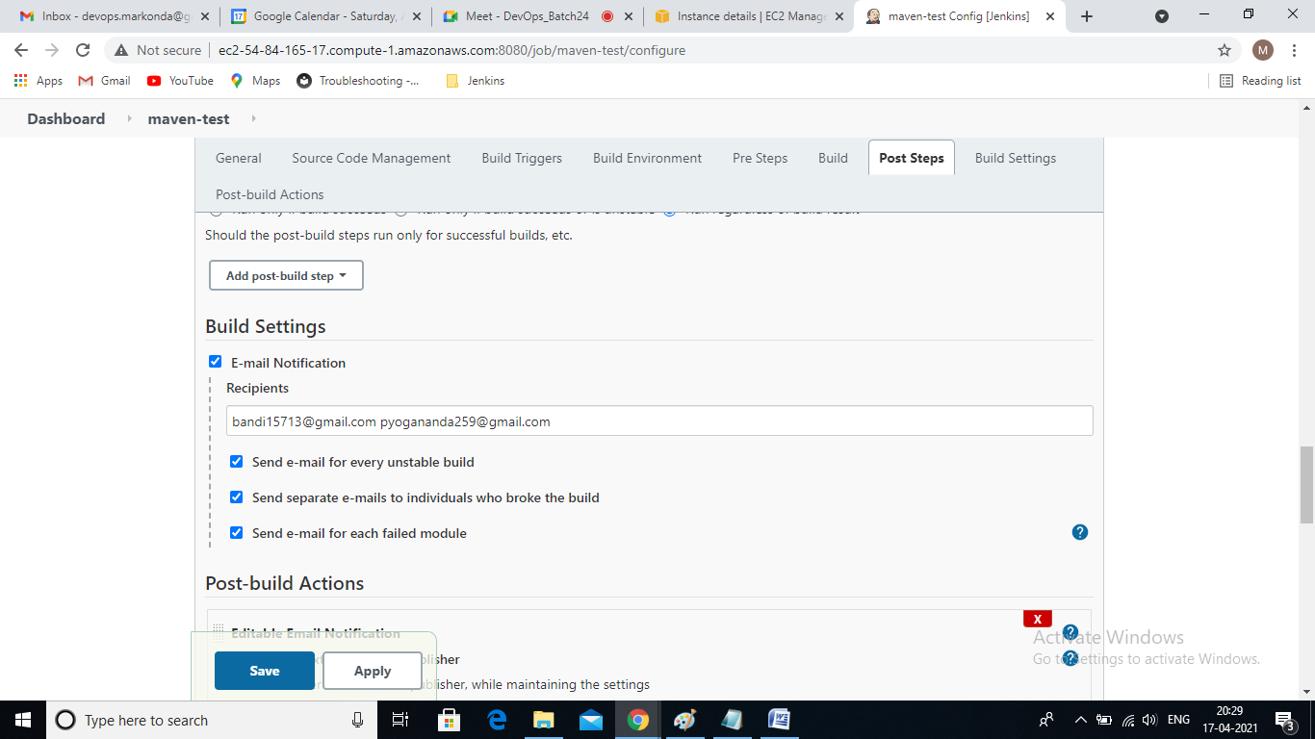

or

If you want to attach to log file while sending email configure -> Editable Email Notification.

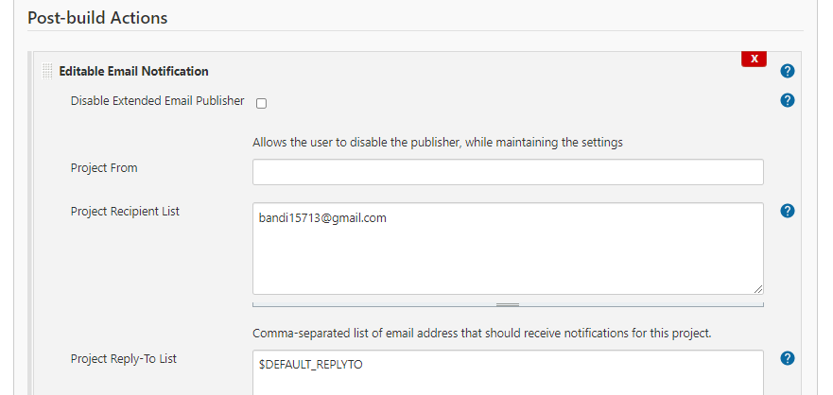

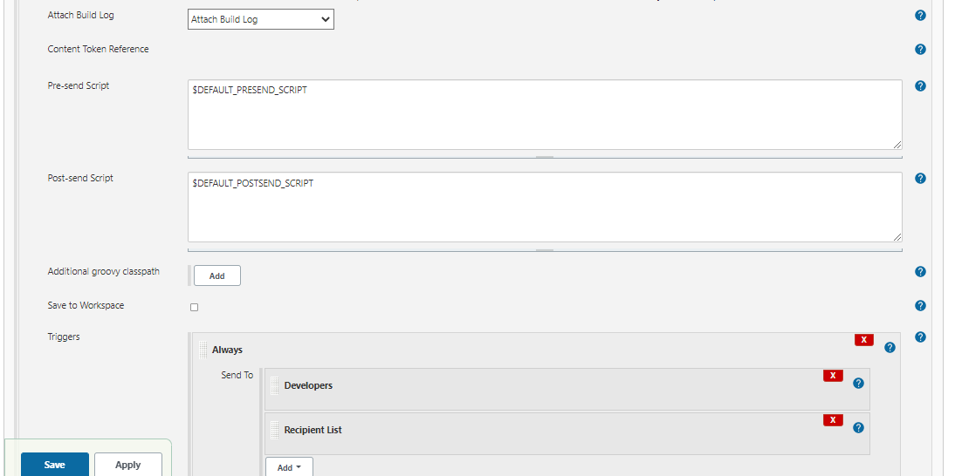

Step3: SMTP server configuration

Goto Manage Jenkins -> Configure System

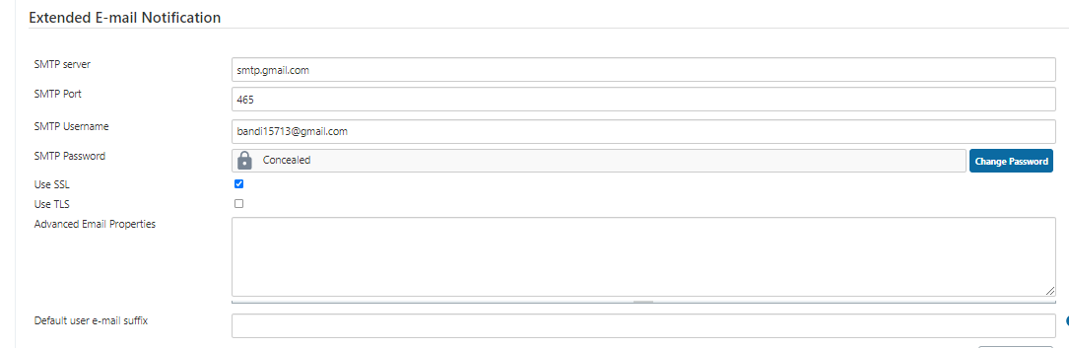

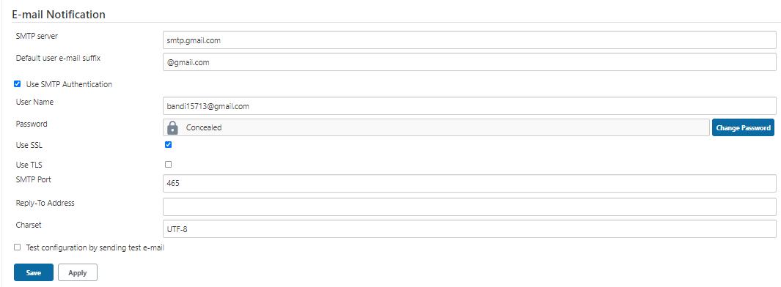

Step 3: Less Secure App Access in Gmail

Goto you Gmail Account -> Manage your google Account -> Security -> Less Secure App Access :**On**

Note: If Test Configuration by sending test e-mail is not success. Please enable below url.

**https://accounts.google.com/b/0/DisplayUnlockCaptcha**

Step 4: Start the build and check the your email.