

**Jenkins Master/Slave**

**Adding Remote linux server slaves into Jenkins master**

1. I have a linux server spin up in aws ec2-instances.
2. You must have install java 1.8 in all slaves.
3. Got to jenkins home → manage Jenkins → manage nodes →add new node.
4. Give name of the slave and click permanent agent.
5. Fill following appropriate vales like description, executors, labels, ans select a launch method is **Launch agent agents via SSH** and add the public ip of slave node ,credentials . here before adding credentials you must add credentials in Jenkins .
6. 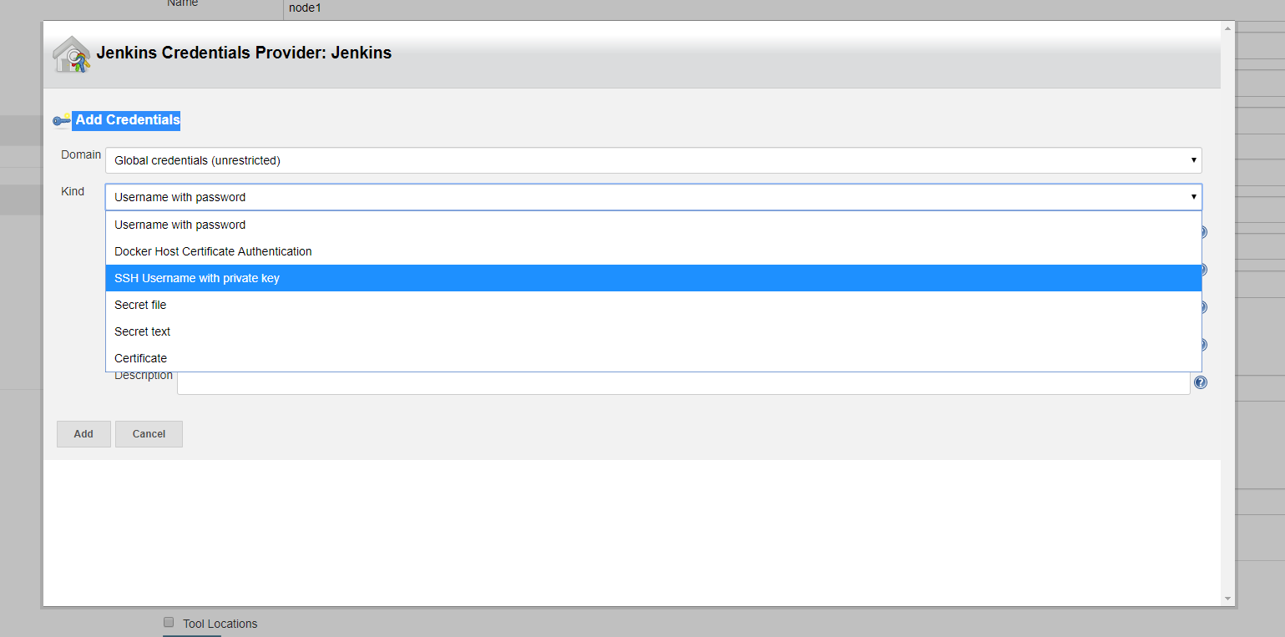Add credentials here you can select kind is ssh **username with private key .**

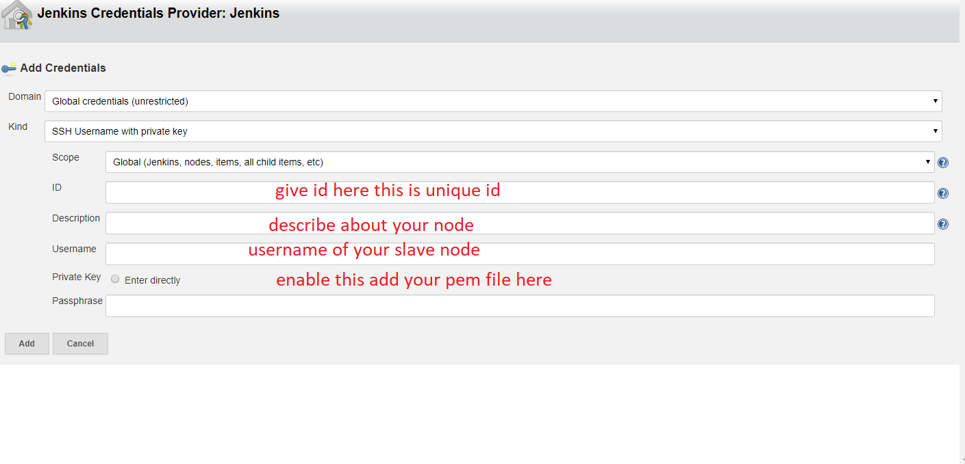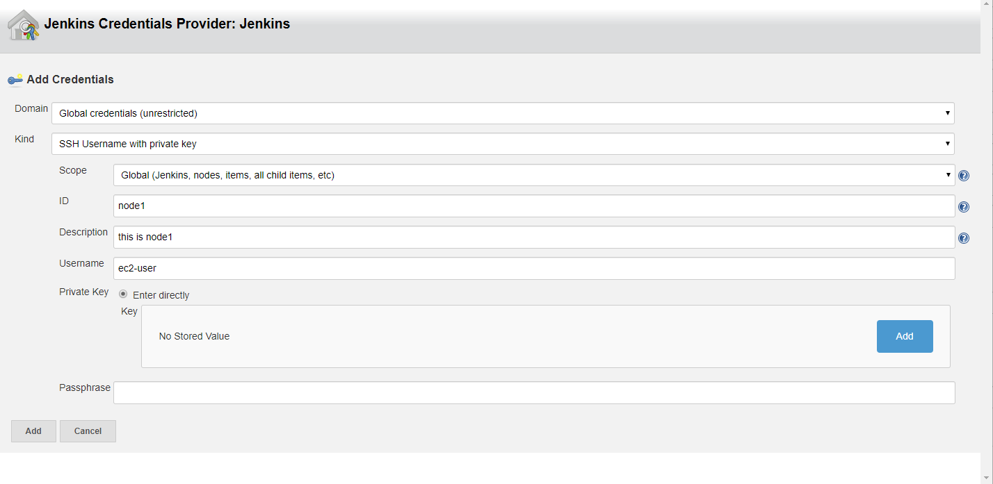

Click add here and paste your pem file key which is used while creation of your instance and click add.

1. After adding the credentials it will come under dropdown of credentials section and select credentials.
2. And here important thing is selection host key verification here I am selecting

**manually trusted key verification strategy** and click the save button.

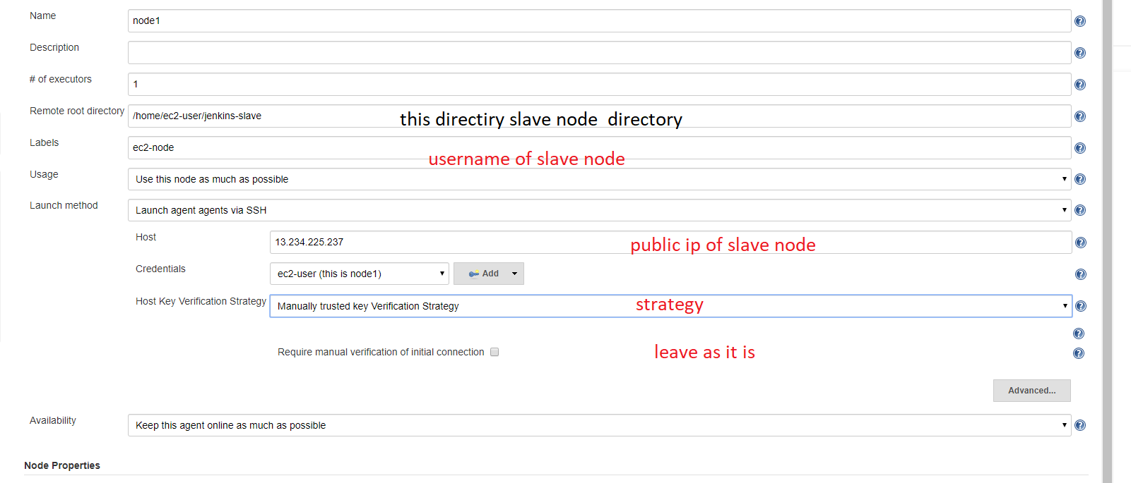

1. Now go and check nodes main page out slave ready to use

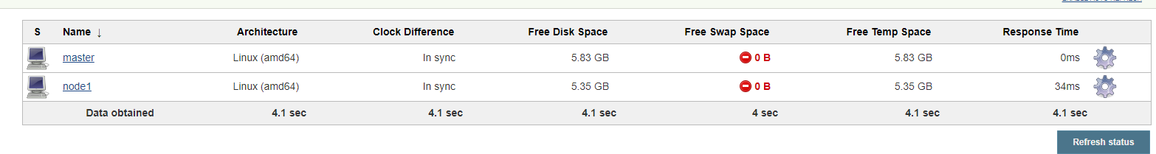

**Note**: it should be come online or we cont use this lave in our Jenkins job.

How to user our slave node:

Jenkins home -> create Job

Goto Job -> Configurations -> General (Restrict where this project can be run) -> search your slave node name.

