1. My Information
2. Name: Arvin Siva
3. Email: [sivaar1@umbc.edu](mailto:sivaar1@umbc.edu)
4. Description of Project

* First, to start the game, the player will have to enter in their name and a password; the password potion will be explained in the personal add-ons section. In the game, the player will enter in their answer in the text boxes below the clock. After they submit their answer, the clock will randomize to a new time for the next question. The game has a level and point format that will be explained later. After each student has played the game, the teacher can click the “Get Scores” button and enter in the password given in the password.txt file to access the student scores. The scores are presented from highest to lowest like a leaderboard, making it easy for the teacher to know who is doing good or bad.

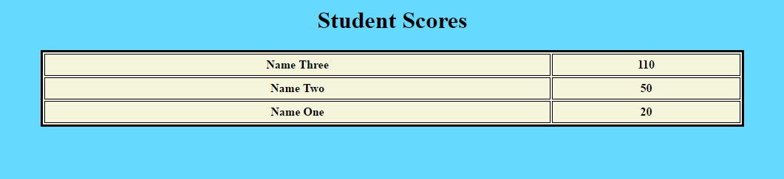

* Personal Add-ons:

The game has an account system for each player. This will allow students to replay the game by using the log in functionality. Once they enter their name and password, they will be able to play the game again, and the highest score will be saved. This is very useful since it gives the students opportunities for more practice.

The game also has a multi-level format. There are three levels of increasing difficulty with five questions per level (15 questions total). Players are rewarded 10 points for level 1, 20 for level 2, and 30 for level 3 (300 points in total). The first level consists of very basic questions. The only thing that will move will be the hour hand while the minute hand stays on 12 (1:00, 2:00, 3:00, etc.). Level 2 incorporates the minute hand. The minute hand can now move in increments of five (1:05, 1:10, 1:15, etc.). Lastly, level three will have no restrictions on the clock hands. The minute hand can now move on any minute marker (Ex: 1:17). This keeps the game fun and not as frustrating since students won’t instantly be asked the hardest type of question at the very beginning. This progression will help students get the hang of reading the clock while slowly ramping up the difficulty.

How the game will look like:

