INTERNSHIP REPORT

**MACHINE DOWNTIME OPTIMIZATION**

Submitted by

MANAKAVOO SIVA BALAJI A – 95072117035

In partial fulfillment for the award of the degree

of

BACHELOR OF TECHNOLOGY

in

ARTIFICIAL INTELLIGENCE AND DATA SCIENCE

FRANCIS XAVIER ENGINEERING COLLEGE

TIRUNELVELI

**FRANCIS XAVIER ENGINERING COLLEGE**

**(Autonomous)**

**TIRUNELVELI 627 003**

**BONAFIDE CERTIFICATE**

Certified that this internship report is the bonafide work of “………………………

.…………………………………...” who carried out the internship work under my

supervision. Certified further that to the best of my knowledge the work reported herein does

not form part of any other thesis or dissertation on the basis of which a degree or award was

conferred on an earlier occasion on this or any other candidate.

HEAD OF THE DEPARTMENT

Submitted for the B.TECH Degree Internship Viva Voce held on ………………………

**INTERNAL EXAMINER** **EXTERNAL EXAMINER**

ACKNOWLEDGEMENT

We would like to acknowledge all the people who have contributed to a great extent towards the initialization, the development, and the success of our internship program.

Our sincere thanks to Dr. V. VELMURUGAN, B.E., M.Tech., Ph.D., Principal, Francis Xavier Engineering College, Tirunelveli for extending the college facilities for the successful completion of internship program and for his kind patronage.

We also thank Dr. A. GNANA SARAVANAN, M.E., Ph.D., Dean – Placement and Industry Institute Interaction, Francis Xavier Engineering College, Tirunelveli for extending his excellent approach towards the industries, initiative ideas and encouragement towards our internship program.

We cordially thank, Dr. L. R. PRIYA, Academics Professor, Francis Xavier Engineering College, Tirunelveli, for providing valuable ideas and expert guidance for the successful completion of our internship program.

We also thank, Dr. A. ANITHA, B.E., M.Tech., Ph.D., Head of Department, Artificial Intelligence and Data Science, Francis Xavier Engineering College, Tirunelveli, for providing valuable ideas and expert guidance for the successful completion of our internship program.

I would express my sincere gratitude to MR. BHARANI KUMAR DEPURU (Chief Data Scientists), 360DigiTMG, Hyderabad.

Finally, we would like to record our deepest gratitude to our parents for their constant encouragement and support which motivated us to complete our project on time

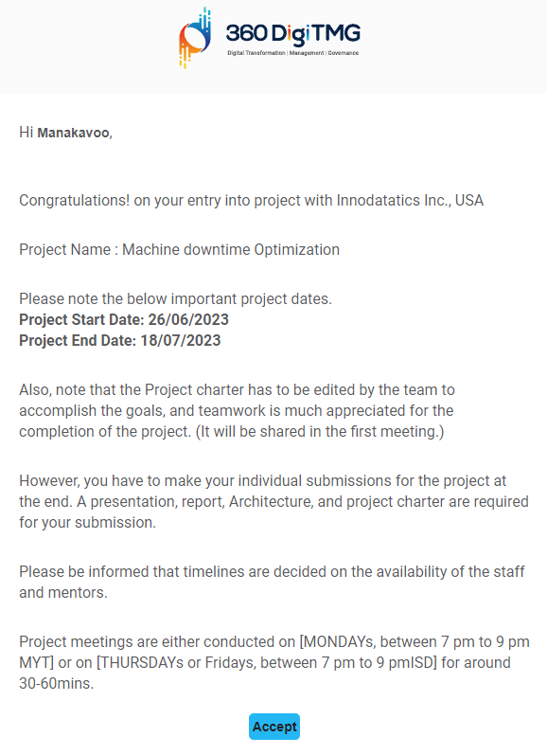

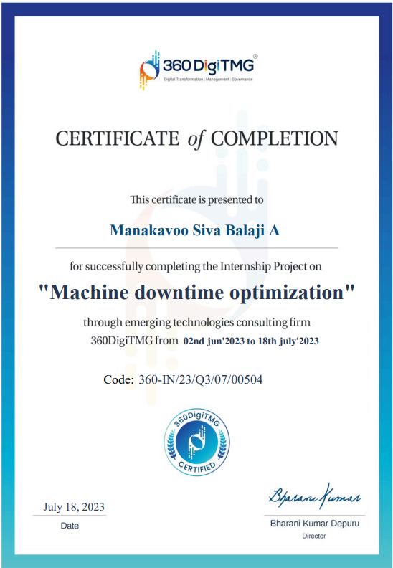

**TABLE OF CONTENTS**

1 ABSTRACT .

2 PROJECT EXECUTIVE SUMMARY 7

3 PROJECT OVERVIEW 8

**4 PROJECT WORK**

4.1 Data collection

4.2 Data cleaning

4.3 Feature engineering

4.4 Correlation

5 PROJECT SCOPE 10

5.1 Project Deliverables 10

5.2 Delivarable scope 10

6 PROJECT CONDITIONS 11

6.1 Project Assumptions 11

*6.2* Project Issues*.* 11

**7 . QUESTIONS & INSIGHTS**

6 PROJECT REFERENCES. 13

7 conclusion 14.

# ABSTRACT

An organization that produces fuel pumps. The fuel pump that is used to move the fuel more quickly makes the car drive more quickly. However, there was a hazy downtime throughout manufacturing. Therefore, this could reduce the company's profitability and lengthen delivery times. To make sense of this massive volume of data, compelling insights require effective visualization. Several graphs and charts will be included in our visualization project.

This project charter defines the scope, objectives, and overall approach for the work to be completed. It is a critical element for initiating, planning, executing, controlling, and assessing the project. It should be the single point of reference on the project for project goals and objectives, scope, organization, estimates, work plan, and budget. In addition, it serves as a contract between the Project Team and the Project Sponsors, stating what will be delivered according to the budget, time constraints, risks, resources, and standards agreed upon for the project.



# PROJECT EXECUTIVE SUMMARY

* Business Problem

A company which manufactures fuel pump. The fuel pump used to move the fuel with a higher velocity results the vehicle faster. But there was a uncertain downtime while production. So, this may affect the profitability of the company and increases the delivery time.

* Business Objective: Minimize the unplanned machine downtime.
* Business Constraint: Minimize maintenance cost.
* Success Criteria:
  + Business Success Criteria: To improve the production by reducing the unplanned downtime at least 10%.
  + Economic Success Criteria: provide cost effective solution with aleast 1 million.
* Data Collection: Update this section after the research is done.
* Scope: If you are doing this for any specific department of the organization then please mention the same.
* Assumptions: E.g., Data will be provided by customer, Cloud & GPU will be provided by customer
* Risks: E.g., Required data might not be available; Server connectivity might be weak, etc.
* Costs: Project cost – You can do assumptions by putting [number of hours * number of human resources (cadre wise) * hourly cost]
* Timeline: High level timeline of the project. E.g., Project will be for 20 to 25 days.
* Approach: Data Analytics Project Management Methodology



# PROJECT OVERVIEW

The 2500 records (provided data) that made up the data that was retrieved to learn more about the reason for the failure included details about the machine's operating conditions, including pressure, temperature, speed, and others. There are 165 days between 2021-08-12 and 2022-12-05. Both SQL and Python are used to pre-process this data and perform some coding-based analysis.

Even if there were no null values, the data needs to be cleaned. Overall, to execute the visualization, we used both the raw data and a customized SQL output.

Data visualization color codes are chosen to illustrate the failure rate and no failure rate after the data has been prepared. All things considered; we have also created a model that can anticipate machine failure even before it occurs.

Sample Data, which contains a variety of metrics factors related to the stages of machine production, is gathered from the internet. The values were recorded by machines and used in visualization. For machine production level data, about 2500 records are taken; thereafter, the failure rate data is extracted.

To utilize in SQL, data is extracted into CSV files. Once the data has been loaded, a second extract using custom SQL is made to summarize the production level data.



## PROJECT WORK

WORKFLOW

* Data Collection
* Descriptive Analysis
* Data Cleansing
* Feature Extraction
* Correlation

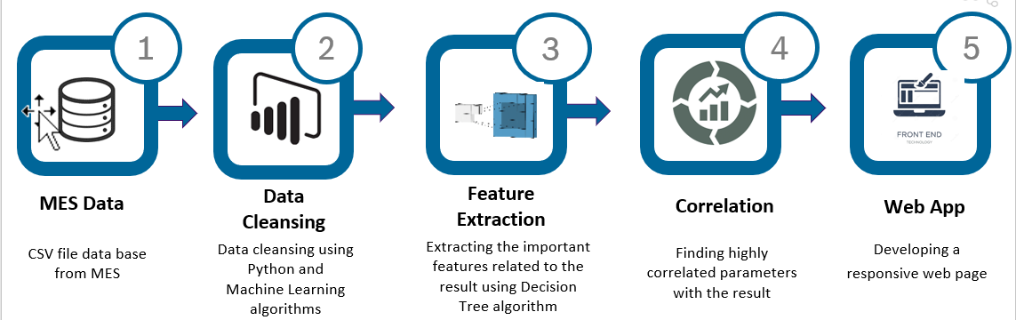

Data Collection

Sample Data, which contains a variety of metrics factors related to the stages of machine production, is gathered from the internet. The values were recorded by machines and used in visualization. For machine production level data, about 2500 records are taken; thereafter, the failure rate data is extracted.

To utilize in SQL, data is extracted into CSV files. Once the data has been loaded, a second extract using custom SQL is made to summarize the production level data.

Descriptive Analysis

Descriptive Analysis is the type of analysis of data that helps describe show or summarize data points in a constructive way such that patterns might emerge that fulfill every condition of the data. It is one of the most important steps for conducting statistical data analysis. Information about the null values, duplicate values, unique values, datatypes of each parameter is understood with the help of descriptive analysis.

Data Cleansing

Data cleansing or data cleaning is the process of detecting and correcting corrupt or inaccurate records from a record set, table, or dataset and refers to identifying incomplete, incorrect, inaccurate or irrelevant parts of the data and then replacing, modifying or deleting the dirty or coarse data.

Categorizing the parameters based on datatypes and removing the irrelevant data. Checking for null values in the dataset and replacing them with their respective mean value or deleting that particular row to avoid overfitting and unnecessary errors.

Feature Engineering

Feature extraction is a process of dimensionality reduction by which an initial set of raw data is reduced to more manageable groups for processing. Feature extraction is the name for methods that select and / or combine variables into features, effectively reducing the amount of data that must be processed, while still accurately and completely describing the original dataset.

Only the important features required for the further process are extracted using Machine Learning algorithm. The model is trained using the Decision Tree Regressor algorithm and the important features gets extracted.

Correlation

Correlation determines how one variable moves/changes in relation with the other variable. It gives us the idea about the degree of the relationship of the two variables.

In most of the business it is useful to express one subject in terms of its relationship with others. Using the corr() function, the correlation operation is carried out. The obtained values are in the matrix form. They are visualized using the matplotlib library.

# PROJECT SCOPE

## Project Deliverables

|  |  |
| --- | --- |
| **Milestone** | **Deliverable** |
| * Identifying Constraints and design the project architecture, explore various public forums to collect relevant data, Data Preparation | * Deliverable 1.1—Identifying Constraints and design the project architecture. * Deliverable 1.2—Explore various public forums to collect relevant data. * Deliverable 1.3— Data Preparation |
| * EDA and Descriptive Analytics | * Deliverable 2.1— EDA and Descriptive Analytics * Deliverable 2.2— Insights documentation |

## Deliverable Scope

* Web Application
* Mobile App
* Cloud based deployment

**Project Duration (start date: 26/06/2023 End date: 16/07/2023)**

|  |  |  |  |
| --- | --- | --- | --- |
| **Project Milestone** | **Date Estimate** | **Deliverable(s) Included** | **Confidence Level** |
| * Identifying Constraints and design the project architecture, explore various public forums to collect relevant data, Data Preparation. | [26/06/2023]  -  [02/07/2023] | * Deliverable 1.1—Identifying Constraints and design the project architecture. * Deliverable 1.2—Explore various public forums to collect relevant data. * Deliverable 1.3— Data Preparation | [High] |
| * EDA and Descriptive Analytics | [03/07/2023]  -  [11/07/2023] | * Deliverable 2.1— EDA and Descriptive Analytics * Deliverable 2.2--- Insights documentation | [High] |
| * Show case and review, Final Presentation and documentation, Handover and supervisor | [12/07/2023]  -  [16/07/2023] | * Deliverable3.1 – show case and review * Deliverable3.2 – Final Presentation and documentation * Deliverable3.3 – Handover and supervisor | [Medium] |



# PROJECT CONDITIONS

## Project Assumptions

* Data will be extracted from public sources and then client provided data is mapped and finally one master data will be shared by **Innodatatics** for further analysis.
* Dashboards and insights are mandatory.

## Project Issues

**Priority Criteria**

1 − High-priority/critical-path issue; requires immediate follow-up and resolution.

2 − Medium-priority issue; requires follow-up before completion of next project milestone.

3 − Low-priority issue; to be resolved prior to project completion.

1. − Closed issue.

## QUESTIONS & INSIGHTS

Questions which will be answered by this visualization:

* Are there any specific patterns or trends in the Hydraulic Pressure, Coolant Pressure, or Air System Pressure that could indicate potential issues with the machine's performance?
  + Patterns and Trends: By plotting the Hydraulic Pressure, Coolant Pressure, or Air System Pressure over time, line charts or area charts can reveal patterns or trends. Any fluctuations, recurring patterns, or abnormal values can be visually identified, helping to understand potential issues with the machine's performance
* Is there any correlation between the Coolant Pressure or Coolant Temperature and the frequency of machine maintenance needs? Can we identify specific coolant conditions that contribute to increased maintenance requirements?
  + Correlations and Relationships: Scatter plots or bubble charts can visualize the relationship between Coolant Temperature and Hydraulic Oil Temperature, Spindle Vibration and Tool Vibration, or any other parameter pairs.
* What are the primary reasons for machine downtime based on the Downtime feature? Are certain issues occurring more frequently than others, and how do they impact production schedules?
  + Optimal Operating Conditions: Through line charts or scatter plots, the Spindle Speed can be plotted against Voltage and Torque.

* Are there any seasonal or periodic variations in the machine's performance or maintenance needs based on the timestamps in the "Date" column?
  + Maintenance Needs: By visualizing coolant-related parameters such as Coolant Pressure and Coolant Temperature alongside maintenance events, patterns or trends can be identified.

# CONCLUSION

Based on the analysis of the machine features, we can draw a simple conclusion:

The machine's performance and efficiency are influenced by major factors such as Hydraulic Pressure, Torque, Cutting. Monitoring and analyzing these parameters can help identify potential issues, optimize maintenance schedules, and improve overall machine performance.

Implementing proactive maintenance strategies based on the analyzed data can reduce unplanned downtime, optimize resource allocation, and enhance product quality. By visualizing the data, we can identify patterns, correlations, and trends that provide valuable insights.

# PROJECT REFERENCES

|  |  |
| --- | --- |
| **Paper** | **link** |
| Downtime on the papermills | http://shodhbhagirathi.iitr.ac.in:8081/jspui/image/pdf/web/viewer.html?file=/jspui/bitstream/123456789/4265/1/PTDG11931.pdf |