Customer Churn Analysis

Here,Creating a Project and Cloud Storage in Watson Studio Projects can be created for various purposes, such as data science, visual recognition, and deep learning. For the customer churn analysis use case, a project called 'BDCs customer churn predictive analytics' is created. A light version of cloud storage with 5 GB of public cloud and 10 GB per month data retrieval is selected.

There are multiple environments available in IBM Watson Studio, such as Python, Scala, R, and more. The use case discussed is customer churn analysis, aiming to identify customers at risk of leaving a service or product.

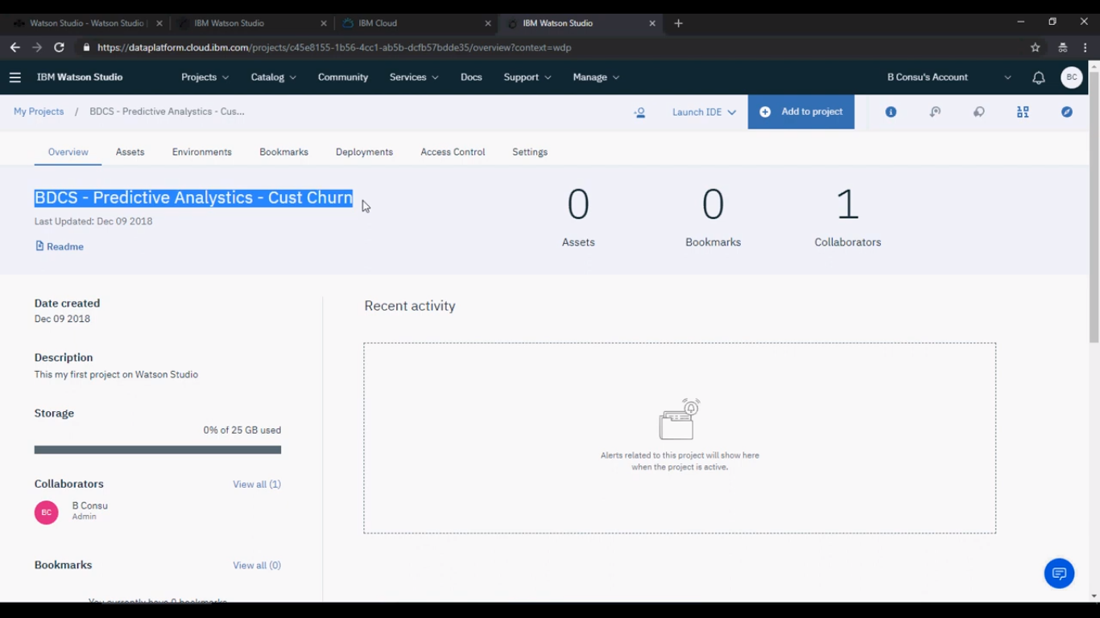

Added customer.csv and churn.csv and refined the data for training

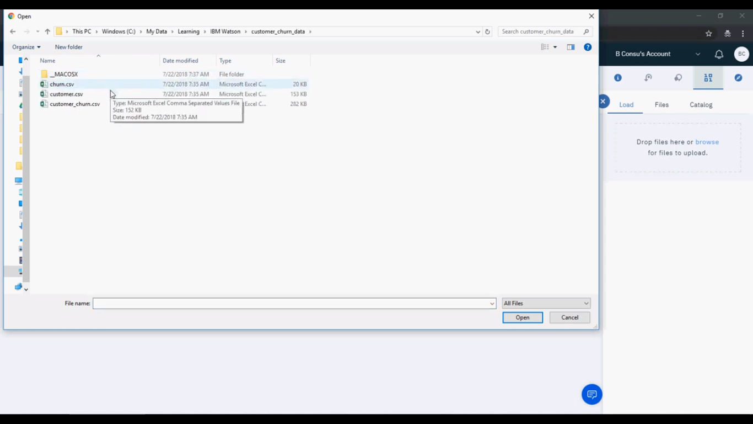

Converting age from string to decimal and running the data refinery flow

Steps to convert age from string to decimal and perform other calculations.

Clicking on 'run data refinery flow' and saving it to run the process.

Understand the data provided in the customer churn dataset, which includes customer information and telecom company data.

Use the data refining feature in Watson Studio to convert the age column from string to integer.

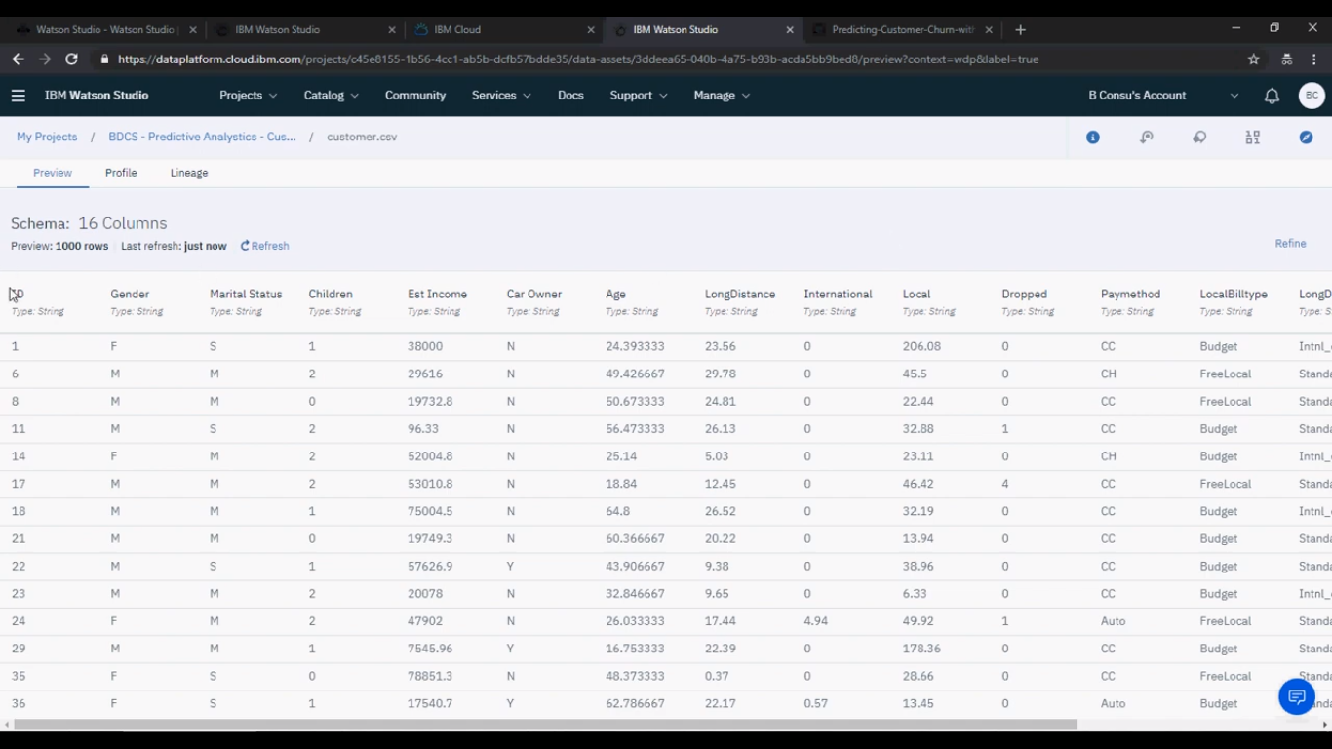

Joining customer and customer churn data to create a new file

The status of the task is completed.

The customer and customer churn data are joined to create a new file called customer_churn.csv.

The new file contains information about customers who left and customers who are still with the company.

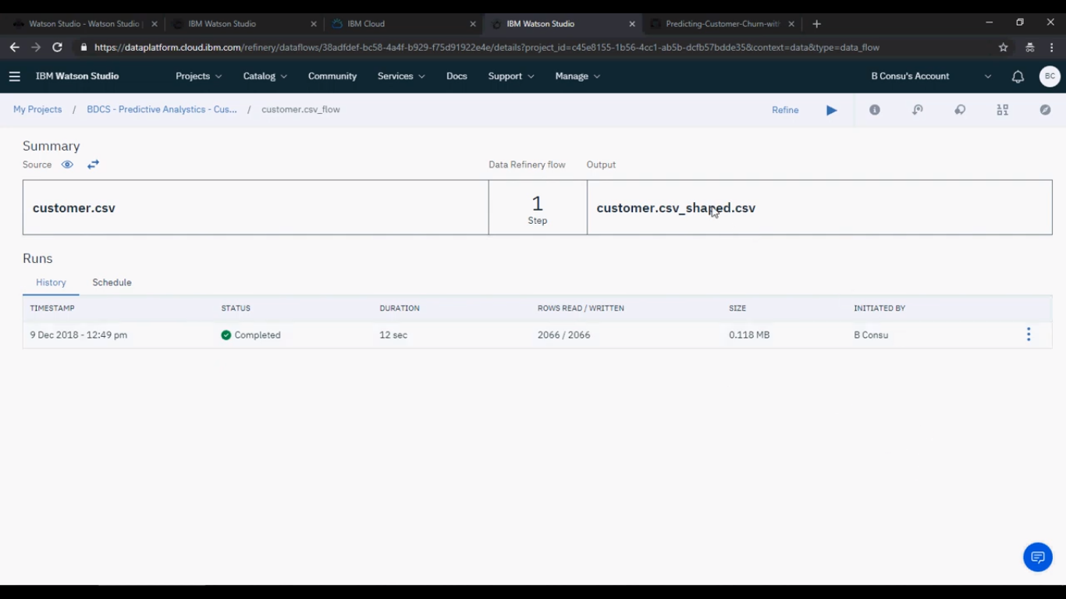

Data Preparation and Analysis in Watson Studio

Datasets are joined and customer_churn.csv is created.

Data sets from customer and churn.csv are used for customer churn analysis.

Data profiling and analysis can be done on the created data set.

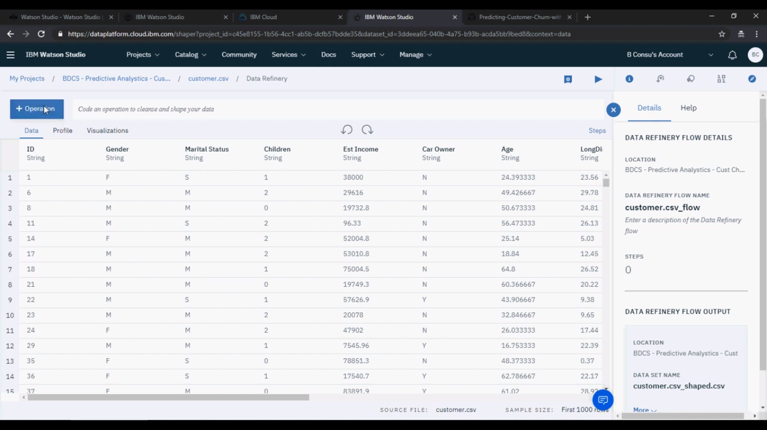

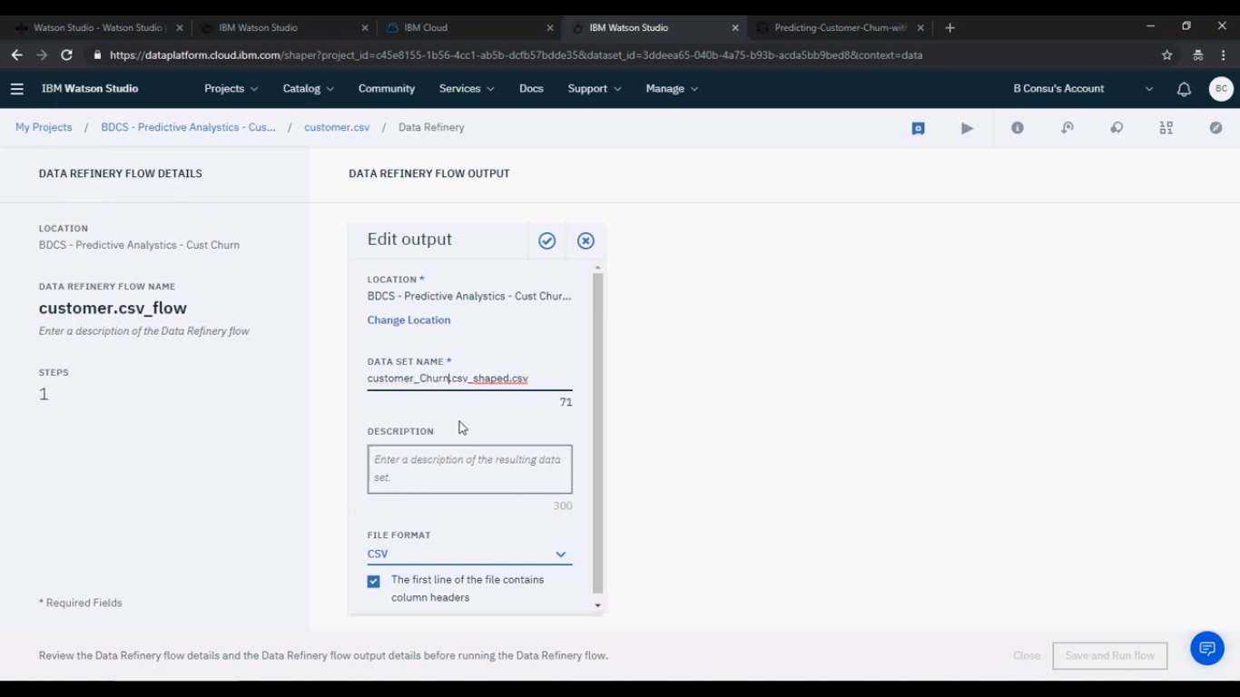

"customer_churn.csv." This new file contains information about customers who have left the company and customers who are still with the company.select the customer and churn datasets, specify the join conditions, and create the new file.

Once the join operation is completed the next step is to prepare the data for analysis. that the joined dataset, customer_churn.csv, can now be used for customer churn analysis.

The data profiling and analysis can be performed on this dataset using the tools and features available in IBM Watson Studio. However.

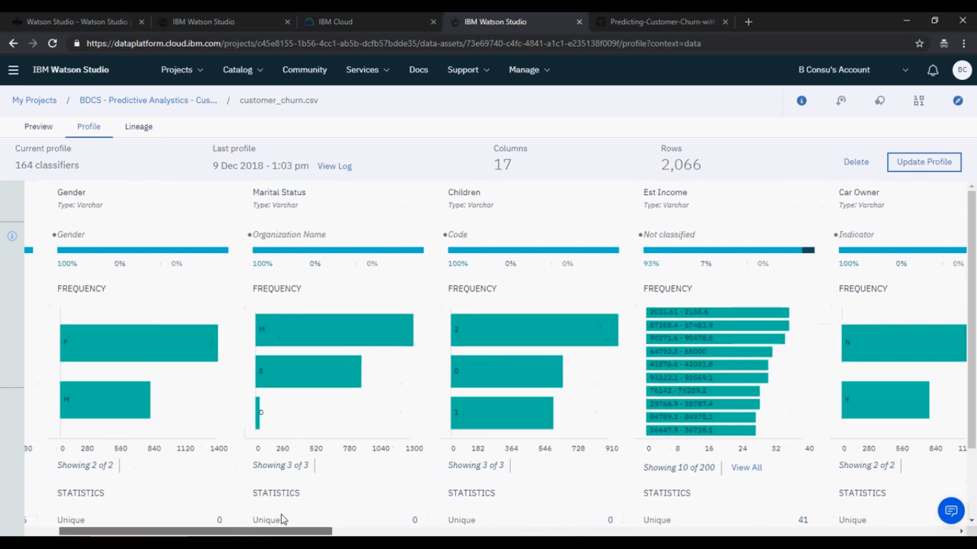

create and deploy machine learning models using IBM Watson Studio.

It explains three methods: SPSS modeler flow, Watson machine learning service, and Python or notebooks. The models can be published and accessed through APIs for various applications.

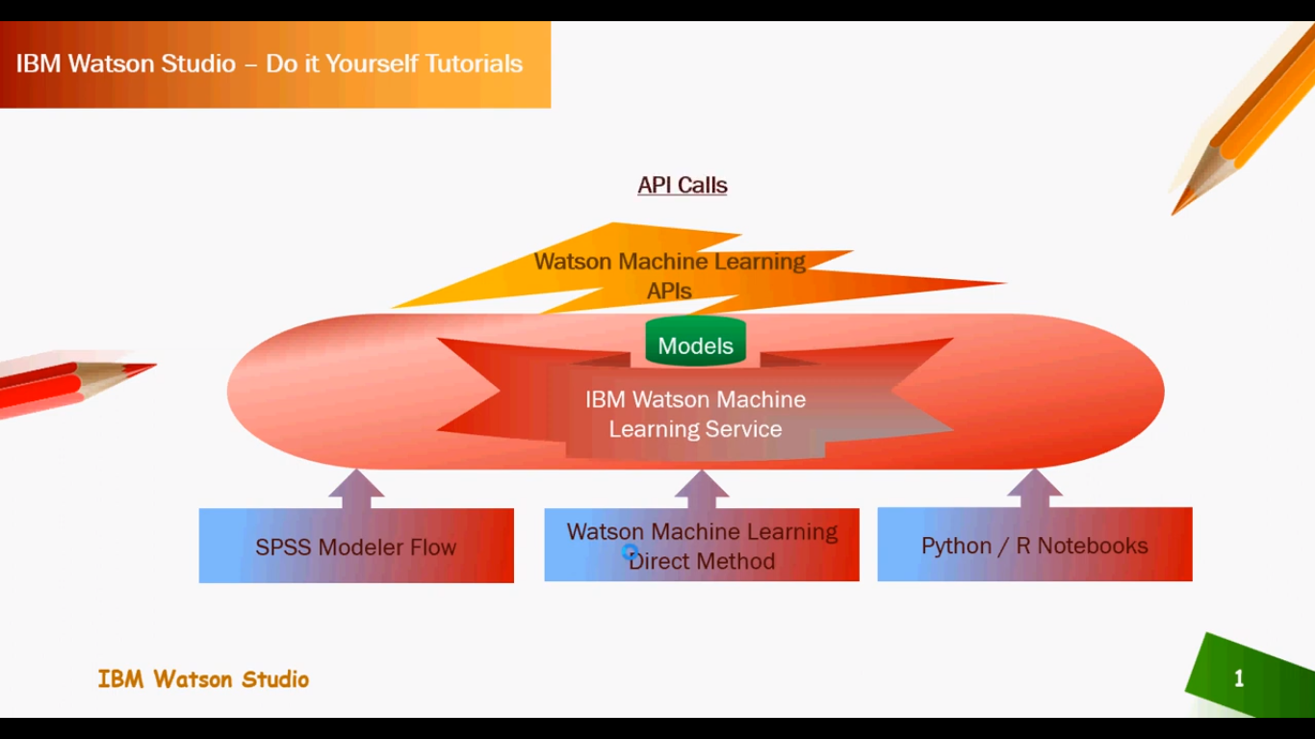

import a customer churn dataset and create an SPSS model using IBM Watson Studio Predictive Analytics. By analyzing the distribution graph, the accuracy of churn predictions can be evaluated and areas for improvement can be identified. The video also covers splitting the dataset, selecting the algorithm, and configuring the churn model.

* Creating an SPSS Model to Predict Customer Churn
* Import customer churn dataset and create an SPSS model to predict customer churn.
* Click on 'Add to Project' and select 'Modular Flow' to create the SPSS model.
* Drag and drop operations and connect data assets to create the model.

Creating a Churn Model with Data Splitting and Modeling Options Splitting the dataset into training and testing sets. Connecting the data with the target variable 'churn'. Selecting the C and R Tree algorithm for modeling and generating the churn model.

Adding distribution analysis for churn and configuring the columns.

Analyzing the Distribution of Churn Predictions

By analyzing the distribution graph, we can see the accuracy of churn predictions.

The graph shows the number of correct and incorrect churn predictions for true and false churn values.

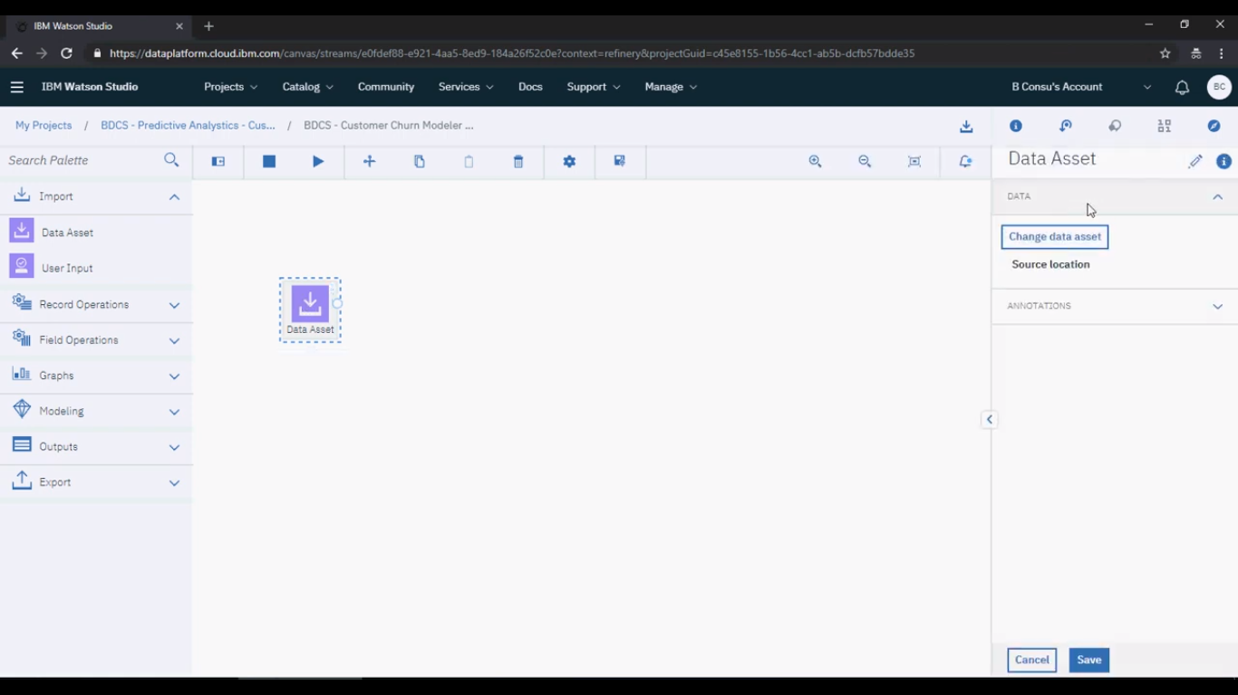

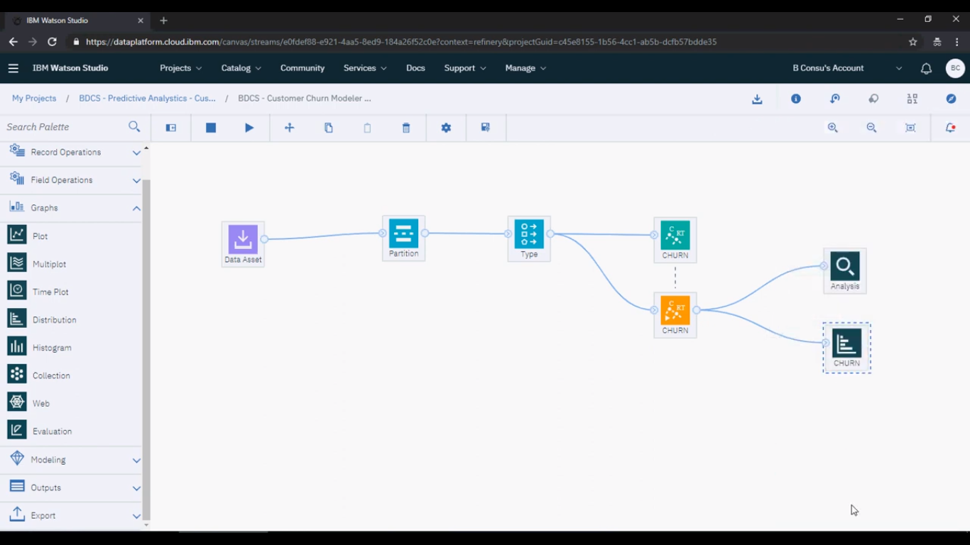

Improving the model's performance can be done by addressing the areas where the predictions are incorrect.

