**Machine Learning Model Deployment With IBM Cloud Watson Studio**



**Project Title:** ML Models With IBM Watson

**Phase 4:** Development Part 2

**DEVELOPMENT PART 1**

Start building the machine learning model using IBM Cloud Watson Studio.

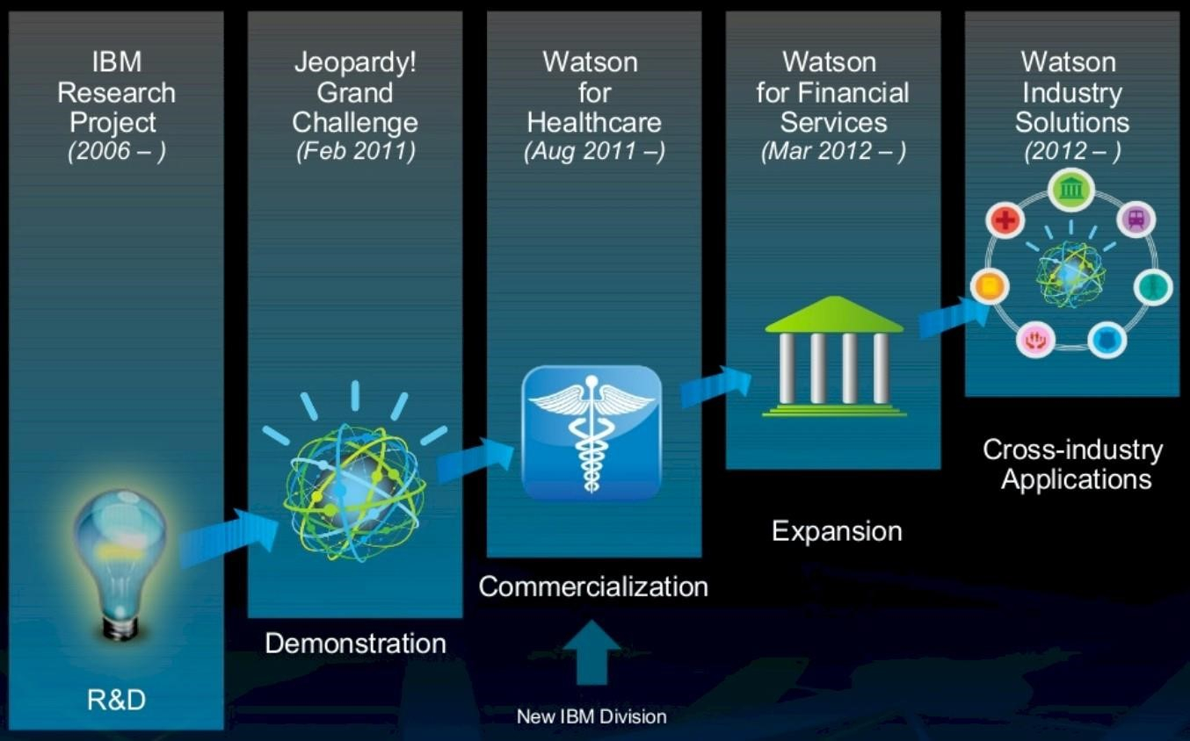

**Introduction:**

Deploying machine learning models effectively is not just about technological advancements; it's about enhancing human experiences, making processes more efficient, and improving decision-making across various domains. IBM Watson, a frontrunner in artificial intelligence, takes a human-centric approach to modern deployment, aiming to empower individuals, organizations, and communities with intelligent solutions tailored for human use.

In the ever-evolving landscape of data science and artificial intelligence, the ability to develop robust machine learning models is crucial. However, the true value of these models is realized when they are deployed and integrated into real-world applications, enabling businesses to make data-driven decisions and enhance user experiences. IBM Watson offers a comprehensive suite of tools and services that facilitate the seamless deployment of machine learning models, transforming complex algorithms into practical solutions.

The world of machine learning with IBM Cloud Watson Studio! In today's rapidly evolving technological landscape, leveraging the power of data and machine learning is essential for making informed decisions, predicting trends, and solving complex problems. IBM Cloud Watson Studio provides a robust and user-friendly platform that empowers you to build, train, and deploy machine learning models efficiently.

**Predictive Use Case:**

**Customer Churn Prediction :**

A predictive use case refers to a specific application of predictive analytics where historical and current data are analyzed to make predictions about future events or outcomes. Predictive analytics involves using statistical algorithms and machine learning techniques to identify patterns, trends, and relationships within data, allowing businesses and organizations to forecast future events accurately.

**In a predictive use case:**

**Historical Data:**

Relevant historical data is collected and analyzed. This data typically includes past events, behaviors, transactions, or patterns related to the specific domain of interest.

**Features and Target Variable:**

The historical data is divided into features (independent variables) and a target variable (dependent variable). Features are the variables used to make predictions, while the target variable is what you want to predict.

**Model Training:**

Statistical algorithms or machine learning models are trained using the historical data, using features to predict the target variable. During training, the model learns the patterns and relationships in the data.

**Prediction:**

Once the model is trained and validated, it can be used to make predictions on new, unseen data. The model analyzes the features of the new data to forecast the likely outcome or behavior.

**Decision-Making:**

Predictions made by the model are used to inform decision-making processes. For example, in customer churn prediction, businesses might use the predictions to identify customers at risk of leaving and implement targeted retention strategies.

**Customer Churn:**

* Customer churn is defined as when customers or subscribers discontinue doing business with a firm or service.
* Customers in the telecom industry can choose from a variety of service providers and actively switch from one to the next. The telecommunications business has an annual churn rate of 15-25 percent in this highly competitive market.
* Individualized customer retention is tough because most firms have a large number of customers and can't afford to devote much time to each of them. The costs would be too great, outweighing the additional revenue. However, if a corporation could forecast which customers are likely to leave ahead of time, it could focus customer retention efforts only on these "high risk" clients. The ultimate goal is to expand its coverage area and retrieve more customers loyalty. The core to succeed in this market lies in the customer itself.
* Customer churn is a critical metric because it is much less expensive to retain existing customers than it is to acquire new customers.

**Given Data Set:**

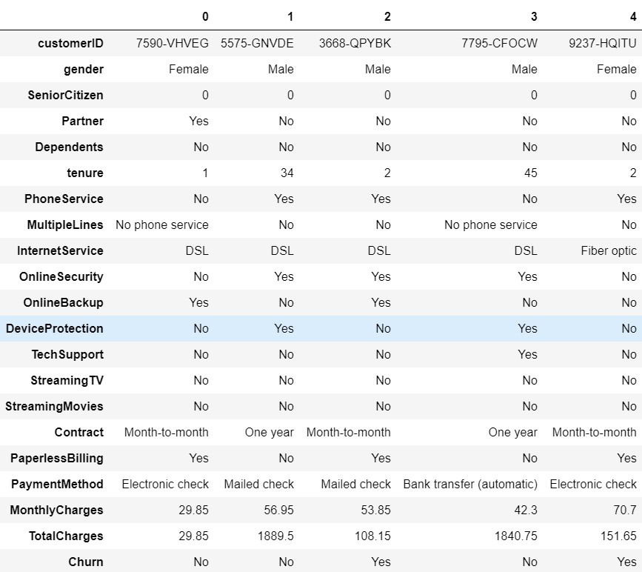

**Necessary Steps To Follow:**

**Import Libraries:**

**Start by importing the necessary libraries:**

**Program:**

import pandas as pdimport numpy as np import missingno as msno import matplotlib.pyplot as plt import seaborn as sns import plotly.express as px import plotly.graph_objects as go from plotly.subplots import make_subplots import warnings warnings.filterwarnings('ignore')

**Load the Dataset:**

**Program:**

from sklearn.preprocessing import StandardScaler from sklearn.preprocessing import LabelEncoder

from sklearn.tree import DecisionTreeClassifier from sklearn.ensemble import RandomForestClassifier from sklearn.naive_bayes import GaussianNB from sklearn.neighbors import KNeighborsClassifier from sklearn.svm import SVC from sklearn.neural_network import MLPClassifier from sklearn.ensemble import AdaBoostClassifier from sklearn.ensemble import GradientBoostingClassifier from sklearn.ensemble import ExtraTreesClassifier

from sklearn.linear_model import LogisticRegression from sklearn.model_selection import train_test_split from sklearn.metrics import accuracy_score from xgboost import XGBClassifier from catboost import CatBoostClassifier from sklearn import metrics from sklearn.metrics import roc_curve

from sklearn.metrics import recall_score, confusion_matrix, precision_score, f1_score, accuracy_score, classification_report df = pd.read_csv('../input/telco-customer-churn/WA_Fn-UseC_-Telco-Customer-Churn.csv') **Data Preprocessing:**

Data preprocessing is a crucial step in any machine learning project, including customer churn prediction. It involves transforming raw data into a format that can be effectively used by machine learning models.

**Here are the key steps involved in data preprocessing:**

1. Data Cleaning.
2. Data Transformation.
3. Data Reduction.
4. Data Splitting.
5. Data Preprocessing Pipeline.

After these preprocessing steps, your data is ready to be used for training machine learning models. Remember that the specific preprocessing techniques can vary based on the dataset and the requirements of your machine learning algorithm.

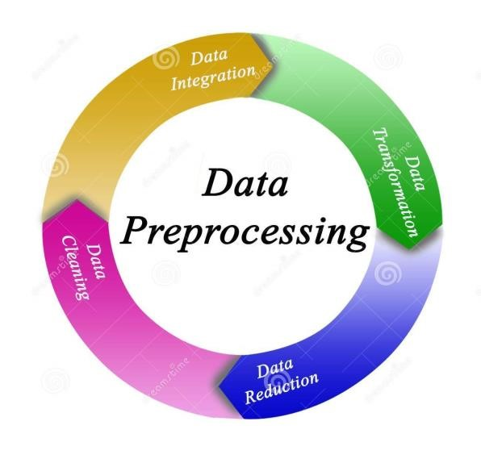

**Select Features:**

**Explore the Data:**

Use Watson Studio's data exploration tools to understand your dataset. Visualize data distributions, check for missing values, and understand the characteristics of each feature.

**Data Cleaning:**

Handle missing values and outliers appropriately. You can use tools within Watson Studio for tasks like imputation and outlier detection.

**Feature Selection:**

Based on your exploration, select relevant features for your model. For example, 'age', 'monthly_spend', and 'customer_service_calls' might be important features for churn prediction.

**Train the Machine Learning Model:**

splitting the data into features (X) and the target variable (y), and splitting the data into training and testing sets.

Training a machine learning model refers to the process of teaching the model to recognize patterns in the input data (features) and associate them with corresponding outputs (labels or predictions). During the training process, the model learns from historical data so that it can make accurate predictions or decisions when presented with new, unseen data. Splitting the data into train and test sets from sklearn. **DEVELOPMENT PART 2**

**1. *Model Deployment on IBM Watson Studio:\***

a. First, you need to have an IBM Cloud account and access to Watson Studio.

b. Once you have Watson Studio set up, navigate to the project where your model is located.

c. In Watson Studio, you can typically create a deployment space for deploying models.

d. You can then deploy your model to this space. Watson Studio provides easy-to-follow wizards and guides to assist you in this process.

e. You might have to configure the deployment environment, including selecting the type of environment (e.g., CPU or GPU), specifying the number of nodes, and setting up runtime options.

f. After deployment, you will be provided with an API endpoint for your model.

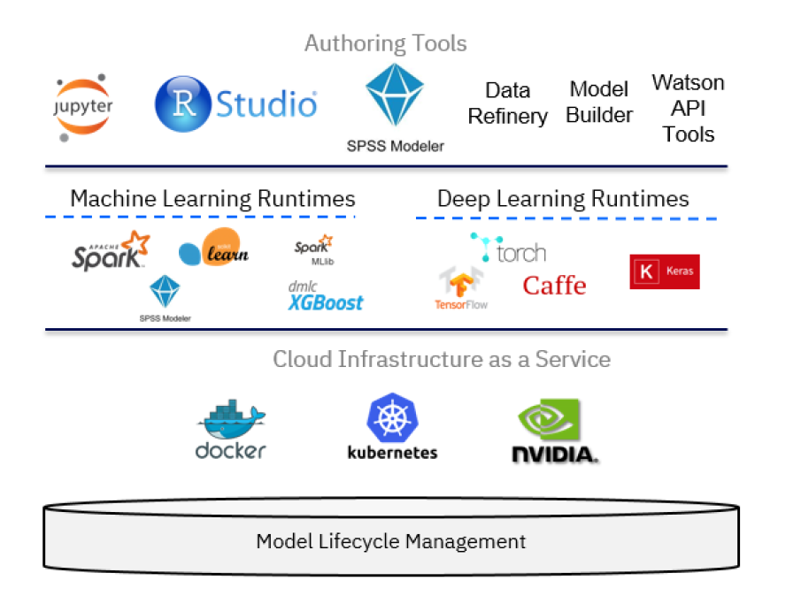

**2. *Integrating the Deployed Model into Applications:\***

a. You can use various programming languages and libraries to interact with the API endpoint provided by Watson Studio.

b. Make HTTP requests to the API endpoint using libraries like `requests` in Python, or other HTTP client libraries in your preferred programming language.

c. Send the data you want to make predictions on as part of your API request.

d. You will receive the model's predictions as a response, usually in JSON format.

e. Parse the response in your application to extract the relevant information.

f. You can then use the predictions in your application for further processing or display.

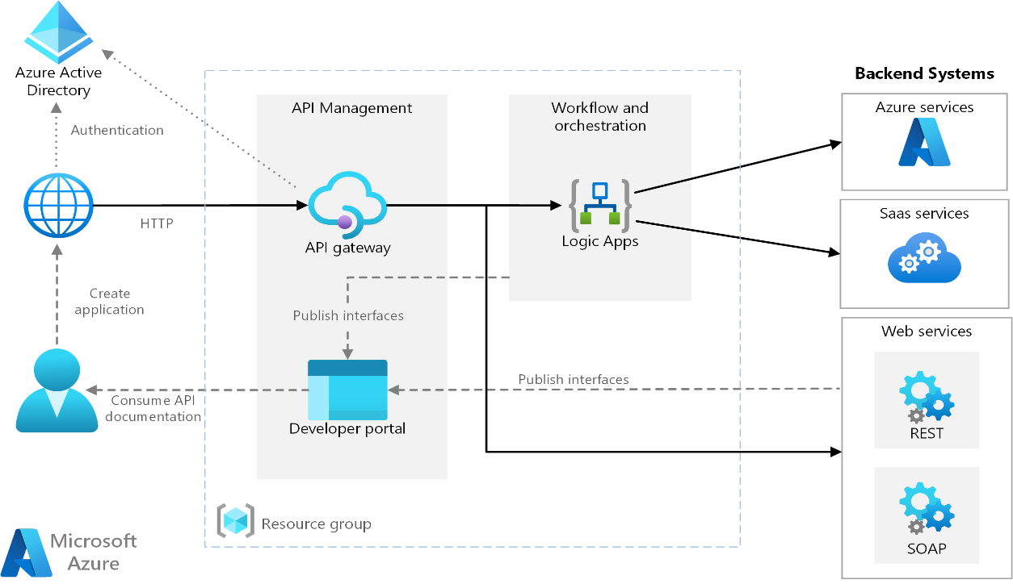

**CONCLUSION:**

Thus, the development part 1 and development part 2 for Machine Learning Model Deployment With IBM Cloud Watson Studio are defined . Here we, see about the development part 2 of machine learning model deployment with IBM cloud Watson studio.