**NAME**  : P.SIVABALAN

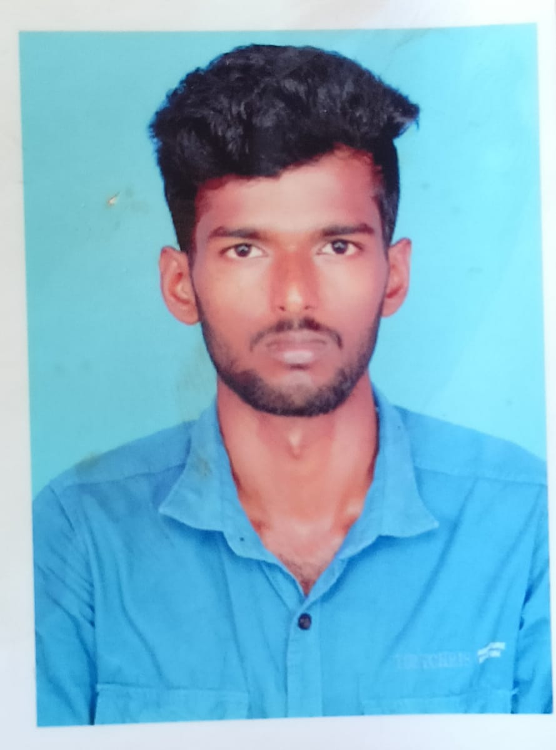

**E-MAIL ID** : [ssivabalan111@gmail.com](mailto:ssivabalan111@gmail.com)

**MOBILE NO :**  8807710291

**ADDRESS :** DHARMANALLUR, MELA STREET, DHARMANALLUR (POST),

VIRUDHACHALAM (TK),

CUDDALORE DISTRICT ,

606 103 **.**

**Objective:**

To be a successful and to work for an organization with full zeal and aiming at not only authority’s satisfaction bull also over all personal development.

**PERSONAL PROFILE :**

**NAME**  : P.SIVABALAN

**FATHER NAME :** R. PANDIYADURAI

**DATE OF BIRTH :** 27:01:2004

**GENDER :**  Male

**NATIONALITY :** INDIAN

**RELIGION :** HINDU

**LANGUAGE KNOWN :** TAMIL, ENGLISH

**PERMANENT ADDRESS :**  DHARMANALLUR, MELA STREET,

DHARMANALLUR (POST), VIRUDHACHALAM (TK),

CUDDALORE DISTRICT ,

606 103 **.**