Title: LinkAlias
Problem Statement:
Today, users frequently interact with long and difficult-to-remember URLs across different websites and browser platforms. When users want to identify or remember the purpose of a particular link, they have to manually copy, and put name below every time.
There is no simple, cross-browser solution that can automatically detect links on web pages and allow users to assign meaningful aliases without modifying the original URL.

Existing System
1. Browser Bookmarks
- Users manually bookmark web pages.
- They can change the bookmark name or title.
- However, there is no automatic pencil icon displayed next to each link on the webpage.
2. Copy and Paste
- Users manually copy links and save them in Notes, WhatsApp, Google Keep, or other applications.
- The relationship between the original URL and its custom alias must be maintained manually.
3. URL Shorteners
- Users can create short or custom URLs from long URLs.
- However, the original URL is transformed into a different URL.
- This does not meet the requirement of keeping the original URL completely unchanged.

Proposed Solution:
LinkAlias aims to solve this problem by providing a browser extension that detects web links on supported browsers, displays a pencil icon next to each link, and allows users to assign and save a custom alias. The original URL remains completely unchanged, while the alias is securely stored and associated with the URL in the LinkAlias system.

Target Users:
Students, researchers, and developers who frequently work with large numbers of web links and need a simple way to identify and organize them without modifying the original URLs.

Wolk Flow:
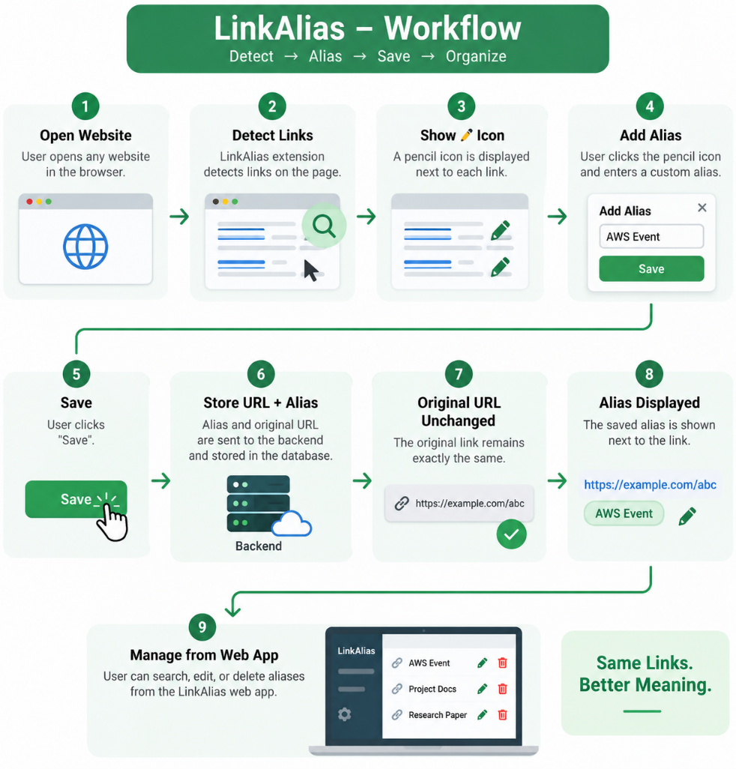

Technical WorkFlow:
gfsssaasssxxxaadads